IEEE P802.11
Wireless LANs
EHT-SIG CR on P802.11be D0.3 – part 4
Date: 2021.02.20
Author(s):
Name | Company | Address | Phone | email
Ross Jian Yu | Huawei Technologies | F3-6-A120, Huawei Base, Bantian, Longgang, Shenzhen, Guangdong, China, 518129 |  | ross.yujian@huawei.com
Edward Au | Huawei Technologies
Abstract
This submission contains proposed comment resolutions to comments on P802.11be D0.3.

9 out of 27 comments under 36.3.11.8.6 Encoding and modulation are resolved:
CID 3054, 3056, 3057, 3058, 3059, 3060, 3061, 3062, 3064

Revision Notes

R0 | Initial revision

CID 3054
Page.  Line | Clause Number | Comment | Proposed Change | Resolution
249.56 | 36.3.11.8.6 | change cannot to shall not | as commented | REJECTED  Similar language is used in 11ax (page 599, L46 of P802.11ax D8.0) shown as follows:  If a Common field is present in a 160 MHz or 80+80 MHz PPDU, a 2×996 tone RU is not permitted and cannot be indicated by the RU allocation subfield.

CID 3056
Page.  Line | Clause Number | Comment | Proposed Change | Resolution
250.31 | 36.3.11.8.6 | This note is a duplication of the following paragraph "For an RU that is referred to by two or more RU Allocation subfields in an EHT-SIG content channel (e.g., a  996-tone RU in a 160 MHz PPDU), the RU Allocation subfield other than the first one in the EHT-SIG  content channel encodes zero additional User fields per RU contributed to the User Specific field in the same  EHT-SIG content channel as the RU Allocation subfield" | Remove this note or considering combine with the refered paragraph | REVSIED  Agreed in principle.  Instructions to the editor, please delete the whole paragraph of NOTE 1 on P250, L30:

Dicussion:
The note is pasted below for reference:
NOTE 1—Although there may be two or more RU Allocation subfields per EHT-SIG content channel for the users of a RU size greater than 484 subcarriers, each user is described by only one User field, which is located in one EHT-SIG content channel.
CID 3057
Page.  Line | Clause Number | Comment | Proposed Change | Resolution
251.19 | 36.3.11.8.6 | "For RU/MRU larger than 484-tone RU, for each EHT-SIG content channel, ..." 996 RU is refered to by 4 RU allocation subfields in total in two CCs. However, 80-88 can only be used in the first RU allocation subfield in one of the two CCs. So "for each EHT-SIG CC" is not correct | change to "for the CC that includes one or more user fields associated with the the RU/MRU larger than 484-tone" | REVISED  Agreed in principle. Reflect the detailed changes with correct wording.  Instructions to the editor  Please make the changes as shown in 11/21-0289r0
Instructions to the editor
Please make the changes to L19, P251 as shown below:
For the EHT-SIG content channel that includes one or more User fields associated with a RU/MRU larger than 484-tone, the first 9-bit RU Allocation subfield referring to the RU/MRU may use values in the range 80–303 (001010y2y1y0–100101y2y1y0 in binary representation) as in Table 36-26 (RU Allocation subfield) with y2y1y0 indicating the number of User fields signaled in the corresponding content channel, while the remaining 9-bit RU Allocation subfields referring to the RU/MRU shall be set as follows:

CID 3058
Page.  Line | Clause Number | Comment | Proposed Change | Resolution
257.01 | 36.3.11.8.6 | change can terminate to shall terminate. This will align the validate definition | as commented | REVISED  Note to the Editor: This paragraph has been deleted in 11/21-0140r2 and reply on the Validate definition itself. No further changes are needed.
Discussion: discussions and changes in 11/21-0140r2 are shown below for reference:
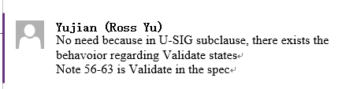
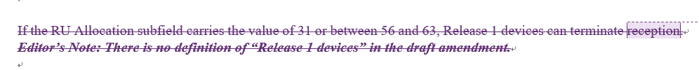

CID 3059
Page.  Line | Clause Number | Comment | Proposed Change | Resolution
257.14 | 36.3.11.8.6 | "number of User fields corresponding to the field value" field value is 304-511.cannot skip that many. | change to "corresponding to the N_user(r,c) R2 users" | REVISED  Agreed in principle  Instructions to the editor  Please make the changes as shown in 11/21-0289r0
Instructions to the editor
Please make the changes to L14, P257 as shown below:
When devices read the RU allocation subfield value of Disregard state, they shall skip N_{user}(r, c) User fields indicated by the field value and continue to process the EHT-SIG.

CID 3060
Page.  Line | Clause Number | Comment | Proposed Change | Resolution
257.24 | 36.3.11.8.6 | consider move line 24-44 to page 249 to put them together with the paragraphs that explain how many RU allocation subfields associated with a large RU. | as commented | ACCEPTED
Discussion:
Line 24-44 of page 257 are as follows:
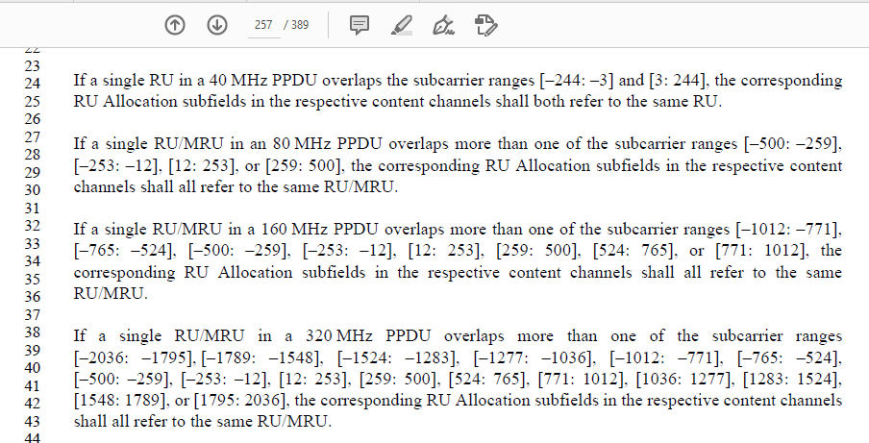
Page 249:
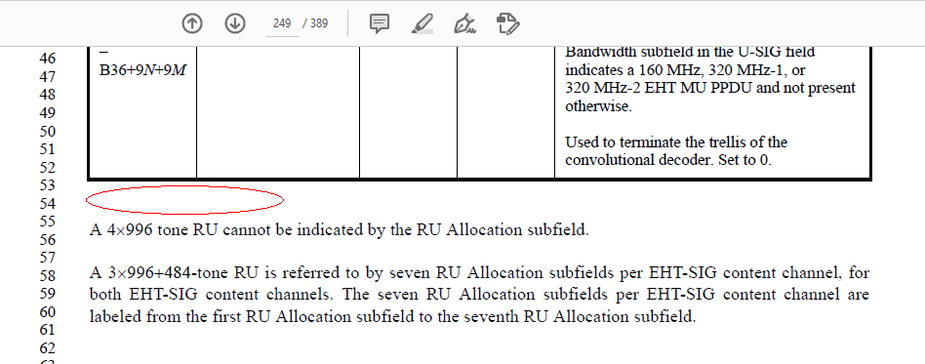
End of discussion

CID 3061
Page.  Line | Clause Number | Comment | Proposed Change | Resolution
257.46 | 36.3.11.8.6 | "In Table 36-26 (RU Allocation subfield), the number of entries column refers to the number of RU  Allocation subfield values that refer to the same RU assignment to be used in the frequency domain but  differ in the number of User fields per RU. " failed to understand what this sentence want to say | Please explain or remove | REJECTED  In P802.11ax D8.0, P604, L48, the same language is applied:  In Table 27-26 (RU Allocation subfield), the number of entries column refers to the number of RU Allocation  subfield values that refer to the same RU assignment to be used in the frequency domain but differ in the  number of User fields per RU.

CID 3062
Page.  Line | Clause Number | Comment | Proposed Change | Resolution
257.54 | 36.3.11.8.6 | why there is "per 80 MHz "? Now dynamic spliting can be done in two dimentions? CC domain and frequency domain? | expalin the intension | REVISED.  The clarification is added.  Instructions to the editor  Please make the changes as shown in 11/21-0289r0
Instructions to the editor
Please make the changes to L54, P257 as shown below:
For an MU-MIMO allocation of RU/MRU size greater than 242 subcarriers in an OFDMA transmission, the dynamic split of User fields between EHT-SIG content channel 1 and EHT-SIG content channel 2 is decided by the AP (on a per case basis) and signaled by the AP using the RU Allocation subfields in each EHT-SIG content channel. The dynamic split of User fields can be different in each 80MHz subblocks if the Bandwidth of the PPDU is greater or equal to 160 MHz.

CID 3064
Page.  Line | Clause Number | Comment | Proposed Change | Resolution
259.41 | 36.3.11.8.6 | change "should not perform" to "may not perform" | as commented | REJCETED  “Should not perform” means highly not recommended, which is different from “may not perform”.

