IEEE P802.11
Wireless LANs
EHT-SIG CR on P802.11be D0.3 – part 3
Date: 2021.02.22
Author(s):
Name | Company | Address | Phone | email
Ross Jian Yu | Huawei Technologies | F3-6-A120, Huawei Base, Bantian, Longgang, Shenzhen, Guangdong, China, 518129 |  | ross.yujian@huawei.com
Edward Au | Huawei Technologies
Abstract
This submission contains proposed comment resolutions to comments on P802.11be D0.3.

6 comments under 36.3.11.8.4 Common field for non-OFDMA transmission:
CID 1406, 1624, 1625, 3004, 3081, 3194
are resolved in this document.

Revision Notes

R0 | Initial revision

CID 1406
Page.  Line | Clause Number | Comment | Proposed Change | Resolution
259.12 | 36.3.11.8.4 | "Indicates the spatial reuse parameters during the transmission of this PPDU" is a description rather than a definition | a) Need to refer to SPATIAL _REUSE parameter in the TXVECTOR, and b) specify what the contents mean. Ditto P247L15, P258L16". | REVISED  Note to the Editor: The proposed changes have been reflected in 11/21-0220r1 and no further changes are needed.
Discussion:
Changes in 11/21-220r1 for reference:
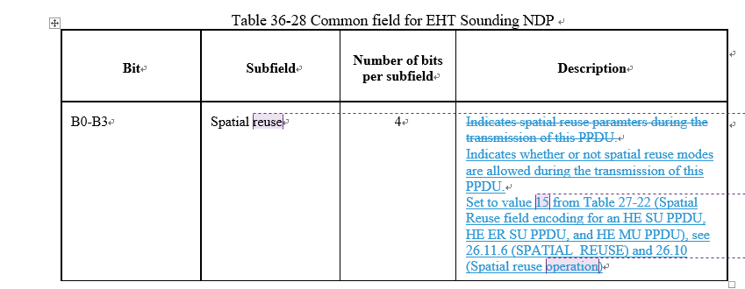

CID 1624
Page.  Line | Clause Number | Comment | Proposed Change | Resolution
258.16 | 36.3.11.8.4 | Add a detailed description or refer to a table for each value in the Spatial Reuse subfield. | See the comment. | REVISED  Note to the Editor: The comment has been resolved in the PDT 11/21-140r2 and no further changes are needed.
Discussion:
Changes in 11/21-140r2 for reference:

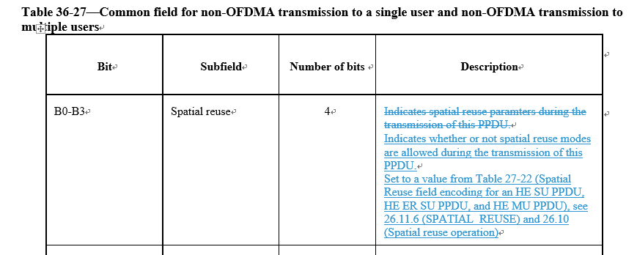

CID 1625
Page.  Line | Clause Number | Comment | Proposed Change | Resolution
259.12 | 36.3.11.8.4 | Add a detailed description or refer to a table for each value in the Spatial Reuse subfield. | See the comment. | REVISED  Note to the Editor: The proposed changes have been reflected in 11/21-0220r1 and no further changes are needed.

CID 3004
Page.  Line | Clause Number | Comment | Proposed Change | Resolution
258.56 | 36.3.11.8.4 | Is the "Number Of Non-OFDMA Users" for the number of non-OFDMA users in each contents channel or in both contents channels? | Please clarify. | REVISED  The answer is for both content channels.  There is already clarification added in the PDT 11/21-0220r1 (page 3):  For non-OFDMA transmission to multiple users (in U-SIG, the UL/DL field is set to 0, and the PPDU Type And Compression Mode field is set to 2) when the Bandwidth of the PPDU is greater or equal to 40 MHz, equitable split is defined as the split of User fields across EHT-SIG content channels, i.e., User field k of a K user non-OFDMA MU-MIMO transmission is carried in EHT-SIG content channel c, where c is defind in equation (36-xx1). Suggested to add total to further calirfy.  Instructions to the editor, please make the changes as follows to Page 258, L56 of P802.11be D0.3:  Indicates the total number of non-OFDMA users.

CID 3081
Page.  Line | Clause Number | Comment | Proposed Change | Resolution
259.29 | 36.3.11.8.4 | B9-B12 "NSS" subfield should indicate as the total number of transmit chains N_Tx | as in comment | REVISED  NSTS is still used as a description for NDP in 802.11ac and 802.11ax. To reflect the difference between a sounding NDP and SU transmission, append “of the EHT sounding NDP” to “the number of spatial stream” in the description.  Instructions to the editor, please make the changes as follows to Page 259, L29 of P802.11be D0.3:  Indicates the number of spatial streams of the EHT sounding NDP:  Set to the number of spatial streams minus 1 for up to 8 spatial streams.  Other values are Validated.

Discussion:
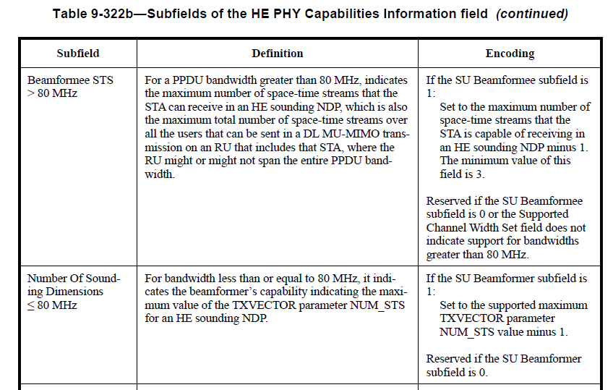

CID 3194
Page.  Line | Clause Number | Comment | Proposed Change | Resolution
259.39 | 36.3.11.8.4 | Table 36-28 is a 'format', so normative language should not be present. | Move  "If the Beamformed field in EHT-SIG of an EHT sounding NDP is 1, then the receiver of the EHT sounding NDP should not perform channel smoothing when generating the compressed beamforming feedback report."  to after Table 36-28. | ACCEPTED
Discussion:
