IEEE P802.11  
Wireless LANs

|  |  |  |  |  |
| --- | --- | --- | --- | --- |
| Resolutions to 32.3.9.9 Midambles | | | | |
| Date: 2020-12-01 | | | | |
| Author(s): | | | | |
| Name | Affiliation | Address | Phone | email |
| Yujin Noh | Newracom |  |  | yujin.noh at newracom.com |
|  |  |  |  |  |

Abstract

This submission shows

* Resolutions for comments from TGbd draft 1.0
* 2 CIDs: 1833 and 1834

Revisions:

* Rev 0: Initial version of the document.

|  |  |  |  |  |
| --- | --- | --- | --- | --- |
| **CID** | **P.L** | **Comment** | **Proposed Change** | **Resolution** |
| 1833 | 76.25 | Equation 32-34 includes error | N_(sym-1) should be replaced with N_sym -1 | Revised.  TGbd Editor: make changes according to this document 11-20-1947-00-00bd Resolutions to 32.3.9.9 Midambles. |
| 1834 | 76.28 | Equation (21-67) is used for multi-user. | update it with proper Equation refering to Nsym based on LDPC for a single user. It should be Equation (19-41) | Revised.  TGbd Editor: make changes according to this document 11-20-1947-00-00bd Resolutions to 32.3.9.9 Midambles. |

***Discussion***

Looking at the spec in 11ac, one more step requires after Nsym obtained by Equation 21-67 as below.

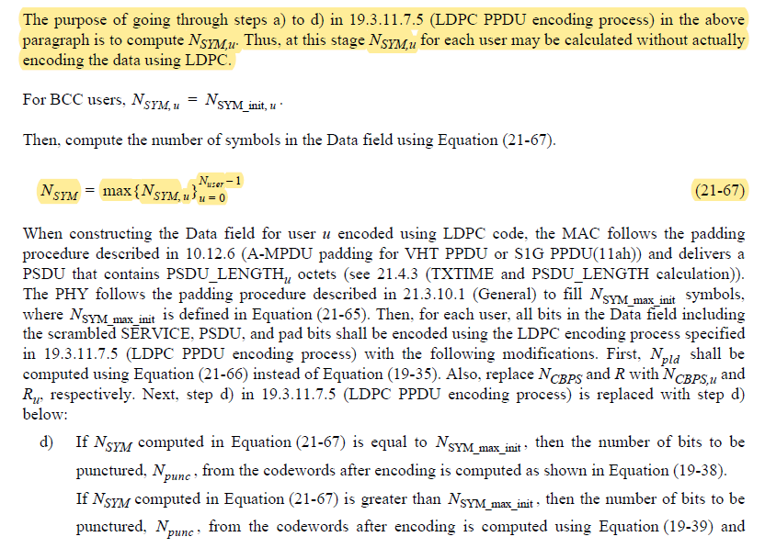

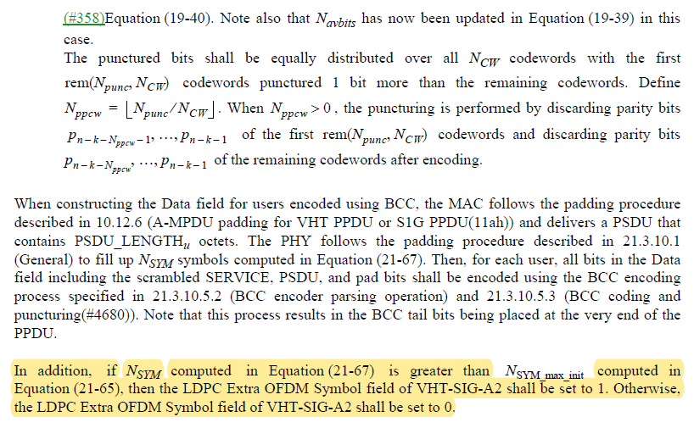

Depending on the condition of *Nsym* and *Nsym_max_init*, the value in LDPC Extra OFDM Symbol field of NGV-SIG shall be determined.

***To TGbd Editor:*** ***P76L21*** *update the description as below.*

***------------- Begin Text Changes ---------------***

If present, the number of midamble periods, *NMA*, in a PPDU is calculated using Equation (32-34).

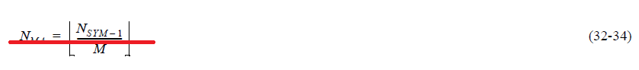

$N_{MA= \left\lfloor \frac{N_{SYM}-1}{M}\right\rfloor }$

where *NSYM* is defined in 32.3.9.4 (Coding)~~Equation (21-67) with single user~~.

***------------- End Text Changes ------------------***

***To TGbd Editor:*** ***P73L31*** *update the description as below.*

***------------- Begin Text Changes ---------------***

**32.3.9.4 Coding**

The Data field of an NGV PPDU shall be encoded using a low-density parity check (LDPC) code~~-~~ and uses

the same LDPC code and encoding process~~-~~ as described in Clause 21.3.10.5.4 (LDPC coding) for a VHT

SU PPDU with parameter *mSTBC* set to 1 and the LDPC Extra Symbol field setting in NGV-SIG.

***------------- End Text Changes ------------------***