IEEE P802.11
Wireless LANs
SIG-B CR on D7.0
Date: 2020.09.24
Author(s):
Name | Company | Address | Phone | email
Ross Jian Yu | Huawei Technologies | F3-6-A120, Huawei Base, Bantian, Longgang, Shenzhen, Guangdong, China, 518129 |  | ross.yujian@huawei.com
Mengshi Hu
Bo Gong
Chenchen Liu
Ming Gan
Abstract
This submission contains proposed comment resolutions to comments on D6.0.

4 comments, CID 25009, 25056, 25074, 25119 are resolved in this document.

Revision Notes

R0 | Initial revision
R1 | Modification based on some offline comments

CID 25009
CID | Page.  Line | Clause Number | Comment | Proposed Change | Resolution
25009 | 627.65 | 27.3.11.7.10 | On behalf of Brian Hart:  From P566L27 in table 27-13, 160M has one frequency segment but 80+80 has two frequency segments, yet oftentimes 160M is treated as having two frequency segments when the correct term is frequency subblock (e.g. P627L65, P628L2, P630L13, P651L38). Also, confusingly, the segment parser for 160M has two outputs (and the deparser has two inputs) | Use "frequency subblock" where this is the more more correct language (check especially P627L65, P628L2, P630L13, P651L38). Add "number of frequency subblocks" to table 27-13; rename "Segment (de)parser to "Frequency subblock (de)parser" throughout the draft. | REVISED  Agreed with the commenter. Speify the changes below.  Instructions to the editor, plase make the changes as shown under CID 25009 in doc 11-20/1528r0

Discussion:
160MHz PPDU has one frequency segment, whilst two frequency subblocks as shown below.
80+80MHz PPDU has two frequency segment and also two frequency subblocks.
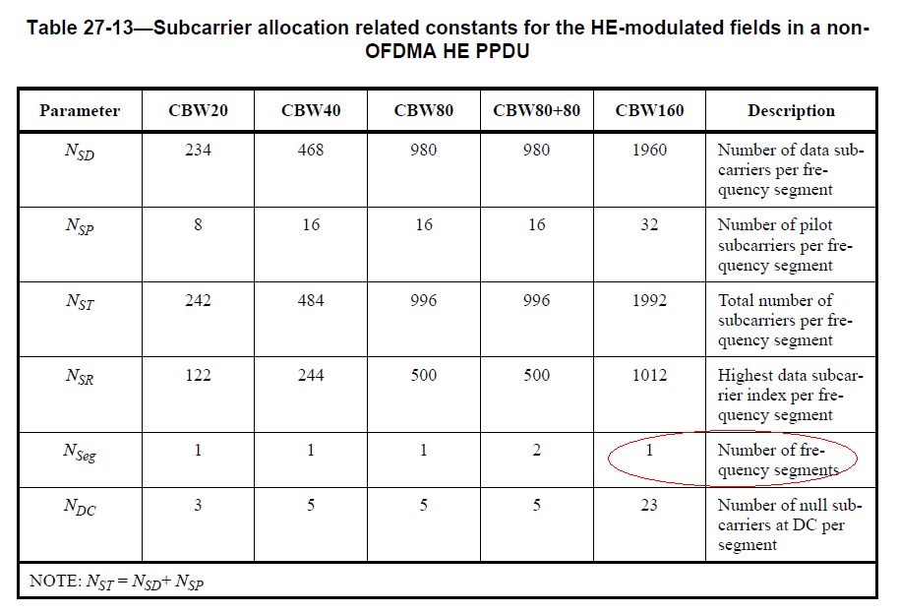
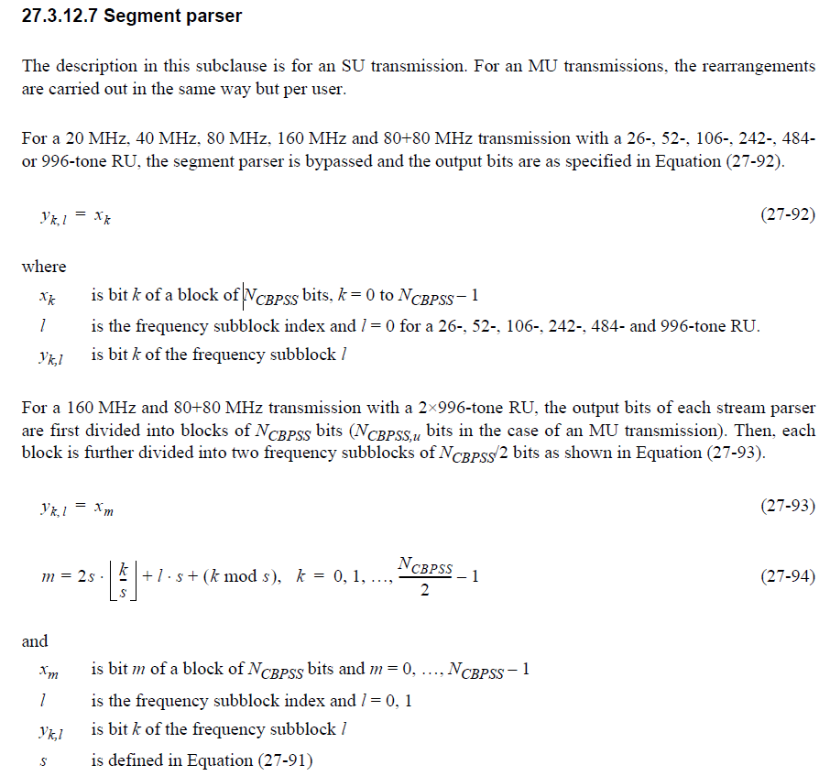

Another thing is do we need to change the function of segment parser to subblock parser? This is a big change. VHT needs to do the same changes too.

Instructions to the editor
Please make the changes to L65, P627 as shown below:
LTF80MHz_lower_2x = {LTF80MHz_part1_2x, LTF80MHz_part2_2x, LTF80MHz_part3_2x, LTF80MHz_part4_2x,
LTF80MHz_part5_2x} shall be used in the lower 80 MHz frequency subblock

LTF80MHz_upper_2x = {LTF80MHz_part1_2x, –LTF80MHz_part2_2x, LTF80MHz_part3_2x, LTF80MHz_part4_2x,
–LTF80MHz_part5_2x} shall be used in the upper 80 MHz frequency subblock

Instructions to the editor
Please make the changes to L13, P630 as shown below:
In an UL MU-MIMO transmission using the HE masked HE-LTF sequence mode, the HE-LTF sequence per frequency subblock is generated by masking the nonzero elements in the common HE-LTF sequence repeatedly with a distinct orthogonal code as defined by Equation (27-53).

Instructions to the editor
Please make the changes to L38, P651 as shown below:
NOTE—LDPC tone mapper for a 26-, 52-, 106-, 242-, 484- and 996-tone RU is defined as one segment. LDPC tone
mapping is performed separately for the upper and lower 80 MHz frequency subblocks of a 2×996-tone RU as indicated by the frequency subblock index l.

Instructions to the editor
Please make the changes to L29, P566 as shown below:
Parameters | CBW20 | CBW40 | CBW80 | CBW80+80 | CBW160 | Descriptions
 | 1 | 1 | 1 | 2 | 2 | Number of frequency  subblocks

Instructions to the editor
Please make the following changes at:
L6P548, L9P555 (within the figure), L20P555 (within the figure), L9P556 (within the figure), L20P556 (within the figure), L45P562, L14P645, L22P645, L40P646,
Subblock parser

Instructions to the editor
Please make the following changes at:
L18P548, L9P555 (within the figure), L20P555 (within the figure), L55P562, L56P562, L61P651,
Subblock deparser

CID 25056
CID | Page.  Line | Clause Number | Comment | Proposed Change | Resolution
25056 |  | 27 | "20 MHz frequency segment" is a misnomer: these are not frequency segments, these are subchannels | Change "20 MHz frequency segment" to "20 MHz subchannel" throughout (11 instances) | ACCEPTED

Discussion
NONE

CID 25074

CID | Page.  Line | Clause Number | Comment | Proposed Change | Resolution
25074 | 612.26 | 27.3.11.8.5 | "If the number of User fields in an HE-SIG-B content channel is odd, CRC and tail bits are added after the last User field, which is not grouped." confusingly suggests CRC and tail bits are not added after the last User field if the number of User fields is even. The description in Table 27-27 is clearer | Change to "If the number of User fields in an HE-SIG-B content channel is odd, the CRC and tail bits are added immediately after the last User field; there is only one User field in the last User Block field (see Table 27-27)." | ACCEPTED

Discussion
NONE

CID 25119

CID | Page.  Line | Clause Number | Comment | Proposed Change | Resolution
25119 |  | 27.3.11.8.3 | “For an MU-MIMO allocation of RU size greater than 242 subcarriers, the dynamic split of User fields between HE-SIG-B content channel 1 and HE-SIG-B content channel 2 is decided by the AP (on a per case basis) and signaled by the AP using the RU Allocation subfields in each HE-SIG-B content channel. See  Annex Z for examples.” seems to duplicate “— If RU r is a 484-tone or larger RU, then the number of users allocated to the RU equals the number of  User fields for the RU summed across both HE-SIG-B content channels, i.e., Nuser(r, 1) + Nuser(r, 2).” | Delete the first cited chunk of text. | REJECTED  The first cited trunck describe how the Tx allocates the user field between CC1 and CC2. It describes there is no restriction for OFDMA case, which is different from full BW MU-MIMO case.  The second trunk describes how the Rx calculates the total number of user fields within a MU-MIMO transmission.  These two are for different purposes.

