IEEE P802.11
Wireless LANs
802.11
SA2 - Proposed Resolutions for EDITOR adhoc and others
Date: 2020-09-14
Author(s):
Name | Company | Address | Phone | email
Emily Qi | Intel Corporation |  |  | Emily.h.qi@intel.com
Abstract

This document contains proposed resolutions to SA2 editorial comments for the EDITOR ad hoc and some technical comments for other adhocs.

R00: Initial proposal.
R01: Incorporated feedback from TGmd teleconference on 9/8.
R02: Provided resolution for CID 5002.
R03: Incorporate additional suggestions for CID 5002.
R04: Incorporate additional suggestions for CID 5002.

Green indicates material agreed to in the group, ready for motion
yellow indicates work-in-progress, material will be discussed/reviewed again.

CID | Clause | Page | Line | Comment | Proposed Change
5002  (EDITOR) | 19.3.21 | 3065 | 23 | The following issue was reported by Eldad Perahia: "In the “Detect HT-SIG” box, there is a reference to 16.2.3 and 19.3.5. The reference to 19.3.5 is definitely wrong, since it points back to the same clause. The reference to 16.2.3 is to the HR/DSSS PHY, which does not make sense. So I went back to 802.11n, and the references were to 17.3.12 and 19.3.6. In 802.11-2007, 17.3.12 was the subclause for Receive PLCP in OFDM PHY. 19.3.6 was the subclause for PLCP receive procedure in ERP specification. In REVmd D3.0, these same references should be 17.3.12 and 18.3.5. ".  I looked at D4.0, these subclause numbers are same as D3.0. | At 3065.23, change "16.2.3 or 19.3.5" to "17.3.12 or 18.3.5."

Discussion

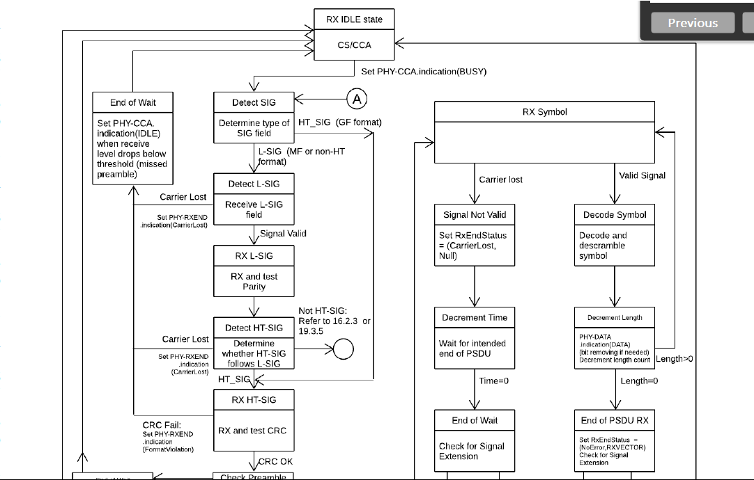

Proposed changes are correct.

Another option could be removing the references. Do we have to have references here? Since the references are included in a figure, the changes must be done manually when the referred subclause numbers are changed, which may cause a potential error.

Option 1: Accepted.
Option 2: Revised. Delete reference in the figures.
Option 3: Delete references in figures. Add references in texts that can be updated automatically.

Option 3 is preferred in the Tuesday discussion. Emily is to provide a resolution.

Following references were identified and will be remove from the figures:

At 3063.23, delete “Refer to Clause 17 or Clause 18”.

At 3065.23, Delete “: Refer to 16.2.3 or 19.3.5”.
- Note that "16.2.3 or 19.3.5" should be "17.3.12 or 18.3.5."

At 3240.17, delete “Refer to Clause 17”
At 3240.19, delete “Refer to Clause 19”

At 3242.8, delete “Refer to 19.3.23”
At 3242.22, delete “Refer to 19.3.23”
- There is no 19.3.23. I think it should be 19.3.21 (PHY receive procedure).
At 3242.25, delete “Refer to 17.3.12”
At 3242.10. delete “in accordance with 21.3.18.5”
- there is no need to add reference “21.3.18.5” as it is already indicted at 3239.55.

Proposed Resolution:

Revised.

At 3063.23, delete “Refer to Clause 17 or Clause 18”.
At 3062.21, make changes as follows:
A typical state machine implementation of the transmit PHY is provided in Figure 19-24 (PHY transmit
state machine(#4296)(#4207)). Requests (.request) and confirmations (.confirm) are issued once per state as shown. This state machine does not describe the operation of optional features, such as LDPC or STBC. If the TXVECTOR parameter FORMAT is equal to NON_HT and NON_HT_MODULATION is equal to ERP-OFDM or OFDM, refer to the transmit procedure and state machine in 17.3.11 (Transmit PHY). If the TXVECTOR parameter FORMAT is equal to NON_HT and NON_HT_MODULATION is equal to ERP-DSSS or ERP-CCK, refer to the transmit procedure in 15.3.6 (Transmit PHY) and 16.2.5 (Transmit PHY), respectively.

NOTE—The transmit procedure and state machine for Clause 18 when TXVECTOR parameter NON_HT_MODULATION is ERP-OFDM is described in 17.3.11 (Transmit PHY), except for the signal extension (refer to 18.3.2.4 (ERP-OFDM PPDU format)).

At 3065.23, Delete “: Refer to 16.2.3 or 19.3.5”.
At 3062.29, make changes as follows:
Typical PHY receive procedures are shown in Figure 19-25 (PHY receive procedure for HT-mixed format PPDU format(#4478)(#2560)(#1002)) and Figure 19-26 (PHY receive procedure for HT-greenfield format PPDU(#2560)(#1002)). The receive procedures correspond to HT-mixed format and HT-greenfield format, respectively. A typical state machine implementation of the receive PHY is given in Figure 19-27 (PHY receive state machine(#2709)). These receive procedures and state machine do not describe the operation of optional features, such as LDPC or STBC. If the detected format indicates a non-HT PPDU format, refer to the receive procedure and state machine in Clause 17 (Orthogonal frequency division multiplexing (OFDM) PHY specification) or Clause 18 (Extended Rate PHY (ERP) specification) 17.3.12 (Receive PHY) and 18.3.5 (PHY receive procedure). Further, through station management (via the PLME), the PHY is set to the appropriate frequency, as specified in 19.4 (HT PLME). Other receive parameters, such as RSSI and indicated DATARATE, may be accessed via the PHY SAP.

At 3240.17, delete “Refer to Clause 17”
At 3240.19, delete “Refer to Clause 19”
At 3239.28, make changes as follows:
A typical state machine implementation of the transmit PHY for an SU transmission is provided in
Figure 21-35 (PHY transmit state machine for SU transmission(#4296)). Request (.request) and
confirmation (.confirm) primitives are issued once per state as shown. If the TXVECTOR parameter FORMAT is equal to NON_HT, refer to the transmit procedure and state machine in 17.3.11 (Transmit PHY). If the TXVECTOR parameter FORMAT is equal to HT_MF or HT_GF, refer to the transmit procedure and state machine in 19.3.20 (PHY transmit procedure).

At 3242.8, delete “Refer to 19.3.23”
At 3242.22, delete “Refer to 19.3.23”
At 3242.25, delete “Refer to 17.3.12”
At 3242.10. delete “in accordance with 21.3.18.5”

At 3239.37, make changes as follows:
A typical PHY receive procedure is shown in Figure 21-36 (PHY receive procedure for SU
transmission(#1002)) for VHT format. A typical state machine implementation of the receive PHY is given in Figure 21-37 (PHY receive state machine(#2615)(#287)). This receive procedure and state machine do not describe the operation of optional features, such as LDPC or STBC. If the detected format indicates a NON_HT PPDU, refer to the receive procedure and state machine in Clause 17 (Orthogonal frequency division multiplexing (OFDM) PHY specification) 17.3.12 (Receive PHY). If the detected format indicates an HT PPDU format, refer to the receive procedure and state machine in Clause 19 (High-throughput (HT) PHY specification) 19.3.21 (PHY receive procedure). Further, through station management (via the PLME) the PHY is set to the appropriate frequency, as specified in 21.4 (VHT PLME). The PHY has also been configured with group information (i.e., group membership and position in group) so that it can receive data intended for the STA. Other receive parameters, such as RSSI and indicated DATARATE, may be accessed via the PHY SAP.

5005 (EDITOR) | 9.6.3.1 | 1514.3 | Reference to ADDTS Request frame Action field seems to be wrong. | Replace "Table 9-360 (ADDBA Request frame Action field)" with "see Table 9-350 (Basic ADDTS Request frame variant Action field format) and Table 9-351 (DMG ADDTS Request frame variant Action field format.)"
5006 (EDITOR | 9.6.3.1 | 1514.5 | Reference to ADDTS Response frame Action field seems to be wrong. | Replace "Table 9-361 (ADDBA Response frame Action field)" with " see Table 9-352 (Basic ADDTS Response frame variant Action field format) and Table 9-353 (DMG ADDTS Response frame variant Action field format) ".

Discussion

Cited text:

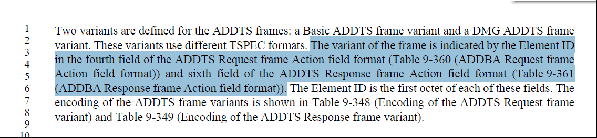

The correct reference should be ADDTS Request frame Action field format, not ADDBA Request frame Action field format. Since there are two variants for ADDTA frames, both table references are added here.

At 1514.3
Replace "Table 9-360 (ADDBA Request frame Action field)" with "see Table 9-350 (Basic ADDTS Request frame variant Action field format) and Table 9-351 (DMG ADDTS Request frame variant Action field format)".

At 1514.5
Replace "Table 9-361 (ADDBA Response frame Action field)" with "see Table 9-352 (Basic ADDTS Response frame variant Action field format) and Table 9-353 (DMG ADDTS Response frame variant Action field format) ".

Proposed Resolution:

CID 5005: Revised. Replace "Table 9-360 (ADDBA Request frame Action field)" with "see Table 9-350 (Basic ADDTS Request frame variant Action field format) and Table 9-351 (DMG ADDTS Request frame variant Action field format)".

CID 5006: Accepted.

5003 (MAC) | 11.9.3.2 | 2282.40 | "If dot11ExtendedChannelSwitchActivated is false, the AP shall send the Channel Switch Announcement element and frame, or both the Extended Channel Switch Announcement and the Channel Switch Announcement elements and frames." If dot11ExtendedChannelSwitchActivated is false, why 'Extended" Channel Switch Announcement elements and frames are allowed to be sent? Should they be only Channel Switch Announcement elements and frames? | at 2282.40, remove ", or both the Extended Channel Switch Announcement and the Channel Switch Announcement elements and frames".

Discussion

Cited text:

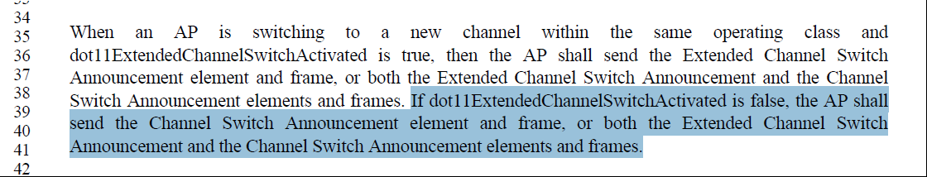

If dot11ExtendedChannelSwitchActivated is false, why are 'Extended" Channel Switch Announcement elements and frames allowed to be sent? Should they be only Channel Switch Announcement elements and frames?

at 2282.40, remove ", or both the Extended Channel Switch Announcement and the Channel Switch Announcement elements and frames".

Proposed Resolution:

Accepted.

========================================================

5004 (MAC) | 11.9.3.2 | 2282.54 | "When both the Extended Channel Switch  Announcement and the Channel Switch Announcement elements are transmitted in Public Action frames, they shall be sent in separate frames." I though CSA frame is Action Management frame of Spectrum Management category while the ECSA frame is Action Management frame of Public Action frame. Thus, what is the intention of the above sentence? It is not clear how both CSA element and ECSA element can be transmitted as Public Action frames (and therefore should be transmitted in separate frames)? | Removed cited sentence or clarify it.

Discussion

Cited text:
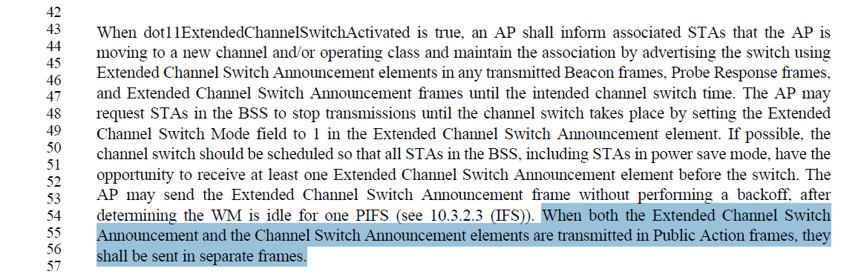

The ECSA frame is Action Management frame of Public Action frame.

However, I am not aware of CSA element can be included in a Public Action frame.

The CSA element may be included in Beacon/Probe Response frames and CSA frames. The CSA frame is an Action frame with the Spectrum Management category, not Public action frame.

Proposed Resolution:
Revised. Change the cited sentence to “When both the Extended Channel Switch
Announcement and the Channel Switch Announcement elements are transmitted in Action frames, they shall be sent in separate frames.”

========================================================

5007 (GEN) | 3.2 | 166.46 | Peer-to-peer link has been used for a STA- to-STA communication beyond IBSS. The definition of peer-to-peer link for a STA- to-STA communication should not be restricted to IBSS. | At cited location, change ", or a station-to-station (STA-to-STA) communication in an independent basic service set (IBSS).” To “, or a communication between non-AP STAs.”

Discussion

Cited text:

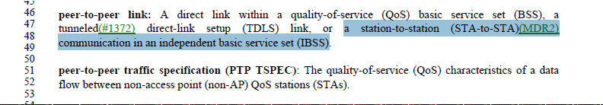

Peer-to-peer link has been used away beyond the IBSS. Also, the definition of peer-to-peer link is not consistent with the definition peer-to-peer traffic specification.

Change “peer-to-peer link: A direct link within a quality-of-service (QoS) basic service set (BSS), a tunneled direct-link setup (TDLS) link, or a station-to-station (STA-to-STA) communication in an independent basic service set (IBSS).”

to “peer-to-peer link: a communication between non-AP STAs.”

Proposed Resolution:
Revised.

Change “peer-to-peer link: A direct link within a quality-of-service (QoS) basic service set (BSS), a tunneled direct-link setup (TDLS) link, or a station-to-station (STA-to-STA) communication in an independent basic service set (IBSS).”

to “peer-to-peer link: a communication between non-AP STAs.”

========================================================

5019 (Editor) | 9.7.2 | 1687.60 | The text states that the MPDU delimiter CRC field is used as a frame check sequence (FCS) to protect the Reserved and MPDU Length fields, however this text probably predates introduction of the EOF field so it's out of date. | Consistent with the CRC field descriptions in Tables 9.527 and 9-528, change the sentence to: It is used as a frame check sequence (FCS) to protect the preceding 16 bits

Discussion

Cited text:

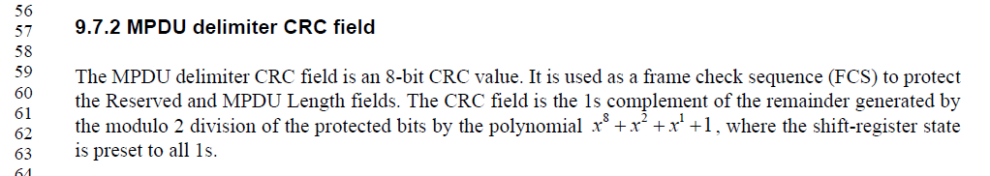

Table 9-52 (1686.31):
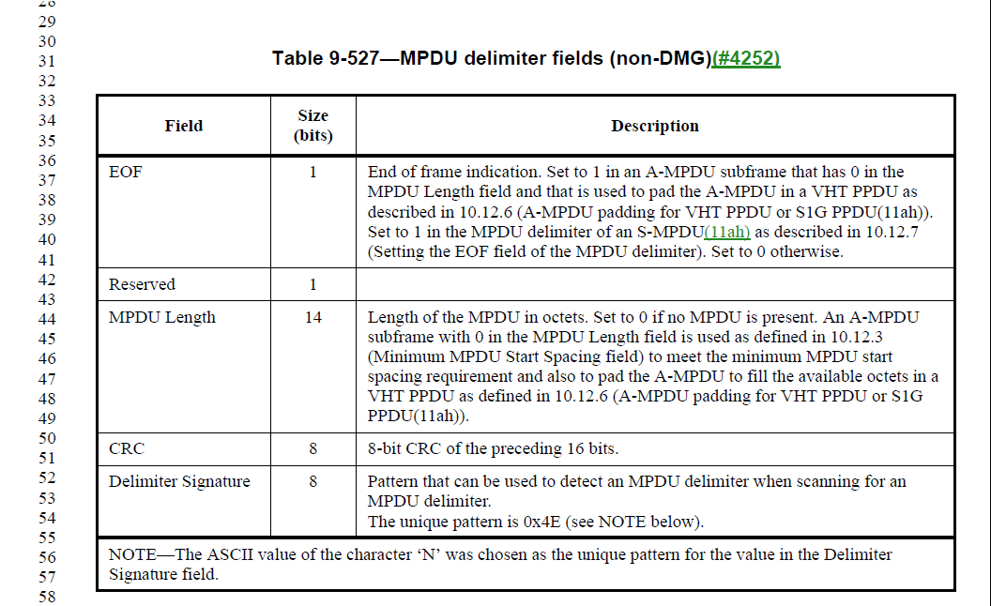

As stated in comment, the EOF field should be part of 16 bits and be protected, which is missed.
Agreed with the commenter.

At 1687.59, change “It is used as a frame check sequence (FCS) to protect
the Reserved and MPDU Length fields.”
to “It is used as a frame check sequence (FCS) to protect the preceding 16 bits.”

to “It is used as an MPDU delimiter check sequence to protect the fields that precede it in the MPDU delimiter”.

Option 1: to “It is used as a check sequence to protect the fields that precede it in the MPDU delimiter”.

Option 2: to “It is used as a check sequence to protect the preceding 16 bits.”

At 1686.50, 1687.11, add “(see 9.7.2)”.

Proposed Resolution:
Revised.

Change the cited sentence to “It is used as a check sequence to protect the fields that precede it in the MPDU delimiter”.

At 1686.50, 1687.11, add “(see 9.7.2)” at the end of “Description” column.

========================================================

5033 (Editor) | 6.3.69.2.2 | 584.6 | Based on the text style for different parameter types in Section 6 (strings in the "Type" columns), the correct type for parameters that are MAC addresses is "MAC address" (with a space and no capitalization for address). There are instances of "MAC Address", "MACAddress" (majority), "MacAddress", and "MAC address" (I think 1 instance) as a type in Section 6, all of which should be unified.  Correct type is "MAC address" in commenter's view, and the most common one is "MACAddress". Proposed resolution is to unify all to "MAC address".  Note: There is a "MacAddress" type in Annex C for MIB variables that seems to be consistent and could be kept as is. | Replace all instances of "MacAddress" in Type columns in Clause 6 (P584L6, P585L39, P587L17, P588L35, P590L40, P747L53, and P754L37) with "MAC address".  Replace all instances of "MAC Address" in Type columns in Clause 6 (P441L6, P482L6, P482L49, P483L26, P484L7, P488L46, P489L20, P490L32, P491L19, P493L20, P494L31, P495L42, P496L12, P497L19, P499L19, P500L5, P501L20, P503L37, ..) with "MAC address".  Replace all instamces of "MACAddress in Type columns in Clause 6 (P322L36, P327L27, P338L29, P345L11, P345L5, P349L3, P350L28, P352L8, P352L50, ...) with "MAC address".

Discussion

Agreed with commenter.
Recommend accepting the proposed changes.

Proposed Resolution:
Accepted.

========================================================

5020 (Editor) | 3.2 | 186.1 | The definition of individually addressed bufferable unit restricts it to various PHYs which is incorrect. The bufferable unit definition used to be similar but was modified to apply to QoS STAs recently so a similar change should be made in this case. | Change the definition of individually addressed bufferable unit to: An individually addressed medium access control (MAC) service data unit (MSDU), individually addressed aggregate MAC service data unit (A-MSDU) [quality-of-service (QoS) stations (STAs) only], or individually addressed bufferable MAC management protocol data unit (MMPDU).

Discussion

Cited text:
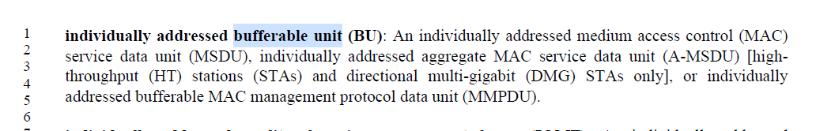

The definition for bufferable unit (BU) was changed per CID 4288 as follow:

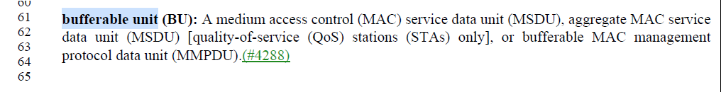

Proposed changes from the commenter:

individually addressed bufferable unit (BU):
An individually addressed medium access control (MAC) service data unit (MSDU), individually addressed aggregate MAC service data unit (A-MSDU) [highthroughput (HT) stations (STAs) and directional multi-gigabit (DMG) STAs only quality-of-service (QoS) stations (STAs) only], or individually addressed bufferable MAC management protocol data unit (MMPDU).

Proposed Resolution:

Accepted.

