IEEE P802.11
Wireless LANs
802.11
SA2 - Proposed Resolutions for EDITOR adhoc and others
Date: 2020-09-07
Author(s):
Name | Company | Address | Phone | email
Emily Qi | Intel Corporation |  |  | Emily.h.qi@intel.com
Abstract

This document contains proposed resolutions to SA2 editorial comments for the EDITOR ad hoc and some technical comments for other adhocs.

R00: Initial proposal.

Green indicates material agreed to in the group, ready for motion
yellow indicates work-in-progress, material will be discussed/reviewed again.

CID | Clause | Page | Line | Comment | Proposed Change
5002  (EDITOR) | 19.3.21 | 3065 | 23 | The following issue was reported by Eldad Perahia: "In the “Detect HT-SIG” box, there is a reference to 16.2.3 and 19.3.5. The reference to 19.3.5 is definitely wrong, since it points back to the same clause. The reference to 16.2.3 is to the HR/DSSS PHY, which does not make sense. So I went back to 802.11n, and the references were to 17.3.12 and 19.3.6. In 802.11-2007, 17.3.12 was the subclause for Receive PLCP in OFDM PHY. 19.3.6 was the subclause for PLCP receive procedure in ERP specification. In REVmd D3.0, these same references should be 17.3.12 and 18.3.5. ".  I looked at D4.0, these subclause numbers are same as D3.0. | At 3065.23, change "16.2.3 or 19.3.5" to "17.3.12 or 18.3.5."

Discussion

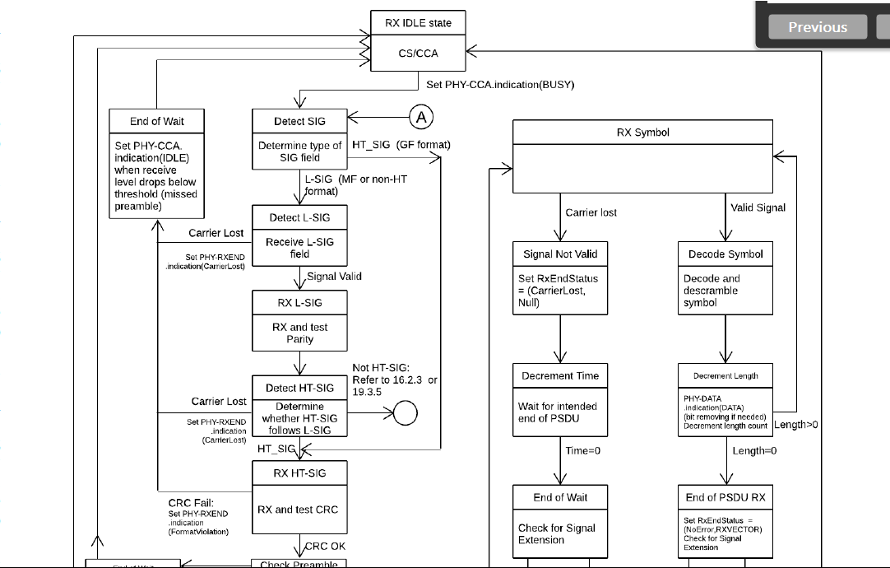

Proposed changes are correct.

Another option could be removing the references. Do we have to have references here? Since the references are included in a figure, the changes must be done manually when the referred subclause numbers are changed, which may cause a potential error.

Option 1: Accepted.
Option 2: Revised. Delete “: Refer to 16.2.3 or 19.3.5”.

Proposed Resolution:

??

5005 (EDITOR) | 9.6.3.1 | 1514.3 | Reference to ADDTS Request frame Action field seems to be wrong. | Replace "Table 9-360 (ADDBA Request frame Action field)" with "see Table 9-350 (Basic ADDTS Request frame variant Action field format) and Table 9-351 (DMG ADDTS Request frame variant Action field format.)"
5006 (EDITOR | 9.6.3.1 | 1514.5 | Reference to ADDTS Response frame Action field seems to be wrong. | Replace "Table 9-361 (ADDBA Response frame Action field)" with " see Table 9-352 (Basic ADDTS Response frame variant Action field format) and Table 9-353 (DMG ADDTS Response frame variant Action field format) ".

Discussion

Cited text:

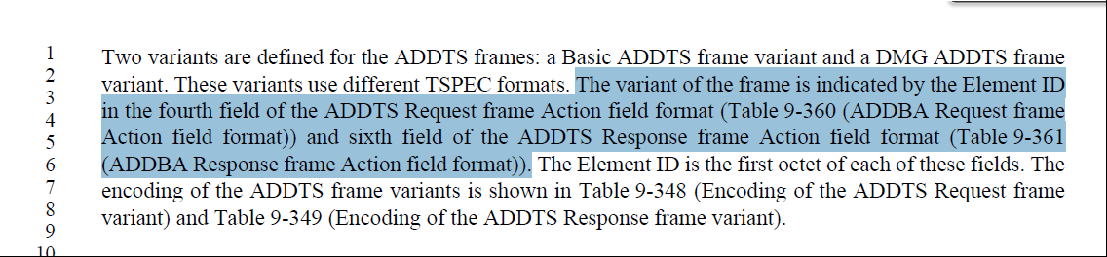

The correct reference should be ADDTS Request frame Action field format, not ADDBA Request frame Action field format. Since there are two variants for ADDTA frames, both table references are added here.

At 1514.3
Replace "Table 9-360 (ADDBA Request frame Action field)" with "see Table 9-350 (Basic ADDTS Request frame variant Action field format) and Table 9-351 (DMG ADDTS Request frame variant Action field format.)"

At 1514.5
Replace "Table 9-361 (ADDBA Response frame Action field)" with " see Table 9-352 (Basic ADDTS Response frame variant Action field format) and Table 9-353 (DMG ADDTS Response frame variant Action field format) ".

Proposed Resolution:

Accepted.

5003 (MAC) | 11.9.3.2 | 2282.40 | "If dot11ExtendedChannelSwitchActivated is false, the AP shall send the Channel Switch Announcement element and frame, or both the Extended Channel Switch Announcement and the Channel Switch Announcement elements and frames." If dot11ExtendedChannelSwitchActivated is false, why 'Extended" Channel Switch Announcement elements and frames are allowed to be sent? Should they be only Channel Switch Announcement elements and frames? | at 2282.40, remove ", or both the Extended Channel Switch Announcement and the Channel Switch Announcement elements and frames".

Discussion

Cited text:

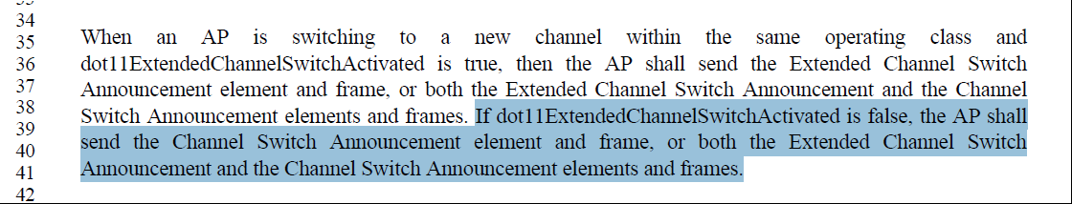

If dot11ExtendedChannelSwitchActivated is false, why are 'Extended" Channel Switch Announcement elements and frames allowed to be sent? Should they be only Channel Switch Announcement elements and frames?

at 2282.40, remove ", or both the Extended Channel Switch Announcement and the Channel Switch Announcement elements and frames".

Proposed Resolution:

Accepted.

========================================================

5004 (MAC) | 11.9.3.2 | 2282.54 | "When both the Extended Channel Switch  Announcement and the Channel Switch Announcement elements are transmitted in Public Action frames, they shall be sent in separate frames." I though CSA frame is Action Management frame of Spectrum Management category while the ECSA frame is Action Management frame of Public Action frame. Thus, what is the intention of the above sentence? It is not clear how both CSA element and ECSA element can be transmitted as Public Action frames (and therefore should be transmitted in separate frames)? | Removed cited sentence or clarify it.

Discussion

Cited text:
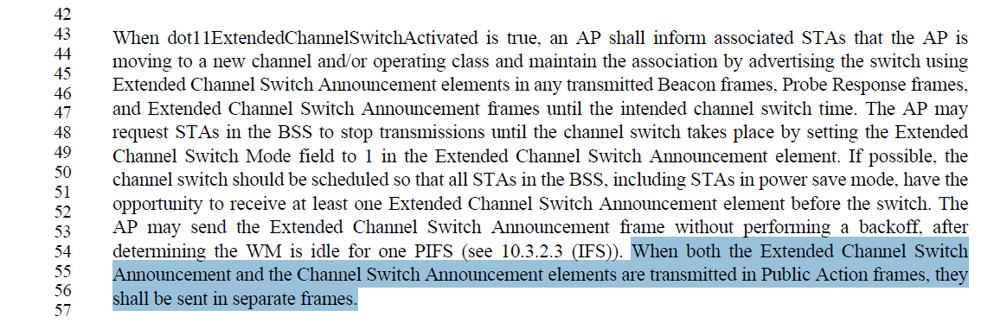

The ECSA frame is Action Management frame of Public Action frame.

However, I am not aware of CSA element can be included in a Public Action frame.

The CSA element may be included in Beacon/Probe Response frames and CSA frames. The CSA frame is an Action frame with the Spectrum Management category, not Public action frame.

Proposed Resolution:
Accepted.

========================================================

5007 (GEN) | 3.2 | 166.46 | Peer-to-peer link has been used for a STA- to-STA communication beyond IBSS. The definition of peer-to-peer link for a STA- to-STA communication should not be restricted to IBSS. | At cited location, change ", or a station-to-station (STA-to-STA) communication in an independent basic service set (IBSS).” To “, or a communication between non-AP STAs.”

Discussion

Cited text:

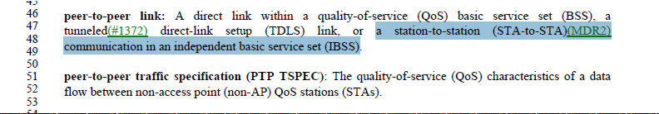

Peer-to-peer link has been used away beyond the IBSS. Also, the definition of peer-to-peer link is not consistent with the definition peer-to-peer traffic specification.

Change “peer-to-peer link: A direct link within a quality-of-service (QoS) basic service set (BSS), a tunneled direct-link setup (TDLS) link, or a station-to-station (STA-to-STA) communication in an independent basic service set (IBSS).”

to “peer-to-peer link: a communication between non-AP STAs.”

Proposed Resolution:
Revised.

Change “peer-to-peer link: A direct link within a quality-of-service (QoS) basic service set (BSS), a tunneled direct-link setup (TDLS) link, or a station-to-station (STA-to-STA) communication in an independent basic service set (IBSS).”

to “peer-to-peer link: a communication between non-AP STAs.”

========================================================

5019 (Editor) | 9.7.2 | 1687.60 | The text states that the MPDU delimiter CRC field is used as a frame check sequence (FCS) to protect the Reserved and MPDU Length fields, however this text probably predates introduction of the EOF field so it's out of date. | Consistent with the CRC field descriptions in Tables 9.527 and 9-528, change the sentence to: It is used as a frame check sequence (FCS) to protect the preceding 16 bits

Discussion

Cited text:

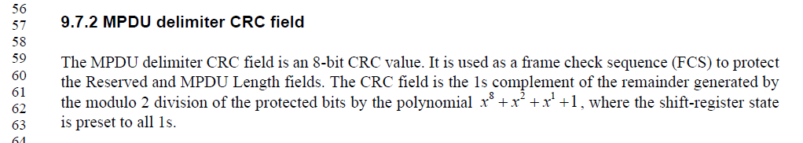

Table 9-52 (1686.31):
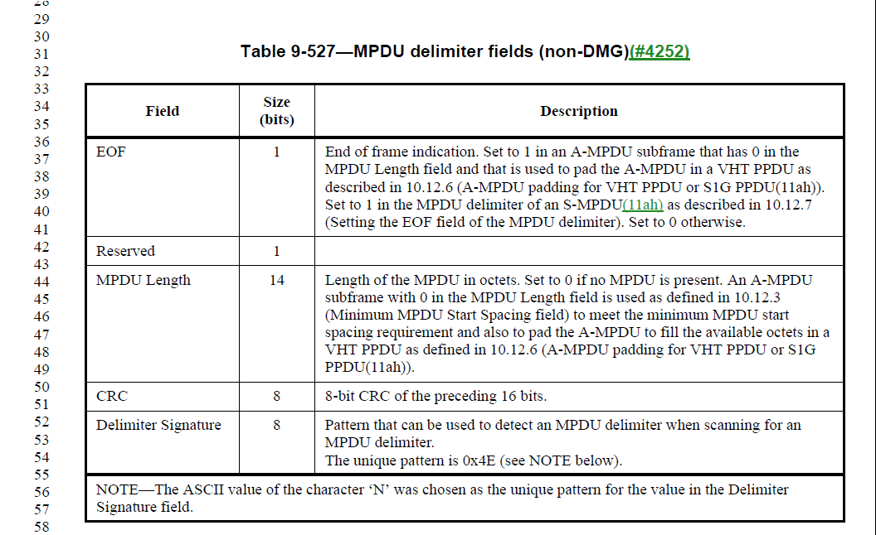

As stated in comment, the EOF field should be part of 16 bits and be protected, which is missed.
Agreed with the commenter.

At 1687.59, change “It is used as a frame check sequence (FCS) to protect
the Reserved and MPDU Length fields.” to “It is used as a frame check sequence (FCS) to protect the preceding 16 bits.”

Proposed Resolution:
Accepted.

========================================================

5033 (Editor) | 6.3.69.2.2 | 584.6 | Based on the text style for different parameter types in Section 6 (strings in the "Type" columns), the correct type for parameters that are MAC addresses is "MAC address" (with a space and no capitalization for address). There are instances of "MAC Address", "MACAddress" (majority), "MacAddress", and "MAC address" (I think 1 instance) as a type in Section 6, all of which should be unified.  Correct type is "MAC address" in commenter's view, and the most common one is "MACAddress". Proposed resolution is to unify all to "MAC address".  Note: There is a "MacAddress" type in Annex C for MIB variables that seems to be consistent and could be kept as is. | Replace all instances of "MacAddress" in Type columns in Clause 6 (P584L6, P585L39, P587L17, P588L35, P590L40, P747L53, and P754L37) with "MAC address".  Replace all instances of "MAC Address" in Type columns in Clause 6 (P441L6, P482L6, P482L49, P483L26, P484L7, P488L46, P489L20, P490L32, P491L19, P493L20, P494L31, P495L42, P496L12, P497L19, P499L19, P500L5, P501L20, P503L37, ..) with "MAC address".  Replace all instamces of "MACAddress in Type columns in Clause 6 (P322L36, P327L27, P338L29, P345L11, P345L5, P349L3, P350L28, P352L8, P352L50, ...) with "MAC address".

Discussion

Agreed with commenter.
Recommend accepting the proposed changes.

Proposed Resolution:
Accepted.

========================================================

5020 (Editor) | 3.2 | 186.1 | The definition of individually addressed bufferable unit restricts it to various PHYs which is incorrect. The bufferable unit definition used to be similar but was modified to apply to QoS STAs recently so a similar change should be made in this case. | Change the definition of individually addressed bufferable unit to: An individually addressed medium access control (MAC) service data unit (MSDU), individually addressed aggregate MAC service data unit (A-MSDU) [quality-of-service (QoS) stations (STAs) only], or individually addressed bufferable MAC management protocol data unit (MMPDU).

Discussion

Cited text:
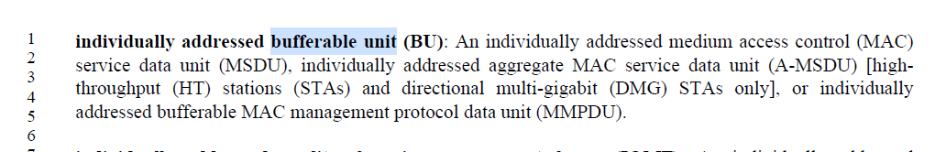

The definition for bufferable unit (BU) was changed per CID 4288 as follow:

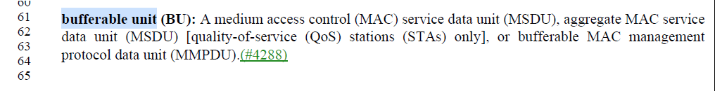

Proposed changes from the commenter:

individually addressed bufferable unit (BU):
An individually addressed medium access control (MAC) service data unit (MSDU), individually addressed aggregate MAC service data unit (A-MSDU) [highthroughput (HT) stations (STAs) and directional multi-gigabit (DMG) STAs only quality-of-service (QoS) stations (STAs) only], or individually addressed bufferable MAC management protocol data unit (MMPDU).

Proposed Resolution:

Accepted.

========================================================

5035 (Editor) | 1.5 | 151.63 | Follow-up to CID 4625. Calling the operator dec() is confusing because it's not generating a decimal per se, it's just generating a number, which you can choose to encode in whatever form you want (typically in binary, actually, when it goes into a field). | Change "dec(" to "int (" throughout

Discussion

Cited text:
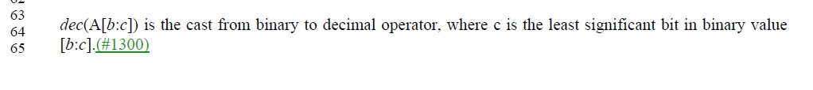

13 instances.

Need feedback.

Proposed Resolution:

?

