IEEE P802.11
Wireless LANs
MAC CR MU cascading
Date: 2020-05-06
Author(s):
Name | Affiliation | Address | Phone | email
Ming Gan | Huawei | F3-06, Huawei Industrial Base, Bantian, Longgang District, Shenzhen, China | +86 15889743667 | ming.gan@huawei.com
Abstract
This submission proposes resolutions of comments received for TGax draft 6.0. (The proposed change is based on TGax Draft 6.0)
- 24082
- 24328
- 24329
- 24427
- 24428 (5 CIDs)

Revisions:
- Rev 0: Initial version of the document.
- Rev 3: Correct the corresponding CIDs and make the change as per offline discussion.

Interpretation of a Motion to Adopt

A motion to approve this submission means that the editing instructions and any changed or added material are actioned in the TGax Draft. This introduction is not part of the adopted material.

Editing instructions formatted like this are intended to be copied into the TGax Draft (i.e. they are instructions to the 802.11 editor on how to merge the text with the baseline documents).

TGax Editor: Editing instructions preceded by “TGax Editor” are instructions to the TGax editor to modify existing material in the TGax draft. As a result of adopting the changes, the TGax editor will execute the instructions rather than copy them to the TGax Draft.

CID | Page | Clause | Comment | Proposed Change | Resolution
24082 | 361.26 | 26.5.3 | "An MU cascading sequence is a frame exchange sequence between an AP and one or more non-AP STAs carried in an HE MU PPDU in the downlink and HE TB PPDU in the uplink and characterized by the exchange of Control, Data and/or Management frames in both directions."  The key factor of the MU cascading is the exchange of Data and/or Management frames in both directions. Trigger frame that is a Control frame or A-Control that is not a Control frame can be both used to have the STAs transmit HE TB PPDU. And an Ack or a BlockAck frame that is a Control frame may not be transmitted at all if all the soliciting frames have No Ack policy. | Delete "Control, " from the cited sentence.  Add a note as follows, if necessary.  "NOTE - Trigger frames in downlink and Control frames such as Ack or BlockAck frames in downlink and/or uplink may be present accordingly to achieve exchanging Data/Management frames in both directions. A frame that carries a TRS Control subfield may be used instead of a Trigger frame according to the rules specified in 26.5.2 (UL MU operation)" | Revised-  Agree with the commenter in principle. As per the offline email discussion, propose resolution to address the issue.  TGax editor please make the changes as shown in 11-20/0980 r3 under CID 24082
24328 | 361.25 | 26.5.3 | "An MU cascading sequence is a frame exchange sequence between an AP and one or more non-AP STAs  carried in an HE MU PPDU in the downlink and HE TB PPDU in the uplink and characterized by the  exchange of Control, Data and/or Management frames in both directions." fails to capture the underlying requirement | After the cited sentence add "In an MU cascading sequence at least one transmission by the AP is a triggering PPDU that contains an Ack or BlockAck frame." | Revised-  Agree with the commenter in principle. As per the offline email discussion, propose resolution to address the issue.  TGax editor please make the changes as shown in 11-20/0980 r3 under CID 24328
24329 | 361.25 | 26.5.3 | It is not clear that in an MU cascading sequence there have to be MU PPDUs. The definition just says "characterized by the  exchange of Control, Data and/or Management frames in both directions" and the only normative requirement is "transmit an A-MPDU to a non-AP STA that includes an Ack or BlockAck frame together  with a triggering frame" | Delete "HE MU PPDU in the downlink and" and delete "MU " in Figure 26-5--An example of an MU cascading sequence | Revised-  This comment is about the definition of MU cascading sequence. As per the offline email discussion, propose resolution to address the issue.  TGax editor please make the changes as shown in 11-20/0980 r3 under CID 24329
24427 |  | 26.5.3 | [Resubmission of comment withdrawn on D5.0] CID 20732. The resolution is vague and not responsive to the comment "Re CID 16076: the comment was valid. The normative requirement is that cascading is defined by the use of "an A-MPDU to a non-AP STA that includes an Ack or BlockAck frame together with a Trigger frame or a frame carrying a TRS Control subfield." (342.33)" | Change the first sentence of the referenced subclause to "An MU cascading sequence is a frame exchange sequence between an AP and a non-AP STA where at least one transmission by the AP is a triggering PPDU that includes an acknowledgment." | Revised-  Agree with the commenter in principle. As per the offline email discussion, propose resolution to address the issue.  TGax editor please make the changes as shown in 11-20/0980 r3 under CID 24427
24428 |  | 26.5.3 | [Resubmission of comment withdrawn on D5.0] CID 20733. The resolution is vague and not responsive to the comment "Re CID 16076: the comment was valid. The normative requirement is that cascading is defined by the use of "an A-MPDU to a non-AP STA that includes an Ack or BlockAck frame together with a Trigger frame or a frame carrying a TRS Control subfield" (342.33). The resolution suggests this is wrong" | Change the first sentence of the referenced subclause to "An MU cascading sequence is a frame exchange sequence between an AP and a non-AP STA where a triggering PPDU follows after SIFS an UL MU transmission." Elsewhere, change "An AP shall not transmit an A-MPDU to a non-AP STA that includes an Ack or BlockAck frame together with a Trigger frame or a frame carrying a TRS Control subfield unless" to "An AP shall not transmit a triggering PPDU a SIFS after an HE TB PPDU the AP has triggered unless" | Revised-  Agree with the commenter in principle. As per the offline email discussion, propose resolution to address the issue.  TGax editor please make the changes as shown in 11-20/0980 r3 under CID 24428

Discussion: …
Part 1:
Two options for MU cascading sequence definition in the first paragraph:

Opt1: An MU cascading sequence is a frame exchange sequence between an AP and one or more non-AP STAs that allows Data and/or Management frames to be carried in both directions (a generic description)

Opt2: An MU cascading sequence is a frame exchange sequence between an AP and one or more non-AP STAs carried in an HE MU PPDU in the downlink and HE TB PPDU in the uplink where both the HE MU PPDU and the HE TB PPDU contain at least one Data or Management frame which solicits immediate acknowledgement except for the last PPDU of this frame exchange sequence (similar to the forbidden behavior)

Part 2:
Three options for forbidden behaviour at the AP side in the second paragraph

Opt1:
Unless both the AP and the non-AP STA have indicated support by setting the MU Cascading Support subfield to 1 in the MAC Capabilities Information field in the HE Capabilities element they transmit, an AP shall not transmit to the non-AP STA an A-MPDU that includes both
1) A Data or Management frame that solicits an immediate acknowledgment
2) A triggering frame which solicits a Data or Management frame

Opt2:
Unless both the AP and the non-AP STA have indicated support by setting the MU Cascading Support subfield to 1 in the MAC Capabilities Information field in the HE Capabilities element they transmit, an AP shall not transmit to the non-AP STA an A-MPDU that includes both
1) One or both of
a) A Data or Management frame that solicits an immediate acknowledgment
b) An Ack or BlockAck frame
2) A triggering frame which solicits a Data or Management frame

Opt 3:
Unless both the AP and the non-AP STA have indicated support by setting the MU Cascading Support subfield to 1 in the MAC Capabilities Information field in the HE Capabilities element they transmit, an AP shall not transmit to the non-AP STA an A-MPDU that includes both
1) An Ack or BlockAck frame
2) A triggering frame which solicits a Data or Management frame

26.5.4 MU cascading sequence

An MU cascading sequence is a frame exchange sequence between an AP and one or more non-AP STAs that allows Data and/or Management frames to be carried in both directions. An example of an MU cascading sequence is shown in Figure 26-5 (An example of an MU cascading sequence): in this figure the HE MU PPDUs contain a triggering frame and a Data or Management frame which solicits an immediate acknowledgement, and the HE TB PPDUs contain an Ack or BlockAck frame and a Data or Management frame which solicits an immediate acknowledgement. (#CID 20732, 20733 and 21450)

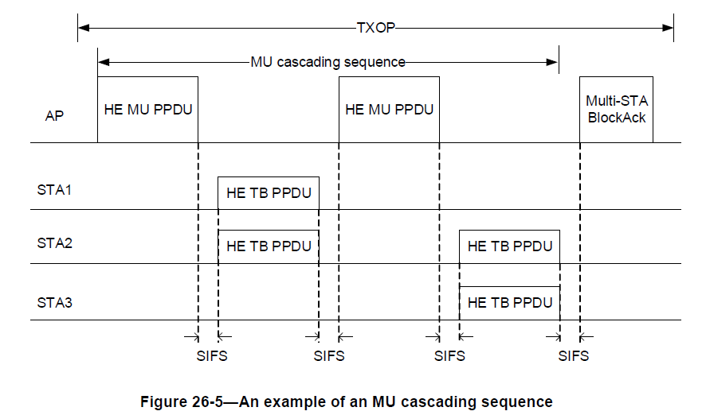

Unless both the AP and the non-AP STA have indicated support by setting the MU Cascading Support subfield to 1 in the MAC Capabilities Information field in the HE Capabilities element they transmit, and the AP is the TXOP holder, an AP shall not transmit to the non-AP STA an A-MPDU that includes both
1) One or both of
a) A Data or Management frame which solicits an immediate acknowledgment
b) An Ack or BlockAck frame
2) A triggering frame which solicits a Data or Management frame. (#CID 20732 and 20733)
The A-MPDU may additionally contain one or more MPDUs and is constructed following the rules in 26.6 (A-MPDU operation in an HE PPDU).

The MU cascading sequence may have a different set of transmitters in HE TB PPDUs as compared to the receivers of the HE MU PPDU that immediately follows the HE TB PPDUs within the same TXOP. The MU cascading sequence may have a different set of receivers in the HE MU PPDU as compared to the set of transmitters of HE TB PPDUs that immediately follow the HE MU PPDU within the same TXOP.

An AP follows the procedure in 26.5.2.2.5 (AP access procedures for UL MU operation).

