IEEE P802.11
Wireless LANs
MAC CR MU cascading
Date: 2020-05-06
Author(s):
Name | Affiliation | Address | Phone | email
Ming Gan | Huawei | F3-06, Huawei Industrial Base, Bantian, Longgang District, Shenzhen, China | +86 15889743667 | ming.gan@huawei.com
Abstract
This submission proposes resolutions of comments received for TGax draft 6.0. (The proposed change is based on TGax Draft 6.0)
- 20732 20733 21450 (3 CIDs)

Revisions:
- Rev 0: Initial version of the document.

Interpretation of a Motion to Adopt

A motion to approve this submission means that the editing instructions and any changed or added material are actioned in the TGax Draft. This introduction is not part of the adopted material.

Editing instructions formatted like this are intended to be copied into the TGax Draft (i.e. they are instructions to the 802.11 editor on how to merge the text with the baseline documents).

TGax Editor: Editing instructions preceded by “TGax Editor” are instructions to the TGax editor to modify existing material in the TGax draft. As a result of adopting the changes, the TGax editor will execute the instructions rather than copy them to the TGax Draft.

CID | Page | Clause | Comment | Proposed Change | Resolution
20732 | 341.40 | 26.5.4 | Re CID 16076: the comment was valid. The normative requirement is that cascading is defined by the use of "an A-MPDU to a non-AP STA that includes an Ack or BlockAck frame together with a Trigger frame or a frame carrying a TRS Control subfield" (342.33) | Change the first sentence of the referenced subclause to "An MU cascading sequence is a frame exchange sequence between an AP and a non-AP STA where at least one transmission by the AP is a triggering PPDU that includes an acknowledgment." | Revised-  Agree with the commenter in principle. As per the offline email discussion, propose resolution to address the issue.  TGax editor please make the changes as shown in 11-20/0980 r2 under CID 20732
20733 | 341.40 | 26.5.4 | Re CID 16076: the comment was valid. The normative requirement is that cascading is defined by the use of "an A-MPDU to a non-AP STA that includes an Ack or BlockAck frame together with a Trigger frame or a frame carrying a TRS Control subfield" (342.33). The resolution suggests this is wrong | Change the first sentence of the referenced subclause to "An MU cascading sequence is a frame exchange sequence between an AP and a non-AP STA where a triggering PPDU follows after SIFS an UL MU transmission." At 342.33 change "An AP shall not transmit an A-MPDU to a non-AP STA that includes an Ack or BlockAck frame together with a Trigger frame or a frame carrying a TRS Control subfield unless" to "An AP shall not transmit a triggering PPDU a SIFS after an HE TB PPDU the AP has triggered unless" | Revised-  Agree with the commenter in principle. As per the offline email discussion, propose resolution to address the issue.  TGax editor please make the changes as shown in 11-20/0980 r2 under CID 20733
21450 | 341.40 | 26.5.4 | "It says ""An MU cascading sequence is a frame exchange sequence between an AP and one or more non-AP STAs carried in an HE MU PPDU in the downlink and HE TB PPDU in the uplink and characterized by the exchange of Control, Data and/or Management frames in both directions.""  Is "Control" frame in the above a must?  From my understanding of the cascading sequence, there are both UL and DL exchange of Data and/or Management frames. For acknowledging, as a result, there may be Control frames in both sides. But that is not essential from the definition point of view. | Delete "Control, " from the cited sentence.  Add a note as follows, if necessary.  "NOTE - There are Trigger frames in downlink and Control frames such as Ack or BlockAck frames may be present in downlink and/or uplink accordingly to achieve exchanging Data/Management frames in both directions." | Revised-  Agree with the commenter in principle. As per the offline email discussion, propose resolution to address the issue.  TGax editor please make the changes as shown in 11-20/0980 r2 under CID 21450

Discussion: …

26.5.4 MU cascading sequence

An MU cascading sequence is a frame exchange sequence between an AP and one or more non-AP STAs that allows Data and/or Management frames to be carried in both directions. An example of an MU cascading sequence is shown in Figure 26-5 (An example of an MU cascading sequence): in this figure the HE MU PPDUs contain a triggering frame and a Data frame or Management frame, and the HE TB PPDUs contain an Ack or BlockAck frame and a Data frame or Management frame. (#CID 20732, 20733 and 21450)

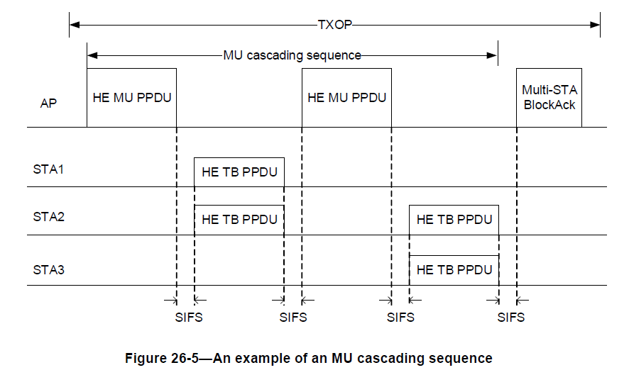

Unless both the AP and the non-AP STA have indicated support by setting the MU Cascading Support subfield to 1 in the MAC Capabilities Information field in the HE Capabilities element they transmit, an AP shall not transmit to the non-AP STA an A-MPDU that includes both
1) A Data or Management frame that solicits an immediate acknowledgment
2) A triggering frame that solicits a Data or Management frame. (#CID 20732 and 20733)
The A-MPDU may additionally contain one or more MPDUs and is constructed following the rules defined in 26.11 (Setting TXVECTOR parameters for an HE PPDU).

The MU cascading sequence may have a different set of transmitters in HE TB PPDUs as compared to the receivers of the HE MU PPDU that immediately follows the HE TB PPDUs within the same TXOP. The MU cascading sequence may have a different set of receivers in the HE MU PPDU as compared to the set of transmitters of HE TB PPDUs that immediately follow the HE MU PPDU within the same TXOP.

If an AP does not receive an immediate response from any of the non-AP STAs addressed by a Trigger frame or frame carrying a TRS Control subfield contained in the HE MU PPDU sent at the beginning of the TXOP, then the AP follows the backoff procedure described in 10.24.2.2 (EDCA backoff procedure).

