IEEE P802.11
Wireless LANs
Misc CR on D6.0
Date: 2020.03.17
Author(s):
Name | Company | Address | Phone | email
Ross Jian Yu | Huawei Technologies | F3-6-A120, Huawei Base, Bantian, Longgang, Shenzhen, Guangdong, China, 518129 |  | ross.yujian@huawei.com
Abstract
This submission contains proposed comment resolutions to comments on D6.0.

10 comments, CID 24105, 24106, 24107, 24175, 24193, 24194, 24195, 24196, 24357, 24358 are resolved in this document.

Revision Notes

R0 | Initial revision

CID 24105
CID | Page.  Line | Clause Number | Comment | Proposed Change | Resolution
24105 | 561.25 | 27.3.11.7.2 | "where in the primary 80 MHz ... at least  one 20 MHz subchannel that is not in the primary 40  MHz is punctured". Does this mean that in 160 MHz preamble puncturing using bandwidth field value 7, at least one 20 MHz within the Secondary 40 MHz need to be punctured? Probably that is not what was intended. The phrase "where in the primary 80 MHz" is unnecessary and may cause confusion. | Delete "the primary 80 MHz of". | ACCEPTED

Discussion
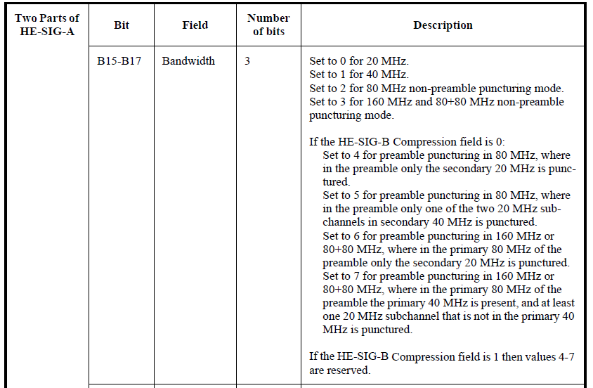

CID 24106
CID | Page.  Line | Clause Number | Comment | Proposed Change | Resolution
24106 | 192.57 | 9.4.2.247.3 | As written, B2 means that in 160 MHz, only one 20 MHz can be punctured, and that 20 MHz is the Secondary20. Is this the correct intention of this capability bit? | Please clarify. | Revised  The changes are specified, follow the description in HE-SIG-A. The spec doesn’t have any restrictions on S80. The restrictions are for P80 only.  Instructions to the editor, plase make the changes as shown in doc 11-20/0497r0

Discussion

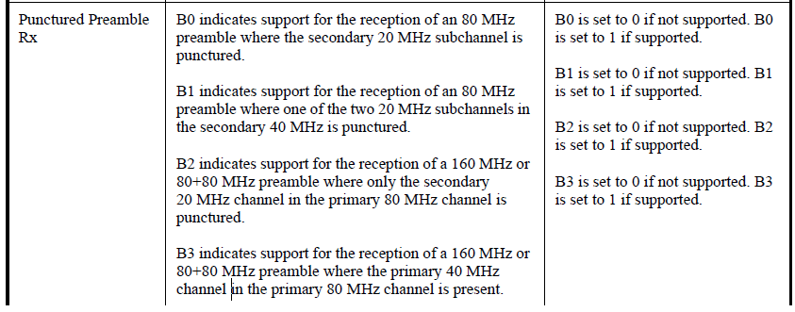

Instructions to the editor
Please make the changes to L57, P192 as shown below:
B0 indicates support for the reception of an 80 MHz preamble where the secondary 20 MHz subchannel is punctured.

B1 indicates support for the reception of an 80 MHz preamble where one of the two 20 MHz subchannels in the secondary 40 MHz is punctured.

B2 indicates support for the reception of a 160 MHz or 80+80 MHz preamble where in the primary 80 MHz of the preamble only the secondary 20 MHz channel is punctured.

B3 indicates support for the reception of a 160 MHz or 80+80 MHz preamble where the primary 40 MHz channelis present, and at least one 20 MHz subchannel that is not in the primary 40 MHz is punctured.

CID 24107

CID | Page.  Line | Clause Number | Comment | Proposed Change | Resolution
24107 | 192.62 | 9.4.2.247.3 | Does this capability bit match the operation for value 7 of the Bandwidth field in HE-SIG-A of an HE MU PPDU? | Please clarify. | Revised.  Instructions to the editor,  Please refer to the proposed change in CID24106. No further changes are needed.

CID 24175

CID | Page.  Line | Clause Number | Comment | Proposed Change | Resolution
24175 | 484.46 | 27.2.2 | "HE-CBW-PUNC160-SEC40 for preamble puncturing in 160 MHz or 80+80 MHz" | Remove "or 80+80 MHz". This is covered by HE-CBW-PUNC80+80-SEC40 | Revised  Agreed with the commenter. Only specify the changes as some reasons are already put in the proposed changes.  Instructions to the editor, plase make the changes as shown in doc 11-20/0497r0

Instructions to the editor
Please make the changes to L46, P484 as shown below:
HE-CBW-PUNC160-SEC40 for preamble puncturing in 160 MHz, where in the primary 80 MHz of the preamble the primary 40 MHz is present, and at least one 20 MHz subchannel that is not in the primary 40 MHz is punctured.

CID 24193

CID | Page.  Line | Clause Number | Comment | Proposed Change | Resolution
24193 | 574.48 | 27.3.11.8.3 | "none are defined". None what? | Replace with "No RU allocation is defined" or delete words in parentheses. | Revised  Agreed with the commenter. Specify the changes.  Instructions to the editor, plase make the changes as shown in doc 11-20/0497r0

Instructions to the editor
Please make the changes to L48, P574 as shown below:
If a Common field is present in a 160 MHz or 80+80 MHz PPDU, a 2×996 tone RU is not permitted.

CID 24194

CID | Page.  Line | Clause Number | Comment | Proposed Change | Resolution
24194 | 586.36 | 27.3.11.8.5 | "The number of OFDM symbols in the HE-SIG-B field, denoted by NSYM,HE-SIG-B, shall be signaled by the Number Of HE-SIG-B Symbols Or MU-MIMO Users field in the HE-SIG-A field of an HE MU PPDU". Only true if No Compression is used. | Add "If the HE-SIG-B Compression field in the HE-SIG-A field is 0" | Revised  Agreed with the commenter. Specify the changes.  Instructions to the editor, plase make the changes as shown in doc 11-20/0497r0

Instructions to the editor
Please make the changes to L36, P586 as shown below:
If the HE-SIG-B Compression field in the HE-SIG-A field is 0, the number of OFDM symbols in the HE-SIG-B field, denoted by NSYM,HE-SIG-B, shall be signaled by the Number Of HE-SIG-B Symbols Or MU-MIMO Users field in the HE-SIG-A field of an HE MU PPDU (see 27.3.11.7.2 (Content)).

CID 24195

CID | Page.  Line | Clause Number | Comment | Proposed Change | Resolution
24195 | 588.05 | 27.3.11.8.5 | "fourth lowest in frequency" is a strange way of saying "highest" | Change to "highest" | Revised  Agreed with the commenter. Specify the changes.  Instructions to the editor, plase make the changes as shown in doc 11-20/0497r0
Instructions to the editor
Please make the changes to L36, P586 as shown below:
HE-SIG-B content channel 2 occupies the 20 MHz frequency segment that is second lowest in frequency and is duplicated on the 20 MHz frequency segment that is highest in frequency.

CID 24196

CID | Page.  Line | Clause Number | Comment | Proposed Change | Resolution
24196 | 594.49 | 27.3.11.10 | Wrong reference: 27.3.19 should be 27.3.17 (HE Sounding PPDU) | Correct | Revised  Agreed with the commenter. Specify the changes.  Instructions to the editor, plase make the changes as shown in doc 11-20/0497r0

Discussion
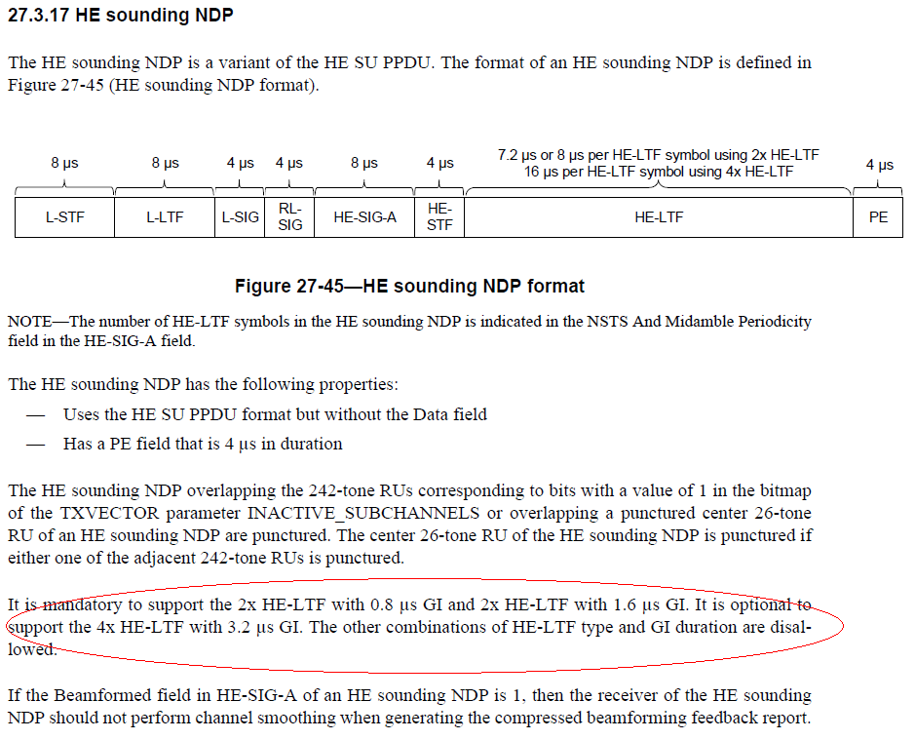

Instructions to the editor
Please make the changes to L49, P594 as shown below:
If an HE PPDU is an HE sounding NDP, the combinations of HE-LTF types and GI durations are listed in 27.3.17 (HE sounding NDP).

CID 24357

CID | Page.  Line | Clause Number | Comment | Proposed Change | Resolution
24357 | 681.17 | 27.4.2 | Table 27-54--HE PHY MIB attributes is missing dot11HEPuncturedSoundingOptionImplemented | As it says in the comment | Revised  Agreed with the commenter. Specify the changes.  Instructions to the editor, plase make the changes as shown in doc 11-20/0497r0

Instructions to the editor
Please make the changes to L17, P681 as shown below:
Managed object | Default value/range | Operational semantics
… | … | …
dot11HEPuncturedPreambleRxImplemented | Implementation dependent | Static
dot11HEPuncturedSoundingOptionImplemented | Implementation dependent | Static

CID 24358

CID | Page.  Line | Clause Number | Comment | Proposed Change | Resolution
24358 |  |  | Preamble puncturing doesn't just puncture the preamble, it punctures the entire PPDU transmission (see "If the Bandwidth field in the HE-SIG-A field of an HE MU PPDU is 4, 5, 6 or 7, then one or more 20 MHz  subchannels of the preamble are punctured, as defined in Table 27-20 (HE-SIG-A field of an HE MU  PPDU). If two adjacent 20 MHz subchannels that comprise a 40 MHz subchannel in which a 484-tone RU is  located are punctured, then B7-B0 of the RU Allocation subfields corresponding to the two 20 MHz sub-  channels shall both be set to 113 (242-tone RU is empty) or shall both be set to 114 (see Table 27-26 (RU  Allocation subfield)) to indicate that the preamble is punctured in both the 20 MHz subchannels. Each punc-  tured 20 MHz subchannel that does not have B7-B0 of its corresponding RU Allocation subfield set to 114  shall have B7-B0 of its RU Allocation subfield set to 113.") | Delete "preamble" in "preamble puncturing" throughout | REJECTED  The author agrees that for HE MU PPDU, if the preamble is punctured, the RUs that overlap with the frequency of the corresponding channel should be empty.  Whilst, as the preamble is punctured, it is not an issue to use preamble puncture. People now are familiar with the wording. Also, for HE sounding NDP, only the preamble is present, and punctured.  On the other hand, by only saying puncturing, it is confusing what is really punctured.

