IEEE P802.11
Wireless LANs
802.11
Proposed Resolutions for D3.0 Public Review Comment
Date: 2020-02-19
Author(s):
Name | Company | Address | Phone | email
Emily Qi | Intel Corporation |  |  | Emily.h.qi@intel.com
Abstract

This document contains proposed resolutions for REVmd D3.0 Public Review Comments.

R00: Initial proposal.
R01: Incorporated feedback from the ad hoc meeting on 2/18/2020.

7101 | 1706.09 | 11.11.10.3 | "the reporting AP has dot11LciCivicInNeighborReport and the neighbor AP has LCI MeasurementCapability (RM Enabled Capabilities element with the LCI Measurement Capability Enabled fieldset to 1) dot11RMLCIMeasurementActivated equal to true"-- this has at least two errors "has dot11LciCivicInNeighborReport" and"Measurement Capability (...) dot11RMLCIMeasurementActivated equal to true"Note that " (RM Enabled Capabilities element with the LCI Measurement Capability Enabled field set to 1)" is also a informal way of anonymously referencing a transmission by the AP)." this can also be improved. This informality occurs in a number of places in this subclause. The proposed changes addresses two of these. | Change cited text to:"the reporting AP has dot11LciCivicInNeighborReport equal to true and the neighbor AP indicates support for LCI measurement(the neighbor AP has transmitted an RM Enabled Capabilities element with the LCI Measurement Capability Enabled field equal to true)"Make matching changes at 1706.32.

Category | Comment | Proposed Change
General | Public Review Comment no. [208] by [v.hayes@hccnet.nl] on draft designation [802.11]:In this draft standard P802.11REVmd D3.0 the wrong symbol for data rate, i.e. b/s, has been used. The correct symbol, i.e. bit/s, should replace all occurrences of the symbol b/s. In this draft only 6 occurences of bit/s has been counted and more than 600 occurences of b/s.  Unfortunately, writer of this comment has no access to the IEEE terminology standards to verify the official position of the IEEE. However, the International Telecommunications Union clearly has adopted the bit/s as the official symbol as can be seen in the “ITU-R / ITU-T Terms and Definitions” available in an online database at the URL https://www.itu.int/ITU-R/index.asp?category=information&link=terminology-database&lang=en. Filling in “bit/s” in the field “Abbreviaton/term” yields 27 results. Filling in “b/s” yields 2 results, both referring to the term “Browser and Server Mode” which has nothing to do with rates.  In https://en.wikipedia.org/wiki/Data-rate_units one can find proof of the correct symbol of bit/s with the reference to standard IEC 60027-2:2019, Letter symbols to be used in electrical technology - Part 2: Telecommunications and electronics. Unfortunately, writer of this comment has no access to the standard due to the cost of $ 352.00.  In the original standard titled ANSI/IEEE Std 802.11, 1999, the symbol bit/s has correctly been used in around 160 cases. Unfortunately the wrong symbol b/s occurs around 6 times. | Replace all occurrences of the unit symbol "b/s" by the unit symbol "bit/s"

Discussion

In IEEE Standards Style Manual 2007, IEEE Std 260.1 is listed as a standard reference for writing an IEEE standard draft.
See Clause 2 Helpful documents (in IEEE Standards Style Manual 2007):
... ...
IEEE Std 260.1™, IEEE Standard Letter Symbols for Units of Measurement (SI Units, Customary Inch-
Pound Units, and Certain Other Units).
... ...

In Clause 13.3.1 Units of measure, IEEE Std 260.1 is specifically referred. See:

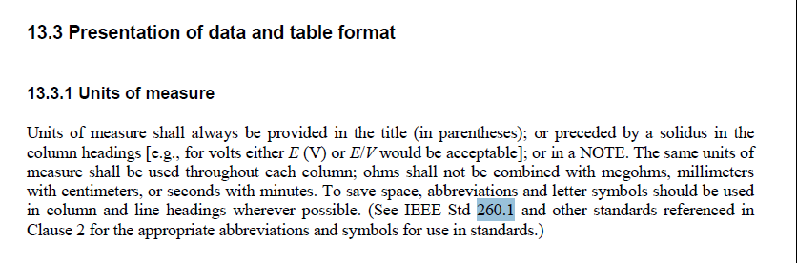

Now, let’s look at IEEE Std 260.1. On Page 8,

Note: SI stands for “Système International d’Unités (International System of Units)”
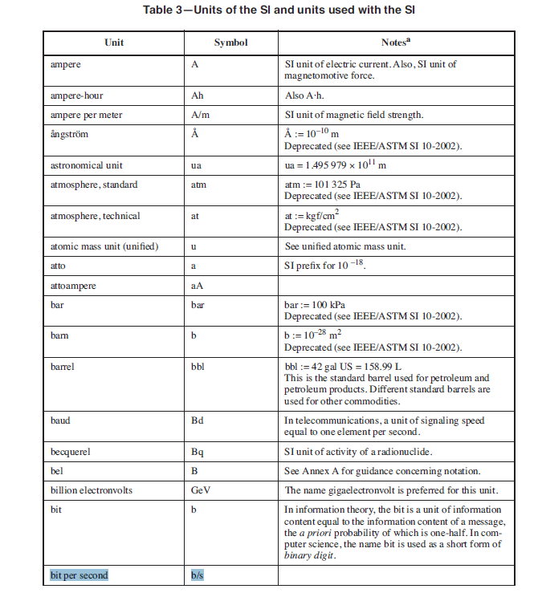

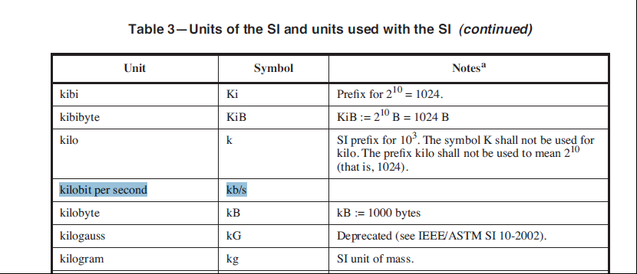

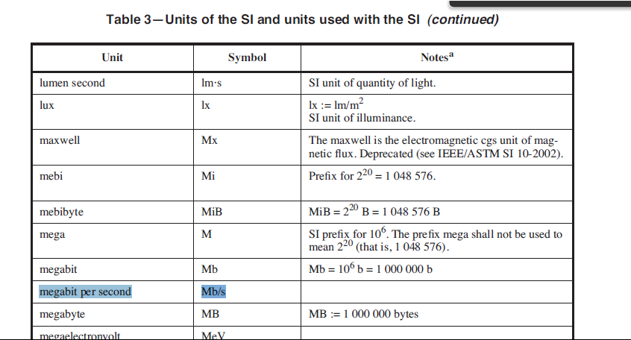

Therefore, the unit symbol "b/s" is correctly used in D3.0.

One instance of using “bits/second” was found.
6 instanaces of using “bit/s” were found.
Those instances should be changed to “b/s”.

Proposed Resolution:

Revised.
According to IEEE std 260.1 (Table 3), “b/s” is correct.

Changes are based on D3.0.
At 4145.23, 4145.33, 4145.44, 4145.54, 4145.64, and 4146.8: Change “kbit/s” to “kb/s”.
At 4612.55, change “bits/second” to “b/s”.

