IEEE P802.11
Wireless LANs
802.11 REVmd
Initial SB - Proposed Resolutions for Beacon Protection Comments
Date: 2020-06-12
Author(s):
Name | Company | Address | Phone | email
Emily Qi | Intel Corporation |  |  | Emily.h.qi@intel.com
Abstract

This document contains proposed resolutions for CID 4047, 4049, 4046, and 4165. Proposed text is based on D3.0.

R00: Initial proposal.
R01: some editorial changes.
R02: Added feedback from TGmd teleconference on 2/14.
R03: Updated resolution for CID 4046.
R04: Updated resolution for CID 4049.
R05: Added referebce for CID 4049.
R06: Incorporated the feedback from TGmd Teleconference.

7101 | 1706.09 | 11.11.10.3 | "the reporting AP has dot11LciCivicInNeighborReport and the neighbour AP has LCI MeasurementCapability (RM Enabled Capabilities element with the LCI Measurement Capability Enabled fieldset to 1) dot11RMLCIMeasurementActivated equal to true"-- this has at least two errors "has dot11LciCivicInNeighborReport" and"Measurement Capability (...) dot11RMLCIMeasurementActivated equal to true"Note that " (RM Enabled Capabilities element with the LCI Measurement Capability Enabled field set to 1)" is also a informal way of anonymously referencing a transmission by the AP)." this can also be improved. This informality occurs in a number of places in this subclause. The proposed changes addresses two of these. | Change cited text to:"the reporting AP has dot11LciCivicInNeighborReport equal to true and the neighbor AP indicates support for LCI measurement(the neighbor AP has transmitted an RM Enabled Capabilities element with the LCI Measurement Capability Enabled field equal to true)"Make matching changes at 1706.32.

CID | Page | Clause | Comment | Proposed Change
4047  (MAC) | 1099.5 | 9.4.2.24.2 | It is not clear which Cipher suite is used for Beacon frame protection. Presumably, the group management cipher suite is used for beacon protection. If so, add clarification. | 1. At 1099.5 (9.4.2.24.2 Cipher suites), make changes as follows:  "The Group Management Cipher Suite field contains the cipher suite selector used by the BSS to protect group addressed robust Management frames and Beacon frames."  2. At 1099.11, insert a sentence before "Use of BIP-CAMC-128 ..." as follows: "When beacon protection is enabled, the group management cipher suite is used to protect Beacon frames."  3. at 2645.32, insert a para: "The group management cipher suite is used to protect Beacon frames."
Discussion:
It is assumed that the group management cipher suite is usded for beacon protection. However, there is no statement in D3.0 in this regard.
Also, in Multiple BSSIDs scenario, different BSS may use different group management cipher suite. Therefore, a further clarification is needed for Multiple BSSIDs scenarios.

At 2645.29 (12.6.23 Protection of Beacon frames), make changes as follows:
An AP shall transmit protected Beacon frames if beacon protection is enabled. Protected Beacon frames cannot be validated until a BIGTKSA has been established. If a BIGTKSA exists, the non-AP STA shall validate the MME in received Beacon frames.

For Multiple BSSIDs, each of Authenticators shall maintain and transmit the BIGTK and BIPN which are
common to all of the co-located transmitted and nontransmitted BSSs, and the Supplicant uses the
received BIGTK and BIPN to maintain a BIGTKSA. If a Supplicant that has a BIGTKSA with an
Authenticator that is using a nontransmitted BSSID receives a protected Beacon frame from the AP
with the transmitted BSSID, it shall execute the BIP procedures (see 12.5.4 (Broadcast/multicast integrity
protocol (BIP))) to validate the Beacon frame.

If AP is not a member of a multiple BSSID set, the group management cipher suite that is used by the BSS to protect group addressed robust Management frames shall be used for the protection of Beacon frames. For Mutltiple BSSIDs, the group management cipher suite that is used by the BSS corresponding to the transmitted BSSID shall be used for the protection of Beacon frames.

Beacon protection is not applicable to IBSS and MBSS.

The original proposed changes in the comment also proposed some changes to 9.4.2.24.2. After reviewing these changes in 9.4.2.24.2, I belive the changes in 12.6.23 Protection of Beacon frames should be sufficient. There is no need to repeat the sentence. No change needed to 9.4.2.24.2.

Mark H suggested following sentence:
The group management cipher suite of the AP transmitting a Beacon is used to protect Beacon frames.
Proposed Resolution:
Revised.
At 2645.41 of D3.0 (12.6.23 Protection of Beacon frames), add a para as below:
“The group management cipher suite of the AP transmitting a Beacon is used to protect Beacon frames.”.

CID | Page | Clause | Comment | Proposed Change
4049  (PHY) | 2660.00 | 12.7.2 | The Key Description Version field is a 2-bits field, which can indicate 3 "old" combinations. However, with the introduction of new AKMs for GCMP-128, GCMP-256, FILS, FILS+FT, there are additional combinations. Suggest using 2 reserved bits (bit 4 and bit 5) to indicate additional combinations. | If the direction is agreed, the commenter will provide a submission for the comment resolution.

Discussion:
Cited text on Page 2660:
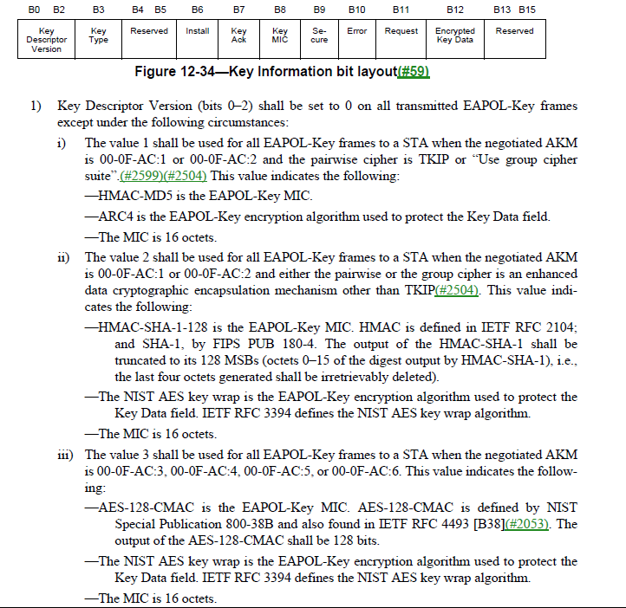

Jouni and I had a discussion and agreed:
The Key Descriptor Version field was used to indicate which algorithms are used with some older AKM suites. However, use of this field for any new AKM suite has been deprecated and for them, the AKM suite selector specifies the used algorithms (see Table 12-10 in 12.7.3). The Key Descriptor Version field is set to 0 for all these newer AKM suites, including all the combinations listed in the comment.

Here is Table 12-10 (Page 2668):

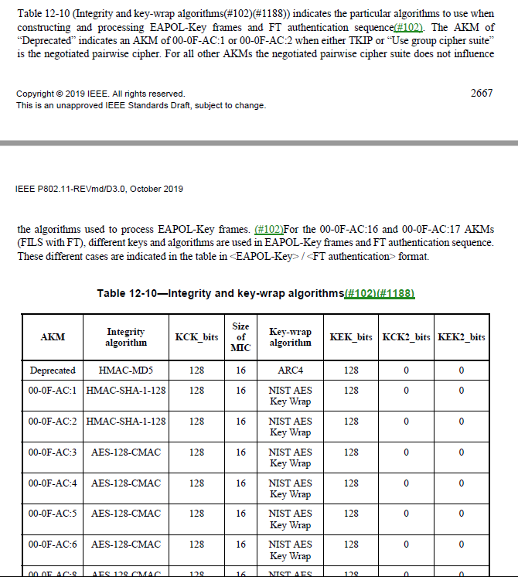

However, since AKM suites are partically mentioned on page 2660, it is not clear how to describe other AKMs from page 2660. I was thinking of adding a note, something like:
“NOTE—For all other negotiated AKMs, the AKM suite selector specifies the used algorithms (see Table 12-10).”

Jouni suggested:
Table 12-10 describes this for _all_ AKM suite selectors. It would seem to make more sense to remove the duplicated information for the exception cases instead of adding a note that could be misunderstood to mean that 12.7.3 (including Table 12-10) does not cover some of the cases. In other words, I'd rather delete the three instances of "This value indicates the following: <all subitems>" from page 2060 lines 14-18, 22-33, and 35-44. That description of the Key Descriptor Version subfield is overly long anyway, so making it shorter would make 12.7.2 more readable. This would make the standard clear since 12.7.3 would be the only place describing which algorithms are used based on the AKM suite selector (and pairwise=TKIP exception).

I am okay with Jouni’s suggestion.

2/14 tele: defer to Jouni to answer Mark R’s questions.
Proposed Resolution:

Revised.

At 2660.8 to 2660.46, change as follows:
1) Key Descriptor Version (bits 0–2) shall be set to 0 on all transmitted EAPOL-Key frame indicating that the EAPOL-Key frame is constructed and processed according to the negotiated AKM as described in Table 12-10 (Integrity and key-wrap algorithms) except under the following circumstances:
i) The value 1 shall be used for all EAPOL-Key frames to a STA when the negotiated AKM
is 00-0F-AC:1 or 00-0F-AC:2 and the pairwise cipher is TKIP or “Use group cipher
suite”. In this case, the “Deprecated” row in Table 12-10 (Integrity and key-wrap algorithms) is used. This value indicates the following:
—HMAC-MD5 is the EAPOL-Key MIC.
—ARC4 is the EAPOL-Key encryption algorithm used to protect the Key Data field.
—The MIC is 16 octets.
ii) The value 2 shall be used for all EAPOL-Key frames to a STA when the negotiated AKM
is 00-0F-AC:1 or 00-0F-AC:2 and either the pairwise or the group cipher is an enhanced
data cryptographic encapsulation mechanism other than TKIP. In this case, the matching AKM row in Table 12-10 (Integrity and key-wrap algorithms) is used. This value indicates
the following:
—HMAC-SHA-1-128 is the EAPOL-Key MIC. HMAC is defined in IETF RFC 2104;
and SHA-1, by FIPS PUB 180-4. The output of the HMAC-SHA-1 shall be
truncated to its 128 MSBs (octets 0–15 of the digest output by HMAC-SHA-1), i.e.,
the last four octets generated shall be irretrievably deleted).
—The NIST AES key wrap is the EAPOL-Key encryption algorithm used to protect the
Key Data field. IETF RFC 3394 defines the NIST AES key wrap algorithm.
—The MIC is 16 octets.
iii) The value 3 shall be used for all EAPOL-Key frames to a STA when the negotiated AKM is 00-0F-AC:3, 00-0F-AC:4, 00-0F-AC:5, or 00-0F-AC:6. In this case, the matching AKM row in Table 12-10 (Integrity and key-wrap algorithms) is used. This value indicates the following:
—AES-128-CMAC is the EAPOL-Key MIC. AES-128-CMAC is defined by NIST
Special Publication 800-38B and also found in IETF RFC 4493 [B38]. The
output of the AES-128-CMAC shall be 128 bits.
—The NIST AES key wrap is the EAPOL-Key encryption algorithm used to protect the
Key Data field. IETF RFC 3394 defines the NIST AES key wrap algorithm.
—The MIC is 16 octets.

=============

CID | Page | Clause | Comment | Proposed Change
4046  (PHY) | 2553 | 12.2.9 | OCVC capability can provide Operating Channel Validation, which is described in 12.2.9 Requirements for Operating Channel Validation. Beacon Protection capability can also provide Operating Channel Validation, which is missed in 12.2.9. Add using beacon protection capability for Operating Channel Validation in 12.2.9. | At the end of 12.2.9, add a para:  "When beacon protection is enabled, a STA receiving the first valid protected Beacon frame shall validate that the operating channel information in the protected Beacon frame matches the current operating channel parameters. The operating channel information is included in HT Operation element, VHT Operation element, TVHT Operation element, DMG Operation element, S1G Operation element, or CCMG Operation element, respectively ".

Discussion:

We discussed this comment in the January meeting.

Clarification on benefits:
Given that OCVC is an optional feature, Beacon protection can be used for operating channel validation when OCVC is not suppoted, but Beacon protection is supported.

Three comments were received in the January meeting:
- Don’t want to mandate STA’s behavior.
  - Response:
    - Since OCVC is an optional feature, STAs may not support OCVC, but support Beacon protection.
    - Added a condition of presence of OCVC capability so that the Beacon validate is required only when OCVC capability is not supported.
- The proposed change might be considered in the subclause related to Beacon Protection.
  - Response:
    - The proposed sentence is for operating channel validation when OCVC capability is not supported by the STA. I think 12.2.9 is the place.
    - The Beacon protection subclauses describe the Beacon protection requirement or procedure. I don’t think this sentence belongs there.
    - I will update the proposed change to add a condition when OCVC capability is not supported.
- There is no need to metion all elements including the operating channel information
  - Response: agreed. Will remove them.

Also, received additional suggestions/edits from Jouni:

“If OCVC capability is not present in a non-AP STA or if the current AP does not advertise OCVC capability, but beacon protection is enabled, the non-AP STA shall verify that the operating channel information in the first received Beacon frame that passes BIP validation matches the current operating channel parameters. If there is a mismatch, the non-AP STA shall disassociate from the AP.”

Feedback on 2/14:

Mark/Mark suggested:
“If OCVC capability is not present in a non-AP STA or if the current AP does not advertise OCVC capability, but beacon protection is enabled, the non-AP STA shall verify that the operating channel information in the first received Beacon frame that has been validated using BIP matches the current operating channel parameters. If there is a mismatch, the non-AP STA shall disassociate from the AP.”

Additional Comments:
- Comment #1: Consider to move the new para to 11.53.
➔ Response: Okay, moved the change to 11.53.
- Comment #2: What happen if there is a mismatch? The channel information in the receiving a Beacon that doesn’t match the operating channel. In OCVC, it seems to discard the frame when there is a mismatch. Should the non-AP STA discard the Beacon frame instead of dissociation?
➔Response:
- when the OCVC is included in the 4-way handshake, if there is a mismatch, message 1 message 2 or message 3 will be discarded. In this case, the 4-way handshake fails and the connection is not established, which is similar to the proposed text, “If there is a mismatch, the non-AP STA shall disassociate from the AP.”.
- In the beacon protection case, if the Beacon frame is received with valid BIP, it means:
  - Beacon was generated by the good AP (it has a valided beacon protection key).
  - Beacon was received correctly by the non-AP STA, and the channel information included in the Beacon frame is the real channel where the AP is operating.
  - If the operating channel doesn’t match with the channel information in the Beacon frame, it means that the good AP is not really on the channel where the non-AP STA received the Beacon. This means that there is an on-going man-in-the-middle attack: not only the Beacon are not trusted, but also the data-frames and management-frames.

Therefore, the correct action for the non-AP STA is to disconnect from the AP.

Proposed Resolutions:

Revised.

Add a paragraph at the end of end of 11.53 Beacon frame protection procedures:

“If OCVC capability is not present in a non-AP STA or if the current AP does not advertise OCVC capability, but beacon protection is enabled, the non-AP STA shall verify that the operating channel information in the first received Beacon frame that has been validated using BIP matches the current operating channel parameters. If there is a mismatch, the non-AP STA shall disassociate from the AP.”

=========================

CID | Page | Clause | Comment | Proposed Change
4165  (MAC) | 895 | 9.3.4.3 | Beacon protection does not seem to be specified for S1G beacon frames, i.e. in terms of when the MME shall be included in the long and short S1G beacons and in terms of which TSF related fields are masked to zero before creation of the MME. | Define beacon protection for S1G beacon frames.

Discussion:

Need feedback from TGmd.

The comment fails to identify changes in sufficient detail so that the specific wording of the changes that will satisfy the commenter can be determined.

Proposed Resolutions:

Reject.

The comment fails to identify changes in sufficient detail so that the specific wording of the changes that will satisfy the commenter can be determined.

