IEEE P802.11  
Wireless LANs

|  |  |  |  |  |
| --- | --- | --- | --- | --- |
| Proposed Resolution for CID 4108  5.9 GHz (5.850-5.895 GHz) for Unlicensed Use | | | | |
| Date: 2020-01-13 | | | | |
| Author(s): | | | | |
| Name | Company | Address | Phone | email |
| Lili Hervieu | CableLabs |  |  | l.hervieu@cablelabs.com |
| Thomas Derham | Broadcom |  |  | Thomas.derham@broadcom.com |
| Carol Ansley | CommScope |  |  | carol.ansley@commscope.com |
|  |  |  |  |  |

Abstract

On December 12th, 2019, the FCC issued a Notice of Proposed Rulemaking proposing the lower 45 megahertz of the 5.9 GHz band for unlicensed uses (not under DFS rules). This contribution proposes the addition of the corresponding channels to the channels listing in Annex E - Table E-4 - Global operating classes

**Discussion**:

On December 12th, 2019, the FCC issued a Notice of Proposed Rulemaking [1] proposing the lower 45 megahertz of the 5.9 GHz band (5.850-5.895 GHz) for unlicensed uses (not under DFS rules). This additional 45 MHz spectrum, depicted below in the proposed U-NII-4 band, accommodates an additional two 40 MHz channels, one 80 MHz channel, and one 160 MHz channel.

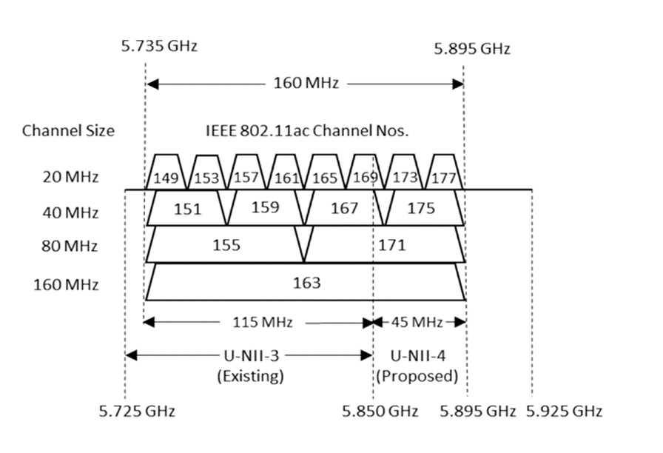

The NPRM also proposes that U-NII-4 devices be subject to similar technical and operational rules that apply to the U-NII-3 band and that U-NII-4 devices be permitted to operate at the same power levels as U-NII-3 devices.

**Proposed changes (red)**:

**Annex E – Table E-4 - Global operating classes Operating classes**

|  |  |  |  |  |  |  |
| --- | --- | --- | --- | --- | --- | --- |
| Operating class | Nonglobal operating class(es) | Channel starting frequency (GHz) | Channel spacing (MHz) | Channel set | Channel center frequency index | Behavior limits set |
| 125 | E-1-5,  E-2-17, E-5-3 | 5 | 20 | 149, 153, 157, 161, 165, 169, 173, 177 | — | LicenseExemptBehavior, UseEirpForVHTTxPowEnv |
| 126 | E-1-25,26, E-5-6 | 5 | 40 | 149, 157, 165, 173 | — | PrimaryChannelLowerBehavior, UseEirpForVHTTxPowEnv |
| 127 | E-1-30,31 | 5 | 40 | 153, 161, 169, 177 | — | PrimaryChannelUpperBehavior, UseEirpForVHTTxPowEnv |
| 128 | E-1-128, E-2-128, E-3-128 E-5-128 | 5 | 80 | — | 42, 58, 106, 122, 138, 155, 171 | UseEirpForVHTTxPowEnv |
| 129 | E-1-129, E-2-129, E-3-129 E-5-129 | 5 | 160 | — | 50, 114, 163 | UseEirpForVHTTxPowEnv |
| 130 | E-1-130, E-2-130, E-3-130 E-5-130 | 5 | 80 | — | 42, 58, 106, 122, 138, 155, 171 | 80+,  UseEirpForVHTTxPowEnv |

**Reference:**

[1] [<https://mentor.ieee.org/802.18/dcn/19/18-19-0163-00-0000-fcc19-138-nprm-revisiting-use-of-the-5-850-5-925-ghz-band.docx>](https://mentor.ieee.org/802.18/dcn/19/18-19-0163-00-0000-fcc19-138-nprm-revisiting-use-of-the-5-850-5-925-ghz-band.docx)