IEEE P802.11
Wireless LANs
802.11
Proposed Resolution for CID 4048
Date: 2020-01-15
Author(s):
Name | Company | Address | Phone | email
Emily Qi | Intel |  |  | Emily.h.Qi@intel.com
Ido Ouzueli | Intel |  |  | ido.ouzieli@intel.com
Nehru Bhandaru | Broadcom |  |  | nehru.bhandaru@broadcom.com
Thomas Derham | Broadcom |  |  | thomas.derham@broadcom.com
Jouni Malinen | Qualcomm |  |  | jouni@qca.qualcomm.com
Abstract

This document provides resolutions for CID 4048(PHY).

R00: Initial proposal.

4048 (PHY) |  |  | The BIGTK's Key ID is included in the Management MIC element and added at the end of Beacon frame body. The receiving STA won't be able to start computing MIC value until reaching the end of Beacon frame body. Some implementations may start computing MIC without checking BIGTK ID. However, when BIGTK ID is changed, it has to recalculate the MIC. Beacon frame is a long frame, recalculation is not efficient. To avoid the cited issue, a synched BIGTK ID update mechanism is needed. This might not be an issue for IGTK as the IGTK is only for Disassociation frame protection. Disassociation frame is a short frame and recalculation of MIC is feasible. | The commenter will provide a submission for the comment resolution.

Discussion

Background:
- Since BIGTK is shared by all associated STAs, the APs typically update their value with following steps:
  - First, updating all associated STAs, one by one via unicast frame
  - Once the new non-active BIGTK is set in all STAs, the AP will start using the new Key ID as the ‘active’ BIGTK for the following Beacon frames protection, respectively.
- Which means that there is a delay between the time the new key was set by AP in the STA and the time where AP actually starts using the new key instead of the old one.

Problem statement:
- For group addressed data frame, the used GTK Key ID is indicated in the beginning of the frame (e.g. the Key ID field in the CCMP header), so that the STA knows quiet early which GTK to use.
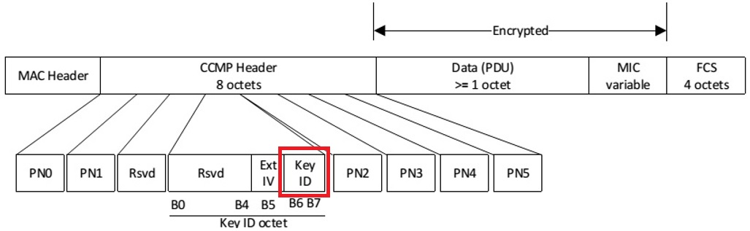

- For protected beacon frame, the used BIGTK Key ID is indicated in the MMIE (Management MIC Information Element), which is located at the end of the protected Beacon frame.
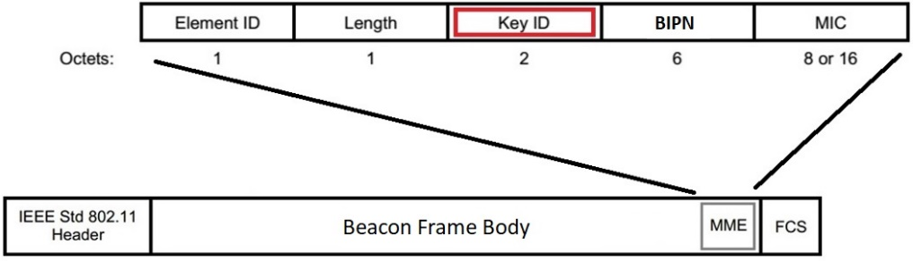

- Most of implementations will start computig MIC value using the existing key without reaching the end of Beacon frame body.

Possible Solutions:
- Option 1: Following BIGTK rekeying, AP notifies all associated STAs on when it will start using the new BIGTK. A new information element will be defined.
- Option 2: Using the first Beacon frame received with a different key index as an indication of the key change. The implementation may
  - Revalidate the first Beacon frame using the new key. This is a more complex approach. Or
  - Drop the first Beacon frame and start using the new key for the subsequent Beacon validation. There would be no significant harm from dropping a single Beacon frame whenever BIGTK is switched since Beacon frames are lost anyway regardless of this new protection mechanism.

With this approach, we should add a text stating that the AP should not be switching between two keys (which is allowed, but not described), i.e., allow move only to a new key index and once the first frame goes out using that key, no new frames can be sent using the old key. The note should apply to IGTK as well.

Option 2.b is preferred.

Proposed Resolution:

Revised.

At the end of 12.5.4.5 BIP transmission (2613.21), add a paragraph and a note as follows:
Once a STA transmits a protected Beacon frame using a new BIGTK, the STA shall not transmit protected Beacon frames using the replaced BIGTK.

NOTE— Once a STA transmits a protected group addressed robust Management frame using a new IGTK, the STA is advised not to transmit protected group addressed robust Management frames using the replaced IGTK.

