IEEE P802.11
Wireless LANs
802.11
SA1 - Proposed Resolutions for EDITOR adhoc
Date: 2020-04-01
Author(s):
Name | Company | Address | Phone | email
Emily Qi | Intel Corporation |  |  | Emily.h.qi@intel.com
Abstract

This document contains proposed resolutions to SA1 editorial comments for the EDITOR ad hoc that require TG’s feedback.

R00: Initial proposal. Provided resolutions for CID 4312(EDITOR2), 4202(EDITOR2), 4117, 4601, and 4533
R01: Discussed and approved CIDs included in R00.
R02: Provided resolutions for 3 items raised in D3.1 candidate draft review.
R03: Provided draft resolutions for more editorial comments
R04: Incorporated feedback from the TGmd Adhoc meeting on Tuesday (2/18), PM1
R05: Incorporated feedback from the TGmd Adhoc meeting on Tuesday (2/18), PM2
R06: Incorporated feedback from the TGmd Adhoc meeting on Wednesday (2/19), PM2
R07: Incorporated feedback from the TGmd Adhoc meeting on Thursday AM (2/20), and added additional comment resolutions.
R08: Incorporated feedback from Mark R on CID 4469 and 4375.
R09: Incorporated feedback from the teleconference on March 6th on CID 4469.
R10: Updated proposed resolutions for CID 4800 and 4591.
R11: Incorporated feedback from the teleconference on March 13th.
R12: Updated the resolution for CID 4375 for discussion.
R13/14: Added additional notes for CID 4800 for discussion.
R15: Incorporated feedback from the teleconference on March 27th.
R16: added more discussion for CID 4587, 4375, and 4800.

Green indicates material agreed to in the group, ready for motion
yellow indicates work-in-progress, material will be discussed/reviewed again.

7101 | 1706.09 | 11.11.10.3 | "the reporting AP has dot11LciCivicInNeighborReport and the neighbor AP has LCI MeasurementCapability (RM Enabled Capabilities element with the LCI Measurement Capability Enabled fieldset to 1) dot11RMLCIMeasurementActivated equal to true"-- this has at least two errors "has dot11LciCivicInNeighborReport" and"Measurement Capability (...) dot11RMLCIMeasurementActivated equal to true"Note that " (RM Enabled Capabilities element with the LCI Measurement Capability Enabled field set to 1)" is also a informal way of anonymously referencing a transmission by the AP)." this can also be improved. This informality occurs in a number of places in this subclause. The proposed changes addresses two of these. | Change cited text to:"the reporting AP has dot11LciCivicInNeighborReport equal to true and the neighbor AP indicates support for LCI measurement(the neighbor AP has transmitted an RM Enabled Capabilities element with the LCI Measurement Capability Enabled field equal to true)"Make matching changes at 1706.32.

CID | Clause | Page | Line | Comment | Proposed Change
4312  (EDITOR2) |  |  |  | The names of the following fields should have all initials upper-case, to avoid confusion: "Number of Channel Measurement Info" should be "Of". Also "Number of RX DMG Antennas", "Number of Channels", "Number of Time Blocks", "Normal Number of Frames per Channel", "Number of ANQP OIs", "OI #1 and #2 Lengths" | As it says in the comment
4202 (EDITOR2) |  |  |  | The name of fields should start with uppercase letters for each word, to avoid confusion (especially with fields with "And" or "Or" in their name). | As it says in the comment

Discussion

The commenter lists the following in CID 4312:
- Number of Channel Measurement Info
- Number of RX DMG Antennas
- Number of Channels
- Number of Time Blocks
- Normal Number of Frames per Channel
- Number of ANQP OIs
- OI #1 and #2 Lengths
I am sure there are more instances as CID 4202 comments on the same issue without the locations.

Obviously, it is a broad issue, not specific to TGmd.

We brought up this issue in the editor meeting this week.

Here is summary of the discussion from the Editor meeting.
- Moving forward, in future amendments, Editors shall use all upper case for the (sub)field names and (sub)element names, including preposition and conjunction words, e.g. Of, And, Or, etc ....... The Editor Style guide will be updated accordingly.
- The new style guide will apply to the new amendments (the amendments haven't done MDR).
- This new guidance has no intention to update the existing amendments/revisions. Due to legacy issue, changing Grandfathered terms where were widely used is considered excessive.
WG Editor updated 802.11 style guide (09/1034r16 draft) by adding the following paragraph in 2.6 Capitalization

… …
For proper names, all words in the name should be capitalized, including prepositions and conjunctions. This is to avoid ambiguity where the preposition or conjuction might be misinterpreted as part of the sentence. For example, “HT And VHT Trigger Frame RX Support subfield.” This rule does not apply to legacy text; these remain unchanged since the effort involved in changing all instances is substantial and no harm has been demonstrated.

Therefore, my proposal is to reject these two comments, or revised.

Proposed Resolution:

Rejected.

Rejec Reason: WG editor will update 802.11 Editorial Style guide 09/1034 to add a new rule including preposition and conjunction capitalization in the (sub)field and (sub)element names. This rule applies for new amendments. As stated in the style guide, “This rule does not apply to legacy text; these remain unchanged since the effort involved in changing all instances is substantial and no harm has been demonstrated.”

4117 (DeLaOlivaDelgado, Antonio) | 9.4.5.1 | 1473.37 | Third column of Table 9-330 shows the first letter of each ANQP Element in upper case but the ones of element Local MAC Address Policy | Change "Local MAC address policy ANQP element" in the third column of Table 9-330 to "Local MAC Address Policy ANQP element"

Discussion

This comment was original included in the trivial comment tab.
My proposed resolution is:

REVISED (EDITOR: 2020-01-08 20:26:03Z). At 1494.16, change "Local MAC address policy" to "Local MAC Address Policy". Note to the commenter, when the text in 1494.16 is changed, the text in 1473.37 will be changed automatically.

Mark R suggested other locations to be changed, such as: "Advice of Charge ANQP-element" and
"Network Authentication Type with Timestamp ANQP-element" should become "…Of…" and "…With…" too.

Therefore, this comment is here for discussion.
My receommendation is to reject additional changes as proposed by Mark R, with the reason:
- Additional suggestions are out of scope of the original comment.
- Preposition and conjunction capitalization is a new rule and does not apply to legacy text.

Proposed Resolution:

REVISED.
At 1494.16, change "Local MAC address policy" to "Local MAC Address Policy". Note to the commenter, when the text in 1494.16 is changed, the text in 1473.37 will be changed automatically.

Note to the commenter: this change resolved the comment in the direction suggested by the commenter.

4601 (RISON, Mark) | 3.2 | 193.19 | "and a temporal key, which" should be "and a temporal key that" | As it says in the comment.

Discussion

Cited text:
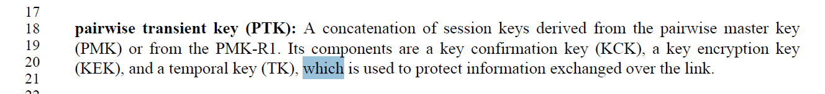

A temporal key (TK) is used to pretet information exchanged over the link.

My recommendation is to accept it.

Proposed Resolution:

Revised.

Delete “, which is used to protect information exchanged over the link”.

========================================================

4533 (RISON, Mark) | 9.4.2.21.9 | 1059.25 | The text describing the fields shown in Figure 9-236--Measurement Report field format for STA Statistics report are not described with "field" | Add missing "field"s

Discussion

There are multiple locations.

Here is the Figure 236:

 | Measurement Duration | Group Identity | Statistics Group Data | Optional  Subelements
Octets: | 2 | 1 | variable | variable
- Measurement Report field format for STA Statistics report

Proposed Resolution:

Revised.

Change text from 1059.39 to 1059.59 as follows:

The STA Statistics report reports the change in, or current values of, the requested statistics group data measured within the measurement duration.
The Measurement Duration field is set to the duration over which the change in statistics group data was measured and reported, in units of TUs. (MDR2) A Measurement Duration field set to 0 indicates a report of the current values of the statistics group data.
The Group Identity field indicates the requested statistics group describing the Statistics Group Data field according to Error: Reference source not found.
The Statistics Group Data field contains the requested statistics from the MIB in Annex C related to the interface on which the request was received according to Error: Reference source not found. Units used for reporting a statistic or change in statistic are the units used to define the statistic in Annex C. When the Measurement Duration field is nonzero, the reported data values for statistics that are not counters are the current values of the statistics data at the end of the measurement duration. When the Measurement Duration field is zero the current values of the requested statistics group data are reported, rather than the change.

<< Trival Editorial Corrections >>

These changes raised during TGmd Draft D3.1-0500 review.

Item D3.1-1:

 | Related comments |  |  | Comments | Proposed Changes
Mark RISON | 4461 | C.3 |  | The DESCRIPTION of dot11WirelessMGTEventPeerSTATxPower and dot11WNMEventPeerRprtStaTxPower say "peer-to-peer link" but don't mention "event" anywhere, unlike similar DESCRIPTIONs | As it says in the comment

Discussion:

For dot11WirelessMGTEventPeerSTATxPower, at 3925.40 (D3.1), it states “peer-to-peer link”. At 3925.27, it states “peer-topeer
event report”, see:

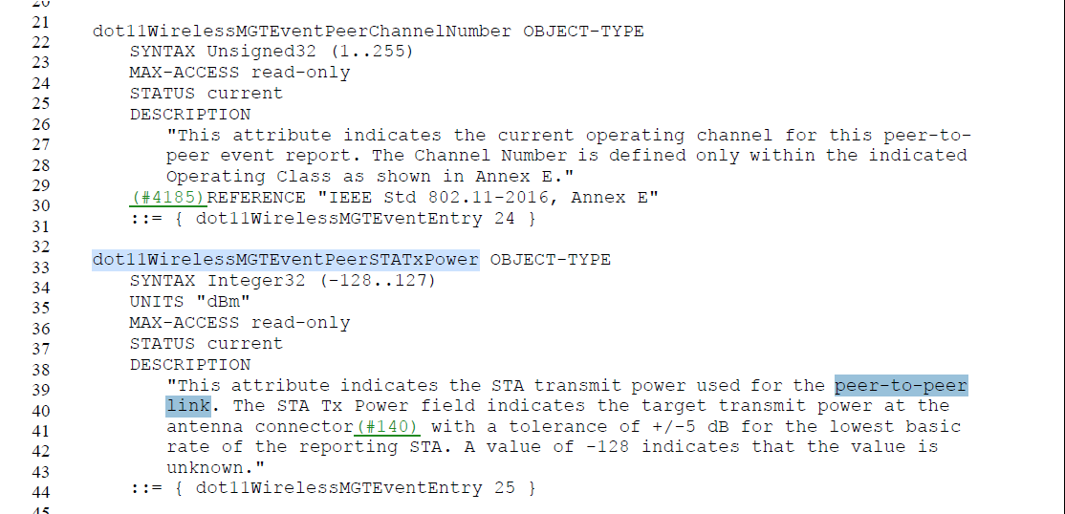

Proposed to change to “peer-to-peer link event report” at 3925.40.

For dot11WNMEventPeerRprtStaTxPower, at 4063.32, it states “peer-to-peer
Link”. At 4063.17, it states “peer-to-peer link event report”.

Proposed to change to “peer-to-peer link event report” at 4063.32.

Proposed changes for Item D3.1-1:

Note that the changes are based on D3.1.

At 3925.40 and 4063.32, change “peer-to-peer link” to “peer-to-peer link event report”.

=======
Item D3.1-2:
 | Related comments |  |  | Comments | Proposed Changes
Mark H | 4595 | 9.4.5.22 | 1491.1 | There are 12 more of these in the Draft, 7 "is a 2-octet field"s, 1 "is a 3-octet field", 1 "is a 5-octet field", and 1 "is a 6-octet field". Should we fix all of these (Editorial correction), so it doesn't come back next time as another comment? | As it says in the comment

Discussion:
Agreed with Mark H that we need to fix them.

I searched for “octet field” throughout the draft. There are 29 instances of “octet field” in D3.1.
I believe 23 instances in clause 9 and clause 12 need to be fixed.

Proposed changes for Item D3.1-2:

Note that the changes are based on D3.1.

At 937.32, change “The Venue Info field is a 2-octet field. It contains Venue Group and Venue Type subfields.” To “The Venue Info field contains Venue Group and Venue Type subfields.”

At 1197.37 change “The Frequent Transition Count Threshold field is a 1-octet field containing the number of transitions ...” to “The Frequent Transition Count Threshold field contains the number of transitions ...”

At 1211.8, change “The BSSID field is a 6-octet field, as described in 9.2.4.3.4 (BSSID field), that identifies the BSS indicated in the AP Descriptor subelement.” To “The BSSID field identifies the BSS indicated in the AP Descriptor subelement, as described in 9.2.4.3.4 (BSSID field).”

At 1211.30, change “The Antenna Count field contains a 1-octet field indicating the number of antennas of the indicated antenna type and antenna gain pair.” To “The Antenna Count field contains the number of antennas of the indicated antenna type and antenna gain pair.”

At 1211.60, change “The Collocated Radio Type subelement contains a 1-octet field indicating the type of collocated radio” to “The Collocated Radio Type subelement indicates the type of collocated radio”

At 1212.50, change “The Device Type field is a 1-octet field indicating the category of device.” to “The Device Type field indicates the category of device.”

At 1261.14, change “The Alert Identifier Hash (AIH) is an 8-octet field. It is a unique value used to indicate an instance of an EAS message.” To “ The Alert Identifier Hash (AIH) field contains a unique value used to indicate an instance of an EAS message.”

At 1366.3, change “The Association Delay Info field(M101) is a 1-octet field whose value is an unsigned integer indicating the minimum association response delay in number of TUs.” To “The Association Delay Info field(M101) contains an unsigned integer indicating the minimum association response delay in number of TUs.”

At 1476.23, change “The Venue Info field is a 2-octet field and is defined in 9.4.1.34 (Venue Info field).” To “The Venue Info field is defined in 9.4.1.34 (Venue Info field).”

At 1476.30, change “The Length field is a 1-octet field whose value is equal to 3 plus the number of octets in the Venue Name field.” To “The Length field is equal to 3 plus the number of octets in the Venue Name field.”

At 1477.21, change “The Length of Emergency Call Number field is a 1-octet field whose value is set to the length of the Emergency Call Number field.” To “The Length of Emergency Call Number field is set to the length of the Emergency Call Number field.”

At 1478.1, change “The Network Authentication Type Indicator field is a 1-octet field and has one of the values shown in Table 9-331” to “The Network Authentication Type Indicator field is set to one of the values shown in Table 9-331.”
Also, at 1478.24, 1478.29, 1478.34, 1478.37, change “if the Network Authentication Type Indicator” to “if the Network Authentication Type Indicator field”.

At 1478.42, change “The Redirect URL Length field is a 2-octet field whose value is the length of the Redirect URL.” To “The Redirect URL Length field contains the length of the Redirect URL.”

At 1481.10, change “The NAI Realm Count field is a 2-octet field that specifies the number of NAI realms included in the NAI Realm ANQP-element.” To “The NAI Realm Count field specifies the number of NAI realms included in the NAI Realm ANQP-element.”

At 1488.33, change “The Length field is a 1-octet field whose value is set to 1 plus the number of octets in the Venue URL field.” To “The Length field is set to 1 plus the number of octets in the Venue URL field.”.

At 1489.13, change “The Length field is a 2-octet field whose value is set to 3 plus the number of octets in the NAI Realm and Plan Information Tuples fields.” to “The Length field is set to 3 plus the number of octets in the NAI Realm and Plan Information Tuples fields.”

At 1489.17, change “The Advice of Charge Type field is a 1-octet field with the values defined in Table 9-337.”. “the Advice of Charge Type field is set to one of the values defined in Table 9-337”

At 1489.52, change “The Length field is a 2-octet field whose value is set to the number of octets in the Language, Currency Code, and Plan Information fields.” to “The Length field is set to the number of octets in the Language, Currency Code, and Plan Information fields.”

At 1490.34, change “The Length field is a 1-octet field whose value is set to 2(#2203) plus the number of octets in the Local Content URL, Label Length and Label fields.” to “The Length field is set to 2(#2203) plus the number of octets in the LocalContent URL, Label Length and Label fields.”

At 1490.39, change
“The State field is a 1-octet field whose value is defined in Table 9-338” to
“The State field is defined in Table 9-338” .

At 1492.32, change
“The AP List Length (#8)field is a 1-octet field whose value indicates the length of the BSSIDs field” to
“The AP List Length (#8)field indicates the length of the BSSIDs field”.

At 1497.47, change
“The Length field is a 2-octet field that indicates the number of octets in the Information field.(#1462)” to
“The Length field indicates the number of octets in the Information field.(#1462)”.

At2606.1, change
“QoS Control field, if present, a 2-octet field that includes the MSDU priority.” To
“QoS Control field contains the MSDU priority, if present.”

Item D3.1-3:
 | Related comments |  |  | Comments | Proposed Changes
Mark H | 4140 |  | 1710.33 | I know I’m not supposed to judge the Resolution at this time, just whether it was Edited correctly. However, I believe the Resolution is just wrong here. There are two parts to this sentence, for then the NDP BllockAck is used during a BlockAck session, and for when the NDP BlockAck is used during a fragment BA session. Each of needs to cite how the field is defined for that particular case, the first one was missing the reference, and that was the error in the D3.0 text. It should not have been changed to word around having the reference. This error was in the published 802.11ah, so it's hard to know what the correct cross-reference text is, but it appears that subclause 10.24.7.5 (802.11ah numbering) was intended. That subclause is now 10.25.6.5 in REVmd D3.1 | Change the text back, and add the reference, to say, "This field is defined in 10.25.6.5 when the NDP BlockAck is used during a BlockAck session …"  Confirm this change with the TG, since it goes against the agreed Resolution and will require updating the Resolution.

Discussion:

We discussed on TGmd teleconference on Jan 31st.
TGmd agreed on the following changes.

Updated the resolution CID 4140 with follows:

Revised. Change text in D3.0
"This field is defined in when the NDP BlockAck is used during a BlockAck session and is defined in 10.3.2.12 (Fragment BA procedure(11ah)) when it is used during a fragment BA session." to

"This field is defined in 10.25.6.5 (Generation and transmission of BlockAck frames by an HT STA, DMG STA, or S1G STA(11ah)) when the NDP BlockAck is used during a BlockAck session and is defined in 10.3.2.12 (Fragment BA procedure(11ah)) when it is used during a fragment BA session."

Note that the cited text in D3.0 was changed to “ This field is (#4140)used when the NDP BlockAck is used
during a BlockAck session and is defined in 10.3.2.12 (Fragment BA procedure(11ah)) when it is used
during a fragment BA session.” in D3.1

Therefore, we need to change D3.1 text instead.

Proposed resolutions for Item D3.1-3(#4140):
- Change the status of CID 4140 to “Revised”.
- At 1710.33 (D3.1), change
“This field is (#4140)used when the NDP BlockAck is used
during a BlockAck session and is defined in 10.3.2.12 (Fragment BA procedure(11ah)) when it is used
during a fragment BA session.” to
"This field is defined in 10.25.6.5 (Generation and transmission of BlockAck frames by an HT STA, DMG STA, or S1G STA(11ah)) when the NDP BlockAck is used during a BlockAck session and is defined in 10.3.2.12 (Fragment BA procedure(11ah)) when it is used during a fragment BA session."

<<End of Trival Editorial Corrections >>
====

4499 (RISON, Mark) | 9.4.2.21.9 | 1059.25 | If the term "slave" is no longer acceptable (CID 2020), is the term "master" still acceptable (other than "master key" contexts)? There are only a few such instances | As it says in the comment

Discussion

IEEE Editor completed MEC with TGmd draft 2.1. There is no issue with the term “Master”.

206.30, 1506.3, 1506.46 (2x), 1506.47, 1507.5 (2x), 2146.34, 3773.33

At 206.30:
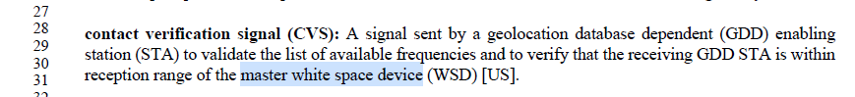

At 3773.33:
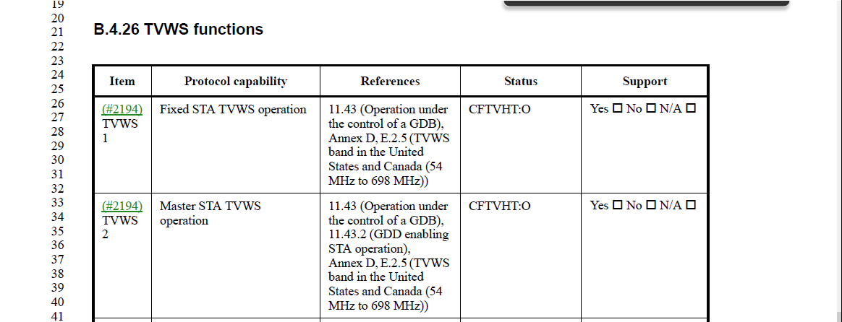

Above two locations are related to master WPD, which is regulatory term.
My recommendation is not change.

At 1506, 1507: those are related a field name. My recommendation is not change.

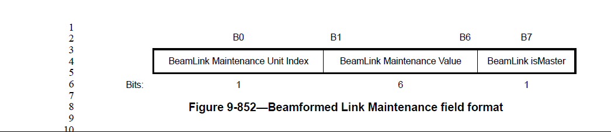

2146.34:
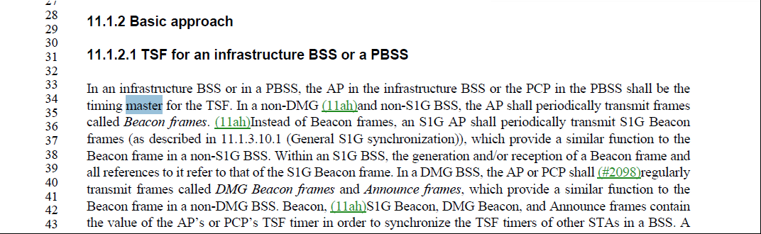

“timing master” for the TSF?

We could change it to “timing controller”. or keep as it is.

Feedback on 2/18: No need to do changes.

Proposed Resolution

Rejected

IEEE Editor completed MEC with TGmd draft 2.1. There is no issue with the term “Master”.

============

4807 (Mark H) | 9.9 | 1700.57 | This entire subclause is about PPDU headers. This is not MAC frame format, and shouldn't be in clause 9. | Move the contents of 9.9 to be at the end of 23.3.11.

Discussion

9.9 is for 9.9 NDP CMAC PPDUs(#2398)(11ah)
23.3.11 is for 23.3.11 S1G preamble format for NDPs
The commenter suggested to move 9.9 to the end of 23.3.11 as 23.3.12.

Proposed Resolution

Accepted.
Note to Editor: Remove 9.9 and insert the contents of 9.9 after 23.3.11 as a new clause 23.3.12.

=======
4800 (Mark H) | 1.3 | 150.5 | The draft is full of the terms "collocated", "co-located" and "colocated", all with apparently the same general meaning (within specific contexts, per subsequent nouns). Align all these. From a Google search:  - collocated (pronounced KAHL-uh-kated) seems to be mostly an older word, that was really supposed to be a linguistic concept.  - colocated (pronounced koh-LOH-kated) seems to be a somewhat deprecated spelling of co-located.  - co-located (also pronounced koh-LOH-kated) seems to be a newer (since the 1960's) word for "put two or more things near each other".  Recommend aligning on "co-located". | Throughout the draft, replace "collocated" (254 occurrences) and "colocated" (2 occurrences) with "co-located".

Discussion

Definition of “collocated”: https://www.merriam-webster.com/dictionary/collocate

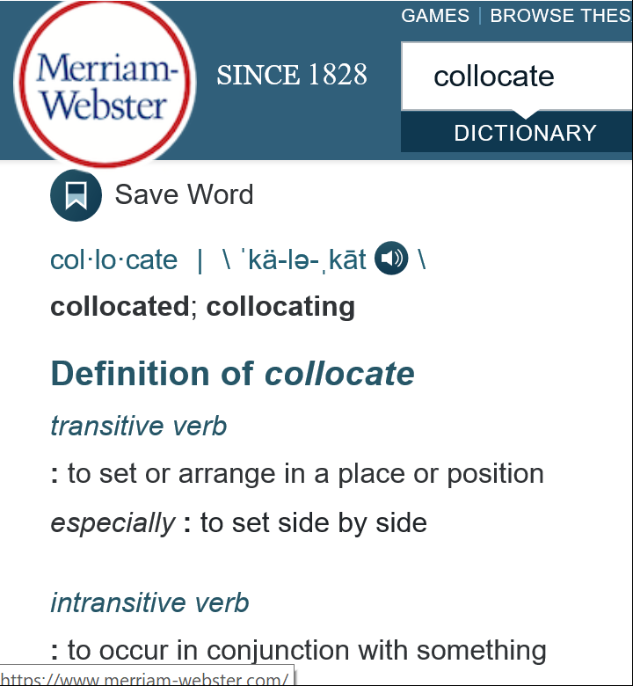

Definition of “colocated” and “co-located”: https://www.merriam-webster.com/dictionary/colocate

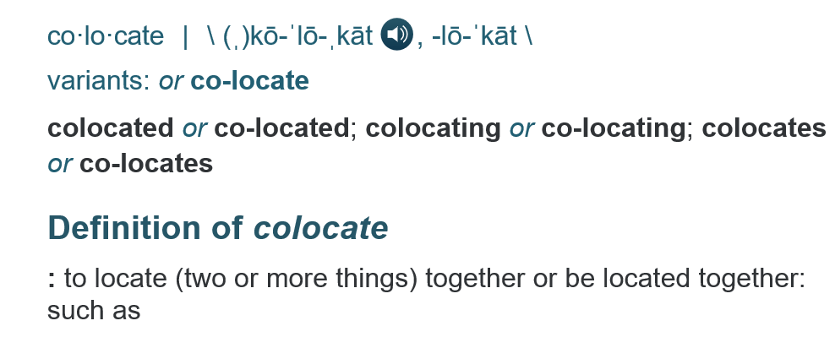

“collocated” and “colocated” are different. “colocated” and “co-located” are same.

“Collocated” is used for “collocated interference” in most usages.

“colocated” is used for “colocated BSSID” in most usages.

According to IEEE style guid, we should try not include a hyphen. Suggest change “co-located” to “colocated” throughout the draft.

There is no change to “Collocated”.

Motion failed in the Feb Ad hoc meeting.
Further feedback: This is going to leave us with a mixture
of "collocated" and "colocated". Furthermore, "colocated"
seems to me to be the least correct spelling (either "co-located" if
you don't share the IEEE's hatred of hyphens, or "collocated" if
you do and want to use the currently accepted spelling)

Okay, to avoid mixture of "collocated" and "colocated", propose to change all "colocated" and "co-located" to "collocated"

Straw Poll #1: Can you accept the spelling of these words?

A: Colocated
B: Co-located
C: Collocated

You can have multiple options.

Straw Poll #2: Do you prefer the spelling of this word?

A: Colocated: 1
B: Co-located: 7

4/1/2020:
Personally, I will vote against the proposed resolution for CID 4800, for the following reasons:
- According to IEEE editor style guide that Hyphen should be avoided. TGmb/TGmc/TGmd have spent a lot of effort to remove hyphenation. Now, with this resolution, we need to add an exception to the hyphenation list again. This is a wrong direction for REVmd.
- In D3.0, 254 occurrences of "collocated", 3 instances of "colocated", and 36 instances of "co-located". Some of them are in figures. The proposed resolution is to change all 250+ instances to "co-located", which will take huge unnecessary editing effort.
- Again, according to above quotes from the dictionary, “collocated” and “colocated” are different. For example, “collocated interference” is a perfect usage of “collocated” as an inference is caused by radios placed side by side.

So, I would like to ask the group to reconsider the resolution.

In D3.0:
36 instances of "co-located"
254 occurrences of "collocated",
3 instances of "colocated",

36 instances of "co-located":
- “Co-located” is used to defining “BSSID”. For example, 23 instances of “Co-located BSSID”.
- Other 13 instances are also related “co-located with AP” or co-located BSSID concept.

254 occurrences of "collocated":
- “Collocated” is used for defining interference. For example, 181 instances of “Collocated Interference”.
- 26 instances of “collocated with”: 25 instances are “collocated with AP”, “collocated with a Mesh STA” or similar, except one at 2387.40.
- 2 instances of “collocated AP”; 5 instances of “collocated STA”.
- 1 instance of “physically collocated”
- ....

3 instances of "colocated”:
- At 1484.13: The Co-Located BSSID List subelement is present when there is at least one other BSS that is collocated within the same physical device as the reporting BSS
- At 3907.17: “supporting Colocated Interference Reporting. The capability is isabled, otherwise."
- At 3907.31: “support Colocated Interference Reporting is enabled.”

So my recommendation:
- No changes to “Co-Located BSSID”. ➔ no change to “Co-located”
- No changes to “collocated interference”. ➔ no change to “collocated”
- Replace 3 instances of “colocated” with either “collocated” or “co-located”.
  - At 1484.13: change to “The Co-Located BSSID List subelement is present when there is at least one other BSS that is co-located within the same physical device as the reporting BSS.”
  - At 3907.17: change to “supporting collocated interference reporting. The capability is disabled, otherwise."
  - At 3907.31: change to “support collocated interference reporting is enabled.”

Proposed Resolution

Accepted.

Editor: Please add “Co-located” to the editor style guide.

4691 (Mark R) |  |  | "Figure 9-189--Beacon Reporting data field format" should be "Beacon Reporting subelement data field format" -- but what is "data field" (several instances; see also Figure 9-232--Data field format)? | As it says in the comment

Discussion

“Data field” is a field name of the Subelement format. See 9.4.3 subelements.
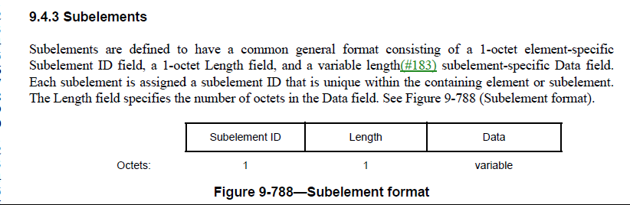

At 1022.11, change
“The Beacon Reporting subelement data field format” to
“The Beacon Reporting subelement Data field format”

At 1022.21, change
“Beacon Reporting data field format” to
“Beacon Reporting subelement Data field format”

Proposed Resolution

Revised.

Throughout the draft, change
“Reporting subelement data field format” to
“Reporting subelement Data field format”
4 instances.

Throughout the draft, change
“Reporting data field format” to
“Reporting subelement Data field format”.
12 instances including the reference locations.

4689 (Mark R) | 9.4.3 |  | "The optional  subelements are ordered by nondecreasing subelement ID." (2x) -- they're ordered per 9.4.3 ("Subelements within an element are ordered by nondecreasing Subelement ID.") | Change to refer to 9.4.3 as for most optional subelement lists

Discussion

In 9.4.3, it states:

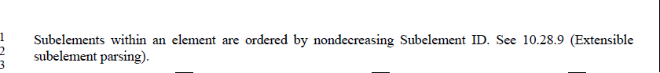

In 9.6.7.37 DCS Measurement Request frame format(11aj) and 9.6.7.38 DCS Measurement Response frame format(11aj), at 1566.5, and 1567.39,

it states: 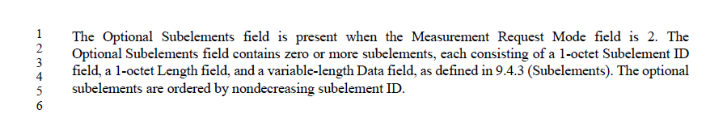

In two usages, sublements are included in a field, not in the element. Therefore the statement in 9.4.3 is not applied,

Proposed Resolution

Rejected.
Reason: In 9.4.3, subelements are within an element. In 9.6.7.37 and 9.6.7.38, subelements are within a field. Therefore, cannot change t o refer to 9.4.3 in 9.6.7.37 and 9.6.7.38.

4679 | 9.3.3.1 | 854.23 | "a) The Address 1 field of the Management frame is the RA (=DA) and is determined as the destination  of the frame.  b) The Address 2 field of the Management frame is the TA (=SA) and is determined as the address of  the STA transmitting the frame(#2013)." arguably duplicates 9.2.4.3.1 | As it says in the comment

Discussion

9.2.4.3.1 (at 794.3) is general. See:

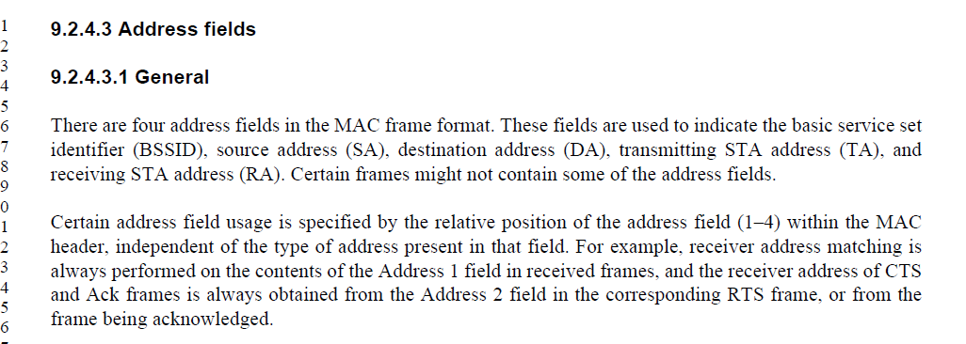

The description of Address fields in 9.3.3 are needed as they are specific to Management frames. Also, we cannot directly jump to the Address 2 or Address 3 field.

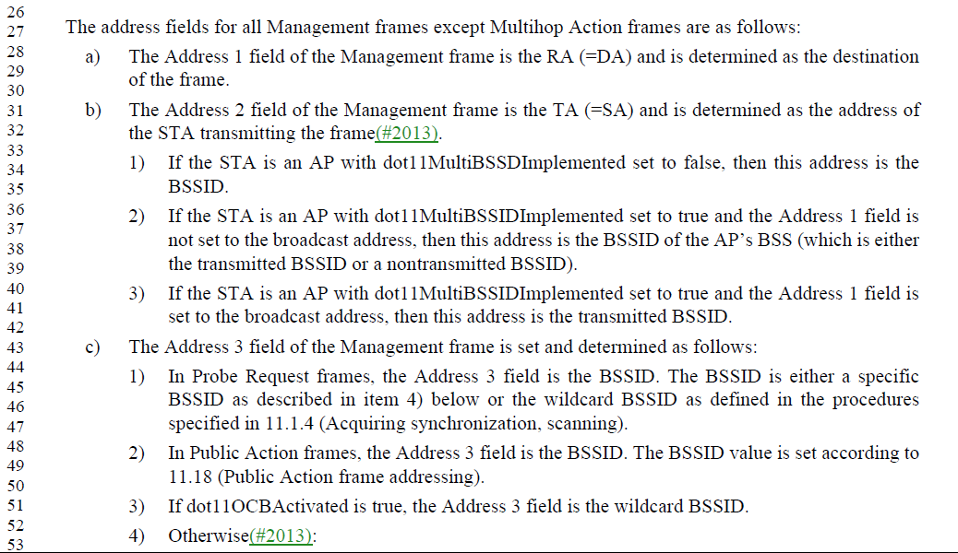

Proposed Resolution
Rejected.
Reason: The description of Address fields in 9.3.3 are needed as they are specific to Management frames.

4661 |  |  | "section" should be "Subclause" | Fix in 9.4.2.47, 9.6.13.19, 12.4.2, 12.7.1.6.5, 12.7.2 (3x)

Discussion

Global search and found 62 instances.
Some of them refer to a section of in IETF draft or RFC, in IETF. “section” is used, not subclause or clause.
There is no change to those usage.

In cited locations, “section” is followed by a subclause number. There is no need to have word “section”.

Delete “section” at cited locations.

Proposed Resolution

Revised.

9.4.2.47, at 1166.47, change
“section 9.4.2.236 (OCI element(M58)(#2328)).” To
“9.4.2.236 (OCI element(M58)(#2328)).

In 9.6.13.19, at 1609.5, change
“section 9.4.2.236 (OCI element(M58)(#2328)).” To
“9.4.2.236 (OCI element(M58)(#2328)).”

In 12.4.2, at 2563.15, change
“sections 12.4.4.2.2 (Generation of the password element with ECC groups by looping(M137))” to
“12.4.4.2.2 (Generation of the password element with ECC groups by looping(M137))”

In 12.7.1.6.5, at 2657.49, delete “section”.
In 12.7.2, at 2663.14, 2666.48, 2667.39, delete “section”.

4625 |  |  | Since 1.4 defines x-y as being inclusive, the word "inclusive" is no longer needed for ranges | Delete "inclusive" in Clause 6 (10x), 9.2.2, 9.2.4.6.1 (2x), 9.4.2.5.1, 9.4.2.21.10, 9.4.2.45 (2x), 9.4.2.94, 9.4.2.154, 9.4.2.167 (3x), 10.19, 10.21 (3x), 11.10.14, 12.5.2.3.3, 19.3.9.3.2, 21.3.8.2.1, Table 23-1, dot11TxPowerLevelExtended in C.3 (2x). Delete "(all inclusive)" in 10.3.2.12 (x). Delete " (inclusive)" in 10.47.6 (second instance), 11.3.9.2, Table 21-23 (2x), Table 22-21 (2x), Table 23-29 (2x). Delete ", inclusive" in 12.3.3.3.6

Discussion
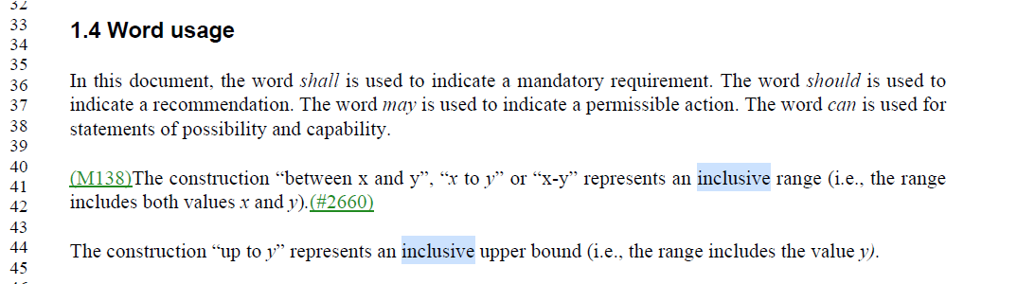

Recommend to accept proposed changes.

Proposed Resolution
Accepted.

4608 | 3.1 |  | "individually addressed: When applied to a medium access control (MAC) service data unit (MSDU), it is  an MSDU with an individual address as the destination address (DA). When applied to a MAC protocol data  unit (MPDU), it is an MPDU with an individual address in the Address 1 field. " v. "group addressed: A group addressed medium access control (MAC) service data unit (MSDU) is an MSDU  that has a group address as its destination address (DA). A group addressed MAC protocol data unit  (MPDU) is an MPDU that has a group address in its Address 1 field. Syn: multicast." -- the wording should be in the same form | As it says in the comment

Discussion

At 163.19:
individually addressed: When applied to a medium access control (MAC) service data unit (MSDU), it is an MSDU with an individual address as the destination address (DA). When applied to a MAC protocol data unit (MPDU), it is an MPDU with an individual address in the Address 1 field. Syn: directed, unicast.

At162.45:
group addressed: A group addressed medium access control (MAC) service data unit (MSDU) is an MSDU that has a group address as its destination address (DA). A group addressed MAC protocol data unit (MPDU) is an MPDU that has a group address in its Address 1 field. Syn: multicast.

Change group addressed definition to align with the same form of individually addressed.

Proposed Resolution

Revised.
At 162.45, change
“group addressed: A group addressed medium access control (MAC) service data unit (MSDU) is an MSDU that has a group address as its destination address (DA). A group addressed MAC protocol data unit (MPDU) is an MPDU that has a group address in its Address 1 field. Syn: multicast.”
To
“group addressed: When applied to a medium access control (MAC) service data unit (MSDU), it is an MSDU with a group address as the destination address (DA). When applied to a MAC protocol data unit (MPDU), it is an MPDU with a group address in the Address 1 field. Syn: multicast. “

4597 | 9.4.2.147 | 1327.55 | There is no behaviour associated with the setting of the A/C Power subfield, so this subfield is useless. CID 2345's resolution claimed that "The field is not useless. The AP or device setting up the relay benefits from information about the power characteristics of a relay device. The definition of the field is clear. An implementation can use this data for relay operation decisions." | After the referenced para add a "NOTE---A STA can use this information for relay operation decisions. How it does so is outside the scope of this standard."

Discussion

This is the same comment as CID 2345. In CID 2345, commenter proposed to rename “A/C Power” to “Reserved” in the figure. The comment CID 2345 was rejected with the rejection reason:
REJECTED (MAC: 2019-04-02 18:43:12Z): The commenter states: “There is no behaviour associated with the setting of the A/C Power subfield, so this subfield is useless.”
The field is not useless. The AP or device setting up the relay benefits from information about the power characteristics of a relay device. The definition of the field is clear. An implementation can use this data for relay operation decisions.

The note is not necessary as the Relay Capability element (whole subclause) is for the STA participating in relay operation to advertise its capabilities. The A/C Power subfield is a subfield of Relay Capability Information field. Obviously, an implementation can use this data for relay operation decisions.

Proposed Resolution

Rejected.
Reason: the note is not necessary as the Relay Capability element (whole subclause) is for the STA participating in relay operation to advertise its capabilities. The A/C Power subfield is a subfield of Relay Capability Information field. Obviously, an implementation can use this data for relay operation decisions.

4591 |  |  | The way UTF-8 strings are referred to is inconsistent. We have a definition of UTF-8 string (in 9.2.2) so just use that | In 9.4.2.2 change "the SSID is interpreted using UTF-8 encoding" to "the SSID is a UTF-8 string". In 9.4.2.21.14 change "The Public Identifier URI/FQDN field contains a URI encoded using UTF-8 and formatted in accordance  with IETF RFC 3986" to "The Public Identifier URI/FQDN field contains a URI as a UTF-8 string, formatted in accordance  with IETF RFC 3986,". In 9.4.2.26 change "The SSID in this BSS is interpreted using UTF-8 encoding" to "The SSID in this BSS is a UTF-8 string". At 1217.8 change "an UTF" to "a UTF". In 9.4.5.4 and 9.4.5.5 change "UTF-8 encoded field" to "UTF-8 string". In 9.4.5.10 change "a UTF-8 encoded character string" to "a UTF-8 string" and "in UTF-8 format" to "in UTF-8". In 9.4.5.17 change "field encoded using UTF-8 and " to "UTF-8 string,". In 9.4.5.21 change "UTF-8 formatted field " to "UTF-8 string ". In 9.4.5.22 change "a UTF-8 formatted string" to "a UTF-8 string"

Discussion

In 9.2.2 (781.37), we have UTF-8 string definition, see

Here is proposed change from the commenter:
In 9.4.2.2 change "the SSID is interpreted using UTF-8 encoding" to "the SSID is a UTF-8 string".
In 9.4.2.21.14 change "The Public Identifier URI/FQDN field contains a URI encoded using UTF-8 and formatted in accordance with IETF RFC 3986" to "The Public Identifier URI/FQDN field contains a URI as a UTF-8 string, formatted in accordance with IETF RFC 3986,".
In 9.4.2.26 change "The SSID in this BSS is interpreted using UTF-8 encoding" to "The SSID in this BSS is a UTF-8 string".
At 1217.8 change "an UTF" to "a UTF".
In 9.4.5.4 and 9.4.5.5 change "UTF-8 encoded field" to "UTF-8 string".
In 9.4.5.10 change "a UTF-8 encoded character string" to "a UTF-8 string" and "in UTF-8 format" to "in UTF-8".
In 9.4.5.17 change "field encoded using UTF-8 and " to "UTF-8 string,".
In 9.4.5.21 change "UTF-8 formatted field " to "UTF-8 string ".
In 9.4.5.22 change "a UTF-8 formatted string" to "a UTF-8 string"

Feedback on 2/18:
This topic was specifically discussed in another standard organization. “UTF-8 string” is confusing for some foreign languages. “UTF-8 encoded” is preferred. “UTF-8 string” should be avoided.

Feedback on 3/11:
This comment will be resolved by Mark Rison’s doc.

Proposed Resolution
Revised.

At 1217.8:
Change “The Certificate ID field contains an UTF-8 string indicating” to “The Certificate ID field contains a sequence of UTF-8 encoded code points indicating”

At 2577.29
Change “If a password identifier is used in generation of the password element
(PWE) the Password identifier element shall be present and the identifier shall be encoded as a UTF-8 string in the Identifier portion of the element (see 9.4.2.216 (Password Identifier element.”
To “If a password identifier is used in generation of the password element
(PWE) the Password identifier element shall be present and the identifier shall be a sequence of UTF-8 encoded code points in the Identifier portion of the element (see 9.4.2.216 (Password Identifier element. “

At 4103.25:
Change “This variable is a UTF-8 string that an implementation uses to uniquely”
To “This variable is a sequence of UTF-8 encoded code points that an implementation uses to uniquely”

At 1480.46:
Change “It is a UTF-8 encoded character string that” To “it is a sequence of UTF-8 encoded code points that”

At1490.6
Change “This is a UTF-8 formatted string.” To “This is a sequence of UTF-8 encoded code points.”

At1489.1
Change “a variable length UTF-8 formatted field” to “a variable length field containing a sequence of UTF-8 encoded code points”

At1475.35
Change “The Venue Name field is a variable length(#183) UTF-8 encoded field containing the venue’s name.”
To “The Venue Name field is a variable length field containing a sequence of UTF-8 encoded code points.”

At1476.22
Change “The Emergency Call Number field is a variable length(#183) UTF-8 encoded field containing information, used to reach emergency services,”
To “The Emergency Call Number field is a variable length sequence of UTF-8 encoded code points containing information, used to reach emergency services,”

At1486.19
Change “The Emergency NAI Information field is a variable length(#183) field encoded using UTF-8”
To
“The Emergency NAI Information field is a variable length(#183) sequence of UTF-8 encoded code points”

4589 | 9 |  | Since "Extended Capabiltities element" appears zillions of times, it should be abbreviated to ECE (cf. RSNE, FTE, etc.) | As it says in the comment

Discussion

301 instances of Extended Capabilities in TGmd D3.0

“Extended Capabilities” was introduced in IEEE802.11-2007. It was used since then.
I don’t think it is good idea to change a well-known word to something else.

Also, “ECE” is the acronyms of “Electrical and Computer Engineering”. 😊.

Proposed Resolution
Rejected.
Reason: “Extended Capabilities” was introduced in IEEE802.11-2007. It was used since then. It is a well-known word and should not be renamed.

4509 | 9.4.1.49 | 949.63 | "has the structure and order" -- everything is implicitly in the order shown | Delete " and order" at the referenced location and at 974.1

Discussion

At 949.63:

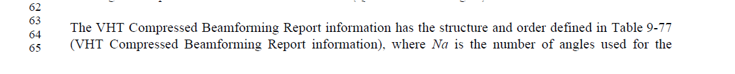

At 974.1:
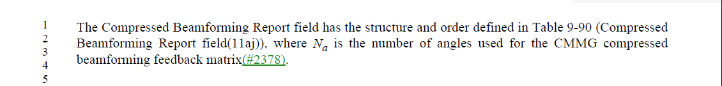

Recommend to accept the proposed changes.

Proposed Resolution

Accepted

4482 | 9.6.3.2.1 | 1512.3 | Table 9-349--Basic ADDTS Request frame variant Action field format says "Higher Layer Stream ID element" but Table 9-350--DMG ADDTS Request frame variant Action field format, Table 9-351--Basic ADDTS Response frame variant Action field format, Table 9-352--DMG ADDTS Response frame variant Action field format, Table 9-356--ADDTS Reserve Request frame Action field format, Table 9-357--ADDTS Reserve Response frame Action field format says just "HIgher Layer Stream ID" | Delete " element" in the cited text in Table 9-349

Discussion

At 1512.3
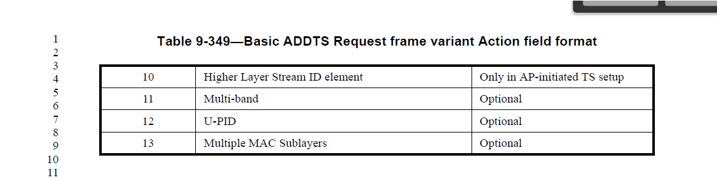

Accept the proposed changes, and make same change to row 8 and 9.

Proposed Resolution

Revised.

At 1511.62, 1511.64, and 1512.3, delete “element”.

4474 |  |  | "over-the-WM" should not have hyphens, except when it's an adjective or adverb | Change hyphens to spaces in the cited text at 648.3, 649.56, 2553.31
Discussion

8 instances.
5 are adjective or adverb.
3 locations need to be changed as listed by the commenter.

Proposed Resolution
Accepted.

4467 |  |  | "robust management frame should be "robust Management frame" | Fix at 197.57, in 11.12 caption, in dot11RSNAUnprotectedManagementFramesAllowed description (also change "frames" to "frame")

Discussion

In Editorial Style guide, “2.1.2 Naming Frames” has a note:

Note, the following correct uses:
- a Management frame

My interpretation:
When it is used for a frame, it should be “Management frame”.
When it is used for other subjects, for example, protection, it doesn’t need to be “capitalized”.
For example, “management frame protection” is used with 91 instances in the draft.

At 197.45,
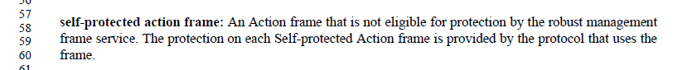

The noun is “service” in “robust management frame service”, not “frame”. There is no need to change “robust management frame service” to “robust Management frame service”.

At 11.12 (2328.50),
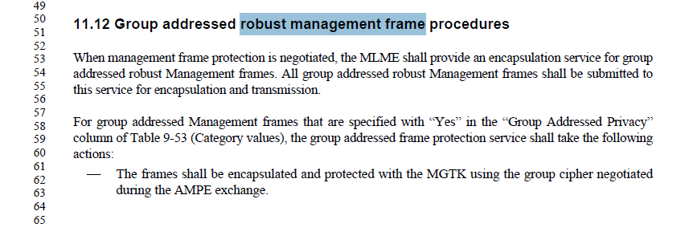

The noun is “procedures”, not “frame”.
At 2328.50:
Change “Group addressed robust management frame procedures” to “Group addressed management frame protection procedures”

At 3839.56, change
“robust management frames protection.” To
“robust management frame protection.”

Proposed Resolution

Revised.

At 2328.50:
Change “Group addressed robust management frame procedures” to “Group addressed management frame protection procedures”

At 3839.56, change
“robust management frames protection.” To
“management frame protection.”

4435 |  |  | Inconsistency/repetition on bit ordering wording in PHY clauses:  21.3.8.3.3 VHT-SIG-A definition  NOTE--Integer fields are represented in unsigned binary format with the least significant bit in the lowest numbered bit  position.  21.3.8.3.6 VHT-SIG-B definition  For fields consisting of multiple bits, the LSB of the value occupies the lowest numbered bit of the field.  23.3.8.2.2.5 SIG definition /  23.3.8.2.3.2.5 SIG-A definition /  23.3.8.3.5 SIG definition  Integer fields are represented in unsigned binary format with the least significant bit in the lowest numbered bit position.  20.4.3.2.1 General /  20.5.3.1.1 General /  24.4.3.2.1 General /  24.5.3.1.1 General  All of the numeric fields are encoded in unsigned binary, least significant bit first.  25.3.9.1 General  All the numeric fields are encoded in unsigned binary, least significant bit first.  19.3.9.4.3 HT-SIG definition  NOTE 1--Integer fields are transmitted in unsigned binary format, LSB first.  All of the fields in the HT-SIG are transmitted LSB first | As it says in the comment

Discussion

Comment:
Inconsistency/repetition on bit ordering wording in PHY clauses:
21.3.8.3.3 VHT-SIG-A definition
NOTE--Integer fields are represented in unsigned binary format with the least significant bit in the lowest numbered bit position.
21.3.8.3.6 VHT-SIG-B definition
For fields consisting of multiple bits, the LSB of the value occupies the lowest numbered bit of the field.
23.3.8.2.2.5 SIG definition /
23.3.8.2.3.2.5 SIG-A definition /
23.3.8.3.5 SIG definition
Integer fields are represented in unsigned binary format with the least significant bit in the lowest numbered bit position.
20.4.3.2.1 General /
20.5.3.1.1 General /
24.4.3.2.1 General /
24.5.3.1.1 General
All of the numeric fields are encoded in unsigned binary, least significant bit first.
25.3.9.1 General
All the numeric fields are encoded in unsigned binary, least significant bit first.
19.3.9.4.3 HT-SIG definition
NOTE 1--Integer fields are transmitted in unsigned binary format, LSB first.
All of the fields in the HT-SIG are transmitted LSB first,

Discussion:
For different PHYs, we may need a sentence to describe it.

In clause19, 20, 21, 23, 24 and 25 general subclauses, add a sentence:
“All of the numeric fields are transmitted in unsigned binary format, LSB first.”

Note that there is no such sentence in clause 22 as it may refer to clause 21. For example.
At 3302.10, “The TVHT-SIG-B field for each BCU in any transmission mode is as defined in 21.3.8.3.6 (VHT-SIG-B definition) for 40 MHz bandwidth.”. Therefore, there is no need to add a sentence in clause 22.

Proposed Resolution for CID 4435 and CID 4319:

Revised.

Delete cited sentences in the cited locations in the comment.

At the end of each of following subclauses:

19.3.9.4.1 Introduction (in 19.3.9.4 HT portion of HT-mixed format preamble)
20.3.6.1 General (in 20.3.6 Common preamble)
21.3.8.3.1 Introduction (in 21.3.8.3 VHT portion of VHT format preamble)
23.3.8.1 Introduction (in 23.3.8 S1G preamble)
24.3.6.1 General (in 24.3.6 Common preamble)
25.3.9.1 General (in 25.3.9 CMMG SIG)

add a paragraph:

“All numeric fields are transmitted in unsigned format, LSB first.”

At 3016.14, replace “NOTE 2” with “NOTE”.

=================================================================
4431 | 9.4.1.62 |  | Elsewhere Na has no subscripting | In Table 9-88--Order of angles in the  CMMG Compressed Beamforming Report field and Table 9-90--Compressed Beamforming Report field and the para above it desubscript the a in Na

Discussion

Table 9-63:

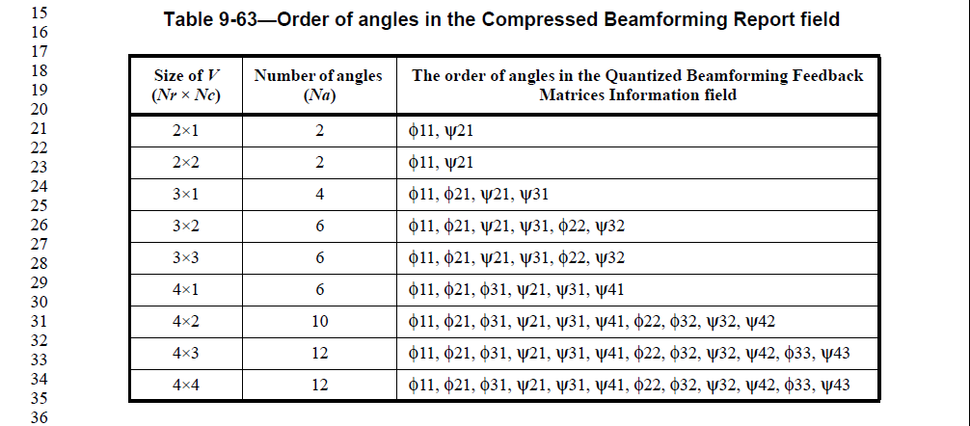

Table 9-88:
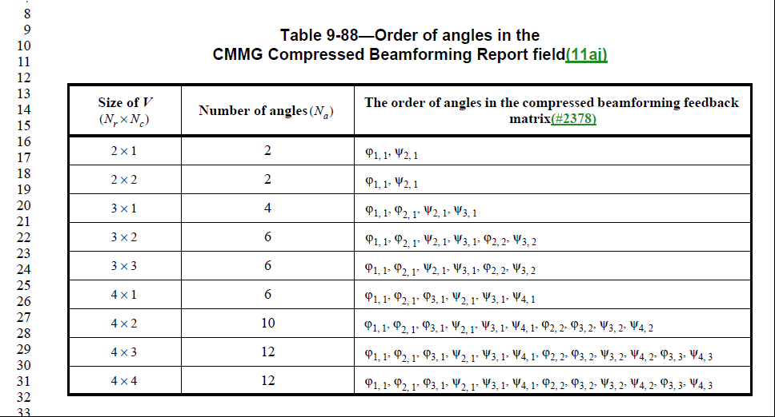

Desubscript the a in Na. Should Nr and Nc should be desubscripted?

At 1947.47,

Change “shall set the value of Nr in the MIMO Control field of the
feedback frame to be the same value as”
To
“shall set the Nr Index subfield in the MIMO Control field of the feedback frame to indicate the same value as “

from Mark RISON (Samsung) to everyone.

Proposed Resolution

Revised.

Desubscript the a in Na at the following locations: 973.14, 974.2, 974.18, 974.21, 974.24 and 974.29.

Desubscript the r in Nr and c in Nc at 973.14, 972.21, 972.24. 974.16, 974.17.

Desubscript the s in Ns 974.30, 974.36, 974.37, 974.40, 975.9 (x2), 976.6 (x2)

At 1947.57,

Change “shall set the value of Nr in the MIMO Control field of the
feedback frame to be the same value as”
To
“shall set the Nr Index subfield in the MIMO Control field of the feedback frame to indicate the same value as “

at 1944.36:

Change “An HT beamformee that transmits a feedback frame of type Compressed Beamforming in response to a sounding PPDU sent by an HT beamformer shall set the value of Nr in the MIMO Control field of the feedback frame to be the same value as the number of streams in the sounding PPDU.”
To "An HT beamformee that transmits a feedback frame of type Compressed Beamforming in response to a sounding PPDU sent by an HT beamformer shall set the Nr Index subfield in the MIMO Control field of the feedback frame to indicate the same value as the number of streams in the sounding PPDU."

4403 |  |  | NDP CMAC frames are generally referred to as such, not as S1G NDP CMAC frames | Delete "S1G " in "S1G NDP CMAC" throughout (~14x)

Discussion

I couldn’t find “S1G NDP CMAC frame”. I think “S1G NDP CMAC frame” has been changed to “S1G NDP CMAC PPDU”.

NDP CMAC PPDU is defined in 9.9, see:

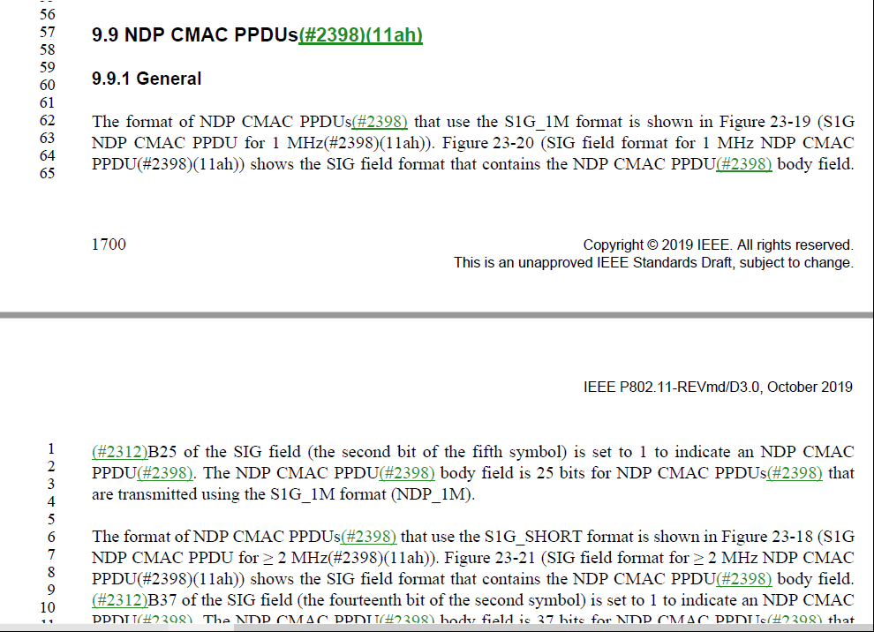

Proposed Resolution

Accepted.

4355 | 9.3.1.2 | 826.20 | "In an RTS frame transmitted by a VHT STA in a non-HT or non-HT  duplicate format to another VHT STA, the scrambling sequence carries the TXVECTOR parameters  CH_BANDWIDTH_IN_NON_HT and DYN_BANDWIDTH_IN_NON_HT (see 10.3.2.7 (CMMG RTS  procedure(11aj)))" -- clearly a broken xref | As it says in the comment
4354 | 9.3.1.2 | 826.20 | "In an RTS frame transmitted by a VHT STA in a non-HT or non-HT  duplicate format to another VHT STA, the scrambling sequence carries the TXVECTOR parameters  CH_BANDWIDTH_IN_NON_HT and DYN_BANDWIDTH_IN_NON_HT (see 10.3.2.7 (CMMG RTS  procedure(11aj)))" -- clearly a broken xref | Delete the parenthetical

Discussion

In 802.11-2016, the reference in the cited paragrapy is 10.3.2.6:
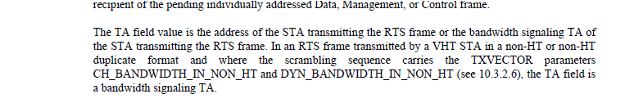

10.3.2.6 in 802.11-2016 is:

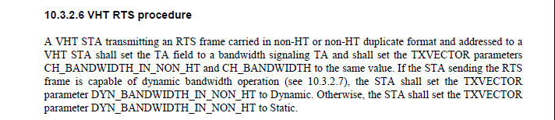

In TGmd D3.0, 10.3.2.6 becomes 10.3.2.8:
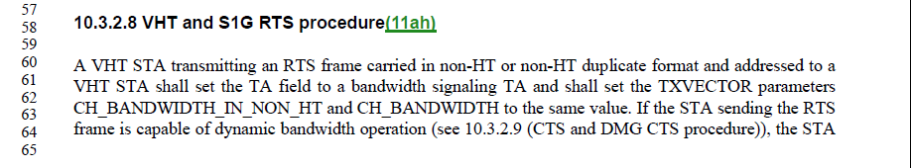

So the correct reference is 10.3.2.8.

Are CID 4355 and CID 4354 the same comment?

Proposed Resolution for CID 4355 and 4354.

Revised.
Change “10.3.2.7 (CMMG RTS procedure(11aj))” to “10.3.2.8 (VHT and S1G RTS procedure(11ah))”

Make the same change at 1786.40, 2340.33, 2357.50, 2357.55, 3764.44, 3765.17, 3765.21, 3794.61, 4400.35.

At 1702.30, 1703.8, change “10.3.2.7 (CMMG RTS procedure(11aj))” to “10.3.2.9 (CTS and DMG CTS procedure)”

Move subclause of “10.3.2.7 (CMMG RTS procedure(11aj))”to follow subclause of “10.3.2.8 (VHT and S1G RTS procedure(11ah))”.

4208 | 152.45 | 2 | Some months in Clause 2 are abbreviated, others not | Abbreviate all months (to their 3-letter form) except May

Discussion

In Draft Recommended Practice for Preparing an IEEE Standards Draft, no abbreviated month is used, for example “November 2013”.
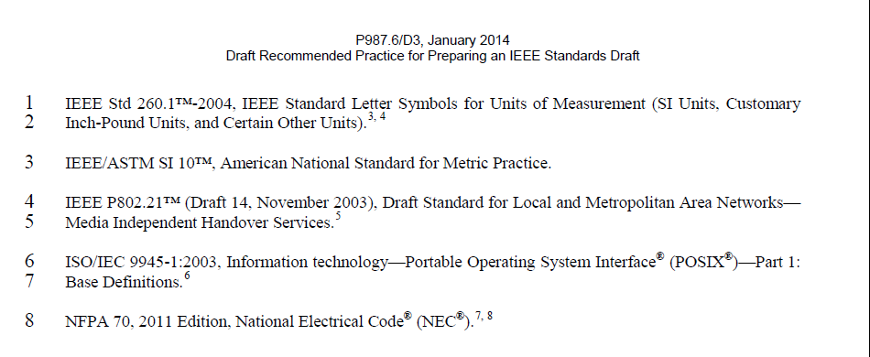
So, change abbreviated name of a month to the full name of a month. For example, change “Sept” to “September”.

Proposed Resolution

Revised.
Throughout Clause 2 and Annex A:
change “Sept.” or “Sep” to “September”.
change “Nov.” to “November”.
change “Feb.” to “February”.
Change “Jan.” to “January”.
Change “Apr.” to “April”.
Change “Mar.” to “March”
And all months.

4203 | 9.4.2.229.2 | 1442.22 | The name of fields should start with uppercase letters for each word, to avoid confusion (especially with fields with "And" or "Or" in their name) | In Figure 9-754--CMMG Capabilities Info field format and Table 9-313--Subfields of the CMMG Capabilities Info field format change "Short GI for  540 MHz" to "Short GI For 540 MHz"

Discussion

See CID 4312.

Proposed Resolution

Rejected.

Reject Reason: WG editor will update 802.11 Editorial Style guide 09/1034 to add a new rule including preposition and conjunction capitalization in the (sub)field and (sub)element names. This rule applies for new amendments. As stated in the style guide, “This rule does not apply to legacy text; these remain unchanged since the effort involved in changing all instances is substantial and no harm has been demonstrated.”

4198 | 9.4.2.24.3 |  | Table 9-151--AKM suite selectors is missing a row for 18. This is confusing, given the presence of a row for 0 | Delete the row for 0 in the table, and change the cell that says "(11ai  )18,  (#17  1)21  -255" to "0, (11ai  )18,  (#17  1)21  -

Discussion

The location is 1106.21.

Proposed Resolution

Revised.
At 1105.52, add a row for “00-0F-AC/18/Reserved/Reserved/Reserved/Reserved”;
At 1106.21, delete “18,”.

4037 | 9.4.2.26 | 1116.22 | THIS COMMENT SUBMITTED ON BEHALF OF ROGER MARKS. The reserved subfields row is not correct. In Rev2.0, the penultimate row was 82, and 83-n were marked Reserved in the final row. Comment #2685 requested inserting a new row and incrementing the reserved row by 1. Instead, the new row was marked 87 and the prior row shows 86 as reserved. The remaining values are no longer marked as Reserved. | Change "Local MAC Address Policy" from 87 to 86. Move the reserved row (currently 86) to the end, and change it to "87-n".

Discussion

The value of Extended Capabilities field is assigned by ANA.
Value “86” is assigned to another task group.
At the bottom of the table, Add a row “88-n”/ “Reserved”

Proposed Resolution

Revised.
At the bottom of the table, Add a row “88-n”/ “Reserved”

4026 | 9.2.4.2 | 793.20 | The Duration/ID field also contains the association identifier for broadcast transmissions of S1G PPDUs. This is only mentioned in Table 9-9, but should be included in the text, which purportedly lists all definitions for the contents of the Duration field. | Change "In Control frames of subtype PS-Poll other than PS-Poll+BDT frames"  to  "In Control frames of subtype PS-Poll other than PS-Poll+BDT frames, and for broadcast transmissions of S1G PPDUs"

Discussion

Proposed changes from the commenter:
Change "In Control frames of subtype PS-Poll other than PS-Poll+BDT frames"
to
"In Control frames of subtype PS-Poll other than PS-Poll+BDT frames, and for broadcast transmissions of S1G PPDUs"

Cited text:
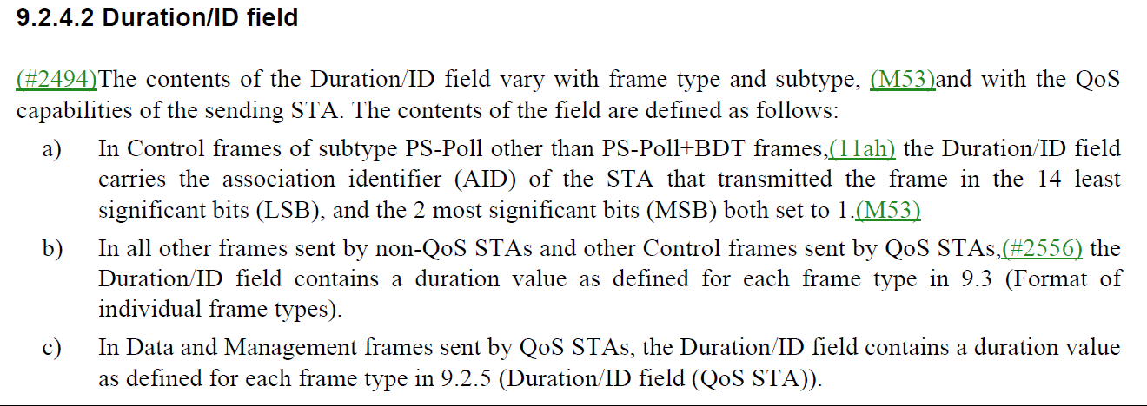

Proposed Resolution

Revised.

Change "In Control frames of subtype PS-Poll other than PS-Poll+BDT frames"
to
"In Control frames of subtype PS-Poll other than PS-Poll+BDT frames, and for broadcast transmissions in S1G PPDUs"

4024 | 9.4.2.1 | 978.36 | The column "Element ID Extension" has a title the doesn't match how it is described in the text (see lines 20-22 above). | Change "Element ID Extension" to  "Element ID Extension present"

Discussion

Cited text;

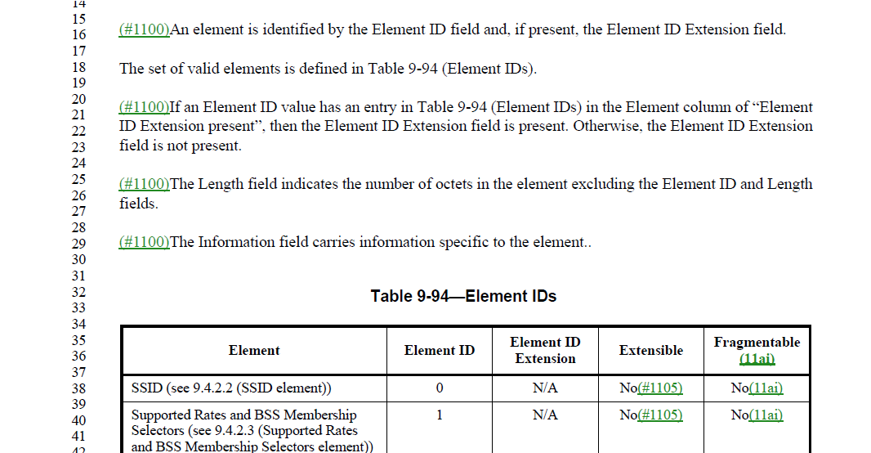

The “Element ID Extension” at line 35 is for a value of “Element ID Extension”, not for “present”.

“Element ID Extension present” is an entry in the column “Element”, and is shown on 989.26.
The title of “Element ID Extension” is correct.

Proposed Resolution
Rejected.
Reject reason:
“Element ID Extension present” is an entry in the column “Element”, and is shown on 989.26.
The title of “Element ID Extension” is correct.

4688 |  |  | "multicast MSDU"/"Multicast MSDU" should be "group addressed MSDU"/"group addressed MSDU"; similarly unicast -> individually addressed | As it says in the comment

Discussion

8 instances for “multicast MSDU”.
3 instances for “unicast MSDU”.

Proposed Resolution

Accepted.
Note to editor: 8 instances for “multicast MSDU”/"Multicast MSDU". 3 instances for “unicast MSDU”.

4593 |  |  | "forty MHz" should be "40 MHz" | As it says in the comment

Discussion
17 instances.
Those 17 instances are names of a field.
In general, we prefer not to change the field name. This field name has been there since 2009.

Proposed Resolution

Rejected.
Reason: In general, we prefer not to change the field name. This field name has been there since 2009.

======

4592 |  |  | CID 2096 asked for "that had received" to be changed to "that receives", and was accepted, but there are still some left | Change in 9.2.2 and 10.3.2.9 (not the other 3)

Discussion

I couldn’t find “that had received”.
I found 5 instances of “that has received”.

Proposed Resolution

Revised.
At 781.50 and 1741.31:
Change “that has received” to “that receives”.

4501 |  |  | "ACM flag" and "ACM bit" should be "ACM subfield", as should "ACM field", for consistency | As it says in the comment

Discussion

Trivial to search for the terms (2x ACM flag, 18x ACM bit, 8x ACM field (note not QACM))

These terms are not referring a field or subfield used in a protocol.
Assign to commenter to bring a submission.

Proposed Resolution

?

4469 | 3.4 |  | definitions with spaces shouldn't be in 3.4 (the components need definition only). So no 802.x LAN, HWMP SN, PP A-MSDU, PTP TSPEC or SA Query  SPP A-MSDU | As it says in the comment

Discussion

802.x LAN,

“LAN” is already defined. So , remove definition of “802.x LAN” in 3.4
Add “802.x/IEEE 802 standard such as IEEE Std 802.3 and IEEE Std 802.11”??

“802.x LAN” to “802.x-LAN” ???

Delete “HWMP SN” in 3.4
“HWMP” is already defined. Add definition for “SN/ sequence number” in 3.4

PP A-MSDU:
“A-MSDU” is already defined.
PP” is already defined for “polling period”.
Add definition for “PPD/payload protected”
Change “PP A-MSDU” to “PPD A-MSDU” throughout. 12 instances.
At 193.37, Change “payload protected (PP)” to “payload protected (PPD)”
In Table 11-12, change “(PP and SPP) A-MSDU” to “(PPD and SPP) A-MSDU”, 4 instances.

Delete “PTP TSPEC”
“TSPEC” is already defined.
Add definition in 3.4: “PTP/peer-to-peer”.

SA Query:

SA is defined for “Source Address”.
SA Query is for “security association query”, 113 instances.

Change “SA Query” to “SAQ” throughout.
???
SPP A-MSDU:
“A-MSDU” is already defined.

Add definition “SPP/signaling and payload protected”.

TGmd discussed on March 6:
Okay to make changes to “HWMP SN” and “PTP TSPEC”. But prefer no changes to other definitions.

Proposed Resolution

Revised.

Delete “HWMP SN” in 3.4
Add definition for “SN/ sequence number” in 3.4
Delete “PTP TSPEC”
Add definition in 3.4: “PTP/peer-to-peer”.

Note to the commenter: remaining definitions are needed to be unambiguous.

4375 | Clause 6 |  | "Integrity Group key"/"integrity group key" should be "integrity group temporal key" throughout. Also in caption for 12.7.1.5 Integrity group key hierarchy | As it says in the comment

Discussion
Comment:
"Integrity Group key"/"integrity group key" should be "integrity group temporal key" throughout. Also in caption for 12.7.1.5 Integrity group key hierarchy

Discussion:
Feedback: if we change them to “integrity group temporal key”, why not change to “IGTK”?

Note to editor: 7 instances.

Options:
integrity group key
integrity group temporal key
IGTK

Change "Integrity Group key"/"integrity group key" to "integrity group temporal key" throughout except the instances in “Integrity group key hierarchy”.

Feedback from Jouni:
In Clause 6, the context for this is "Defines whether this key is a group key, pairwise key, PeerKey, Integrity Group key, or beacon protection key" in the Description column. These are generic references to the types of keys that are being operated on with the particular MLME primitive. "Integrity group key" seems more consistent in this context when comparing to "group key" and "pairwise key". The same logic applies 12.7.1.5 . This subclause describes the key hierarchy for integrity group keys; not for a specific IGTK.

There are 3 instances of “beacon integrity group temporal key” in clause 6. These instances should be changed to a general description.
In D3.0, a general description for beacon key is “beacon protection key”. “beacon integrity group key” is not used at all in D3.0.

Proposed new resolution:
Change "Integrity Group key” to "integrity group key" in clause 6, 3 instances.
Change ", or beacon integrity group temporal key" to ", or beacon protection key" in clause 6, 3 instances.
Change the title of 12.7.1.7 “Beacon integrity group temporal key (BIGTK) hierarchy” to “Beacon protection key hierarchy”.

Note to the commenter: In Clause 6, the context for this is "Defines whether this key is a group key, pairwise key, PeerKey, Integrity Group key, or beacon protection key" in the Description column. These are generic references to the types of keys that are being operated on with the particular MLME primitive. "Integrity group key" seems more consistent in this context when comparing to "group key" and "pairwise key". The same logic applies 12.7.1.5 . This subclause describes the key hierarchy for integrity group keys; not for a specific IGTK.

4/1/20:
Mark Rison pointed additional changes in 9.4.2.47(1166.22) and 9.6.13.20 (1610.15)

The GTK subelement contains the group temporal key -> GTK
The GTK subelement contains the Group Key -> GTK
The IGTK subelement contains the Integrity GTK -> IGTK
The BIGTK subelement contains the beacon integrity group temporal key -> BIGTK

Proposed Resolution

Revised.

Change "Integrity Group key"/"integrity group key" to "integrity group temporal key" throughout, except the instances in “Integrity group key hierarchy”.

Revised.

Change "Integrity Group key” to "integrity group key" in clause 6, 3 instances.

Change ", or beacon integrity group temporal key" to ", or beacon protection key" in clause 6, 3 instances.
Change the title of 12.7.1.7 “Beacon integrity group temporal key (BIGTK) hierarchy” to “Beacon protection key hierarchy”.

At 1165.22 (in 9.4.2.47), Change “The GTK subelement contains the group temporal key” to “The GTK subelement contains the GTK”

In 9.6.13.20, make following changes:
- Change “The GTK subelement contains the Group Key” to “The GTK subelement contains the GTK”, at 1610.15
- Change “The IGTK subelement contains the Integrity GTK” to “The IGTK subelement contains the IGTK”, at 1610.45
- Change “The BIGTK subelement contains the beacon integrity group temporal” to “The BIGTK subelement contains the BIGTK”, at 1611.4.

Note to the commenter: In Clause 6, the context for this is "Defines whether this key is a group key, pairwise key, PeerKey, Integrity Group key, or beacon protection key" in the Description column. These are generic references to the types of keys that are being operated on with the particular MLME primitive. "Integrity group key" seems more consistent in this context when comparing to "group key" and "pairwise key". The same logic applies 12.7.1.5 . This subclause describes the key hierarchy for integrity group keys; not for a specific IGTK.

4586 | 9 |  | "Neighbor report request/response" is confusing. Just call it "Neigbor request/report" | As it says in the comment

Discussion

The Neighbor Report Request frame is transmitted requesting information in the neighbor report about neighboring APs.

The Neighbor Report Response frame is transmitted in response to a Neighbor Report Request
frame. Neighbor Report elements are included in the Neighbor Report Response frame.

There is no confusion about the Neighbor Report Request frame and Neighbor Report Response frame. There is no change needed.

Proposed Resolution

Rejected.

The Neighbor Report Request frame is transmitted requesting information in the neighbor report about neighboring APs. The Neighbor Report Response frame is transmitted in response to a Neighbor Report Request frame. Neighbor Report elements are included in the Neighbor Report Response frame. There is no confusion about the Neighbor Report Request frame and Neighbor Report Response frame.

4581 |  |  | ToA should be TOA and ToD should be TOD, for consistency | As it says in the comment

Discussion

locations: 2370.28/29/31/32/39, 4592.25 (also Arrival->arrival), 4592.26 (2x), 4592.49, 4593.8/10/13/14/19/20/30/31/35/37

Proposed Resolution

Revised.
Change “ToA” to “TOA” and change “ToD” to “TOD” throughout the draft.
At 4592.25, also change “Arrival” to “arrival”.

Note to Editor: locations are: 2370.28/29/31/32/39, 4592.25 (also Arrival->arrival), 4592.26 (2x), 4592.49, 4593.8/10/13/14/19/20/30/31/35/37

4577 |  |  | The PSDU size and PPDU duration limits shown in Table 9-25--Maximum data unit sizes (in octets) and durations (in microseconds) are duplicates of info in the PHY clauses | Just give a reference to the appropriate row of the appropriate PHY table in each case

Discussion

Locations are: 816.13/28
Cited text:

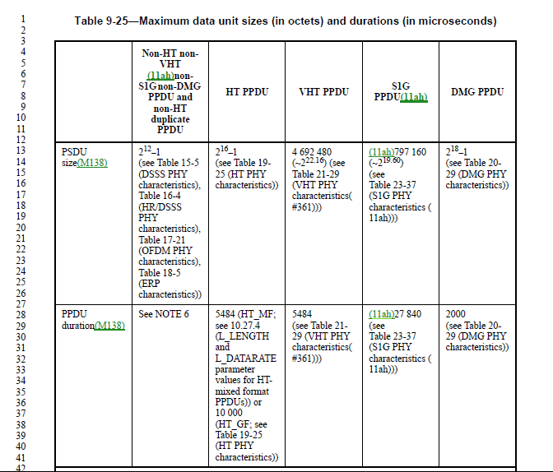

I think the commenter suggested to delete all numbers in the table and leave the references in the table.
For example, at line 28, delete 5484, 27840.

These numbers are not duplications. They provide useful information and comparison for different PPDUs.

My recommendation is to reject the comment.

Straw poll: Do you support resolution:
1 for A: Accept
2 for B: Revised – change to remove values from text and reference the table
4 for C: Reject - No Change:

Proposed Resolution

Rejected.
Reject Reason: Those numbers provide comparison for different PPDUs, which is very useful information for the implementers. No changes needed. The Straw Poll shows: 1 for “Accept”; 2 for “Revised” and 4 for “Reject”.

4554 |  |  | It's sometimes "asymmetric BA" and sometimes "asymmetric block ack". By analogy with "fragment BA", which is always like that, it should always be "asymmetric BA" | Change "symmetric block ack" (case-insensitively) to "symmetric BA" (this is to cover both Asymmetric and asymmetric), and dot11AsymmetricBlockAckActivated to dot11AsymmetricBAActivated

Discussion

Agreed with the commenter to change "symmetric block ack" (case-insensitively) to "symmetric BA".

In general, we don’t change MIB variables.

Proposed Resolution

Revised.
Change "symmetric block ack" (case-insensitively) to "symmetric BA" (this is to cover both Asymmetric and asymmetric).

4551 |  |  | "This contains", "Contains" etc. in Clause 6 is superfluous and should be deleted | As it says in the comment

Discussion

I found 73 instances of “Contains” and 2 instances of “This contains”
Some of “Contains” appear in clause 6 and some of them appears in other clauses.

Do these wordings cause any confusion?
If not, why do we need to change them?

commenter provided following locations per request.
583.15, 586.22, 336.22, 340.36, 361.55, 362.3, 371.3/8, 380.55, 381.3, 391.16/23, 431.10, 433.37, 440.5, 452.49, 453.46, 485.30, 486.46, 522.15, 523.11, 535.11, 535.50, 536.47, 537.3/8/12, 538.9/25/31/35, 539.40, 540.42, 583.15, 586.22, 649.38

Proposed Resolution

Revised.
Delete "This contains", "Contains" at following locations:
583.15, 586.22, 336.22, 340.36, 361.55, 362.3, 371.3/8, 380.55, 381.3, 391.16/23, 431.10, 433.37, 440.5, 452.49, 453.46, 485.30, 486.46, 522.15, 523.11, 535.11, 535.50, 536.47, 537.3/8/12, 538.9/25/31/35, 539.40, 540.42, 583.15, 586.22, 649.38.

4587 | 9 |  | Per the rules on foo report/request, "neighbor report" should be "Neighbor report" | As it says in the comment

Discussion

It's referring to the rule in 9.4.2.21 Measurement Report element:

References in this standard to a ‘<name> report’, where <name> corresponds to one of the Measurement
Types in Table 9-125 (Measurement Type field definitions for measurement reports) is equivalent to
(according to context) a) ‘a Measurement Report frame or Radio Measurement Report frame carrying a
Measurement Report element with the Measurement Type field equal to <name>’ or b) ‘a Measurement
Report element with the Measurement Type field equal to <name>’.

However, neighbor report is not a measurement type of Table 9-125. Therefore, above rules won’t apply to neighbor report

Mark R additional feedback:
So maybe the only thing to do is to lowercase "Neighbor report"(s) at
191.46, 1145.39, 3686.27.
And "Neighbor Report"(s) at 3912.60.
And change "neighbor report data" to "neighbor report" at 458.35.
And change "Neighbor Report Elements" to "Neighbor Report elements" at 1527.29,
and "a Neighbor Report frame" to "a Neighbor Report Response frame" on next line.

Ah, wait, but 4.3.11.1 says "Neighbor Report"s are "measurements".
This needs fixing too.

Emily: we don’t need to fix this one as neighbour report is still part of Wireless LAN radio Measurements.

4/1/20:

In the last meeting, there is suggestion to fix Neighbor Report in 4.3.11.1:

4.3.11.1 General (under 4.3.11 Wireless LAN radio measurements)

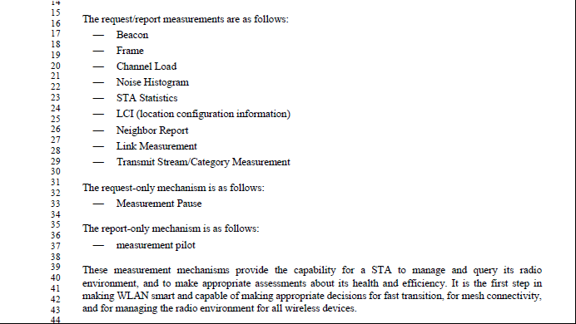

This list is Wireless LAN radio measurements (11k) feature list, not related to any frame format. It should not have any correlation with Table 9-125 (Measurement Type field definitions for measurement reports) or Table 9-100 (Measurement Type field definitions for measurement request).

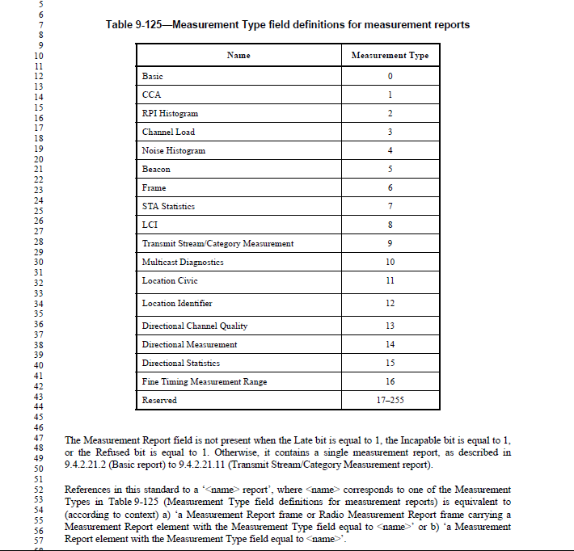

My recommendation is not to make changes in 4.3.11.1:
- I believe subclause 4.3.11.1 intends to give a general description of Wireless LAN radio measurements (802.11k), not the frame format.
- Neighbor Report doesn’t share the same request/report frame format as other radio measurements. However, it is still part of Wireless LAN radio measurements as introduced in 802.11k.
Therefore, I think it is okay to include neighbor report in request/response measurements list in 4.3.11.1.

Proposed Resolution

Revised.
Lowercase "Neighbor report"(s) at 191.46, 1145.39, 3686.27.
Lowercase "Neighbor Report"(s) at 3912.60.
Change "neighbor report data" to "neighbor report" at 458.35.
Change "Neighbor Report Elements" to "Neighbor Report elements" at 1527.29, and "a Neighbor Report frame" to "a Neighbor Report Response frame" on next line.

Note to the commenter: neighbor report is not a measurement type of Table 9-125. Therefore, the rules won’t apply to neighbor report.

