IEEE P802.11
Wireless LANs
MAC CR on CID 22386 and 22387
Date: 2019-11-05
Author(s):
Name | Affiliation | Address | Phone | email
Ming Gan | Huawei | F3-06, Huawei Industrial Base, Bantian, Longgang District, Shenzhen, China | +86 15889743667 | ming.gan@huawei.com
Abstract
This submission proposes resolutions of comments received from TGax LB244. (The proposed change is based on TGax Draft 5.0)
- 22386 22387

Revisions:
- Rev 0: Initial version of the document.

Interpretation of a Motion to Adopt

A motion to approve this submission means that the editing instructions and any changed or added material are actioned in the TGax Draft. This introduction is not part of the adopted material.

Editing instructions formatted like this are intended to be copied into the TGax Draft (i.e. they are instructions to the 802.11 editor on how to merge the text with the baseline documents).

TGax Editor: Editing instructions preceded by “TGax Editor” are instructions to the TGax editor to modify existing material in the TGax draft. As a result of adopting the changes, the TGax editor will execute the instructions rather than copy them to the TGax Draft.

CID | Page | Clause | Comment | Proposed Change | Resolution
22386 |  | 26.5.3 | CID 20732. The resolution is vague and not responsive to the comment "Re CID 16076: the comment was valid. The normative requirement is that cascading is defined by the use of "an A-MPDU to a non-AP STA that includes an Ack or BlockAck frame together with a Trigger frame or a frame carrying a TRS Control subfield." (342.33)" | Change the first sentence of the referenced subclause to "An MU cascading sequence is a frame exchange sequence between an AP and a non-AP STA where at least one transmission by the AP is a triggering PPDU that includes an acknowledgment." | Revised-  Agree with the commenter. Proposed resolution accounts for the suggested change.  TGax editor please make the changes as shown in 11-19/ 1948r0 under CID 22386
22387 |  | 26.5.3 | CID 20733. The resolution is vague and not responsive to the comment "Re CID 16076: the comment was valid. The normative requirement is that cascading is defined by the use of "an A-MPDU to a non-AP STA that includes an Ack or BlockAck frame together with a Trigger frame or a frame carrying a TRS Control subfield" (342.33). The resolution suggests this is wrong" | Change the first sentence of the referenced subclause to "An MU cascading sequence is a frame exchange sequence between an AP and a non-AP STA where a triggering PPDU follows after SIFS an UL MU transmission." Elsewhere, change "An AP shall not transmit an A-MPDU to a non-AP STA that includes an Ack or BlockAck frame together with a Trigger frame or a frame carrying a TRS Control subfield unless" to "An AP shall not transmit a triggering PPDU a SIFS after an HE TB PPDU the AP has triggered unless" | Revised-  The proposed change does not work. Actullay, it is a typical case that An AP transmits a triggering PPDU a SIFS after an HE TB PPDU the AP has triggered unless in a TXOP. It is not strongly related to the MU cascading.  Proposed resolution makes the first sentence of the referenced subclause clear.  TGax editor please make the changes as shown in 11-19/ 1948r0 under CID 22387

Discussion: …

26.5.3 MU cascading sequence

An MU cascading sequence is a frame exchange sequence between an AP and one or more non-AP STAs where at least one transmission by the AP is an A-MPDU that includes an Ack or BlockAck frame together with a triggering frame and characterized by the exchange of Control, Data and/or Management frames in both downlink and uplink directions. An example of an MU cascading sequence is shown in Figure 26-5 (An example of an MU cascading sequence). (#CID 22386 and 22387)

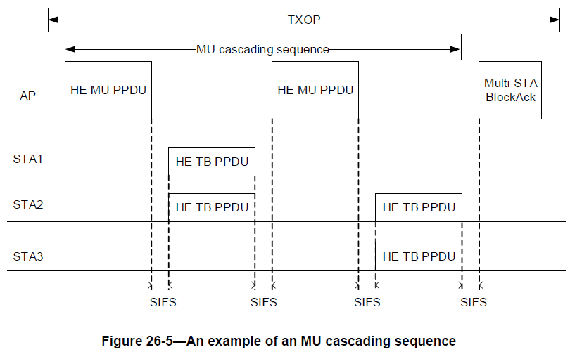

An AP shall not transmit an A-MPDU to a non-AP STA that includes an Ack or BlockAck frame together with a triggering frame unless both the AP and the non-AP STA have indicated support by setting the MU Cascading Support subfield to 1 in the MAC Capabilities Information field in the HE Capabilities element they transmit. The A-MPDU may additionally contain one or more MPDUs and is constructed following the rules defined in 26.11 (Setting TXVECTOR parameters for an HE PPDU).

The MU cascading sequence may have a different set of transmitters in HE TB PPDUs as compared to the receivers of the HE MU PPDU that immediately follows the HE TB PPDUs within the same TXOP. The MU cascading sequence may have a different set of receivers in the HE MU PPDU as compared to the set of transmitters of HE TB PPDUs that immediately follow the HE MU PPDU within the same TXOP.

An AP follows the procedure in 26.5.2.2.5 (AP access procedures for UL MU operation).

