IEEE P802.11
Wireless LANs
802.11 REVmd
LB236 - Proposed Resolutions for CID 2123, 2124, and 2125
Date: 2019-09-16
Author(s):
Name | Company | Address | Phone | email
Emily Qi | Intel Corporation |  |  | Emily.h.qi@intel.com
Mark Hamilton | Ruckus/CommScope |  |  | mark.hamilton2152@gmail.com
Abstract

This document contains proposed resolutions for CID 2123, 2124 and 2125. Proposed text is based on D2.4.

R00: Initial proposal.

7101 | 1706.09 | 11.11.10.3 | "the reporting AP has dot11LciCivicInNeighborReport and the neighbor AP has LCI MeasurementCapability (RM Enabled Capabilities element with the LCI Measurement Capability Enabled fieldset to 1) dot11RMLCIMeasurementActivated equal to true"-- this has at least two errors "has dot11LciCivicInNeighborReport" and"Measurement Capability (...) dot11RMLCIMeasurementActivated equal to true"Note that " (RM Enabled Capabilities element with the LCI Measurement Capability Enabled field set to 1)" is also a informal way of anonymously referencing a transmission by the AP)." this can also be improved. This informality occurs in a number of places in this subclause. The proposed changes addresses two of these. | Change cited text to:"the reporting AP has dot11LciCivicInNeighborReport equal to true and the neighbor AP indicates support for LCI measurement(the neighbor AP has transmitted an RM Enabled Capabilities element with the LCI Measurement Capability Enabled field equal to true)"Make matching changes at 1706.32.

CID | Page | Clause | Comment | Proposed Change
2123 | 1770.55 | 10.7 | The non-QoS STA is required not to transmit more than a certain amount of outstanding MPDUs at any time. However, is not clear what is the relationship between the subclauses that refer to MSDU from particular SA and MMPDU:  - Can the non-QoS STA transmit outstanding MPDU of one MSDU from particular SA OR outstanding MPDU of one MMPDU but not on the same time?  - Can the non-QoS STA transmit outstanding MPDU of one MSDU from particular SA AND outstanding MPDU of one MMPDU on the same time? | Please clarify the relationship between the 2 subclauses within that requirement (as proposed in comment)
Discussion:
The cited text is at 1794.14 of D2.4, see:
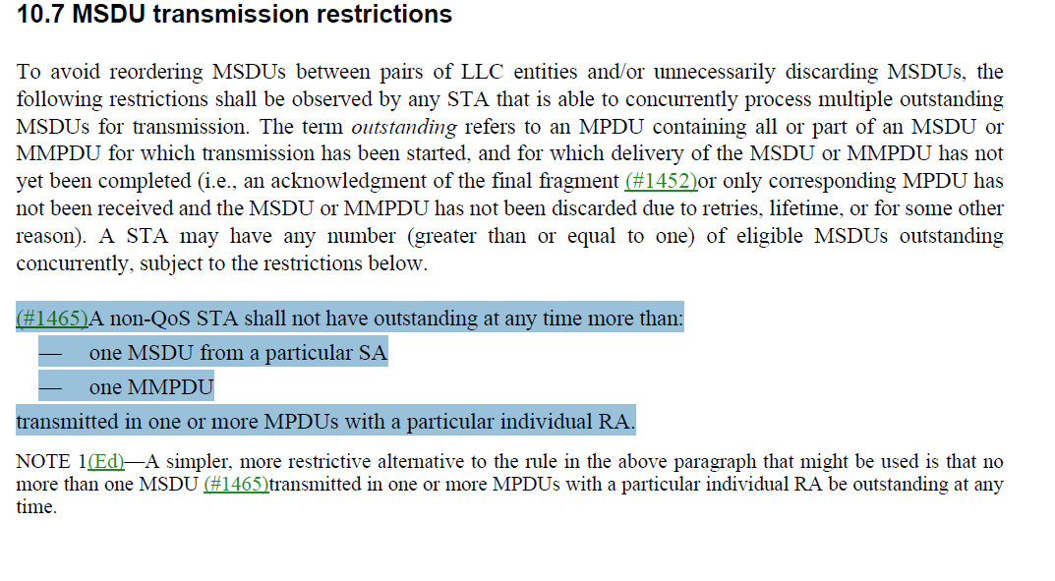
In 802.11-2016, the cited text (before the modification made by #1465) read:
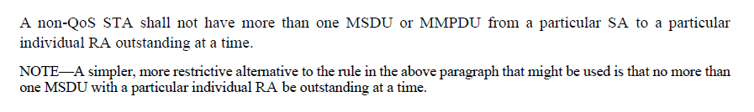
The non-QoS STA is required not to transmit more than a certain amount of outstanding MPDUs at any time. However, it is not clear what is the relationship between the bullets that refer to MSDU from particular SA and MMPDU.

Question: May a non-QoS STA have one MSDU from some SA, _AND_ one MMDPU outstanding at the same time?

I think the answer is Yes.
MSDU transmission restrictions are to avoid reordering MSDUs between pairs of LLC entities and/or unnecessarily discarding MSDUs. Since the MMPDU doesn’t have an SA at all, so the result is that the STA can have outstanding at the same time, at most: one MSDU for every SA this STA can transmit on behalf, plus one MMPDU. Since it can have multiple MSDUs if they are from different SAs, I don’t see why it can’t also have one MMPDU at the same time.
However, it is not clear in both D2.4 and 802.11-2016.
I think we should add a senetence to clarify it. My proposal is to add the senetence to NOTE 1.
Proposed Resolution:
Revised.
At 1794.14 to 1794.23 (of D2.4), make changes as follows:
A non-QoS STA shall not have outstanding at any time more than:
- one MSDU from any particular SA
- one MMPDU
transmitted in one or more MPDUs with a particular individual RA.

NOTE 1 —A simpler, more restrictive alternative to the rule in the above paragraph that might be used is that no
more than one MSDU transmitted in one or more MPDUs with a particular individual RA be outstanding at any
time. A non-QoS STA might have outstanding up to one MSDU from each particular SA and one MMPDU transmitted in one or more MPDUs at a given time.

========

2124 | 1771.1 | 10.7 | The QoS STA without Block ACK agreement is required not to transmit more than a certain amount of outstanding MPDUs at any time. However, is not clear what is the relationship between the subclauses that refer to MSDU from particular SA and MMPDU:  - Can the non-QoS STA transmit outstanding MPDU of one MSDU/ A-MSDU from particular SA OR outstanding MPDU of one MMPDU but not on the same time?  - Can the non-QoS STA transmit outstanding MPDU of one MSDU / A-MSDU from particular SA AND outstanding MPDU of one MMPDU on the same time? | Please clarify the relationship between the 2 subclauses within that requirement (as proposed in comment)

Discussion:
The cited text is at 1790.1 of D2.4, see:
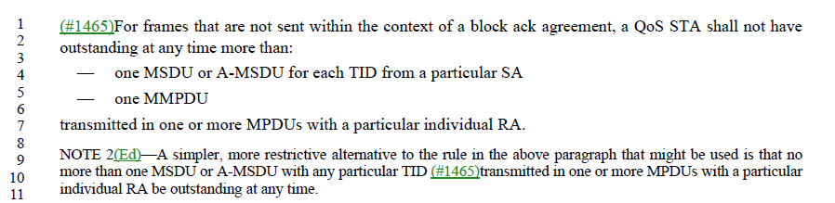

In 802.11-2016, the cited text (before the modification made by #1465) read:
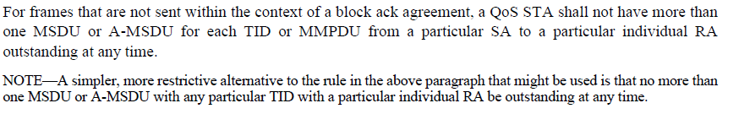
The QoS STA without Block ACK agreement is required not to transmit more than a certain amount of outstanding MPDUs at any time. However, is not clear what is the relationship between the subclauses that refer to MSDU from particular SA and MMPDU.

Question: May a QoS STA have one MSDU or A-MSDU for each TID from any particular SA, AND one MMPDU outstanding at the same time?

I think the answer is: Yes.
However, it is not clear in both D2.4 and 802.11-2016.
I think we should add a senetence to clarify it. My proposal is to add the senetence to NOTE 2.

Proposed Resolution:
Revised.
At 1794.25 to 1794.35 (of D2.4), make changes as follows:
For frames that are not sent within the context of a block ack agreement, a QoS STA shall not have
outstanding at any time more than:
— one MSDU or A-MSDU for each TID from any particular SA
— one MMPDU
transmitted in one or more MPDUs with a particular individual RA.
NOTE 2—A simpler, more restrictive alternative to the rule in the above paragraph that might be used is that no
more than one MSDU or A-MSDU with any particular TID transmitted in one or more MPDUs with a particular
individual RA be outstanding at any time. A QoS STA might have outstanding up to one MSDU or A-MSDU for each TID from any particular SA, and one MMPDU transmitted in one or more MPDUs at a given time.

========

2125 | 1740.50 | 10.5 | "A STA shall support the concurrent reception of fragments of at least three MSDUs or MMPDUs." The requirement for STA to support concurrent reception of fragments of at least three MSDUs or MMPDUs is in conflict with the rule in section 10.7 for not having more than on outstanding MSDU (transmitted in one or more MPDUs) at any time. | Please resolve the conflict between having concurrent fragments of at least 3 MSDUs and the rule not to have more than a single outstanding MSDU at any time
Discussion:
The cited text is at 1763.50 of D2.4, see:
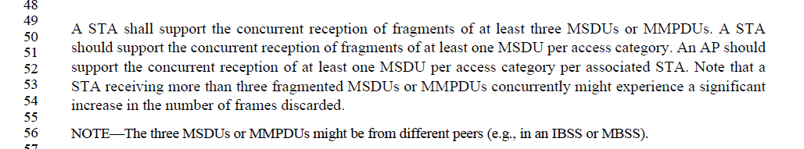

The refered text in 10.7 is:
There is no conflict between the cited text in 10.5 and 10.7.
For MSDU transmission (10.7), a non-QoS STA shall not have outstanding at any time more than one MSDU......
For receiving, a STA shall support the concurrent reception of fragments multiple MSDUs or MMPDUs.
As noted, those MSDUs or MMPDUs might be from different peers (e.g., in an IBSS or MBSS). The other situation is that the frames might be MSDUs from different SAs, even though they are from the same TA (peer).
My proposal is to reject the comment.
Proposed Resolution:
Reject.
Reason: There is no conflict between the cited text in 10.5 and 10.7.
For MSDU transmission (10.7), a non-QoS STA shall not have outstanding at any time more than one MSDU......
For receiving, a STA shall support the concurrent reception of fragments multiple MSDUs or MMPDUs.
As noted, those MSDUs or MMPDUs might be from different peers (e.g., in an IBSS or MBSS). The other situation is that the frames might be MSDUs from different SAs, even though they are from the same TA (peer).

