IEEE P802.11
Wireless LANs

802.11bc Functional Requirements Document Proposed Update
Date: 2019-06-11
Author(s):
Name | Affiliation | Address | Phone | email
Stephen McCann | BlackBerry | The Pearce Building, West Street, Maidenhead, SL6 1RL, UK |  | smccann@blackberry.com

Abstract
This document describes a proposed update to the 802.11bc Functional Requirements Document 11-19-0151r2.

- Introduction
- Purpose
This document summarizes requirements, which agreed to by the Task Group, for solutions addressing functionality to be provided by the 802.11bc amendment, referred to as the TGbc Functional Requirements (FRs).
- Scope
The scope for deriving functional requirements is primarily set by the P802.11bc PAR Error: Reference source not found and CSD Error: Reference source not found, as well as by the TGbc usage models Error: Reference source not found. Additional requirements may be added if agreed by and considered essential by the task group. The following figure illustrates the workflow on how to derive functional requirements and how to add them to the Functional Requirements Document owned by the task group following the steps of the 802.11bc Selection Procedure [Ref-4].

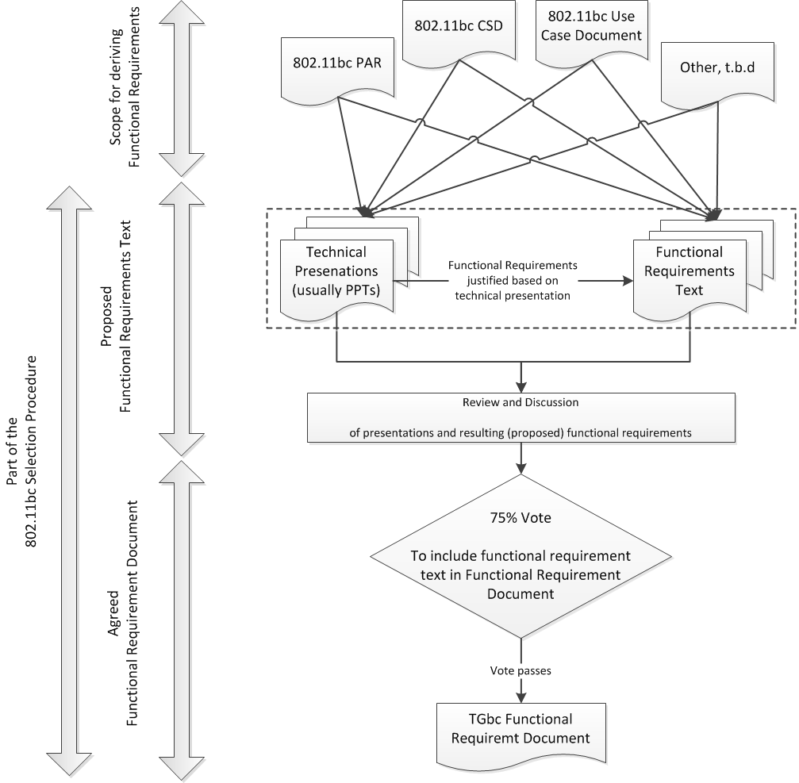

- Notation
Requirements are identified by a preceding unique number in the format of “TGbc Rn”, where n is an integer number representing the ID of the requirements.

- Definitions
TGbc D1: “Consuming”: By “consuming a broadcast service”, it is meant that STA receives a corresponding frame and forwards its contents to the upper layer.

- Functional Requirements
- Compliance to PAR
TGbc R1: The 802.11bc amendment shall comply with the PAR Error: Reference source not found and the CSD Error: Reference source not found.

- Restrictions
TGbc R2: The 802.11bc amendment shall not change the IEEE 802.11 PHY specifications. [Ref-1 5.2.b]

- Security
TGbc R3: The 802.11bc amendment shall provide origin authenticity protection for broadcast data frames. [Ref-1 5.2.b]

TGbc R4: The 802.11bc amendment shall provide a broadcast mechanism in which e2e security w/ confidentiality and integrity between STA and the server is assumed. [Ref-5]

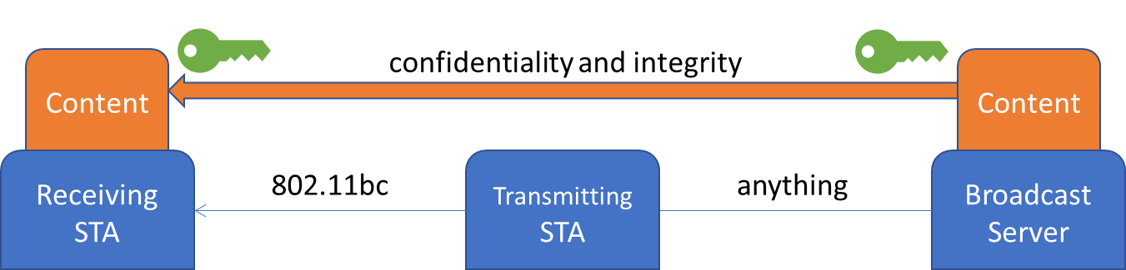

TGbc R5: The 802.11bc amendment shall provide a mechanism for the AP to authenticate the STA before forwarding the packets. [Ref-5]

- Association state
TGbc R6: The 802.11bc amendment shall support modes of operation:
- in an infrastructure BSS where there is an association between the transmitter and the receiver(s)
- in cases where there is no association between transmitter(s) and receiver(s). [Ref-1 5.2.b]

TGbc R7: 802.11bc amendment shall have a mechanism to facilitate power-efficient broadcasting.

TGbc R8: 802.11bc amendment assumes that there is no association and/or handshake required between STA and the AP. [Ref-5]

  - Discovery
TGbc R9: 802.11bc amendment shall have a mechanism to facilitate discovery of 11bc-capable STAs.
TGbc R9.1: 802.11bc amendment shall describe the use of an extended capability bit to indicate eBCS capability.

TGbc R10: 802.11bc amendment shall have a mechanism to facilitate the discovery of STAs consuming a particular broadcast service.
TGbc R10.1 802.11bc amendment shall describe an ANQP query for eBCS services.
TGbc R10.2 802.11bc amendment shall describe an ANQP response for eBCS services.
TGbc R10.3 802.11bc amendment shall be capable of indicating 0, 1, or multiple eBCS services in the eBCS ANQP response.

  - Simultaneous broadcast service
TGbc R11: STAs should be capable of consuming multiple broadcast services simultaneously.
TGbc R11.1: STAs should be capable of receiving multiple broadcast services from the same STA or many STAs simultaneously.
  - Air time consumption
TGbc R12: 802.11bc amendment shall have a mechanism to facilitate the sharing of airtime between all broadcast services and all non-broadcast services communications.
TGbc R13: 802.11bc amendment shall have a mechanism for starting a broadcast service.
TGbc R14: 802.11bc amendment shall have a mechanism for stopping a broadcast service.

- References
- https://mentor.ieee.org/802.11/dcn/18/11-18-0825-09-0bcs-a-par-proposal-for-bcs.docx
- https://mentor.ieee.org/802.11/dcn/18/11-18-0826-09-0bcs-a-csd-proposal-for-bcs.docx
- https://mentor.ieee.org/802.11/dcn/19/11-19-0268-04-00bc-tgbc-use-case-document.pptx
- https://mentor.ieee.org/802.11/dcn/19/11-19-0135-00-00bc-tgbc-selection-procedure.docx
- https://mentor.ieee.org/802.11/dcn/19/11-19-0446-03-00bc-proposed-functional-requirements-for-802-11bc.doc

