IEEE P802.11
Wireless LANs
Remaining CR on SIG-B Part I
Date: 2019-07-10
Author(s):
Name | Company | Address | Phone | email
Ross Jian Yu | Huawei Technologies | F3-6-A120, Huawei Base, Bantian, Longgang, Shenzhen, Guangdong, China, 518129 |  | ross.yujian@huawei.com
Abstract
This submission contains proposed comment resolutions to comments on D4.0.

7 Comments, CID 20856, 20914, 20915, 21008, 21035, 21036, 21408, are resolved in this document.

Revision Notes

R0 | Initial revision

CID 20856
CID | Page.  Line | Clause Number | Comment | Proposed Change | Resolution
20856 | 555.19 | 27.3.10.8.5 | "If the STA-ID subfield is set to 2046, then the other subfields can be set to arbitrary values." -- they should be reserved | In Tables 27-27 and 27-28 change "If the STA-ID subfield is set to 2046, then the other subfields are reserved and set to 0." | REJECTED  Set to arbitrary values and set to reserved values are two different soultions. There is no technical issue of the existing solution. The commenter doesn’t provide the reason why an alternative solution should be applied.

CID 20914

CID | Page.  Line | Clause Number | Comment | Proposed Change | Resolution
20914 | 552.51 | 27.3.10.8.4 | "can be indicated" is too tentative | Change to "is indicated" | REVISED  Agree that the use of can is not good here according to the editorial style (09-1304r13):  Whilst the description after “can be indicated” is not the only way of indication. Hence “is able to” is suggested to be used here.  Instrution to the editor:  Change “can” to “is able” in P560, L22 of P802.11ax D4.2

Discussion:
The comment is for:
The preamble is punctured in a 20 MHz subchannel S1 of an HE MU PPDU if and only if one of the following conditions apply:
- B7–B0 of the RU Allocation subfield corresponding to the 20 MHz subchannel S1 is 01110001 (242-tone empty)
- Preamble puncturing the 40 MHz comprising two adjacent 20 MHz subchannels S1 and S2 can be indicated by setting B7–B0 of the RU Allocation subfields corresponding to the 20 MHz subchannels S1 and S2 to 01110001
- B7–B0 of the RU Allocation subfields corresponding to the 20 MHz subchannels S1 and S2 are both 01110010 where the 20 MHz subchannels S1 and S2 are adjacent to each other and comprise the 40 MHz subchannel in which the 484-tone RU is located. In this case, the preamble is punctured in both 20 MHz subchannels S1 and S2.

Description regarding the use of can in the editorial style guide (09-1304r13)
The non-normative verbs are:
- can – equivalent to “is able to” or “is allowed to, as defined elsewhere in this standard” (see below)
- might – equivalent to “chooses according to unspecified criteria”

The use of “can” should be considered carefully. It should be interpreted as meaning “is allowed to” or “is able to”, when interpreted in the context of normative statements made elsewhere in the standard, or referenced from the standard, or that are generally well known or self-obvious. When those conditions do not exist, use the word “might” as this expresses the possibility of something happening without use understanding how it can happen.

CID 20915

CID | Page.  Line | Clause Number | Comment | Proposed Change | Resolution
20915 |  |  | Re CID 16085: the resolution is not specific enough | Make the change proposed in CID 16085 | REJECTED  The description in P802.11ax D4.0 and later in D4.2 is specific enough with the proposed change in CID 16085. No further edits are needed.

Discussion
Resoultion to CID 16085 on D3.0 is pasted as follows:
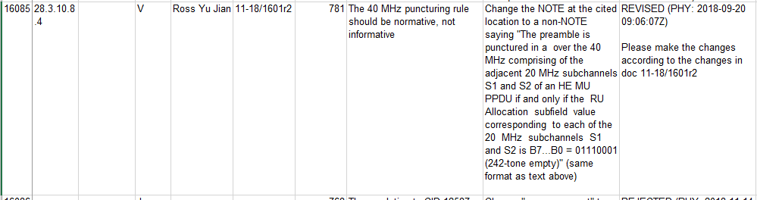

The description in D4.2 is as follows:
The preamble is punctured in a 20 MHz subchannel S1 of an HE MU PPDU if and only if one of the following conditions apply:
- B7–B0 of the RU Allocation subfield corresponding to the 20 MHz subchannel S1 is 01110001 (242-tone empty)
- Preamble puncturing the 40 MHz comprising two adjacent 20 MHz subchannels S1 and S2 can be indicated by setting B7–B0 of the RU Allocation subfields corresponding to the 20 MHz subchannels S1 and S2 to 01110001
- B7–B0 of the RU Allocation subfields corresponding to the 20 MHz subchannels S1 and S2 are both 01110010 where the 20 MHz subchannels S1 and S2 are adjacent to each other and comprise the 40 MHz subchannel in which the 484-tone RU is located. In this case, the preamble is punctured in both 20 MHz subchannels S1 and S2.

CID 21008

CID | Page.  Line | Clause Number | Comment | Proposed Change | Resolution
21008 | 549.34 | 27.3.10.8.4 | Re CID 16309: resolution does not appear to address comment | Make "The same value is applied to  both HE-SIG-B content channels." an explicit "shall" | REJECTED  “Shall” is to be described in text, but not in the description of a field.

Discussion
Resoultion to CID 16309 on D3.0 is pasted as follows:
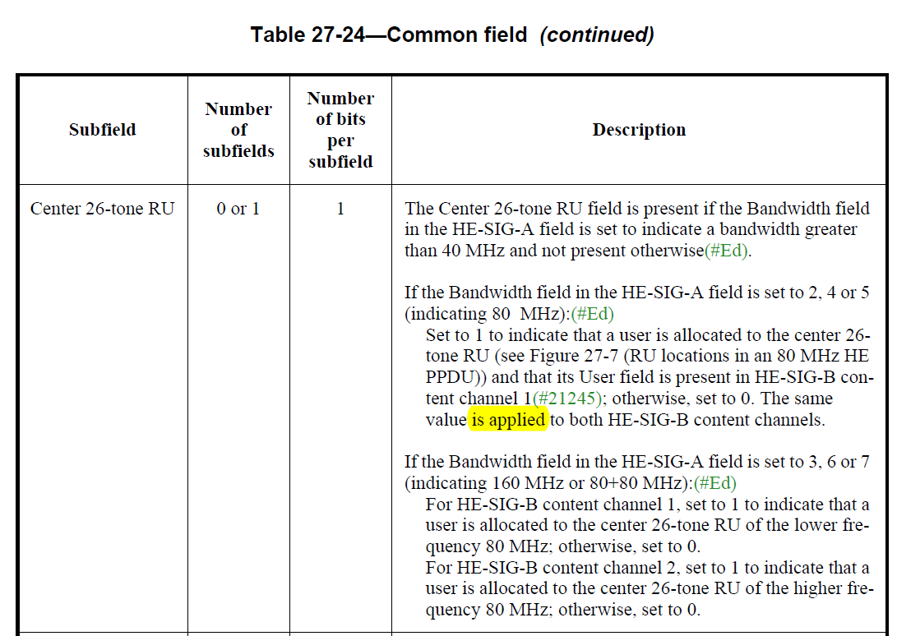

CID 21035

CID | Page.  Line | Clause Number | Comment | Proposed Change | Resolution
21035 | 551.19 | 27.3.10.8.4 | Table 27-25 is confusing for indices 01110010, 01110011, 11001y2y1y0, 11010y2y1y0, since it's not clear what #1 to #9 above refer to | Clarify | REJECTED  There already exists clear description and examples in Doc 18-1774r18, specifically pointed in the discussion part of CID 21035 in doc 19-0972r0.  No further edits are needed.

Discussion
In P802.11ax D4.2:
01110010 | 484-tone RU; contributes zero User fields to the User Specific field in the same HE-SIG-B content channel as this RU Allocation subfield(#21237) | 1
01110011 | 996-tone RU; contributes zero User fields to the User Specific field in the same HE-SIG-B content channel as this RU Allocation subfield(#21238) | 1
11001y₂y₁y₀ | 484 | 8
11010y₂y₁y₀ | 996 | 8

An RU of size 996 is referred to by two consecutive RU Allocation subfields per HE-SIG-B content channel, for both HE-SIG-B content channels. The two consecutive RU Allocation subfields per HE-SIG-B content channel are labelled the first RU Allocation subfield and the second RU Allocation subfield. An RU of size 484 is referred to by a single RU Allocation subfield per HE-SIG-B content channel, for both HE-SIG-B content channels. Smaller RU sizes are referred to by a single RU Allocation subfield in a single HE-SIG-B content channel. If a Common field is present in a 160 or 80+80 MHz PPDU, RUs of size 2×996 are not permitted (none are defined in Table 27-25 (RU Allocation subfield)).

Z.5 Example 4
An example of alternative dynamic splitting options to balance the load across HE-SIG-B content channels is as follows. Two users are transmitted using MU-MIMO in the lowest 484-tone RU of an 80 MHz or wider PPDU. The example shows just the associated RU Allocation subfields (i.e. a fragment of the HE-SIG-B), which may be sent in one of three alternative ways, as shown in Table xxxc (RU Allocation subfields for different dynamic splits of User fields for the example of two MU-MIMO users in the lowest 484-tone RU of an 80 MHz or wider PPDU).
Table xxxc: RU Allocation subfields for different dynamic splits of User fields for the example of two MU-MIMO users in the lowest 484-tone RU of an 80 MHz or wider PPDU
Alternative dynamic splitting options | First RU Allocation subfield of HE SIG-B content channel 1 | Number of User fields contributed to HE SIG-B content channel 1 | First RU Allocation subfield of HE SIG-B content channel 2 | Number of User fields contributed to HE SIG-B content channel 2
Both User fields signaled in HE-SIG-B content channel 1 | MSb-first: 11001_001  LSb-first: 100_10011 | 2 | MSb-first: 01110010  LSb-first: 01001110 | 0
Both User fields signaled in HE-SIG-B content channel 2 | MSb-first: 01110010  LSb-first: 01001110 | 0 | MSb-first: 11001_001  LSb-first: 100_10011 | 2
One User field per HE-SIG-B content channel | MSb-first: 11001_000  LSb-first: 000_10011 | 1 | MSb-first: 11001_000  LSb-first: 000_10011 | 1
(#21229)

CID 21036

CID | Page.  Line | Clause Number | Comment | Proposed Change | Resolution
21036 | 551.17 | 27.3.10.8.4 | Table 27-25 is confusing for indices 01110001, since it's not clear whether a User field is indicated | At the referenced location change "242-tone RU empty" to "242-tone RU empty, with zero User fields indicated" (cf. next two rows) | REVISED  Instruction to the editor:  Add “(with zero users)” after 242-tone RU empty

Discussion
In P802.11ax D4.0:
01110001 | 242-tone RU empty | 1

CID 21408

CID | Page.  Line | Clause Number | Comment | Proposed Change | Resolution
21048 | 545.38 | 27.3.10.8.3 | The word "duplicated" used to illustrate the content channels for 80 MHz PPDU or above appears confusing. It was worse (more confusing) in D3.3 when the number of bits in RU Allocation of TXVECTOR was short (it's corrected in D4.0). According to the examples in Annex Z, there is no "duplicated" content channels. I understand the intent to illustrate how to use content channels. As an example, I propose wording for consideration the proposed change column for "HE-SIG-B content channel 1 occupies the 20 MHz frequency segment that is lowest in frequency and is duplicated on the 20 MHz frequency segment that is third lowest in frequency", copied form the text. | Proposed wording: "HE-SIG-B content channel 1 denotes the use of the 20 MHz frequency segment in the lowest in frequency as well as the  20 MHz frequency segment in the third lowest in frequency." If agreed, please make all the changes accordingly in this subclause. | REJECTED  Without the word duplicated, it is not clear that how content channel is allocated to different 20MHz channels, split, duplicate? It is better to keep the description as it is unless a better description is provided.

------------------------------------------------- End of Document------------------------------------------------

