IEEE P802.11
Wireless LANs
CR on CID 20760 and 20793
Date: 2019-07-10
Author(s):
Name | Company | Address | Phone | email
Ross Jian Yu | Huawei Technologies | F3-6-A120, Huawei Base, Bantian, Longgang, Shenzhen, Guangdong, China, 518129 |  | ross.yujian@huawei.com
Abstract
This submission contains proposed comment resolutions to comments on D4.0.

CID 20760, 20793 are resolved in this document.

Revision Notes

R0 | Initial revision

CID 20760
CID | Page.  Line | Clause Number | Comment | Proposed Change | Resolution
20760 |  |  | Re CID 16179: this field, now called Beamformed; only has behaviour for HE sounding NDP (end of 27.3.16) so reserve for HE ER SU PPDU and in Table 27-27---User field format for a non-MU-MIMO allocation | At the end of the rightmost cell at 528.19 add "Reserved in an HE ER SU PPDU.". In Table 27-27 change the B14 row to "B14", "Reserved", "1", "Reserved and set to 0" | REJECTED  The bit is used to indicate the behavior at the Tx side, and let the Rx know if beamforming steering matrix is applied to  the waveform or not, whilst how to implement/behave at the Rx side is up to implementation. As it has its meanings for both SU PPDU and ER SU PPDU. The beamformed field should not be set to reserved for both PPDUs.

Discussion
Resoultion to CID 16179 on D3.0 is pasted as follows:
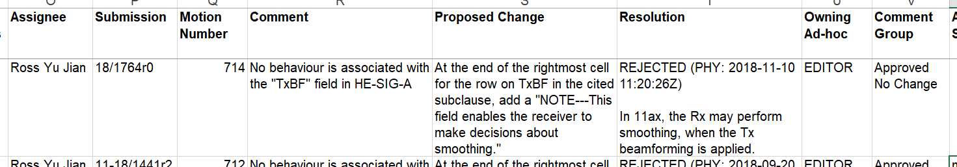
CID 20760 is on Page 528, Line 18, on the Beamformed bit.

CID 20793

CID | Page.  Line | Clause Number | Comment | Proposed Change | Resolution
 |  |  | Re CID 16381: the resolution is not clear. "For 80MHz, if both channels in secondary channel are punctured out, then it goes back to 40MHz." -- what's "it"? "This is different for 160MHz/80+80MHz channel." -- what's "This"? | As it said in CID 16381 | REJECTED  When Bandwidth is set to 4, a preamble puncturing in 80Mhz mode is indicated, when Bandwidth is set to 7, a preamble puncturing in 160Mhz or 80MHz + 80MHz mode is indicated. The two modes are different. Accordingly the common fields in HE-SIG-B are also different.  Regarding the commenter’s question on the previous resolution, “it” means the BW of the PPDU. “This” means the condition descrbied in the previous sentence, i.e., both channels in secondary 40Mhz are punctured when BW=80MHz. And it is different from the condition that both channels in secondary 40MHz are punctured when BW=160MHz/80+80MHz.

Discussion
Resolution to CID 16179 on D3.0 is pasted as follows:

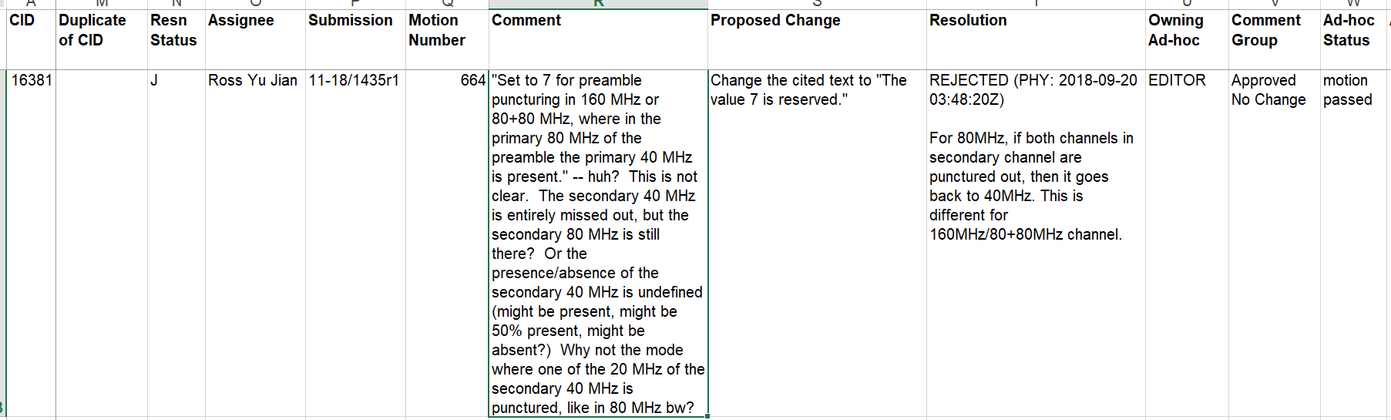
CID 20793 is on Page 530, Line 7, on the Bandwidth subfield

