IEEE P802.11
Wireless LANs
Adding Dialog Token in Ranging Trigger Frames
Date: 2019-05-15
Author(s):
Name | Company | Address | Phone | email
Qi Wang | Apple, Inc. |  |  | qi_wang2@apple.com
Tianyu Wu | Apple, Inc. |  |  | tianyu@apple.com

Abstract
For the TB ranging operation specified in 802.11az, this submission proposes to add the dialog token value in the ranging trigger frames.

Introduction

Discussion

For the TB ranging operation specified in 802.11az, this submission proposes to add the dialog token value to the ranging trigger frames.

For TB ranging, an RSTA can transmit multiple trigger sounding frames to trigger the UL NDP transmissions, followed by a single DL NDPA frame and DL NDP, as depicted by Figure 11-36e in 11az_D1.0 [1] and shown below:

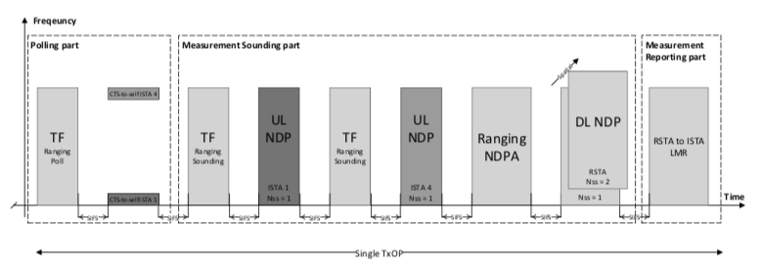
Figure 11-36e TB Ranging availability window with multiple TF Ranging Sounding

In 11az_D1.0 [1], a dialog token value is included in the DL NDPA frame to identify one measurement round. It would be helpful that the dialog token value is available at the time of the UL NDP transmission and reception to help identify to which measurement round an UL NDP belongs. This is especially valuable to a client STA that utilizes passive ranging to passively locate itself, where it needs to identify the UL NDPs transmitted by multiple passive ISTAs and match them to the transmission of DL NDP by a single passive RSTA.

Proposed 11az spec modification:

Instruction to the editor: The proposed modifications are in reference to the text in IEEE P802.11802.11az_D1.0, and are indicated by the change marks as follows:

9.3.1.23.9 Ranging Trigger variant

The format of the Trigger Dependent User Info field for the Ranging Trigger frame is dependent on the Trigger Subtype field value in the Trigger Dependent Common Info field of the Ranging Trigger frame (Table 9-25k Ranging Trigger subtype field encoding).

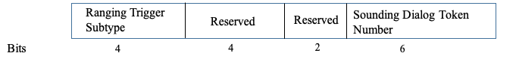

Figure 9-61d - Trigger Dependent Common Info subfield for the Ranging Trigger variant

The Value of the Ranging Trigger Subtype for the Ranging Trigger frame variant is defined in Table9-25k.

Table 9-25k — Ranging Trigger Subtype field encoding
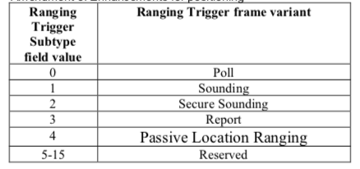

For all Ranging Trigger Subtypes, the Sounding Dialog Token Number subfield contains a value in the range of 0 to 63 which identifies a Measurement Sounding Part (UL NDP frame and DL NDP frame announced by a Sounding Trigger frame and the Ranging NDP Announcement frame) following a successfully transmitted Ranging trigger poll, and
the same value is included in the Sounding Dialog Token field of the Ranging NDP Announcement frame transmitted within the same Availability Window (see 9.3.1.19).

9.3.1.19 VHT/HE/Ranging NDP Announcement frame format

…

The Duration, RA, and TA fields are set as in a VHT NDP Announcement frame. The Sounding Dialog Token Number subfield in the Sounding Dialog Token (SDT)field contains a value in the range of 0 to 63 which identifies a Measurement Sounding Part (DL NDP frame and UL NDP frame announced by a Ranging NDP Announcement in non-TB ranging or UL NDP frames + DL NDP frame announced by Sounding Trigger frame + NDP Announcement frame in TB ranging).

References:

1. IEEE Draft P802.11az_D1.0, Draft standard for information technology – telecommunications and information exchange between systems – local and metropolitan area networks – specific requirements – Part 11: Wireless LAN medium access control (MAC) and physical layer (PHY) specifications, Amendment 8: Enhancements for locationing

