IEEE P802.11
Wireless LANs
Proposed resolution to LB#240 CID 2302 on AoD for passive ranging
Date: 2019-07-01
Author(s):
Name | Company | Address | Phone | email
Qi Wang | Apple, Inc. |  |  | qi_wang2@apple.com
Tianyu Wu | Apple, Inc. |  |  | tianyu@apple.com

Abstract
This submission contains a proposal to resolve LB#240 CID-2302. The proposed resolution enables AoD measurement at client stations for passive ranging.

Introduction

Introduction

This submission contains a proposal to resolve LB#240 CID- 2302. The proposed resolution enables AoD measurement at client stations for passive ranging.
Comments:

CID | Page | Clause | Comment | Proposed change | Resolution
2302 |  |  | For passive ranging, the spec needs to specify a method to enable AoD measurement at the client STA in order to improve location accuracy and reduce the number of anchor STAs needed for passive ranging. | As in comment. | Revised.  Agreed in principle.  TGaz editor makes changes as specified in 11-19/0677r3 for its resolution.

Discussion:

Enabling AoD for passive ranging will:
- Improve ranging accuracy due to the collection of additional data samples;
- Reduce the minimum number of ASTAs needed for passive ranging.
The HE-LTF symbol generation is illustrated in the figure below:
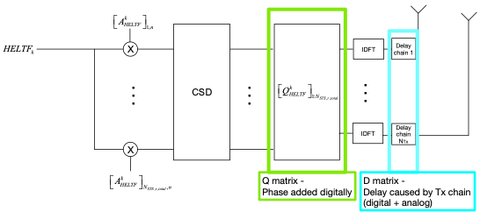
Where frequency domain Tx signal of the n-th HE-LTF symbol and subcarrier k is:
To resolve the AoD from the N_{Tx} antenna port, N_{STS} needs to equal to N_{Tx}, and Rx needs to find out the original per chain phase difference of Tx signal X^{k}_{n}.
Vector A is a row of P matrix. Rx need to know the mapping of a row in P matrix to an antenna port.
M_{CSD} is the CSD matrix. Since CSD is not applied, this is an Identity matrix.
Since beamforming is not applied, Q matrix is the spatial mapping matrix. If N_{STS =} N_{Tx} , Q matrix shall be Identity matrix which is implied in the spec but better to have some clarification. If N_{STS <} N_{Tx} , Q matrix shall be an antenna selection matrix with no antenna swapping. Which means Q matrix becomes Identity matrix when the rows with all zero elements are removed. Example: Select 2nd and 4th antenna.
D matrix is a phase adjustment matrix caused by different delay of antenna RF chains and other factors such as different per RF chain phase response of the filter, phase change due to reflection etc. Each diagonal element of D matrix is mainly contributed by two parts, the common phase adjustment for all subcarriers and a linear increasing/decreasing phase shift for subcarriers.
The common phase adjustment mainly comes from the RF factors such as phase rotation caused by filter or internal reflection that inverse the phase of all subcarriers etc.
The linear phase shift comes from different delay of RF chains. Example: If the antenna port i has a delay of τ_{i}, the phase shift for subcarrier k will be .
So for i-th antenna port and k-th subcarrier,
Where is the common phase adjustment and is the delay of antenna i. The two parameters need to be reported to the client STAs for passive ranging. Typically τ_{i} is very small and less than 10ns.
Summary:
The key modifications proposed to the 11az_spec are summarized as follows:
- Specify that, when performing passive ranging, an RSTA or an ISTA can optionally support the AoD measurement by a client STA that locates itself through passive ranging. When an RSTA or an ISTA supports the AoD measurement, it shall include the antenna placement, common phase adjustment and the delay information for each transmit antenna in the LCI report that it transmits.
- Clarify the characteristics of Q matrix.

Proposed 11az spec modification:

Instruction to the editor: The proposed modifications are in reference to the text in IEEE P802.11_REVmd_D2.2 and 802.11az_D1.0, and are indicated by the change marks as follows:

9.4.2.21.10 LCI report (Location configuration information report)

An LCI report for a known LCI includes latitude, longitude, altitude, and related information. An unknown LCI is indicated by the Length field of the LCI subelement being set to 0 and there being no following subelements. The LCI report field format is shown in Figure 9-245 (Format of Location Configuration Information Report).

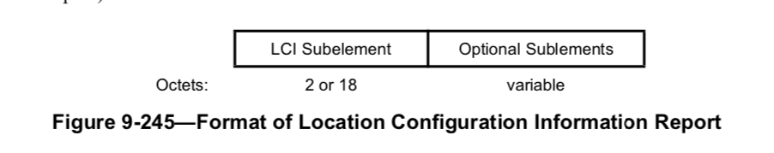
The subelements in the LCI report are defined in Table 9-134 (Subelement IDs for LCI Report).

11az Editor: change Table 9-134 in P802.11az _D1.0 as shown below.

Table 9-134—Subelement IDs for LCI Report

Subelement ID | Name | Extensible
0 | LCI
1 | Azimuth Report | Yes
2 | Originator Requesting STA MAC Address
3 | Target MAC Address
4 | Z | Subelements
5 | Relative Location Error | Yes
6 | Usage Rules/Policy | Yes
7 | Co-located BSSID List | Yes
8 | Relative Compact LCI
9 | Antenna Placement and Calibration | Yes
1089-220 | Reserved
221 | Vendor Specific
222-255 | Reserved

……
The Relative Altitude subfield contains a signed integer in two’s complement format indicating the elevation offset of the reported location on in relation to the specified reference location, in units of 2 cm.

NOTE— This example shows how to encode the coordinates of the Sydney Opera House using the encoding defined in IETF RFC 6225. The building is a polygon with the following (latitude, longitude) coordinates.

11az Editor: insert the following text after the above paragraphs in P802.11az_D1.0.

The Antenna Placement and Calibration Subelement contains the antenna placement and the delay information for each of the transmit antenna. The format of the Antenna Placement and Calibration subelement is shown in Figure 9-xx1.

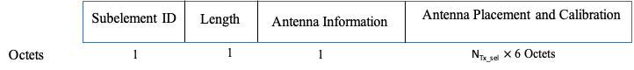
Figure 9-xx1—Antenna Platform and Calibration subelement format

The Subelement ID field is equal to the value for Antenna Placement and Calibration in Table 9-134 (Subelement IDs for Antenna Placement and Calibration).

The Length field is defined in 9.4.3 (Subelements).

The Antenna Information field is formatted as shown in Figure 9-xx2 (Antenna Information field format), where the Number of Antenna subfield indicates N_{Tx_sel}, the total number of the antennas selected for transmission.
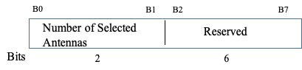

Figure 9-xx2—Antenna Information field format

The Antenna Placement and Calibration field is formatted as shown in Figure-9-xx3 (Antenna Placement and Calibration field format).

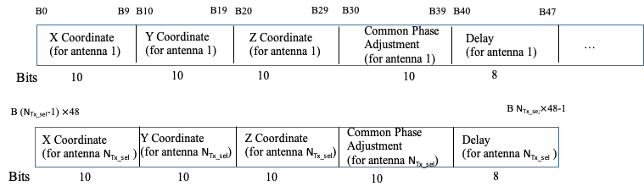

Figure 9-xx3—Antenna Placement and Calibration field format

The X Coordinate field, Y Coordinate field and Z Coordinate field contain the placement information of each antenna, where the origin of the axis which is defined by the Latitude, Longitude and Altitude field values of the LCI subelement, the X axis points to the East, the Y axis points to the North and the Z axis points up and is perpendicular to the plane formed by the X axis and the Y axis.

The values in the X, Y and Z Coordinate field range from 0 to 1023, mapping to -512 to 511, in unites of millimeter.

The value in the Common Phase Adjustment subfield indicates the additional phase rotation introduced in the RF chain that is common for all subcarriers. The value for this subfield, denoted k, ranges from 0 to 1023, and indicates a phase adjustment of .

The value in the Delay subfield indicates the delay per antenna. The value of this subfield, denoted k, ranges from 0 to 255 and indicates (k-128)/10 ns of the delay of an antenna port.

The order of the antenna ports indicated in the Antenna Placement and Calibration field matches the order of the rows in the P matrix applied to the space time streams spatial mapped to the antenna ports.

9.4.2.288 Passive Location LCI Table element

The Passive Location LCI Table Report element, defined in Figure 9-1028, is used by an RSTA to broadcast LCI data for the ISTAs participating in its Passive Location Ranging exchanges.

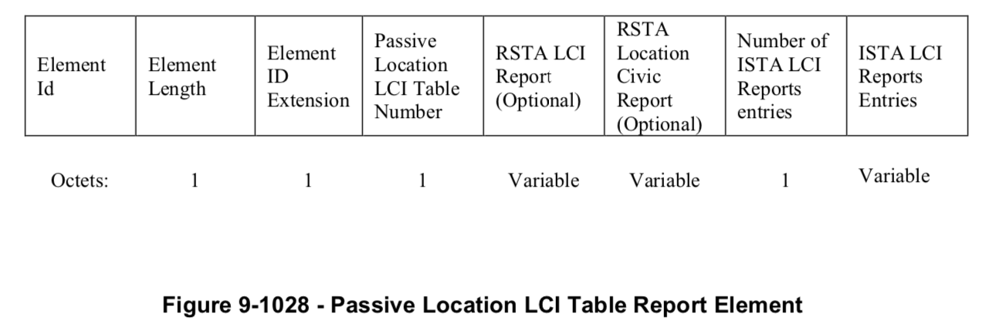
The Element ID, Length and Element ID Extension fields are defined in 9.4.2.1.

11az Editor: change the text below in P802.11az_D1.0 as shown below.

The RSTA LCI Report field is present if the RSTA has never transmitted it before or its content has changed, and it is periodically present otherwise. If present, it contains a Measurement Report element with Measurement Type field equal to LCI (see Table 9-118 (Measurement Type field definitions for measurement reports)), which either indicates the LCI of the RSTA and may include the Z subelement, Usage Rules/Policy subelement, Antenna Placement and Calibration subelement, or indicates an unknown LCI (see 11.22.6.7 (LCI and Location Civic retrieval using FTM procedure)).

The RSTA Location Civic Report field is optionally present. If present, it contains a Measurement Report element with Measurement Type field equal to Location Civic (see Table 9-118 (Measurement Type field definitions for measurement reports)), which either indicates the Civic address of the ISTA or an unknown Civic address (see 11.22.6.7 (LCI and Location Civic retrieval using FTM procedure)).

The ISTA LCI Reports field contains Number of ISTA LCI Reports ISTA LCI Report field fields defined as in Figure 9-1029.

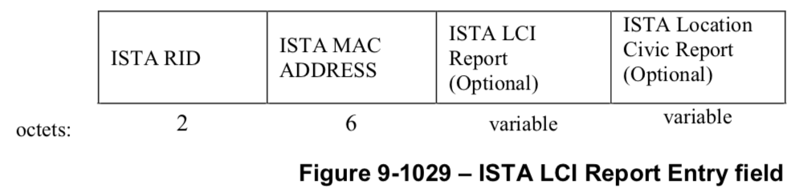

The ISTA RID subfield contains the ranging ID of the ISTA reported on.

The ISTA MAC ADDRESS subfield contains the MAC address of the ISTA reported on.

The ISTA LCI Report subfield is present if the ISTA has never transmitted it before or its content has changed and it is periodically present otherwise. If present, it contains a Measurement Report element with Measurement Type field equal to LCI (see Table 9-118 (Measurement Type field definitions for measurement reports)), which either indicates the LCI of the ISTA and may include the Z subelement, Usage Rules/Policy subelement, Antenna Placement and Calibration subelement or indicates an unknown LCI (see 11.22.6.7 (LCI and Location Civic retrieval using FTM procedure)).

The ISTA Location Civic Report field is optionally present. If present, it contains a Measurement Report element with Measurement Type field equal to Location Civic (see Table 9-118 (Measurement Type field definitions for measurement reports)), which either indicates the Civic address of the ISTA or an unknown Civic address (see 11.22.6.7 (LCI and Location Civic retrieval using FTM procedure)).

When a Measurement Type equal to ‘Relative Compact LCI’ is used in the ISTA LCI reporting, the reference location to which the ISTA’s relative location is reported is the location reported for the RSTA in the Passive Location LCI Table Report within which it is contained.

9.6.7 Public Action details

9.6.7.32 Fine Timing Measurement Request frame format

Insert new columns to the left of Figure 9-876 (Fine Timing Measurement Request Action field format) as shown below:

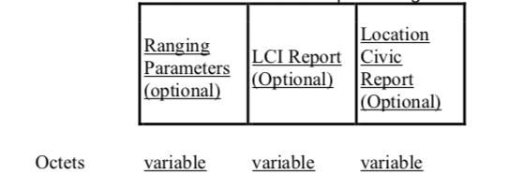
Figure 9-876 Fine Timing Measurement Request Action field format

Change the following paragraphs of Clause 9.6.7.32 as shown below:

The Trigger field set to 1 indicates that the initiating STA requests that the responding STA start or continue sending Fine Timing Measurement frames (see 11.22.6 (Fine timing measurement (FTM) procedure)). The Trigger field set to 0 indicates that the initiating STA requests that the responding STA stop sending Fine Timing Measurement frames. The Trigger field is set to 2 to indicate the initiation of a PDMG/PEDGM FTM measurement exchange using the first path AWV (see 11.22.6.4.7.1 (General)). The Trigger field is set to 3 to indicate that the following FTM burst shall contain an LOS assessment measurement. If the FTM burst is performed over the first path AWV and shall contain an LOS assessment measurement the Trigger field is set to 4. Trigger field values 23–255 are reserved

The Fine Timing Measurement Parameters field is present in the initial Fine Timing Measurement Request frame (see 11.24.6.3 (Fine timing measurement procedure negotiation)) and its retransmissions if the responder selects Fine Timing Measurement as the ranging protocol for the ranging phase; and is not present in subsequent Fine Timing Measurement Request frames. If present, it contains a Fine Timing Measurement Parameters element as defined in 9.4.2.168 (Fine Timing Measurement Parameters element).

Insert the following paragraphs of Clause 9.6.7.32 as shown below:

The Ranging Parameters field is present in the initial Fine Timing Measurement Request frame (see 11.22.6.3 (Fine timing measurement procedure negotiation)) and its retransmissions if the initiator requests negotiation of parameters with the responder in order to perform non-TB ranging and/or TB Ranging protocol(s) with the responder in the ranging phase. If present, it contains a Ranging Parameters element as defined in 9.4.2.279 (Ranging Parameters).

11az Editor: insert the following text after the above paragraph in P802.11az_D1.0.

The LCI Report field and optionally the Location Civic Report fields are present in the initial Fine Timing Measurement Request frame that has the Passive Location Ranging field set to 1. The format of the LCI Report is defined in 9.4.2.21.1 (Measurement Report element, General) and 9.4.2.21.10 (LCI report). The LCI Report contains the Antenna Placement and Calibration subelement if the ISTA has dot11PassiveRangingAoDEnablementActivated set to 1, and does not contain the Antenna Placement and Calibration subelement if the ISTA has dot11PassiveRangingAoDEnablementActivated set to 0. The format of the Location Civic Report is defined in 9.4.2.21.1 (Measurement Report element, General) and 9.4.2.21.13 (Location Civic report).

9.6.7.50 Primus RSTA Broadcast Passive Location Measurement Report frame format

The Primus RSTA Broadcast Passive Location Measurement Report frame is an Action No Ack frame of category Ranging. The Primus RSTA Broadcast Passive Location Measurement Report frame is used to support the passive location ranging mechanisms of the FTM procedure described in 11.22.6 (Fine timing measurement (FTM) procedure). The format of the Primus RSTA Broadcast Passive Location Measurement Report Action field is shown in Figure 9-981e (Primus RSTA Broadcast Passive Location Measurement Report Action field format).

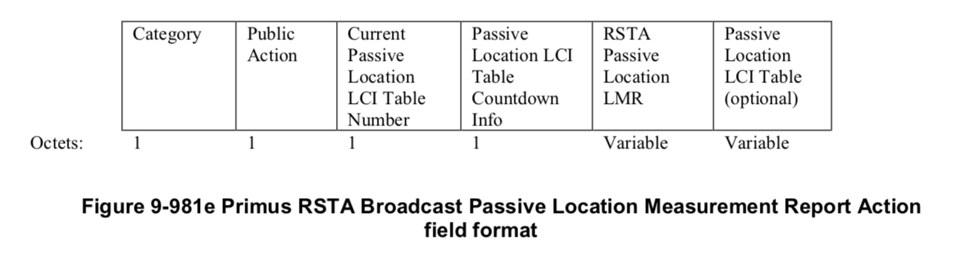
The Category field is defined in 9.4.1.11 (Action field).

The Public Action field is defined in 9.6.8.1 (Public Action frames).

The Current Passive Location LCI Table Number field contains the number of the current valid Passive Location LCI Table.

The Passive Location LCI Table Countdown Info field contains two subfields as shown in Figure 9-981f ‘Passive Location LCI Table Countdown field’.

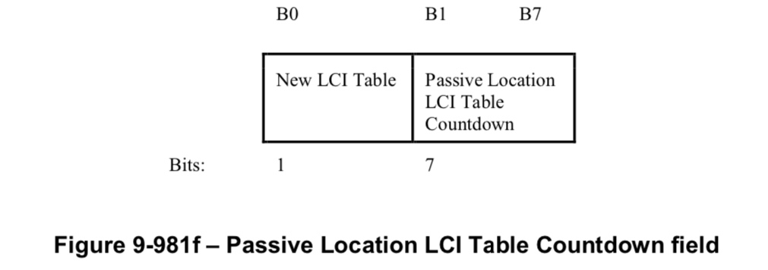

The subfield New LCI Table is 0 if the current LCI table and LCI table to be transmitted at the end of the countdown are the same, else it is 1.

The Passive Location LCI Table Countdown subfield is an index pointing the next Passive Location Ranging Availability window where the Passive Location LCI table will be contained in the Primus RSTA Broadcast Passive Location Measurement Report frame. The current availability window has index zero, the next one has index 1, the one after that has index 2, and so on.

The RSTA Passive Location LMR element is defined in Section 9.4.2.287 (RSTA Passive Location LMR element).

The Passive Location LCI Table field is defined in Section 9.4.2.nnn titled ‘Passive Location LCI Table Report’.

11.22.6.4.10.3 Passive Location Ranging Measurement Reporting

The last part of the Passive Location Ranging measurement sequence is the Passive Location Ranging measurement reporting part and is transmitted a SIFS time after the Passive location ranging measurement sounding part.

In the Passive Location Ranging measurement reporting part, an RSTA shall send a Location Measurement Report frame and the LMR Sub-variant Ranging Trigger Frames to one or more ISTAs that sent an HE Ranging NDP in the preceding passive location ranging measurement sounding part. An ISTA addressed by the LMR Sub-variant Ranging Trigger Frame shall transmit an ISTA Passive Location Measurement Report frame a SIFS time after the LMR Sub-variant Ranging Trigger Frame transmission. The ISTA Passive Location Measurement Report frame is defined in Section 9.6.7.38 (ISTA Passive Location Measurement Report frame format) and contains the ISTAs TOD and TOA time stamps measured by the ISTA during a Passive Location Polling-Sounding-Reporting triplet identified by a Dialog Token included in the report.

The RSTA shall send two RSTA Broadcast Passive Location Measurement Report frames a SIFS time after receiving the ISTA Passive Location Measurement Report frames from the ISTAs.

The Primus RSTA Broadcast Passive Location Measurement Report frame containing the following is transmitted first:
— Current Passive Location LCI Table Number
— Passive Location LCI Table Countdown
— RSTA Passive Location LMR
— Passive Location LCI Table (optionally present)

11az Editor: insert the following text after the above paragraph in P802.11az_D1.0.

When the Passive Location LCI Table is present in the Primus Broadcast Passive Location Measurement Report frame, the RSTA LCI Report field of the Passive Location LCI Table Report element shall contain the Antenna Placement and Calibration subelement if the RSTA has dot11PassiveRangingAoDEnablementActivated set to 1, and shall not contain the Antenna Placement and Calibration subelement if the RSTA has dot11PassiveRangingAoDEnablementActivated set to 0.

When the Passive Location LCI Table is present in the Primus Broadcast Passive Location Measurement Report frame, the corresponding entree of the ISTA LCI Reports Entries field of the Passive Location LCI Table Report element shall contain the Antenna Placement and Calibration subelement if the ISTA has dot11PassiveRangingAoDEnablementActivated set to 1, and shall not contain the Antenna Placement and Calibration subelement if the ISTA has dot11PassiveRangingAoDEnablementActivated set to 0.

See Section 9.6.7.39 Primus RSTA Broadcast Passive Location Measurement Report frame format.

The Secundus RSTA Broadcast Passive Location Measurement Report frame containing the following is subsequently transmitted with a SIFS interval later.
— ISTA Passive Location Measurement Reports

See Section 9.6.7.40 Secundus RSTA Broadcast Passive Location Measurement Report frame format.

11.22.6.7 LCI and Location Civic retrieval using FTM procedure

11az Editor: change the text in P802.11_REVmd_D2.2 as shown below:

Within the FTM procedure, a STA, to request the LCI of a responding STA that transmits an Extended Capabilities element with the Fine Timing Measurement Responder field set to 1, shall include a Measurement Request element with Measurement Type field equal to LCI within the Fine Timing Measurement Request frame.
Within the FTM procedure, a STA, to request the Location Civic of a responding STA that transmits an Extended Capabilities element with the Fine Timing Measurement Responder field set to 1, shall include a Measurement Request element with Measurement Type field equal to Location Civic within the Fine Timing Measurement Request frame.
A Measurement Request element with Measurement Type field equal to LCI shall not be included in a Fine Timing Measurement Request frame unless the Fine Timing Measurement Request frame also includes a Fine Timing Measurement Parameters element or a Ranging Parameters element. A Measurement Request element with Measurement Type field equal to Location Civic shall not be included in a Fine Timing Measurement Request frame unless the Fine Timing Measurement Request frame also includes a Fine Timing Measurement Parameters element or a Ranging Parameters element.
When a responding STA that has both dot11FineTimingMsmtRespActivated and dot11RMLCIConfigured equal to true receives a Measurement Request element with Measurement Type field equal to LCI within an initial Fine Timing Measurement frame, the responding STA shall include a Measurement Report element with Measurement Type field equal to LCI in the initial Fine Timing Measurement frame. If the maximum horizontal or vertical location error of the responding STA relative to a reference STA is known and this relative error is smaller than the absolute error indicated in the LCI subelement, then the responding STA may include a Relative Location Error subfield in the Measurement Report field. The responding STA shall not include a Measurement Report element with the Measurement Type filed equal to LCI in the Fine Timing Measurement frame in the current FTM session unless the responding STA’s LCI has changed since the last time it was reported to the initialing STA.
…

28.3.19 Receiver specification

28.3.19a HE Ranging NDP

….

The HE Ranging NDP has the following properties:
— Uses the HE SU PPDU format but without the Data field.

11az Editor: change the text below in P802.11az_D1.0 as shown:

- No beamforming steering matrix is applied to the waveform, the Beamformed field in HE-SIG-A of a Ranging NDP is always set to 0. For transmission of passive ranging with dot11PassiveRangingAoDEnablementActivated set to 1, when N_{STS} = N_{Tx}, Q matrix is an Identity matrix, and when N_{STS} < N_{Tx}, Q matrix is antenna selection matrix with no antenna swapping. Q matrix becomes an Identity matrix when all 0 rows are removed.
- Can use regular HE-LTFs or Secure HE-LTFs with randomized LTF sequence (see Section 28.3.17d).
- Has a Packet Extension (PE) field that is 4 μs in duration; when using Secure HE-LTFs with randomized LTF sequence, the PE will start with a zero-power GI.
- When the TXVECTOR parameter NUM_USER is more than 1, the TXVECTOR parameter NUM_STS[1]is used to encode the NSTS And Mid-amble Periodicity field of the HE-SIG-A1. Otherwise, the TXVECTOR parameter NUM_STS is used to encode the in the NSTS And Mid- amble Periodicity field of the HE-SIG-A1.
- The TXVECTOR parameter LTF_REP that indicates the number of repetitions of the HE-LTF symbols and TXVECTOR parameter LTF_OFFSET that indicates the number of HE-LTF to skip to receive are not encoded in the HE-SIG-A. For decoding the HE-LTF fields, a PHY- RXLTFSEQUENCE.request primitive issued from the MAC provides the LTF_REP parameter and LTF_OFFSET parameter

Annex C
(normative)
ASN.1 encoding of the MAC and PHY MIB
C. 3 MIB detail
TGaz Editor: Insert the following entries into Dot11WirelessMgmtOptionsEntry as shown below:

Dot11WirelessMgmtOptionsEntry ::= SEQUENCE {
….
dot11PassiveRangingAoDEnablementActivated, TruthValue,
}
TGaz Editor: Insert the following as shown below:

dot11PassiveRangingAoDEnablementActivated OBJECT-TYPE
SYNTAX TruthValue
MAX-ACCESS read-write
STATUS current
DESCRIPTION
"This is a control variable.
It is written by an external management entity or the SME.
Changes take effect at the next occurrence of an MLME-START.request or
MLME-JOIN.request primitive.
This attribute, when true, indicates that the station, when performing passive ranging, enables the AoD measurement by the client STA that locates itself through passive ranging(see 11.22.6.4.10) (Measurement Exchange in Passive Location Ranging Mode)).
False indicates that the station, when performing passive ranging, does not enable the AoD measurement by the client STA that locates itself through passive ranging. (see 11.22.6.4.10) (Measurement Exchange in Passive Location Ranging Mode)."
DEFVAL {true}
::= { dot11WirelessMgmtOptionsEntry <tbd>}

References:

1. IEEE Draft P802.11az_D1.0, Draft standard for information technology – telecommunications and information exchange between systems – local and metropolitan area networks – specific requirements – Part 11: Wireless LAN medium access control (MAC) and physical layer (PHY) specifications, Amendment 8: Enhancements for locationing

