IEEE P802.11
Wireless LANs
802.11 REVmd
LB236 - Proposed Resolutions for CID 2574
Date: 2019-04-03
Author(s):
Name | Company | Address | Phone | email
Emily Qi | Intel Corporation |  |  | Emily.h.qi@intel.com
Abstract

This document contains proposed resolutions for CID 2574

R00: Initial proposal.

7101 | 1706.09 | 11.11.10.3 | "the reporting AP has dot11LciCivicInNeighborReport and the neighbor AP has LCI MeasurementCapability (RM Enabled Capabilities element with the LCI Measurement Capability Enabled fieldset to 1) dot11RMLCIMeasurementActivated equal to true"-- this has at least two errors "has dot11LciCivicInNeighborReport" and"Measurement Capability (...) dot11RMLCIMeasurementActivated equal to true"Note that " (RM Enabled Capabilities element with the LCI Measurement Capability Enabled field set to 1)" is also a informal way of anonymously referencing a transmission by the AP)." this can also be improved. This informality occurs in a number of places in this subclause. The proposed changes addresses two of these. | Change cited text to:"the reporting AP has dot11LciCivicInNeighborReport equal to true and the neighbor AP indicates support for LCI measurement(the neighbor AP has transmitted an RM Enabled Capabilities element with the LCI Measurement Capability Enabled field equal to true)"Make matching changes at 1706.32.

2574 | 11.22.16.2 | 2363.62 | "NOTE---There is no requirement that the number of DMS Request elements and the number of DMS Response elements  match. There is no requirement that the number of DMS Descriptor fields within any DMS Request element matches the  number of DMS Status fields within any DMS Response element." seems to contradict "The response frame shall contain a matching (i.e., as the same DMSID) DMS Status field for each received  DMS Descriptor field preserving the order present in the request frame." above, so the NOTE is not helping. And the number of DMS Req/Rsp elements will always be 0 or 1 anyway | Either make the NOTE clearer, or delete it

Discussion

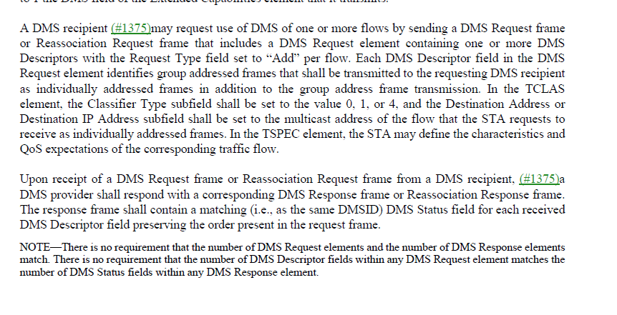

A DMS Request frame includes “multiple” DMS Request elements and a DMS Request element includes “multiple” DMS Descriptors. A DMS Response frame includes “multiple” DMS Response elements and a DMS Response element includes “multiple” DMS Status. There is no requirement on matching numbers of “multiple”.

For example, A DMS Request frame may include 7 DMS Request elements. In each of those DMS Request elements, one DMS Descriptor is included. The corresponding DMS Response frame can include one DMS Response element that includes 7 DMS Status.

Therefore there is no contradiction between the cited note and cited normative sentence.

Proposed Resolution:
Reject.
Rejected Reason: A DMS Request frame includes “multiple” DMS Request elements and a DMS Request element includes “multiple” DMS Descriptors. A DMS Response frame includes “multiple” DMS Response elements and a DMS Response element includes “multiple” DMS Status. There is no requirement on matching numbers of “multiple”. As long as DMS IDs in the DMS Status fields are matching with DMS IDs in DMS Decriptor fields, it would be fine.

There is no contradiction between the cited note and cited normative sentence.

