IEEE P802.11
Wireless LANs

802.11bc Functional Requirements Document
Date: 2019-01-15
Author(s):
Name | Affiliation | Address | Phone | email
Hitoshi Morioka | SRC Software | 2-14-38 Tenjin, Chuo-ku, Fukuoka 810-0001 Japan | +81-92-791-5766 | hmorioka@src-soft.com
Marc Emmelmann | Koden-TI | Berlin, Germany |  | emmelmann@ieee.org

Abstract
This document describes the 802.11bc Functional Requirements.

- Introduction
- Purpose
This document summarizes requirements, which agreed to by the Task Group, for solutions addressing functionality to be provided by the 802.11bc amendment, referred to as the TGbc Functional Requirements (FRs).
- Scope
The scope for deriving functional requirements is primarily set by the P802.11bc PAR Error: Reference source not found and CSD Error: Reference source not found, as well as by the TGbc usage models Error: Reference source not found. Additional requirements may be added if agreed by and considered essential by the task group. The following figure illustrates the workflow on how to derive functional requirements and how to add them to the Functional Requirements Document owned by the task group following the steps of the 802.11bc Selection Procedure [Ref-4].

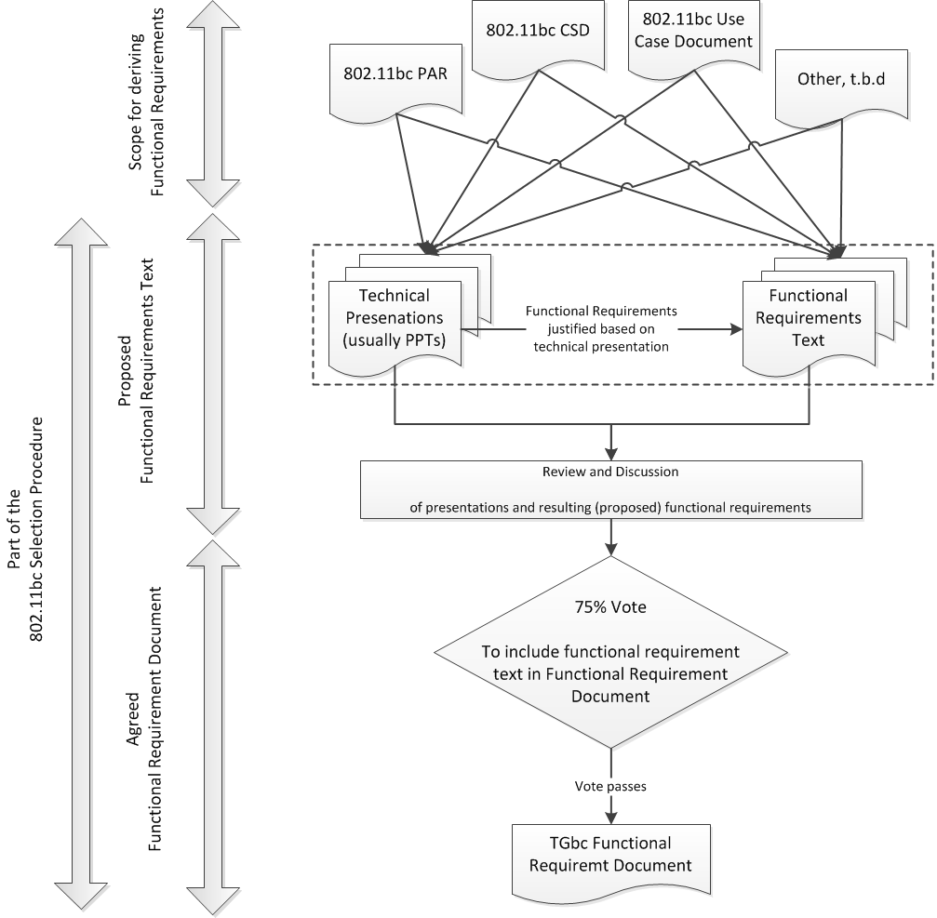

- Notation
Requirements are identified by a preceding unique number in the format of “TGbc Rn”, where n is an integer number representing the ID of the requirements.

- Functional Requirements

- References
- https://mentor.ieee.org/802.11/dcn/18/11-18-0825-09-0bcs-a-par-proposal-for-bcs.docx
- https://mentor.ieee.org/802.11/dcn/18/11-18-0826-09-0bcs-a-csd-proposal-for-bcs.docx
- [TBD – TGbc Use Case Document if created]
- [TBD -- TGbc Selection Procedure]

