IEEE P802.11  
Wireless LANs

|  |  |  |  |  |
| --- | --- | --- | --- | --- |
| ARC SC Meeting Minutes November 2018 | | | | |
| Date: 2018-11-13 | | | | |
| Author(s): | | | | |
| Name | Affiliation | Address | Phone | email |
| Joseph LEVY | InterDigital Communication, Inc. | 2 Huntington Quadrangle  4th floor, South Wing Melville, NY 11747 | +1.631.622.4139 | [joseph.levy@interdigital.com](mailto:joseph.levy@interdigital.com) |

Abstract

This document contains the minutes of the IEEE 802.11 ARC SC meeting sessions held on 13 November 2018 at 16:00 ICT, 14 November 2018 at 8:00 ICT, and 15 November 2018 at 10:30 ICT in Bangkok, Thailand

Note: Highlighted text are action items.

**Contents:**

Tuesday, 13 November 2018, PM2 3

Wednesday, 14 November 2018, AM1 7

Thursday, 15 November 2018, AM2 9

# Tuesday, 13 November 2018, PM2

**Administration:**

**Chair: Mark Hamilton, Ruckus/Arris**

**Vice Chair/Secretary Joseph Levy, InterDigital**

**Meeting call to order in ARC meeting room by Chair 16:01 ICT,**

Agenda slide deck: [11-18/1725r2](https://mentor.ieee.org/802.11/dcn/18/11-18-1725-02-0arc-arc-sc-agenda-nov-2018.pptx), proposed agenda copied here for reference:

**Tuesday, November 13, PM2**

* Administrative: Minutes
* IEEE 1588 mapping to IEEE 802.11/802.1ASrev and use of FTM
* 802 (and 802.1) activities: 802.1CQ: [11-18/1934r0](https://mentor.ieee.org/802.11/dcn/18/11-18-1934-00-0arc-mac-address-assignment-in-ieee-802-11.pptx)
* IETF/802 coordination
* WBA liaison, on MAC Address Randomization: [11-18/1579r1](https://mentor.ieee.org/802.11/dcn/18/11-18-1579-01-0000-2018-09-liaison-from-wba-re-mac-randomization-impacts.docx), [11-18/1671r0](https://mentor.ieee.org/802.11/dcn/18/11-18-1671-00-0arc-notes-for-response-to-wba-liaison-on-mac-address-randomization.docx), [11-18/1988r0](https://mentor.ieee.org/802.11/dcn/18/11-18-1988-00-0arc-proposed-response-to-liaison-from-wba-on-mac-address-randomization-impcats.docx)

**Wednesday, November 14, AM1**

* TGba (WUR) continued discussion: [11-18/1017r0](https://mentor.ieee.org/802.11/dcn/18/11-18-1017-00-0arc-wur-multi-ap-reference-model.vsd), [11-18/1020r5](https://mentor.ieee.org/802.11/dcn/18/11-18-1020-05-0arc-discussion-on-wur-802-11ba-states.pptx), [11-18/1494r2](https://mentor.ieee.org/802.11/dcn/18/11-18-1494-02-00ba-overview-of-802-11-ba-power-management-in-d0-4.pptx), [11-18/1641r0](https://mentor.ieee.org/802.11/dcn/18/11-18-1641-00-0arc-discussion-on-wur-802-11ba-nomenclature.pptx)
* New topics:
* Multiple MAC Addresses (and IPv6), “Multiple radios”
* System architecture views for common use scenarios
* Continue the other items, as needed

**Thursday, November 15, AM2**

* + Future sessions / SC activities
  + Finalize Response to WBA liaison, on MAC Address Randomization
  + NEW TOPIC: Multiple MAC Addresses (and IPv6), “Multiple radios” (any contributions?)
  + NEW TOPIC: System architecture views for common use scenarios (any contributions?)
  + “What is an ESS?”: [11-18/1051r3](https://mentor.ieee.org/802.11/dcn/18/11-18-1051-03-0arc-what-is-an-ess.pptx)
  + Consider IETF DetNet/time-sensitive networking input (potential relationship to RTA TIG?)
  + AP/DS/Portal architecture and 802 and GLK concepts - [11-17/0136r2](https://mentor.ieee.org/802.11/dcn/17/11-17-0136-02-0arc-bridging-architecture-considerations.docx), [11-16/1512r0](https://mentor.ieee.org/802.11/dcn/16/11-16-1512-00-0arc-glk-802-1q-bridge.pptx), [11-16/0720r0](https://mentor.ieee.org/802.11/dcn/16/11-16-0720-00-0arc-stacked-architecture-discussion.pptx), [11-15/0454r0](https://mentor.ieee.org/802.11/dcn/15/11-15-0454-00-0arc-some-more-ds-architecture-concepts.pptx), [11-14/1213r1](https://mentor.ieee.org/802.11/dcn/14/11-14-1213-01-0arc-ap-arch-concepts-and-distribution-system-access.pptx) (slides 9-11)
  + MLME-RESET, versus MLME-JOIN and MLME-START
  + Does TGba discussion lead into other “split” PHYs (LC, 28 GHz (Phazr))?
  + Continue the other items, as needed

**Administration:**

The Chair reviewed the Administrative information in slides 5-10 in Agenda document,

**Call for Patents:**

The Chair reviewed the Patent policy and called for potentially essential patents – there was no response to the call.

**Approval of the Agenda:**

The Chair reviewed the agenda and called for comments or amendments to the agenda – there was no response to the call.

The proposed agenda was approved by unanimous consent.

**ARC Minutes:**

* **September face-to-face minutes:**
  + [11-18/1726r0](https://mentor.ieee.org/802.11/dcn/18/11-18-1726-00-0arc-arc-sc-meeting-minutes-september-2018.docx)
* **Oct 11 teleconference:** 
  + [11-18/1758r0](https://mentor.ieee.org/802.11/dcn/18/11-18-1758-00-0arc-arc-sc-teleconference-minutes-11-october-2018.docx)

Minutes approved by unanimous consent.

**IEEE 1588 mapping to IEEE 802.11/802.1ASrev use of FTM update**

Update (Ganesh Venkatesan, Intel)

Working with 802.1AS – providing support for fine timing measurement – they have comments on the FTM protocol – the one comment they would like to resolve is about that there are two protocols, and how they can avoid conflict – they have asked WFA which protocol they should use, but they got no response. So, they are implementing both protocols for switches, allowing end stations to use either one.

**IEEE 1588/802.1AS**

First Sponsor Ballot of IEEE 1588 revision, Sept 17 – Oct 28

**802.1ASrev use of 802.11 FTM:**

D7.3 in WG recirculation comment resolution ([802-1AS-rev-d7-3.pdf](http://www.ieee802.org/1/files/private/as-rev-drafts/d7/802-1AS-rev-d7-3.pdf), [802-1AS-rev-d7-3-dis-v01.pdf](http://www.ieee802.org/1/files/private/as-rev-drafts/d7/802-1AS-rev-d7-3-dis-v01.pdf) )

**802 (and 802.1) activities: 802.1CQ:**

[11-18/1934r1](https://mentor.ieee.org/802.11/dcn/18/11-18-1934-01-0arc-mac-address-assignment-in-ieee-802-11.pptx) Presented by: Antonio de la Oliva (InterDigital, University Carlos III of Madrid)

* Comment – from a .11 perspective all security is based on the MAC address – if you are looking at FILS or SAE – if you are using .1X – all security is negotiated after association.
* Comment – why do we need this MAC allocation in the first place? Then we could discuss this.
* Ans – in 802.c we will have these 4 quadrants – maybe right now it is not clear why we need the 4 quadrants – if you have the 4 quadrants, you can use simple routing in the network. For IoT it can save you.
* Comment – the routing is usually after association
* Ans- but then you would have to reassociate. Which takes extra time.
* Comment – so the question is how often.
* Comment – we discussed this morning, in WNG, the question is how far is local. So, the big problem is what is local, how far does the MAC address go. If the AP hides the MAC address – which will allow proxy.
* Chair – the scope of the network domain, verses local domain (broadcast domain).
* Comment – the 1CQ is not about avoiding collisions – it is about assigning specific addresses to terminals.
* Comment – and there is something in the protocol which makes the address unique?
* Comment – yes that is case.
* Comment - there are multiple use cases –
* Comment – it is not only self assignment or one address that is assigned.
* Comment – it is highly desirable – that the MAC address and the IP address match – as this allows it to be compressed. You can formulate an IPv6 based on the MAC address – if you register all of your MAC addresses – you can then associate with the address and you can make sure no one can steal your address, it is important that you can own your address – keeping it unique. But, this can be done 8505 can allow the proxy function, keeping things unique.
* Chair – this seems to be a .1 conversation, so who is driving this.
* Comment – Roger Marks is the editor, and Max Riegel is the OmniRAN Chair, this project in under OmniRAN in 802.1.
* Comment – part of this project – is about devices claiming their addresses. We’ve had a proposal from DHCP address people, which can cover some cases where DHCP v6 applies, but we also need additional methods. If you need to do a double association it not really a big problem.
* Comment – for .1CQ – without an association procedure, we have problems extending this to .11.
* Chair – is .1CQ – far along enough to provide more specific requirements than this presentation.
* OmniRAN Chair – we are working the solution, but we need to address the .11 piece to complete our work.
* Chair – so you are far enough that you have found a gap that needs to be address
* Comment – the issue for us (.11) the MAC address needs: the issue when do we kick the process off, if we do it earlier it could cause problems, we could piggyback it on the .11 security protocols – but there are issues here, it is not a quick fix.
* Chair – one of the issues out of the MAC randomization, we have to deal with address being used for probing.
* Comment – maybe we need to look at the JOIN or SCAN primitives.
* Comment – in an AP we have the concept of a link local MAC address – there doesn’t need to be anyone other than me to assign a unique address – in 1504 there is a short address.
* Chair – that assumes you have peer to peer links.
* Comment – it sounds simple, when you look at the details in .11 it become complicated, it will be hard to make it work.
* Comment – I don’t think we will support link level connectivity.
* Chair – I think .1 will need to explain what is missing.
* Comment - the base is .11aq – but then we got told it will not really work. We can document what we will do in the external, but we can’t do the details.
* Chair – well that is what we want, we don’t expect you to solve the problem.
* Comment – the .11 experts were Stephen McCann and Roger Marks.
* Chair – so we request .1 to provide a problem statement to the .11 ARC SC with.
* Stephen McCann volunteered to try to follow this .1 activity and to report back to the .11 ARC SC
* Comment from a .1 participant – we (.1) will try to write a problem statement.
* Comment – if you can document the problem – even from the .3 perspective – we may be able to work with it.
* Comment - .21 was faced with this years ago, and the .21 architecture may address these issues.
* Comment – after the last .21 rev all information was removed, so don’t look at the publish standard, look at annex F, in the pre- published version.

**Local Administrative 11-18/2022r0 – Stephen McCann, Blackberry.**

Comment – you say yourself don’t believe it, so what is the value.

Ans – this mechanism may allow you to select a BSS – this may be a quick way to find the network with locally administrated addresses.

Comment – if you don’t trust this piece then there is no benefit, so you will have to assume that this is correct.

Question: Have you thought about the difference between what proposed here vs. what is proposed in [11-18/1934r1](https://mentor.ieee.org/802.11/dcn/18/11-18-1934-01-0arc-mac-address-assignment-in-ieee-802-11.pptx)?

Ans – so you may be using a hash – and bloom filters.

Comment – to answer the question – this is complementary – the PAD is an advertising mechanism, so it is like anything else and is used by the station to select things.

Question: Are you saying the STA can’t use a randomized MAC? The user may want the STA to use a randomized MAC address.

Chair – well you could view this as a hint – as to if you should use a random MAC or your real MAC.

Question: When you use ANQP what are you getting.

Comment - this could give you additional information

Chair – how do you do this without a MAC?

Ans – the STA has a MAC address to do ANQP –

Question – do people want me to do more work on this or not.

Ans – Stephen McCann will liaise with .1 and see how things go, and report back.

**IEEE 802 activities directly related to IEEE 802.11 ARC**

802.1CQ update (Stephen McCann/Mike Montemurro/Roger Marks)

802.1CQ is currently gathering Scenarios and Functions

Considering Local MAC Address Assignment Protocol(LAAP)

Discovery of an address server for local addresses on the network

Relation to 802.11aq/other 802.11?

Discuss with ARC, and 11aq experts

**IETF/802 coordination**

*Peter Yee* the IETF Liaison – deferred till later in the week.

Pascal Thubert (Cisco) – presenting 11-18/1920r2 –

There may be ARC issues regarding – the way layer 3 services interact with the layer 2 services – or there may not be. This needs to be reviewed in detail to see if there are .11 issues with the current proposed solution. Will be discussing this in the TGmd session tomorrow – PM1 Wednesday.

**WBA liaison on MAC Address randomization**

Incoming liaison is here: [11-18/1579r1](https://mentor.ieee.org/802.11/dcn/18/11-18-1579-01-0000-2018-09-liaison-from-wba-re-mac-randomization-impacts.docx)

* Points out several areas of concern for WBA members, if/when MAC Addresses are randomized
* Majority of concerns (but not all) are higher layer uses
* Majority of concerns are post-association w/random MAC Address

Discussion notes for 802.11 (ARC) discussion so far, are here: [11-18/1671r0](https://mentor.ieee.org/802.11/dcn/18/11-18-1671-00-0arc-notes-for-response-to-wba-liaison-on-mac-address-randomization.docx)

Initial draft of response: [11-18/1988r0](https://mentor.ieee.org/802.11/dcn/18/11-18-1988-00-0arc-proposed-response-to-liaison-from-wba-on-mac-address-randomization-impcats.docx)

Chair reviewed [11-18/1988r0](https://mentor.ieee.org/802.11/dcn/18/11-18-1988-00-0arc-proposed-response-to-liaison-from-wba-on-mac-address-randomization-impcats.docx)– asking for review and comments.

Chair also reviewed [11-18/1671r1](https://mentor.ieee.org/802.11/dcn/18/11-18-1671-01-0arc-notes-for-response-to-wba-liaison-on-mac-address-randomization.docx) – showing where we are at and what we need to address – will talk about Thursday morning. So, if you’ve been involved refresh yourself and be ready to complete this work Thursday morning.

Comment - The 33-33 address is used to generate a broad cast – to find if you are there.

Comment – some of these IPV6 address are being used for privacy.

Comment – every time you choose a IPV6 address – you would transmit the 33-33 address to check if it is clear.

Comment – we don’t need to include the 11aq and related stuff – as they don’t need to know this stuff.

Chair – Plan to continue this discussion, complete proposed response on Thursday.

**Recessed:** 18:03 ICT.

# Wednesday, 14 November 2018, AM1

**Call to order 8:06 ICT**

**Agenda document:** [11-18/1725r3](https://mentor.ieee.org/802.11/dcn/18/11-18-1725-03-0arc-arc-sc-agenda-nov-2018.pptx)

**Agenda:**

* TGba (WUR) continued discussion: [11-18/1017r0](https://mentor.ieee.org/802.11/dcn/18/11-18-1017-00-0arc-wur-multi-ap-reference-model.vsd), [11-18/1020r5](https://mentor.ieee.org/802.11/dcn/18/11-18-1020-05-0arc-discussion-on-wur-802-11ba-states.pptx), [11-18/1494r2](https://mentor.ieee.org/802.11/dcn/18/11-18-1494-02-00ba-overview-of-802-11-ba-power-management-in-d0-4.pptx), [11-18/1641r0](https://mentor.ieee.org/802.11/dcn/18/11-18-1641-00-0arc-discussion-on-wur-802-11ba-nomenclature.pptx)
* New topics:
* Multiple MAC Addresses (and IPv6), “Multiple radios”
* System architecture views for common use scenarios
* Continue the other items, as needed

**Administration:**

The Chair reviewed the Administrative information in slides 5-10 in Agenda document,

**Call for Patents:**

The Chair reviewed the Patent policy and called for potentially essential patents – there was no response to the call.

**Approval of the Agenda:**

The Chair called for comments or amendments to the agenda – there was no response to the call

The proposed agenda was approved by unanimous consent.

**TGba (WUR) continued discussion:** [**11-18/1017r0**](https://mentor.ieee.org/802.11/dcn/18/11-18-1017-00-0arc-wur-multi-ap-reference-model.vsd)**,** [**11-18/1020r5**](https://mentor.ieee.org/802.11/dcn/18/11-18-1020-05-0arc-discussion-on-wur-802-11ba-states.pptx)**,** [**11-18/1494r2**](https://mentor.ieee.org/802.11/dcn/18/11-18-1494-02-00ba-overview-of-802-11-ba-power-management-in-d0-4.pptx)**,** [**11-18/1641r0**](https://mentor.ieee.org/802.11/dcn/18/11-18-1641-00-0arc-discussion-on-wur-802-11ba-nomenclature.pptx)

Starting with slide 19,

[**11-18/1641r0**](https://mentor.ieee.org/802.11/dcn/18/11-18-1641-00-0arc-discussion-on-wur-802-11ba-nomenclature.pptx) - Joseph Levy (InterDigital)

Long discussion on 2 different points of view of describing what a non-AP STA is:

1. WUR is a capability of a STA
2. WURx is a separate entity

Comment – his big concern about integration of WUR into the overall specification. It all needs to fit together.

Redefining “non-AP STA”:

* Not necessary. Well defined currently. It is what 11ba is calling PCR.
* So, don’t define PCR, use existing (not modified) non-AP STA for this concept

There are other things that can negotiate WUR setup, or send WUR frames. Why restrict it to an AP?

* Starting from the (agreed) notion that a 5 GHz AP and a 2.4 GHz AP are two APs in the same box, it is clear that negotiating WUR with the 5 GHz AP (can) results in the 2.4 GHz AP sending the actual WUR wake-up frames.
* Comment - So, far, there seems to be general agreement with these comments. Note that “PCR” came from the way the spec was developed, to help make it clear to those working within TGba what concepts were being developed, before we really knew what it would end up like.
* Comment - On the AP, WUR is just a new waveform capability, like VHT or HE. This could be imagined on the non-AP STA, too – it just has another receiver waveform capability.

The author stated that the current 11ba spec says a WUR non-AP STA is the colocation of a PCR and a WURx. This is a bit confusing, because it results in a WUR non-AP STA containing a STA (the PCR). How can a STA contain a STA? Prefer to call this device a “WUR device” (or equivalent).

* Is an “HE STA” a dual-band concept? No, the dual-band concept is a device that contains two STAs. Not sure that’s how HE specified it.
* By extension, how does 11ba want to talk about WURx band relative to PCR band? There is no restriction today that there has to be a PCR on the band that a WURx is on. It was suggested that TGba should discuss this, and reach a consensus.
* Remember that the WURx does not transfer data. There is no MAC-SAP for it. It doesn’t have to act like a “STA”. There is no part of the WURx in the data plane.
* Think about this from an implementation view. An implementer should be able to make a simple device that only operates on one band.
* Comment: Yes, but we need to ask if we want the implementer to be capable (within the scope of the amendment) of building a device that does multiple bands.
* Question: Is there a concept (security, routing, other state, etc.) that draws a clear need for the WURx to be a separate entity from the PCR?
* Question: Is the PCR a (non-AP) STA? Yes. Is it a STA with a capability to negotiate WUR agreements?
* The WURx does have a little bit of MAC function in it. The question is whether this bit of MAC function can be/should be within the same (single) MAC (of the PCR) or if it is/should be a separate MAC with communication between the two MACs? This is probably the fundamental question to how to describe the architecture. It could be done either way. Which is better in terms of explaining the amendment to the reader? Which is better in terms of our ability to describe the interactions and complexity this capability can add?
* Is the WURx power on/off (“doze”) concept really any different than SM power save? SM power save can “power down” parts of the STA (some of the chains). Is WURx’s concept of powering down the PCR similar?
* Comment: But, even when doing SM power save, the reduced chains being enabled are still operating in both the control and data planes. WURx power save mode is ‘bigger’, since it has no data plane in that mode.
* Comment: While true, it’s not clear that’s important.
* We should consider the implications on the rest of 802.11, when 11ba is added. How does it affect any other (existing) features/behaviors?
* Comment: Are we are limiting where 11ba can operate, to narrowly? What do we need to focus on? For example, the WURx can only operate in 2.4 GHz or 5 GHz. The PCR has to support non-HT (to make the wake-up frame protection work).
* Comment: But, does this need to be specified or is it simply part of a STA’s current required capabilities?
* Off-line work:

Actions:

* TGba folks, look at how things are described, and perhaps tweak to lead the reader to the understanding and mental model that WUR is a “capability” and not a separate entity.
* ARC folks, look at the latest 11ba draft, and see if the concepts are consistent, when read from this point of view, of a “capability”

**Recessed:** 10:04 ICT.

# Thursday, 15 November 2018, AM2

**Call to order:** 10:32 AM ICT

Agenda:

* Future sessions / SC activities
* Finalize Response to WBA liaison, on MAC Address Randomization
* NEW TOPIC: Multiple MAC Addresses (and IPv6), “Multiple radios” (any contributions?)
* NEW TOPIC: System architecture views for common use scenarios (any contributions?)
* “What is an ESS?”: [11-18/1051r3](https://mentor.ieee.org/802.11/dcn/18/11-18-1051-03-0arc-what-is-an-ess.pptx)
* Consider IETF DetNet/time-sensitive networking input (potential relationship to RTA TIG?)
* AP/DS/Portal architecture and 802 and GLK concepts - [11-17/0136r2](https://mentor.ieee.org/802.11/dcn/17/11-17-0136-02-0arc-bridging-architecture-considerations.docx), [11-16/1512r0](https://mentor.ieee.org/802.11/dcn/16/11-16-1512-00-0arc-glk-802-1q-bridge.pptx), [11-16/0720r0](https://mentor.ieee.org/802.11/dcn/16/11-16-0720-00-0arc-stacked-architecture-discussion.pptx), [11-15/0454r0](https://mentor.ieee.org/802.11/dcn/15/11-15-0454-00-0arc-some-more-ds-architecture-concepts.pptx), [11-14/1213r1](https://mentor.ieee.org/802.11/dcn/14/11-14-1213-01-0arc-ap-arch-concepts-and-distribution-system-access.pptx) (slides 9-11)
* MLME-RESET, versus MLME-JOIN and MLME-START
* Does TGba discussion lead into other “split” PHYs (LC, 28 GHz (Phazr))?
* Continue other items

Agenda is approved: [11-18/1725r3](https://mentor.ieee.org/802.11/dcn/18/11-18-1725-03-0arc-arc-sc-agenda-nov-2018.pptx)

**Administration:**

The Chair reviewed the Administrative information in slides 5-10 in Agenda document,

**Call for Patents:**

The Chair reviewed the Patent policy and called for potentially essential patents – there was no response to the call.

**Future sessions / SC activities**

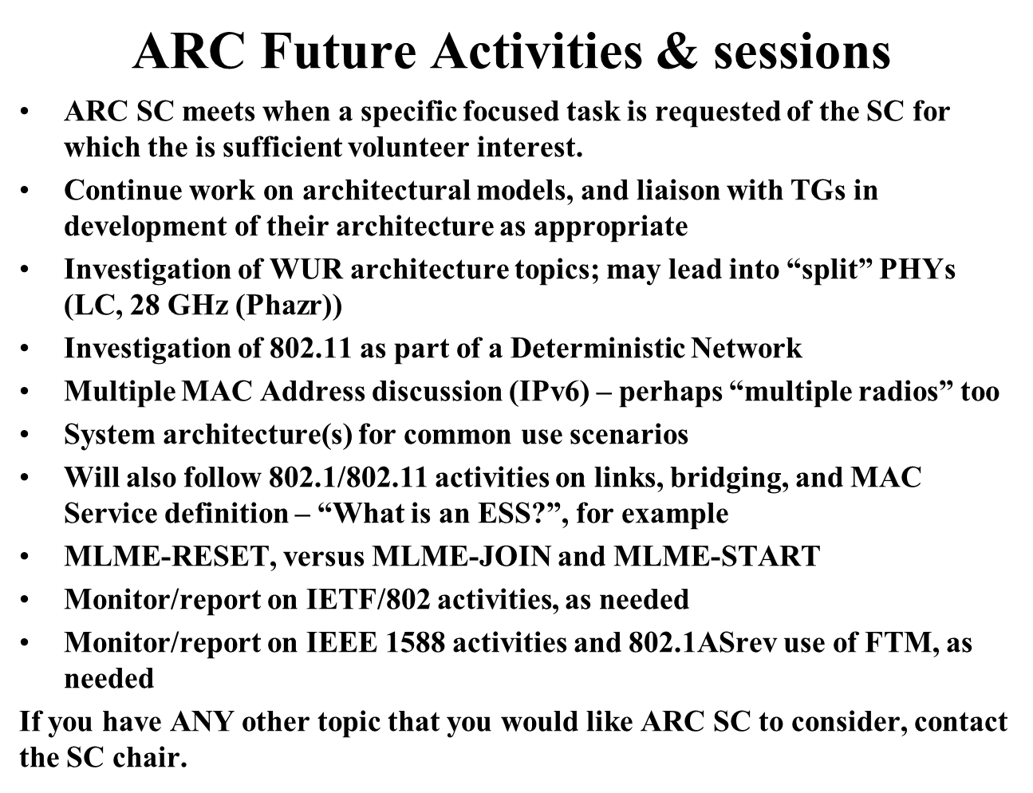

**Planning:  
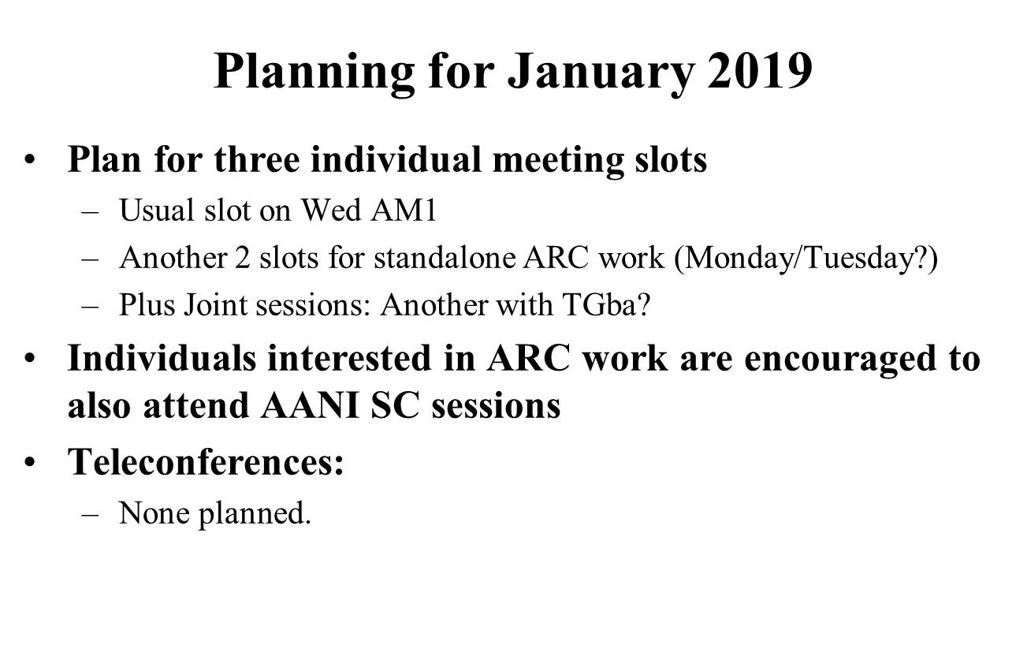**

**Finalize Response to WBA liaison, on MAC Address Randomization**

**Incoming in 11-18/1579r1**

**Proposed draft response:** [11-18/1988r1](https://mentor.ieee.org/802.11/dcn/18/11-18-1988-01-0arc-proposed-response-to-liaison-from-wba-on-mac-address-randomization-impcats.docx) **- will be r2 coming out of session.**

The Chair reviewed of the document.

Multiple comments and discussion followed, the draft was updated during the discussion.

**Motion:**

Approve [11-18/1988r2](https://mentor.ieee.org/802.11/dcn/18/11-18-1988-02-0arc-proposed-response-to-liaison-from-wba-on-mac-address-randomization-impcats.docx) to be sent by the IEEE 802.11 WG to the Wide Band Alliance and copied as shown in the document.

Moved: Dan Harkins (HPE)

Second: Michael Fischer (NXP)

Approved by unanimous consent. 17 present.

No other business was discussed.

**Adjourned 12:30 ICT**

Note: final agenda slide deck is: [11-18/1725r2](https://mentor.ieee.org/802.11/dcn/18/11-18-1725-02-0arc-arc-sc-agenda-nov-2018.pptx) and closing report is: [11-18/2055r0](https://mentor.ieee.org/802.11/dcn/18/11-18-2055-00-0arc-arc-closing-report-nov-2018.pptx)