IEEE P802.11
Wireless LANs
July 2018 BCS SG San Diego Session Minutes
Date: 2018-07-17
Author(s):
Name | Affiliation | Address | Phone | email
Xiaofei Wang | InterDigital Inc. | 2 Huntington Quad  Melville, NY 11747  USA | +1-607-592-2727 | Xiaofei.wang@interdigital.com
Abstract
BCS SG meeting minutes of the IEEE 802.11 San Diego Session, July 9 – 13, 2018.

BCS SG July 2018 San Diego Meeting Minutes

Chair: Marc Emmelmann (Koden-TI)
Vice Chairs: Hitoshi Morioka (SRC Software) & Stephen McCann (BlackBerry)
Secretary: Xiaofei Wang (InterDigital Inc.)

July 9th Monday PM2 Session:

- Chair called the meeting to order at 16:00.
Agenda 11-18/0987r1.
  - Chair introduces himself, vice chairs, and the secretary and their affiliations
  - Motion to approve:
- Agenda 11-18/987r1
    - Moved: Stephen McCann
    - Seconded: Bahar Sadeghi
    - Unanimously approved.

On consent agenda:
2. BCS TIG/SG Meeting Minutes as contained in 11-18/0901r0
3. BCS TIG/SG teleconference minutes as contained in 11-18/1022r0
4. BCS TIG/SG teleconference minutes as contained in 11-18/1031r0
5. BCS TIG/SG teleconference minutes as contained in 11-18/1077r0
6. BCS TIG/SG teleconference minutes as contained in 11-18/1126r0

- Chair reminder on meeting and patent policy.
  - Chair calls for essential patents and no notice was given
  - Chair reminds attendees that participation is on an individual basis
- BCS Submissions & PAR Discussion
  - Chair calls for additional submissions and none was indicated
  - A PAR Proposal for BCS 11-18/825r2 Stephen McCann (BlackBerry)
    - The group conducted live edits on the proposed PAR and the result was uploaded to mentor as 11-18/825r3
    - Straw Poll:
      - Do you support that the PAR document is ready to be forwarded to the WG for approval?
      - Y/N/A: 14/0/10
- Recessed at 17:52.

July 12th Thursday AM1 Session:

- Chair called the meeting to order at 8:04.
  - Chair introduced himself, vice chairs and the secretary and their affiliations
  - Chair reminder on meeting and patent policy.
  - Chair calls for essential patents and no notice was given
  - Motion to approve Agenda: 11-18/987r5.
    - Unanimously approved.

- Presentations
  - A CSD Proposal for EBS 11-18/826r3 Marc Emmelmann (Koden-TI)
    - The group conducted live edits on the CSD proposal for EBS and the result was 11-18/826r4 that was uploaded to mentor

- Recessed at 9:58.

July 12th Thursday PM2 Session:
- Chair called the meeting to order at 16:02.
  - Chair introduced himself, vice chairs and the secretary and their affiliations
  - Chair reminder on meeting and patent policy.
  - Chair calls for essential patents and no notice was given
  - Move to approve agenda: 11-18/987r7 (including teleconference schedules per consent agenda).
    - Mover: Xiaofei Wang (InterDigital)
    - Hitoshi Morioka (SRC Software)
    - Unanimously approved.
- Presentations
  - A PAR Proposal for EBS 11-18/825r5 Marc Emmelmann (Koden-TI)
    - Proposed PAR has been updated to r5 incorporating comments received during the meeting
    - The group conducted live edits and the results is uploaded to mentor as 11-18/825r6.
  - Straw Poll:
    - Do you agree that the PAR and CSD are ready for requesting WG review with the goal of WG approval in the September 2018 meeting?
    - Y/N/A: 9/0/1
- Administrative Items
  - Teleconferences were approved as part of consent agenda approval (approved)
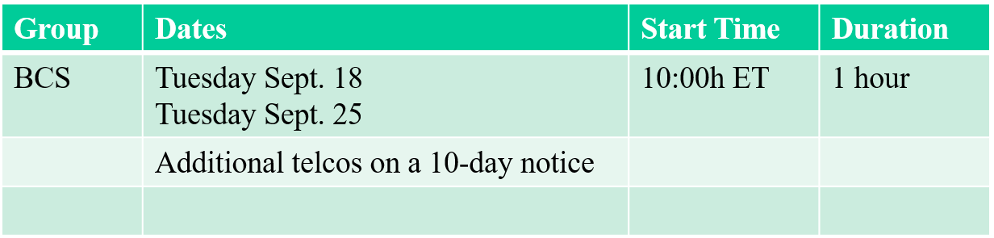

  - Timeline
      - Motion: Move to approve the following timeline for BCS SG:
- Motion PAR/CSD in Sept. WG Closing Plenary
- Post to 802 EC Agenda (due Oct 5)
- PrePost to NesCom Agenda by Oct. 15.
- 802 Plenary process PAR comments in November Plenary
- WG final approval of PAR Nov 2018
- 802 EC Approval of PAR Nov 2018
- SASB/NesCom approval of PAR in December 2018
- Task Group first mtg January 2019
      - Mover: Hitoshi Morioka
      - Seconder: Stephen McCann
      - Approved with unanimous consent

- Old business
  - No old business

- New business
  - No new business

- Adjourned at 17:13.

