IEEE P802.11  
Wireless LANs

|  |  |  |  |  |
| --- | --- | --- | --- | --- |
| Post Ballot LB232 Comments | | | | |
| Date: 2018-07-09 | | | | |
| Author(s): | | | | |
| Name | Affiliation | Address | Phone | email |
| Song H An | Independent | 11835 Carmel Mountain Road, # 1304-328  San Diego, CA 92128 | +1 858-414-2464 | songan@ieee.org |
|  |  |  |  |  |

Abstract

This document contains two post ballot (LB232) comments. Although they appear editorial in nature, they involve equation and parameter value.

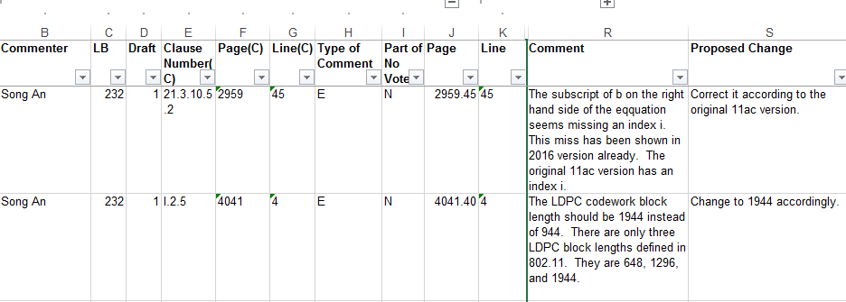

**D1.0 (& D1.2)**

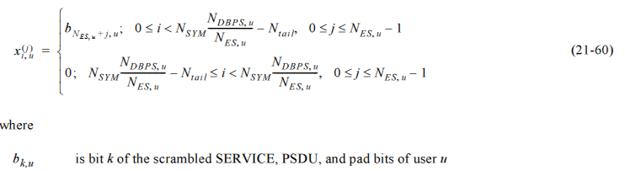

**Original 11ac text**

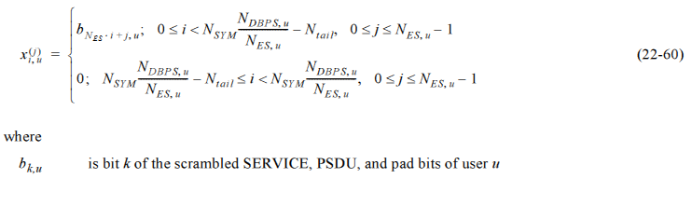

**2016 Verion**

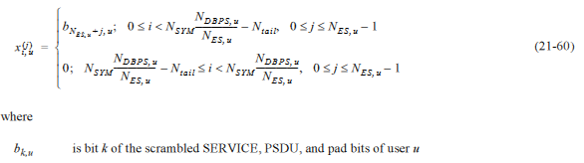

**References:**

N/A