IEEE P802.11
Wireless LANs
802.11
LB232 - Proposed Resolutions for EDITOR ad hoc
Date: 2018-04-23
Author(s):
Name | Company | Address | Phone | email
Emily Qi | Intel Corporation |  |  | Emily.h.qi@intel.com
Abstract

This document contains proposed resolutions to LB232 editorial comments that require TG’s feedback.

R00: Initial proposal.
R01: updated resolutions based on the feedback received from Ad hoc meeting on April 11, AM1. Added CID 1283.
R02: updated resolutions based on the feedback received from Ad hoc meeting on April 12.
R03: updated CID 1508

7101 | 1706.09 | 11.11.10.3 | "the reporting AP has dot11LciCivicInNeighborReport and the neighbor AP has LCI MeasurementCapability (RM Enabled Capabilities element with the LCI Measurement Capability Enabled fieldset to 1) dot11RMLCIMeasurementActivated equal to true"-- this has at least two errors "has dot11LciCivicInNeighborReport" and"Measurement Capability (...) dot11RMLCIMeasurementActivated equal to true"Note that " (RM Enabled Capabilities element with the LCI Measurement Capability Enabled field set to 1)" is also a informal way of anonymously referencing a transmission by the AP)." this can also be improved. This informality occurs in a number of places in this subclause. The proposed changes addresses two of these. | Change cited text to:"the reporting AP has dot11LciCivicInNeighborReport equal to true and the neighbor AP indicates support for LCI measurement(the neighbor AP has transmitted an RM Enabled Capabilities element with the LCI Measurement Capability Enabled field equal to true)"Make matching changes at 1706.32.

1092 | 244.48 | 9.5.4.5 | The line that ends "... means of various protocols and handshakes" is now meaningless (following 11ai modifications). | Remove statemtent or reinstate the list of protocols. At a minimum remove the redundency: a handshake is a protocol.

Discussion

In 802.11-2016, the cited sentence states:
“The procedures defined in this standard provide fresh keys by means of protocols called the 4-way handshake, FT 4-way handshake, FT protocol, FT resource request protocol, and group key handshake.”

802.11ai changed it to “The procedures defined in this standard provide fresh keys by means of various protocols and handshakes.”

Since 11ai introduced “FILS authentication protocol” for key management, I would suggest adding “FILS authentication protocol” to the list.

Proposed Resolution:

Revised.

Change “The procedures defined in this standard provide fresh keys by means of various protocols and handshakes.”
To: “The procedures defined in this standard provide fresh keys by means of protocols called the 4-way handshake, FT 4-way handshake, FT protocol, FT resource request protocol, group key handshake, and FILS authentication protocol.”

1115 | 784.01 | 9.3.1.19 | No such thing as an "NDP Announcement frame" | "VHT NDP Announcement frame"

Discussion

Agreed to change “NDP Announcement frame” to “VHT NDP Announcement frame” at 784.01.

Mark R suggested additional fixes: we need to fix also at 889.61 and 1917.12 and 1917.29 (also fix case) and 1918.16 (also fix case and change "indicator" to "subfield").

At 889.61, it states:
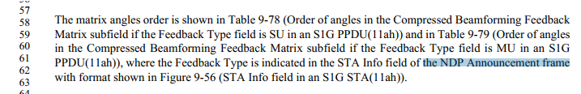
Okay to change “NDP Announcement frame” to “VHT NDP Announcement frame”

At 1917.12:
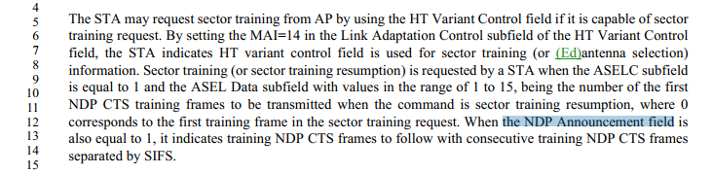

There is no such thing “NDP Annoucement field” or “VHT NDP Annoucement field”. It should be the “HT NDP Annoucement subfield”.
At 1917.12, change “NDP Annoucement field” to “HT NDP Annoucement subfield”.

At 1917.29:

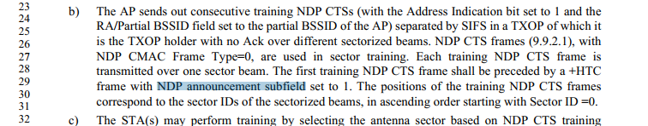

Change “NDP announcement subfield set to 1” to “HT NDP Announcement subfield set to 1”.

At 1918.16:

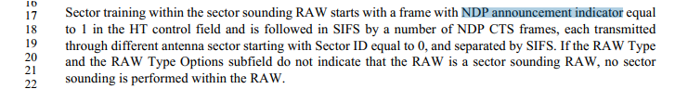

Change “NDP announcement indiator” to “HT NDP Announcement subfield”.

Proposed Resolution:

Revised.
At 784.01: change “NDP Announcement frame” to “VHT NDP Announcement frame”.
At 889.6: change “NDP Announcement frame” to “VHT NDP Announcement frame”.
At 1917.12: change “NDP Annoucement field” to “HT NDP Announcement subfield”.
At 1917.29: Change “NDP announcement subfield set to 1” to “HT NDP Announcement subfield set to 1”.
At 1918.16: Change “NDP announcement indicator” to “HT NDP Announcement subfield”.

1257 | 849.36 | 9.4.1.11 | The Action Category values for P802.11ah got renamed late during the process and it looks like the edits to Table 9-53 were missed in IEEE Std 80.11ah-2016 while the correct names were updated into the subclause titles. The Meaning column in Table 9-53 needs to be modified to use the correct names to avoid confusion here. | In Table 9-53 (Category values) Meaning column, replace "S1G" (for Code 22) with "Unprotected S1G" and replace "S1G Relay" (for Code 23) with "S1G".

Discussion

Cited text:
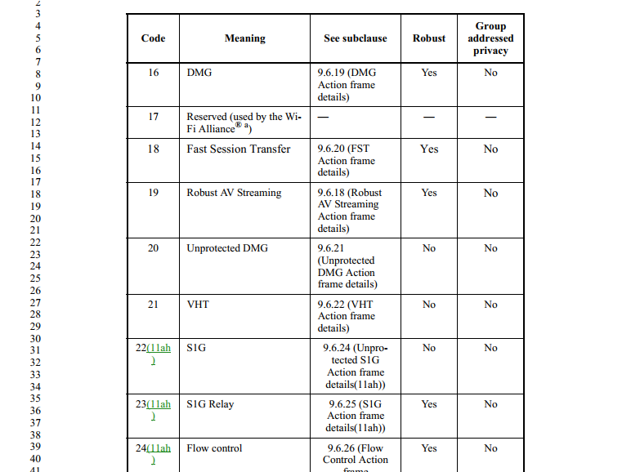

Agreed with the commenter.

Proposed Resolution:

Accept.

1304 | 162.35 |  | Page 162 line 35-controlled access phase (CAP) definition does not spell out the PIFS acronym-add Priority to the definition of the acronym PIFS. It currently just says "an interframe space PIFS)". Page 1575 line 51 says PIFS is a priority interframe space (PIFS) | Page 162 line 35-controlled access phase (CAP)-add Priority to the definition of the acronym PIFS. It currently just says "an interframe space PIFS)". Page 1575 line 51 says PIFS is a priority interframe space (PIFS)

Discussion

Cited text:
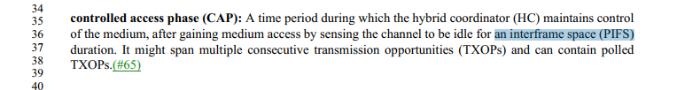

Some feedback from Joseph Levy:
I don’t believe there is a requirement to use PIFS to initiate a CAP, as any IFS which will allow the media to be gained will do. There is a requirement that if the media is not regained at the end of the TXOP within a PIFS that the CAP is over, but this requirement does not apply to the initial gaining of the media. Hence, I think the error was the use of PIFS which should have simply been IFS. Hence, I think the resolution should be:
REVISED at 162.36, change "an interframe space (PIFS)" to "an interframe space (IFS)".

But, after some additional thought I don’t understand why the detail of sensing the channel to be idle for an IFS is even necessary. While it might be helpful to define when the CAP begins and when it ends, i.e. when the media is gained and when it is released, I think it will overly complicate the definition and doesn’t seem necessary. Hence I propose that the definition should read:
controlled access phase (CAP): A time period during which the hybrid coordinator (HC) maintains control of the medium. It might span multiple consecutive transmission opportunities (TXOPs) and can contain polled TXOPs.

Proposed Resolution:

Revised.
Change cited text to “controlled access phase (CAP): A time period during which the hybrid coordinator (HC) maintains control of the medium. It might span multiple consecutive transmission opportunities (TXOPs) and can contain polled TXOPs.”

1086 | 1538.07 | 9.8.1 |  |  | Why is it a PV1 MAC header and not just a MAC header? The section title is "MAC frame format for PV1 frames" and a MAC frame deserves a MAC header. | Change all occurances of "PV1 MAC header" to "MAC header" or "MAC header of PV1 frame" as appropriate. There are only a handful of uses.

Discussion

The format of the PV1 MAC header is different from the format of the original MAC header.
The current text is correct. The feedback from the ad hoc meetng is not to change them.

Proposed Resolution:

Reject.
Reject Reason: The current text is accurate. The format of the PV1 MAC header is different from the format of the original MAC header.

====================

1091 | 1539.07 | 9.8.3.1 | In is not clear what the bullet items in this table signify. They appear to be some sort of format description. | Move the bulleted items into a separate column with approriate header. Alternatively, add prepositions to describe the relationship between the frame type and the bulleted item (e.g., "QoS Data frame where either the A1 field or the A2 is an SID..."). Change the column title to "Description")

Discussion

According to the feedback from the ad hoc, a new colomn need to be added.
Now column titles are: Type Value, Type, and Description

Proposed Resolution:

Revised.
Replace Table 9-497 with the following table:
 |  | PV1 frame types(11ah)
Type Value | Type |  | Description
0 | QoS Data |  | Either the A1 field or the A2 field is an SID (defined in Error: Reference source not found), as determined by the From DS subfield in the Frame Control field
1 | Management |  | Both A1 and A2 fields contain MAC addresses for PV1 Probe Response frames, or  Either the A1 field or the A2 field is an SID (defined in Error: Reference source not found), as determined by the From DS subfield in the Frame Control field.
2 | Control |  | The A1 field is an SID and the A2 field is either an SID or contains a MAC address
3 | QoS Data |  | Both A1 and A2 fields contain MAC addresses
4–6 | Reserved
7 | Reserved for extension

1101 | 904.22 | 9.4.2.1 | Consider dividing Table 9-87 into two tables: "Element IDs" and "Extended element IDs". The "Element ID Extension" column would not be present in the Element IDs table, reducing the number of pages with N/A present. The last row of the first table would be "Extended elements" with 255 in Element ID field column and perhaps a reference to the second table. The second table could have a column "Element ID field/Element ID Extension field" with entries "255/1" etc. (or just an Element ID Extension field column.) Even if this suggestion is not adopted, the column headings should be "Element ID field" and "Element ID Extension field" (the nouns need to be present)). | As commented

Discussion

Feedback from the ad hoc meeting: keep as it is. The current table is clear. No need to change.
904.6 Figure 9-136 shows the Element format. No need to add “field” in the coloumn.

Proposed Resolution:
Reject.
Reject reason: Having all information in one table provides a single reference. The current table is clear. Also, Figure 9-136 shows the Element format. No need to add “field” in the coloumn.

1104 | 915.48 | 9.4.2.1 | Aren't these just "Reserved"? We need a statement that Element ID 255 means a format with the Element ID Extension field present (I have another comment on this). And then we just need to state "Reserved" here | As commented

Discussion

Agree to change to “Reserved”. Additional fix as identified in the ad hoc meeting.

Proposed Resolution:

Revised.

At 915.48 Change “Reserved for elements using the Element ID Extension field” to “Reserved”.
At 914.50, change “Reserved for elements using the Element ID Extension field” to “Reserved”.

1283 | 915.48 | 9.4.2.1 | In Table 9-87, Element ID Extension 44 is double defined. | Please change Element ID Extension "15-32, 35-255" to "15-32, 35-43, 45-255".

Discussion

Proposed Resolution:

Revise.

At 915.37, Add a new row: “Reserved”, “255”, “15-32”.
At 915.44, Add a new row: “Reserved”, “255”, “35-43”.
At 915.48, change “15-32, 35–255” to “45-255”.
Delete Editor’s Note.

1226 | 1302.52 | 9.4.2.198 | What does the star refer to? | Remove star from "TWT parameters*"

Discussion

There is no need to have “*”. Replace “*” with “ (see NOTE)”.

Proposed Resolution:
Revised.
Delete cited “*”.
At 1302.54, add: “(see NOTE)”.

1229 | 1125.64 | 9.4.2.68.5 | The URL http://www.wi-fi.org/knowledge_center/insiston-wifi-certified is outdated | Update URL to point to the right webpage

Discussion
I couldn’t find the link.
I believe the device type is defined in WFA Simple Configuration Tech specification.

https://www.wi-fi.org/download.php?file=/sites/default/files/private/Wi-Fi_Simple_Configuration_Technical_Specification_v2.0.5.pdf

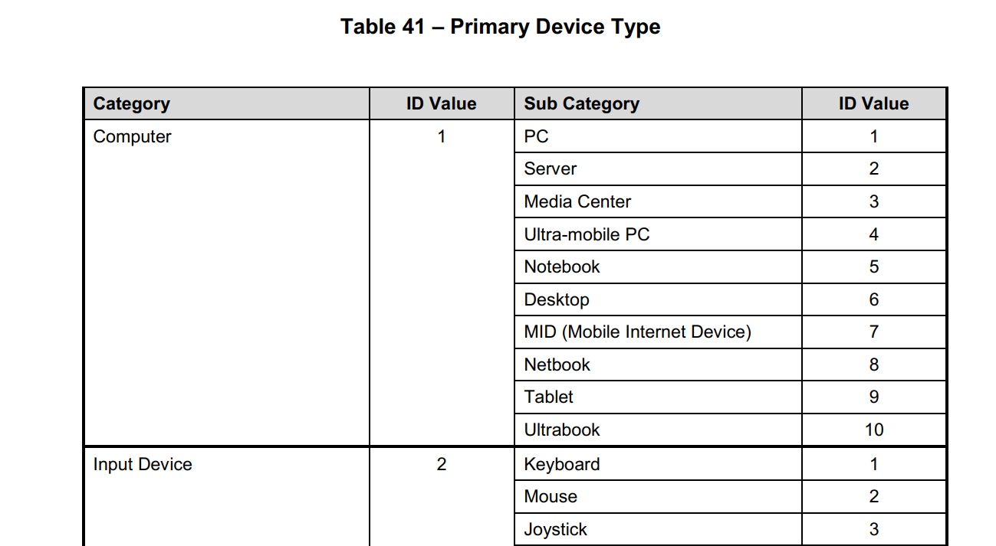

Since the Device type is defined in Table 9-199, there is no need to keep the footnote.

Proposed Resolution:
Revised.

Delete the cited footnote and footnote number.
Since the Device type is defined in Table 9-199, there is no need to keep the footnote.

1239 | 1362.45 | 9.4.5.24 | The ANQP exchange usually comprises ANQP requests and reponses using ANQP-elements. This clause refers to ANQP queries which are not defined anywhere. In addition, the text requires some clairification as to which APs and identifiers are being referred to. | change the text in the 1st paragraph to:  "The Query AP List ANQP-element provides a list of APs and a list of Info IDs of ANQP-elements that the requesting STA is requesting from each AP in the list. The Query AP List ANQP-element declares that the STA performing the ANQP request is requesting that the ANQP-element corresponding to each Info ID be returned in the AP List Response ANQP-element. This element allows an optimization of the single ANQP request procedure (see 9.4.5.2) by having multiple ANQP requests in a single ANQP-element thus reducing the time necessary for network discovery and selection. See 11.23.3.3.14 (Query AP list procedure) for information on the Query AP list procedure."

Discussion

Cited text:
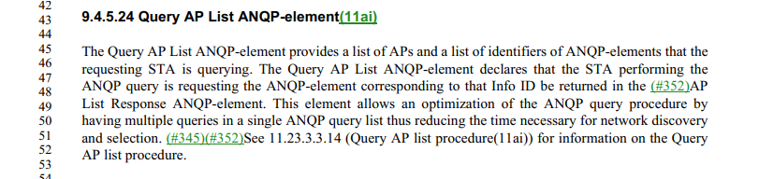

New text:

The Query AP List ANQP-element provides a list of APs and a list of Info IDs of ANQP-elements that the requesting STA is requesting from each AP in the list. The Query AP List ANQP-element declares that the STA performing the ANQP request is requesting that the ANQP-element corresponding to each Info ID be returned in the AP List Response ANQP-element. This element allows an optimization of the single ANQP request procedure (see 9.4.5.2) by having multiple ANQP requests in a single ANQP-element thus reducing the time necessary for network discovery and selection. See 11.23.3.3.14 (Query AP list procedure) for information on the Query AP list procedure.

Proposed Resolution:

Accept.

1250 | 161.48 | 3.2 | BRP packet has been introduced by 802.11ad. However, definition of BRP packet is missing in clause 3. | Add the following definition for BRP packet:  "beam refinement protocol (BRP) packet: A physical layer (PHY) protocol data unit (PPDU) that are used to train DMG STA antenna in beam refinement procedure."

Discussion

“BRP” is defined in 189.19.
“BRP packet” is defined in 20.9.2.2. No further definition is required.

Proposed Resolution:

Reject.
Reason: “BRP” is defined in 189.19. “BRP packet” is defined in 20.9.2.2. No further definition is required.

1280 | 197.48 | 3.4 | Abbreviation SC is double defined for "single carrier" and "sequence counter".  Since SC is defined for "single carrier" earlier, another abbreviation for "sequence counter" is necessary. | Please give a new abbreviation to "sequence counter".
Discussion

“sequence counter” was added by 11ah. It was an error. “sequence counter” was used in clause 12 in 802.11-2016. An abbreviation is not necessary.

“SC” is “sequence control”. SC is also used for “MPDU Sequence Control field”. Mark H will work on cleaning up “Sequence Control (SC)” that was added by 11ah.

As for this comment, we just simply delete the abbreviation.

Proposed Resolution:
Revise.
At 197.49, delete “SC sequence counter”.

1342 | 879.30 | 9.4.1.48.1 | There are lots of references to a "Compressed Feedback Beamforming Matrix subfield" but no such subfield is defined in any field | State in the referenced subclause and in Subclause 9.4.1.48.2 that the VHT Compressed Beamforming Report field consists of a Compressed Feedback Beamforming Matrix subfield

Discussion

There are "Compressed Feedback Beamforming Matrix subfield" and "Compressed Beamforming Feedback Matrix subfield".

17 instances for the first usage. 44 instantances for the second usage.

I believe the later is the correct usage.

Change "Compressed Feedback Beamforming Matrix” to "Compressed Beamforming Feedback Matrix" thoughout.

The format of VHT Compressed Beamforming Report information is defined in Table 9-75. There is no need to state that the VHT Compressed Beamforming Report field consists of a Compressed Feedback Beamforming Matrix subfield.

Proposed Resolution:

Revised.

Change "Compressed Feedback Beamforming Matrix” to "Compressed Beamforming Feedback Matrix" thoughout the draft.

1345 | 245.33 | 4.5.4.9 | "Management frame protection protocols in an infrastructure BSS or IBSS apply to robust Management frames after RSNA PTK establishment for protection of individually addressed frames is completed and after delivery of the IGTK to protect group addressed frames.  Management frame protection protocols in an MBSS apply to the following frames:  --- Individually addressed robust Management frames after establishment of the RSNA MTK,  --- Group addressed robust Management frames that are specified with "Yes" in the "Group Addressed  Privacy" column of Table 9-53 (Category values) after establishment of the RSNA MGTK, and  --- Group addressed robust Management frames that are specified with "No" in the "Group Addressed  Privacy" column of Table 9-53 (Category values) after establishment of the RSNA IGTK.  See 14.7 (Mesh security) for details.  Robust management frame protection is implemented by CCMP, GCMP, and BIP confidentiality protocols and the SA Query procedure." -- MFP should be "robust" everywhere or nowhere | Change "robust management frame protection" to "management frame protection" throughout the document (case-preservingly)

Discussion

Cited text:
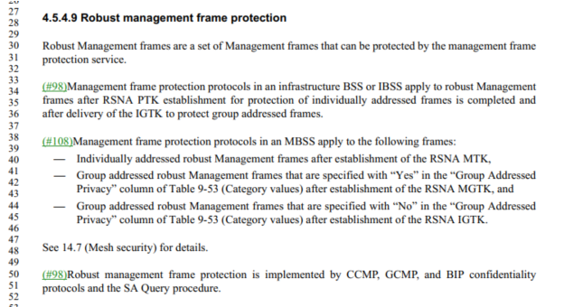

Robust Management frames are a set of Management frames that can be protected by the management frame
protection service.
Management frame protection protocols in an infrastructure BSS or IBSS apply to robust Management
frames after RSNA PTK establishment for protection of individually addressed frames is completed and
after delivery of the IGTK to protect group addressed frames.

Agree with commenter.

Change "robust management frame protection" to "management frame protection" throughout the document (case-preservingly).

7 instanace (exclude contents index).

Proposed Resolution:

Accept.

1360 | 200.01 | 3.4 | "USF" is barely used (2 uses) and we don't need YA TLA | Delete the definition of USF at the referenced location and expand USF to "unified scaling factor" throughout the document elsewhere

Discussion

Agreed.

Proposed Resolution:

Accept.

1362 |  |  | The term "packet" is undefined | Change "packet" to "PPDU" in Table 8-4 (2x), Table 9-177 (3x), Table 9-181, Table 9-263 (3x), last para of 9.4.2.156.2, 9.4.2.189, Table 2-291 (5x), 9.5.4 (3x), 10.3.2.3.3. Change "packet" to "element" (first 2 instances) or "frame" (last 2 instances) in 9.4.2.129. Change "packet" to "frame" in 9.5.3
Discussion

Proposed changes in the cited location seem reasonable.

Proposed Resolution:

Accept.

1379 |  |  | Use of "packet" is contrary to the style guide | Change "packet" to "PPDU", "MPDU", "frame" as appropriate

Discussion

Detail proposal is required.
Submission Required. Assign to the commenter.

Proposed Resolution:

???

1389 |  |  | "when the negotiated akm is" v. "if the negotiated akm is" v. "if the akm negotiated is" not "when the akm negotiated is" -- inconsistent | Change each of the instances of the cited word sequences to "if the negotiated AKM is", case-preservingly

Discussion

24 instances for "when the negotiated akm is"
0 instance for “if the negotiated akm is"
6 instances for "if the akm negotiated is"
13 instances "when the akm negotiated is"

I think both “the negotiated akm” and “the akm negotiated” should be changed to “the negotiated AKM”. Disagree to change “when” to “if”.

For example,
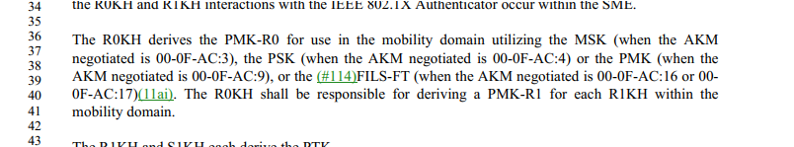

Proposed Resolution:

Revised.
Change “the negotiated akm” to “the negotiated AKM” thoughtout.
Change “the akm negotiated” and “the AKM negotiated” to “the negotiated AKM” thoughtout.

1408 |  |  | "cipher-suite specific" and "cipher-suite dependent" -- both used | Change all instances of "cipher-suite specific" to "cipher-suite dependent" throughout the document

Discussion

1 instance for "cipher-suite specific"
3 instances "cipher-suite dependent"

Proposed Resolution:

Accept.

1416 | 954.55 | 9.4.2.20.10 | There should not be 2 figures with the caption "Format of Maximum Age subelement" | At the referenced location change " The format of the  Maximum Age subelement is defined in Figure 9-194 (Format of Maximum Age subelement). " to " The format of the  Maximum Age subelement is defined in Figure 9-213 (Format of Maximum Age subelement). " and delete Figure 9-194

Discussion

Both figure 9-194 and figure 9-213 define the format of Maximum Age subelement.
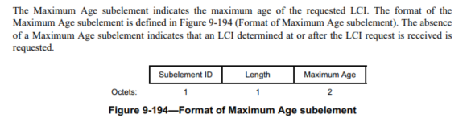

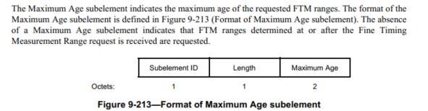

I am okay to remove Figure 9-213 and change the reference to Figure 9-194.

Proposed Resolution:

Revise.
At 967.28, change “The format of the Maximum Age subelement is defined in Figure 9-213 (Format of Maximum Age subelement)” to “The format of the Maximum Age subelement is defined in Figure 9-194 (Format of Maximum Age subelement).
Remove Figure 9-213.

1433 |  |  | Some of the ResultCodes in the SAP have underscores (e.g. JOIN_FAILURE_TIMEOUT, NOT_SUPPORTED) some not (e.g. AUTH FAILURE TIMEOUT, ANTI-CLOGGING  TOKEN REQUIRED) | Change "JOIN_FAILURE_TIMEOUT" to "JOIN FAILURE TIMEOUT" throughout the document

Discussion

The same comment from CC25 CID277.
CID 277 was rejected.
Reject Reason: There is no rule on whether ResultCode should include underscores or not. Uderscores are used for ResultCode everywhere. No need to remove them. The current usage create no confusion.

Proposed Resolution:
Reject.
Reject Reason: There is no rule on whether ResultCode should include underscores or not. Uderscores are used for ResultCode everywhere. No need to remove them. The current usage create no confusion.

1444 | 1535.01 | 9.7.3 | The A-MPDU context tables randomly mix "MPDU" and "frame" | Change "MPDU" to "frame" throughout Tables 9-491 to 9-496, when not preceded by "A-" (i.e. do not change "A-MPDU" to "A-frame")

Discussion

Transder to MAC ad hoc.

Proposed Resolution:

?

1451 |  |  | "data type frames" and "QoS Data type frames" is not canonical | Change "QoS Data type frames" to "QoS Data frames" and change "data type frames" to "Data frames" throughout the document

Discussion

3 locations: 733.23, 3458.12, 3458.27

Proposed Resolution:

Accept. Note: 3 locations: 733.23, 3458.12, 3458.27

1486 |  |  | Per rejection of CID 169, rename (non-Radio/Link) Measurement Request/Response frames to Spectrum Measurement Request/Response frames | Add "Spectrum" before "Measurement Request" and "Measurement Response" throughout the document, except where "Radio" or "Link" is already present there

Discussion

Proposed Resolution:

Accept.

1487 |  | 3.2 | Per rejection of CID 204 add definitions of DSSS/HR/DSSS/OFDM/HT/VHT/TVHT etc. BSS/AP | Add the following defintions in the correct alphabetic location in 3.2:  high throughput (HT) access point (AP): An AP whose radio transmitter is capable of  transmitting and receiving HT physical layer (PHY) protocol data units (PPDUs).  very high throughput (VHT) basic service set (BSS): A BSS in which VHT Beacon frames are  transmitted by VHT stations (STAs).

Discussion

Any opionion?

Proposed Resolution:

?

1508 |  |  | "The xxx element can be included in xxx frames" is just duplication and almost guaranteed to result in spec rot | Delete the sentences containing "can be included" in 4.9.3, 9.4.2.18, 9.4.2.85, 9.4.2.138

Discussion

I don’t think it is duplication. It indicates that these elements can be included in frames. If the frame is not mentioned here, it means it cannot be included in that frame.

In 4.9.3, at 254.65

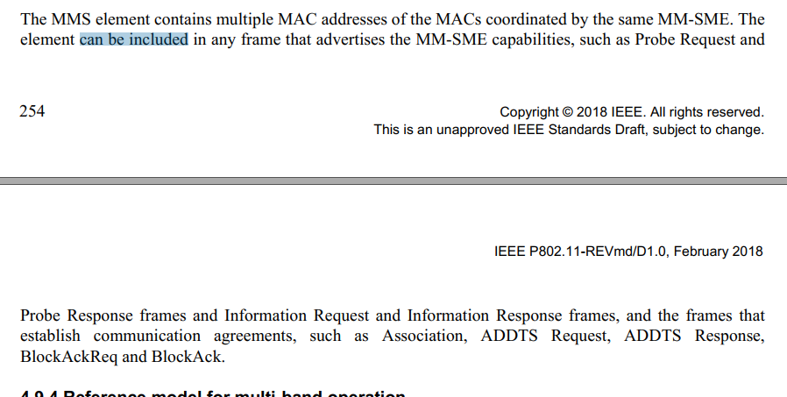

In 9.4.2.18, at 934.17:

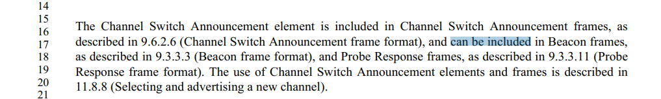

In 9.4.2.85, at 1158.64:
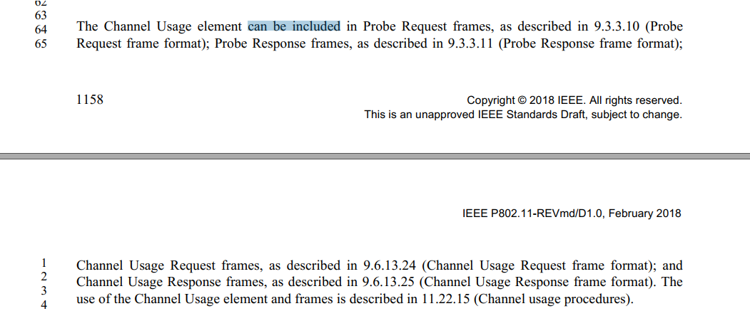

In 9.4.2.138, at 1229.27:

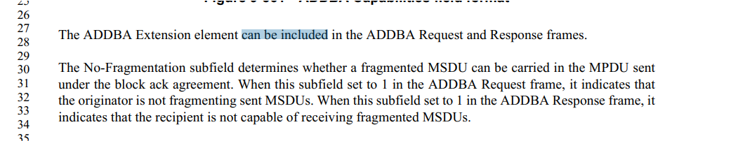

Proposed Resolution:

Reject?

1518 |  |  | "dot11ExcludeUnencrypted" is a WEP thing only | Change "dot11ExcludeUnencrypted" to "dot11WEPExcludeUnencrypted" throughout

Discussion

? MAC comment?
We don’t need to fix this comment.

Reject. ?
WEP has been deprecated and the task group has determined that they are not making any changes to clauses associated with obsolete/deprecated features.

Proposed Resolution:

?

1545 | 137.49 | 2 | The reference to 802.1Q-2003 is obsolete | Replace with the current version of the standard for virtual bridged LANs

Discussion

2014 is the current.
There are two items related to 802.1Q. Should one of them be removed?

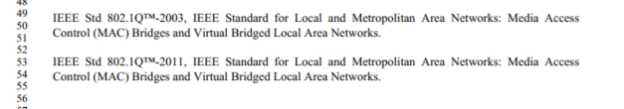

Proposed Resolution:
Revised.
At 137.49, remove “IEEE Std 802.1Q™-2003, IEEE Standard for Local and Metropolitan Area Networks: Media Access Control (MAC) Bridges and Virtual Bridged Local Area Networks”.

At 137.53 change “IEEE Std 802.1Q™-2011” to ““IEEE Std 802.1Q™-2014”

1562 | 257.40 | 4.10.3 | 4.10.3 (and 4.10.4 and 4.10.5) is way too detailed for clause 4 (frame exchange diagrams, etc.) Move it to clause 11. | Move material to clause 11. Insert high-level overview of 802.1X use in 802.11. Do the same for 4.10.4 and 4.10.5.

Discussion

I think 4.10.3, 4.10.4 and 4.10.5 are very useful. Any other opinion?

Proposed Resolution:

?
1595 | 256.20 | 4.9.4 | There are numerous instances of "multiband" at a line break, which then gets hyphenated. This means searching for "multi-band" (the correct spelling) doesn't find these. Can anything be done so the search works properly? | Check with Editors/PDF experts for a better way to represent this. (Maybe prevent the line break, if necessary.)

Discussion

It is not clear to me what the issue is.

Proposed Resolution:

?

1609 | 138.08 | 2 | IEEE 802.3 has been updated | Update all clause 2 references for current versions
Discussion

IEEE Std 754™-2008, IEEE Standard for Binary Floating-Point Arithmetic.4,5 : Current.
IEEE Std 802®-2014, IEEE Standards for Local and Metropolitan Area Networks: Overview and
Architecture : Current

IEEE Std 802.1Q™-2003, IEEE Standard for Local and Metropolitan Area Networks: Media Access
Control (MAC) Bridges and Virtual Bridged Local Area Networks : 2014 is the current. See CID 1545.

IEEE Std 802.1X™-2010, IEEE Standard for Local and Metropolitan Area Networks: Port-Based Network
Access Control: current.

EEE Std 802.21™-2008, IEEE Standard for Local and Metropolitan Area Networks: Media Independent
Handover Services : current.

IEEE Std 802.3™-2012, IEEE Standard for Ethernet: Current is 2015.

Proposed Resolution:

Revised.

At 138.8, change “IEEE Std 802.3™-2012, IEEE Standard for Ethernet” to “IEEE Std 802.3™-2015, IEEE Standard for Ethernet”.

