IEEE P802.11
Wireless LANs
Misc CR Follow up
Date: 2018-01-17
Author(s):
Name | Company | Address | Phone | email
Ross Jian Yu | Huawei Technologies | F1-17-A011S, Huawei Base, Bantian, Longgang, Shenzhen, Guangdong, China, 518129 |  | ross.yujian@huawei.com
Ming Gan | Huawei Technologies |  |  | ming.gan@huawei.com
Abstract
This submission contains proposed comment resolutions to comments on D2.0.

The 4 comments resolved in this document are:
11634, 11654, 11655, 14321

The changes marked in this document are based on TGax Draft D2.0.

Revision Notes

R0 | Initial revision

CID 11634
CID | Page.  Line | Clause Number | Comment | Proposed Change | Resolution
11634 | 404.59 | 28.3.10.7.2 | Lets define or provide references to definitions of all the variables. | as in comment | Instruction to Editor:  REVISED  Agreed that the variables should be either defined or referred.  Please make the changes according to the changes in doc 18-0230r0

Discussion:
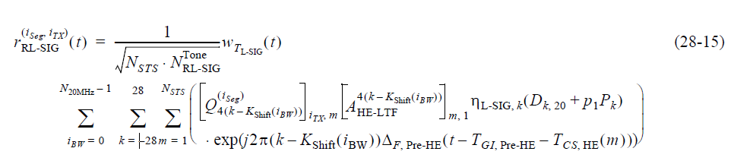
In equation (28-15) as shown above, most of the varialbes are defined in the frequently used parpameters or descriptions of previous equations. The locations where the descriptions first show up are shown below. Only the descriptions of i_{BW} is missing. Although it is better to add all the descrioptions in every equation, however, it is also big overhead. Hence, it is suggetsed to refer the equations where the descriptions can be found.

[Above eq (28-1]] i_{seg}: frequency segment index
[Above eq (28-1]] i_{TX}: transmit chain index
[First shown in equation (28-8)]N_{STS} is defined in Table 28-15—Frequently used parameters
[Description of (28-3/4)] is defined in Table 28-16—Number of modulated subcarriers and guard interval duration values for HE PPDU fields
[Description of (28-3/4)] is given in 17.3.2.5 (Mathemat-ical conventions in the signal descriptions).
[Description of (28-6)] N_{20MHz} is defined in 21.3.7.3 (Channel frequencies)
[Missing, first shown in eq (28-6)] i_{BW}
[Description of (28-3/4)] , where is defined in the description of equation (28-3) and (28-4)
[Description of (28-8)] , where is defined in Equation (28-50)
[Description of (28-3/4)]
[Description of (28-12)]
[Defined (28-15)] p₁
[Description of (28-12)] P_{k}
[Description of (28-6)] K_{Shift}(i_{BW})
[Description of (28-3/4)] is given in Table 28-12 (Timing-related constants)
[Description of (28-3/4)]
[Description of (28-3/4)]
Instruction to Editor: Please add the following paragraph to P401, 15
i_{BW} is the index of 20MHz channels,

CID 11654&11655
CID | Page.  Line | Clause Number | Comment | Proposed Change | Resolution
11654 | 451.39 | 28.3.10.10 | Provide definitions or references for all variables in Eq 28-53. | as in comment | Instruction to Editor:  REJECTED  The varialbes are defined either in the frequently used parameters table or in the descriptions of previuos equations.
11655 | 451.39 | 28.3.10.10 | what is the difference between K_r^HE-LTF and K_r. | as in comment | Instruction to Editor:  REJECTED  The varialbes are defined either in the frequently used parameters table or in the descriptions of previuos equations.

Discussion

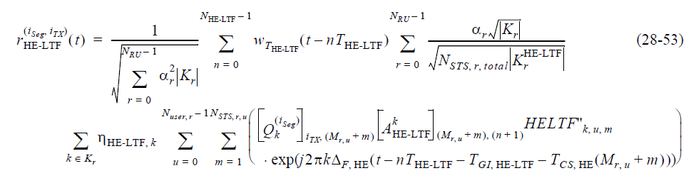

Equation (28-53) and Equation (28-54) are waveforms of HE-LTF for SU/MU/ER SU and TB PPDU respectively. The descriptions should be given together. Moreover, the definitions of varialbes are given in the frequently used parameters talbe or descriptions of previuos equations.
[In frequently used parameters]N_{RU}
[Description of (28-3/4)]
[Description of (28-1)]
[In (28-34)]
[Description of (28-4)]

CID 14321
CID | Page.  Line | Clause Number | Comment | Proposed Change | Resolution
14321 | 432.32 | 28.3.10.8.6 | There is no clear definition of load balancing. Please define it before using it in the text of behavior description. Also there is a seperated section talking about network load balancing. It may confuse people using the same term for different technical purpose. | as in the comment | Instruction to Editor:  REVISED  Please refer to CID 11496 in doc 11-18/0118r6

