IEEE P802.11
Wireless LANs
802.11
[802.11az VHTz Measurement Exchange Protocol]
(based on REVmd D0.5)
Date: 2018-01-18
Author(s):
Name | Company | Address | Phone | Email
Long Luo | Huawei |  |  | k.law@huawei.com
Allan Zhu | Huawei |  |  | chunhui.zhu@huawei.com
Abstract

This submission proposes P802.11az draft amendment text for the P802.11az VHTz Measurement Exchange Protocol. The baseline documents that this proposal depends on are:
- D0.05 of REVmd
- D8.0 of PIEEE802.11aj
- D5.0 of PIEEE802.11ak
- D13.0 of PIEEE802.11aq

History:
R0: Initial Version

[Insert a new section after 11.24.6.4.2]

11.24.6.4.3 Measurement Exchange in VHTz Mode

11.24.6.4.3.1 General

In VHTz mode, the measurement exchange phase of the ranging protocol shall be based on IEEE 802.11 VHT sounding protocol and operates in an unscheduled manner; whenever the medium is available, an iSTA may initiate the measurement exchange procedure (SFD r12 Sub-Clause 3.2.2 (1)). Optionally, LMR feedback calculation (ToA) and its delivery may require a scheduling mechanism (TBD: what is it? Should we define it or we consider it out-of-scope?). A re-occurring availability window mechanism is not required in the VHTz mode (SFD r12 Sub-Clause 3.2.2 (2)). (TBD: Allan to bring a proposal to remove SFD r12 Sub-Clause 3.2.2 (2) from the SFD).

11.24.6.4.3.2 Measurement Exchange Sequence

In the VHTz mode, the measurement exchange shall follow the sequence illustrated in Figure 11-xx. For immediate feedback the LMR carries measurement results of this round, while for delayed feedback the LMR carries measurement results of previous round (11.24.6.4.3.3). (SFD r12 Sub-Clause 3.2.2 (4))

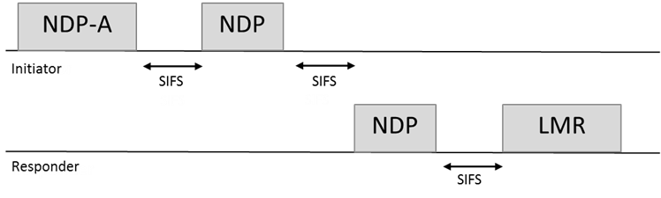
Figure 11-xx VHTz Measurement Exchange Sequence

The frame format of NDP-A, NDP, and LMR are defined in XXX, YYY and ZZZ, respectively (TBD: make sure they are defined). (SFD r12 Sub-Clause 3.2.2 (1))

11.24.6.4.3.3 Measurement Report

Similar to in the HEz mode, LMR feedback can be bi-directional in VHTz mode; both rSTA-to-iSTA and iSTA-to-rSTA LMR feedbacks are supported. The direction(s) of LMR feedback(s) is (are) negotiated at service establishment. (SFD r12 Sub-Clause 3.2.2 (8)) In both directions, LMR feedback is neither acknowledged nor retransmitted. (SFD r12 Sub-Clause 3.2.2 (9))

In VHTz mode, the ranging protocol supports both immediate and delayed reporting. In delayed reporting, the LMR feedback is reported in the next sounding sequence. (SFD r12 Sub-Clause 3.2.2 (3))

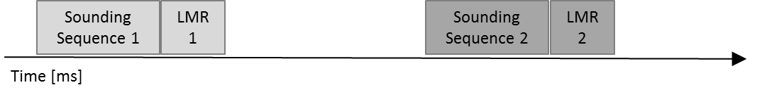
Figure 11-xx VHTz Immediate Reporting

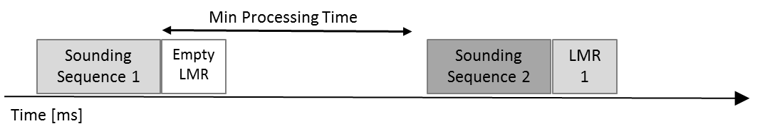
Figure 11-xx VHTz Delayed Reporting

When using delayed reporting in VHTz mode, an iSTA shall not initiate a subsequent measurement sequence earlier than MinToaReady after channel sounding (TBD: people prefer to refer to the start of the responding NDP. Christian will bring a proposal. 1/18/2018). An rSTA shall store a measurement result for at least MaxToaAvailable time. If an iSTA initiates a subsequent measurement sequence later than MaxToaAvailable, the results may not be available in the rSTA. (SFD r12 Sub-Clause 3.2.2 (5)) (TBD: make sure to define MinToaReady and MaxToaAvailable somewhere in the spec)

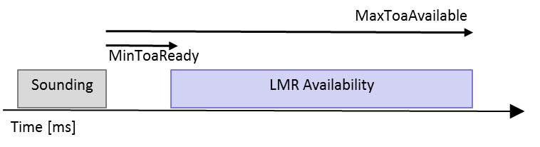
Figure 11-xx Illustration of MinToaReady and MaxToaAvailable

Similar to in HEz mode, VHTz mode supports TOA and TOD reporting in the LMR, but additionally also supports CSI reporting. Support of the TOA and TOD format is mandatory, while support of the CSI format is optional for both the iSTA and rSTA. For CSI reports, only immediate reporting is supported, while the delayed reporting only applies to the TOA/TOD reports. The form of report used is agreed upon during negotiation phase (TBD: did we already cover this?). The formats of TOA/TOD and CSI reports are defined in XXX (TBD). (SFD r12 Sub-Clause 3.2.2 (6))

The data rate or MCS used for delivering ranging report is solely decided by the rSTA. The bandwidth used for delivering ranging report shall not be wider than the bandwidth of the soliciting NDPA. (SFD r12 Sub-Clause 3.2.2 (7))

