IEEE P802.11
Wireless LANs
802.11
[802.11az VHTz Measurement Exchange Protocol]
(based on REVmd D0.5)
Date: 2018-01-15
Author(s):
Name | Company | Address | Phone | Email
Long Luo | Huawei |  |  | k.law@huawei.com
Allan Zhu | Huawei |  |  | chunhui.zhu@huawei.com
Abstract

This submission proposes P802.11az draft amendment text for the P802.11az VHTz Measurement Exchange Protocol. The baseline documents that this proposal depends on are:
- D0.05 of REVmd
- D8.0 of PIEEE802.11aj
- D5.0 of PIEEE802.11ak
- D13.0 of PIEEE802.11aq

History:
R0: Initial Version

[Insert a new section after 11.24.6.4.2]

11.24.6.4.3 Measurement Exchange in VHTz Mode

11.24.6.4.3.1 General

In VHTz mode, the measurement exchange phase of the ranging protocol shall be based on IEEE 802.11 VHT sounding protocol and operates in an unscheduled manner; whenever the medium is available, an iSTA may initiate the measurement exchange procedure (SFD: 11-17/462r11 Sub-Clause 3.2.2 (1)). Optionally, LMR feedback calculation (ToA) and its delivery may require a scheduling mechanism (TBD: what is it? Should we define it or we consider it out-of-scope?). A re-occurring availability window mechanism is not required in the VHTz mode (SFD: 11-17/462r11 Sub-Clause 3.2.2 (2)). (TBD: better way of description?)

11.24.6.4.3.2 Measurement Exchange Sequence

In the VHTz mode, the measurement exchange shall follow the sequence illustrated in Figure 11-xx. For immediate feedback the LMR carries measurement results of this round, while for delayed feedback the LMR carries measurement results of previous round (11.24.6.4.3.3). (SFD: 11-17/462r11 Sub-Clause 3.2.2 (4))

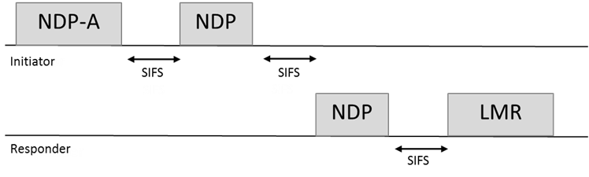
Figure 11-xx VHTz Measurement Exchange Sequence

The frame format of NDP-A, NDP, AND LMR are defined in XXX, YYY and ZZZ, respectively (TBD: make sure they are defined). (SFD: 11-17/462r11 Sub-Clause 3.2.2 (1))
In VHTz mode an iSTA shall not initiate subsequent measurement sequence earlier than MinToaReady (after receiving the current LMR?). An rSTA stores a measurement result for up to MaxToaAvailable time. If an iSTA initiates a subsequent measurement sequence later than MaxToaAvailable, the results may not be available in the rSTA. (SFD: 11-17/462r11 Sub-Clause 3.2.2 (5))

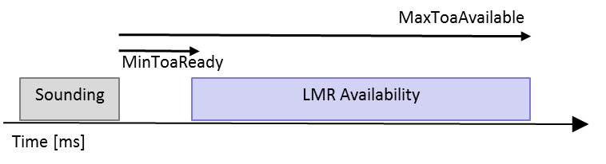
Figure 11-xx Illustration of MinToaReady and MaxToaAvailable

11.24.6.4.3.3 Measurement Report

Similar to in the HEz mode, LMR feedback is bi-directional in VHTz mode; both rSTA-to-iSTA and iSTA-to-rSTA LMR feedbacks are supported. The direction(s) of LMR feedback(s) is (are) negotiated at service establishment. (SFD: 11-17/462r11 Sub-Clause 3.2.2 (7)) In both directions, LMR feedback is neither acknowledged nor retransmitted. (SFD: 11-17/462r11 Sub-Clause 3.2.2 (8))

In VHTz mode, the ranging protocol supports both immediate and delayed reporting. In delayed reporting, the LMR feedback is reported in the next sounding sequence. (SFD: 11-17/462r11 Sub-Clause 3.2.2 (3))

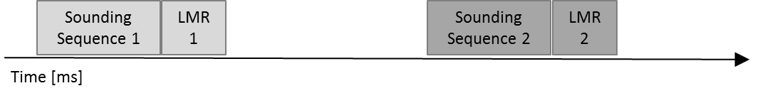
Figure 11-xx VHTz Immediate Reporting

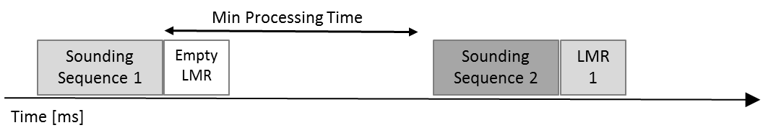
Figure 11-xx VHTz Delayed Reporting

In VHTz mode, the support for TOA and TOD measurement report is mandatory and support for CSI report is optional. The form of report used is agreed upon during negotiation phase (TBD: how?). The formats of TOA/TOD and CSI reports is defined in XXX (TBD). (SFD: 11-17/462r11 Sub-Clause 3.2.2 (5))

The data rate or MCS used for delivering ranging report is solely decided by the rSTA. The bandwidth used for delivering ranging report shall not be wider than the bandwidth of the soliciting NDPA. (SFD: 11-17/462r11 Sub-Clause 3.2.2 (6))

