IEEE P802.11
Wireless LANs
LB230 CR on CID 12060 and 13047
Date: 2018-01-10
Author(s):
Name | Affiliation | Address | Phone | email
Ming Gan | Huawei | F1-17, Huawei Base, Bantian, Longgang District, Shenzhen, China | +86 15889743667 | ming.gan@huawei.com
Shimi Shilo | Huawei
David Xun Yang | Huawei |  |  | david.yangxun@huawei.com
Abstract
This submission proposes resolutions of comments received from TGax LB230. (The proposed change is based on TGax Draft 2.0.)
- CIDs: 12060 13047 (2 CIDs)

Revisions:
- Rev 0: Initial version of the document.

Interpretation of a Motion to Adopt

A motion to approve this submission means that the editing instructions and any changed or added material are actioned in the TGax Draft. This introduction is not part of the adopted material.

Editing instructions formatted like this are intended to be copied into the TGax Draft (i.e. they are instructions to the 802.11 editor on how to merge the text with the baseline documents).

TGax Editor: Editing instructions preceded by “TGax Editor” are instructions to the TGax editor to modify existing material in the TGax draft. As a result of adopting the changes, the TGax editor will execute the instructions rather than copy them to the TGax Draft.

CID | Clause | Page No. | Comment | Proposed Change | Resolution
12060 | 28.3.10.7.2 | 410.20 | In table 28-17, we only have 4 bits (B18-B21) in HE-SIG-A1 field to incated the total number of SIGB symbols. Howerver, the required SIG-B symbols will beyond 16 if it is modulated with low data rate, such MSC0 with DCM. So B18-B21 will bring false info to receiver. | Modify HE-SIG-A to allow the number of SIG-B can be greater than 16. | Revised  Agree with the comment in principle. Proposed resolution accounts for suggested change such that the number of SIG-B symbols can be greater than 16.  TGax editor please make the changes as shown in 11-18/0162 r0
13046 | 28.3.10.7.2 | 410.21 | In table 28-17, B18-B21 in HE-SIG-A1 field only provides 4 bits to indicate the number of SIGB OFDM symbols. That means the maximum of SIGB symbols is 16. However, the maximum required SIG B symbols is about 78 symbols if SIGB using MCS0 & DCM , 39 symbols if using MCS0 or MCS1 & DCM, 20 symbols if using MCS1 or MCS2 & DCM in 160MHz bandwidth. On the other hand, the maximun number STA scheduled over 80MHz or 160MHz if using lowest data rate for SIGB is only 12 under the condition of 16 the maximum SIGB symbols, significantly reducing the multi-user diversity introduced by OFDMA | Please correct the bug to allow more STAs to be be scheduled in DL OFDMA or make the receiver know the HE-SIG-B boundary when lots of STAs are scheduled. | Revised  Agree with the comment in principle. Proposed resolution accounts for suggested change such that the number of SIG-B symboles can be greater than 16.  TGax editor please make the changes as shown in 11-18/0162 r0

Discussion:
Issue:

HE-SIG-B contains 2 HE-SIG-B content channels, each of which has HE-SIG B common field and user specific field. Based on the HE-SIG-B design in ax draft 2.0, the RU allocation field in the HE_SIG B common field per 20 MHz has 8 bits, CRC and tail fields have 10 bits, and user field has 21 bits. We assume each HE-SIG-B content channel has the same number of user fields for simplifying calculations, then the number of bits in HE-SIG-B is

8*N+a+10+X*21+ceil (X/2)*10

where N is number of 20MHz channels within one HE-SIG-B content channel, a is 1 or 0, depending on whether there is a central 26-tone RU indication in the HE-SIG-B common field, and X is the number of user fields contained in one HE-SIG-B content channel.

There are 4 bits in HE-SIG-A to indicate the number of HE-SIG-B symbols, such that the maximum number of HE-SIG-B can reach up to 16. A value of 16 OFDM symbols can accommodate 208 bits if MCS0 and DCM are applied for HE-SIG-B. Therefore, we obtain
8*N+a+10+X*21+ceil (X/2)*10<=208

If we consider an 80 MHz or 160 MHz BW, then a=1 and N = 2 or 4, and after calculation we obtain X<=6. So we can infer that only up to 12 STAs are allowed to be scheduled over 80 MHz or 160 MHz bandwidth although dummy user fields are not considered. However, the number of 26-tone RUs for 80 MHz and 160 MHz BW is 37 and 74, respectively. The limitation of 12 scheduled STAs in total would significantly decrease the multi-user diversity benefit of OFDMA. Moreover, it meets a simlar problem even if DCM is not applied for the HE-SIG B field.

Solution:

Actually, all the factors which decide the required HE-SIG-B OFDM symbols are included in HE-SIG-B common field, such as N, a and X. Therefore, the receiver can obtain the number of HE-SIG-B OFDM symbols based on the received HE-SIG-B common field. However, the receiver needs enough time to prepare AGC on HE-STF which immediately follows HE-SIG-B field. Hence, it is not feasible to have the receiver calculate the number of HE-SIG-B symbols based on the HE-SIG-B common field when the number of HE-SIG-B symbols is small.

We propose to only change the meaning of value 15 in B18-B21. The value 15 in B18-B21 field when the HE-SIG-B compression field is 1 indicates that the number of OFDM symbols in the HE-SIG-B is greater than or equal to 16.

TGax Editor: Please change the subsection of 28.3.10.7.1 of 802.11ax draft 2.0 (CID 12060 and 13406):
28.3.10.7.2 Content

Table 28-18—HE-SIG-A field of an HE MU PPDU

Two Parts of HE-SIG-A | Bit | Field | Number of bits | Description
HE-SIG-A1 | ….. | ….. | ….. | …..
HE-SIG-A1 | B18-B21 | Number Of HE-SIG-B Symbols Or MU-MIMO Users | 4 | Indicates the number of OFDM symbols in the HE-SIG-B field when the HE-SIG-B compression field is 0  Set to the number of OFDM symbols in the HE-SIG-B field minus 1 if the number of OFDM symbols in the HE-SIG-B field is less than 16;  Set to 15 to indicate that the number of OFDM symbols in the HE-SIG-B field is equal to 16 if More Scheduled STAs in DL HE MU PPDU Support subfield of the HE Capabilities element transmitted by at least one recipient STA is 0;  Set to 15 to indicate that the number of OFDM symbols in the HE-SIG-B field is greater than or equal to 16 if More Scheduled STAs in DL HE MU PPDU Support subfield of the HE Capabilities element transmitted by all the recipient STAs are 1. The exact number of OFDM symbols in the HE-SIG-B field is calculated based on the number of User fields within the HE-SIG-B content channel which is indicated by HE-SIG-B common field in this case.  Indicates the number of MU-MIMO users minus 1 when the HE-SIG-B compression field is 1 (#CID 12060 13406)
HE-SIG-A1 | ….. | ….. | ….. | …..

9.4.2.237.3 HE PHY Capabilities Information field

The format of the HE PHY Capabilities Information field is defined in Figure 9-589cl (HE PHY Capabilities Information field format).

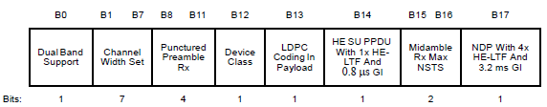
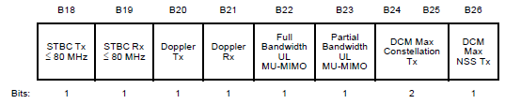
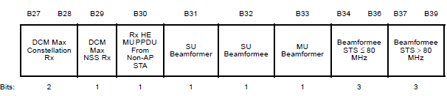
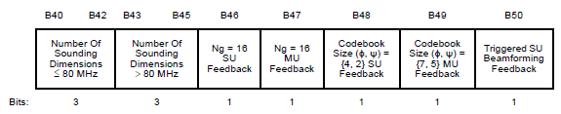
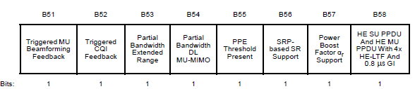
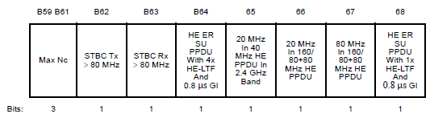

 | B69 | B70 | B71
 | Midamble Rx 2x And 1x HE-LTF | More Scheduled STAs in DL HE MU PPDU Support | Reserved
Bits: | 1 | 1 | 1

Figure 9-589cl—HE PHY Capabilities Information field format

The subfields of the HE PHY Capabilities Information field are defined in Table 9-262aa (Subfields of the HE PHY Capabilities Information field).
Table 9-262z—Subfields of the HE MAC Capabilities Information field
Subfield | Definition | Encoding
… | … | …
Midamble Rx 2x And 1x HE-LTF | When the Doppler Rx subfield is 1, indicates support for receiving midambles with 2x HE-LTF, 1x HE-LTF in HE SU PPDU if the HE SU PPDU With 1x HE-LTF And 0.8 s GI subfield is set to 1, and 1x HE-LTF in HE ER SU PPDU if the HE ER SU PPDU With 1x HE-LTF And 0.8s GI subfield is set to 1. | Set to 0 if not supported.  Set to 1 if supported.
More Scheduled STAs in DL HE MU PPDU Support | Indicates the support for receiving DL HE MU PPDU where HE AP schedules more STAs beyond 16 bytes HE SIG-B OFDM symbols limitation. | Set to 0 if not supported.  Set to 1 if supported.

