IEEE P802.11
Wireless LANs
Misc CR
Date: 2018-01-12
Author(s):
Name | Company | Address | Phone | email
Ross Jian Yu | Huawei Technologies | F1-17-A011S, Huawei Base, Bantian, Longgang, Shenzhen, Guangdong, China, 518129 |  | ross.yujian@huawei.com
Ming Gan | Huawei Technologies |  |  | ming.gan@huawei.com
Abstract
This submission contains proposed comment resolutions to comments on D2.0.

The 14 comments resolved in this document are:
11405, 11406, 11407, 11634, 11637, 11638, 11654, 11655, 12673, , 12890, 13365, 14071, 14084, 14321

The changes marked in this document are based on TGax Draft D2.0.

Revision Notes

R0 | Initial revision

CID 11405
CID | Page.  Line | Clause Number | Comment | Proposed Change | Resolution
10360 | 406.26 | 28.3.10.7.2 | "Set to the value of the SPATIAL_REUSE parameter of the TXVECTOR, which contains a value from Table 28-21 (Spatial Reuse subfield encoding for an HE SU PPDU, HE ER SU PPDU, and HE MU PPDU) subfield encoding for an HE MU PPDU, HE SU PPDU  or HE ER SU PPDU, see 27.11.6 (SPATIAL_REUSE)". Sentence is not clear and has grammar error | as in the comment | Instruction to Editor:  REVISE  Agreed in principal, the detail changes are shown  Please make the changes according to the changes in doc 18-0006r0

Instruction to Editor: Please make the following changes to P406, L26
Set to the value of the SPATIAL_REUSE parameter of the TXVECTOR, which contains a value from Table 28-21 (Spatial Reuse subfield encoding for an HE SU PPDU, HE ER SU PPDU, and HE MU PPDU) subfield encoding for an HE MU PPDU, HE SU PPDU or HE ER SU PPDU, see 27.11.6 (SPATIAL_REUSE).

CID 11406, CID 13365
CID | Page.  Line | Clause Number | Comment | Proposed Change | Resolution
11406 | 411.57 | 28.3.10.7.2 | "STBC is not applied in MU-MIMO RUs." and "STBC is not applied in RUs that are used for MUMIMO allocation" are duplicated. Remove the 2nd statement | as in the comment | Instruction to Editor:  REVISE  Agreed with the duplicated description. The first statement is deleted since the 2nd statement is more clear  Please make the changes according to the changes in doc 18-0006r0
13365 | 411.00 | 28.3.10.7.2 | Text " STBC is not applied in MU-MIMO RUs" and "STBC is not applied in RUs that are used for MU-MIMO allocations" | seems redundant, can remove one of the them | Instruction to Editor:  REVISE  Agreed with the duplicated description.  Please make the changes according to the changes in doc 18-0006r0

Instruction to Editor: Please make the following changes to P411, L57
STBC is not applied in MU-MIMO RUs.

CID 11407
CID | Page.  Line | Clause Number | Comment | Proposed Change | Resolution
11407 | 418.33 | 28.3.10.7.2 | Add the defintion of m sequence | as in the comment | Instruction to Editor:  REVISED  Agreed the definition of m is needed.  Please make the changes according to the changes in doc 18-0006r0

Instruction to Editor: Please add the following paragraph to P418, 49
m_{L} is the serial input as shown in figure 28-23—CRC calculation

CID 11634
CID | Page.  Line | Clause Number | Comment | Proposed Change | Resolution
11634 | 404.59 | 28.3.10.7.2 | Lets define or provide references to definitions of all the variables. | as in comment | Instruction to Editor:  REVISED  Agreed that the variables should be either defined or referred.  Please make the changes according to the changes in doc 18-0006r0

Discussion:
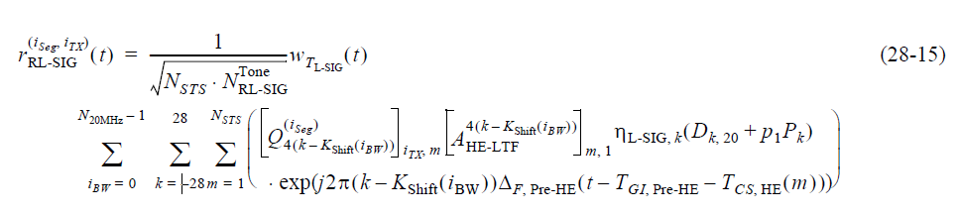
In equation (28-15) as shown above, most of the varialbes are defined in the descriptions of previous equations. The locations where the descriptions first show up are shown below. Only the descriptions of i_{BW} and N_{STS} are missing. Although it is better to add all the descrioptions in every equation, however, it is also big overhead. Hence, it is suggetsed to refer the equations where the descriptions can be found.

[Above eq (28-1]] i_{seg}: frequency segment index
[Above eq (28-1]] i_{TX}: transmit chain index
[Missing in Chapter 28, first shown in equation (28-8)]N_{STS} is defined in Table 28-15—Frequently used parameters
[Description of (28-3/4)] is defined in Table 28-16—Number of modulated subcarriers and guard interval duration values for HE PPDU fields
[Description of (28-3/4)] is given in 17.3.2.5 (Mathemat-ical conventions in the signal descriptions).
[Description of (28-6)] N_{20MHz} is defined in 21.3.7.3 (Channel frequencies)
[Missing, first shown in eq (28-6)] i_{BW}
[Description of (28-3/4)] , where is defined in the description of equation (28-3) and (28-4)
[Description of (28-8)] , where is defined in Equation (28-50)
[Description of (28-3/4)]
[Description of (28-12)]
[Defined (28-15)] p₁
[Description of (28-12)] P_{k}
[Description of (28-6)] K_{Shift}(i_{BW})
[Description of (28-3/4)] is given in Table 28-12 (Timing-related constants)
[Description of (28-3/4)]
[Description of (28-3/4)]

Instruction to Editor: Please add the following paragraph to P401, 43
N_{STS} is defined in Table 28-15—Frequently used parameters.

Instruction to Editor: Please add the following paragraph to P401, 15
i_{BW} is the index of 20MHz channels,

Instruction to Editor: Please add the following paragraph to P405, 3
Please refer to the description of equation (28-1, 3, 4, 6, 8, 12) for the definitions of the other variables.

CID 11654&11655
CID | Page.  Line | Clause Number | Comment | Proposed Change | Resolution
11654 | 451.39 | 28.3.10.10 | Provide definitions or references for all variables in Eq 28-53. | as in comment | Instruction to Editor:  REVISED  Agreed that the variables should be either defined or referred to.  Please make the changes according to the changes in doc 18-0006r0
11655 | 451.39 | 28.3.10.10 | what is the difference between K_r^HE-LTF and K_r. | as in comment | Instruction to Editor:  REVISED  The descriptions of K_r^HE-LTF and K_r is in the description of (28-5), suggest to refer to the previous description  Please make the changes according to the changes in doc 18-0006r0

Discussion

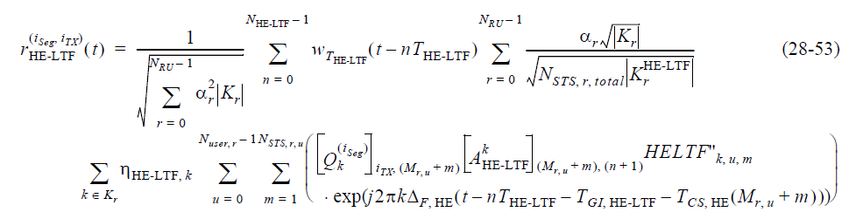

Equation (28-53) and Equation (28-54) are waveforms of HE-LTF for SU/MU/ER SU and TB PPDU respectively. The descriptions should be given together. Moreover, most of the definitions of varialbes are given in the descriptions of previuos equations. It is better to refer to them, rather than repeat again.
Some varialbes are listed here
[Descriptions are Missing, first shown up in eq 28-3]N_{RU}
[Description of (28-3/4)]
[Description of (28-1)]
[In (28-34)]
[Description of (28-4)]

Instruction to Editor: Please make the following changes to P451, 63:
Where in equations (28-53) and (28-54), the following notations are used:

Instruction to Editor: Please add the following paragraph to P451, 65:
is the number of HE MU PPDU recipients (see Table 28-15 (Frequently used parameters)) in RU r
Please refer to the description of equation (28-5) for the definitions of and .
Please refer to the description of equation (28-1, 3, 4, 6, 8, 12, 34) for the definitions of the other variables.

Instruction to Editor: Please add the following paragraph to P397, 50:
N_{RU} is defined in Table 28-15—Frequently used parameters

CID 11637
CID | Page.  Line | Clause Number | Comment | Proposed Change | Resolution
11637 | 407.8 | 28.3.10.7.2 | Consider the case of HE ER SU PPDU, Doppler=0, DCM=1 and STBC=1. What do I set "Nsts And Midamble Periodicity" to if I have one space-time stream? "Set to 0" does not apply since it says "when the STBC subfield is set to 0". "Set to 1" does not apply because it says "for two space-time streams". | as in comment | Instruction to Editor:  REJECT  Reason: When STBC=1, 1SS makes 2 space-time streams, hence it applies to the case of “Set to 1”

CID 11638
CID | Page.  Line | Clause Number | Comment | Proposed Change | Resolution
11638 | 407.20 | 28.3.10.7.2 | Consider the case of HE ER SU PPDU, Doppler=1, DCM=1 and STBC=1. What do I set "Nsts And Midamble Periodicity" to if I have one space-time stream? "Set to 0" does not apply since it says "when the STBC subfield is set to 0". "Set to 1" does not apply because it says "for two space-time streams". | as in comment | Instruction to Editor:  REJECT  Reason: When STBC=1, 1SS makes 2 space-time streams, hence it applies to the case of “Set to 1”

CID 12673
CID | Page.  Line | Clause Number | Comment | Proposed Change | Resolution
12673 | 142.35 | 9.4.2.237.3 | The MU Beamformer subfield has no associated behaviour | Delete from 9.4.2.237.3 (figure and table) and from 27.6.2 (last sentence first bullet, and second bullet) | Instruction to Editor:  REJECT  On one hand, the Tx capability is up to the AP, to decide if to act as a MU Beamformer or not. Whilst on the other hand, the non-AP STA can use this information to decide if or not to associate to one AP or not.  Moreover, in Page 1097 of P802.11-2016, MU Beamformer Capable also exists in Table 9-249—Subfields of the VHT Capabilities Information field  Considering multiple aspects, it is better to follow VHT and keep it there.

CID 12890
CID | Page.  Line | Clause Number | Comment | Proposed Change | Resolution
12890 | 239.6 | 27.4.4.1 | "A STA that sends a PPDU to an intended recipient " -- the STA is not going to send the PPDU to an unintended recipient | Delete "to an intended recipient" in the cited text | Instruction to Editor:  ACCEPTED

CID 14071
CID | Page.  Line | Clause Number | Comment | Proposed Change | Resolution
14071 | 412.28 | 28.3.10.7.2 | range "of" | Change "range 4 to 7" to "range of 4 to 7". Also on line 30. | Instruction to Editor:  ACCEPTED

CID 14084
CID | Page.  Line | Clause Number | Comment | Proposed Change | Resolution
14084 | 463.6 | 28.3.11.9 | Is "b0 b1 b2 b3 b4 b5 b6 b7 b8 b9" in Figures 28-35 ~ 38 defined? | Define "b0 b1 b2 b3 b4 b5 b6 b7 b8 b9". | Instruction to Editor:  REVISED  Here we can follow 256-QAM, and just mentions that: The bit string convention in Figure 28-35, Figure 28-36, Figure 28-37, and Figure 28-38 follows the bit string convention outlined in 17.3.5.8.  Please make the changes according to the changes in doc 18-0006r0

Instruction to Editor: Please add the following sentence to the end of P463, L2:
The bit string convention in Figure 28-35, Figure 28-36, Figure 28-37, and Figure 28-38 follows the bit string convention outlined in 17.3.5.8.

CID 14321
CID | Page.  Line | Clause Number | Comment | Proposed Change | Resolution
14321 | 432.32 | 28.3.10.8.6 | There is no clear definition of load balancing. Please define it before using it in the text of behavior description. Also there is a seperated section talking about network load balancing. It may confuse people using the same term for different technical purpose. | as in the comment | Instruction to Editor:  REVISED  Please refer to CID 11496 in doc 11-18/0118r0

