IEEE P802.11
Wireless LANs
802.11 REVmd
Proposed Resolutions for Editor’s Notes in REVmd D0.4
Date: 2017-11-01
Author(s):
Name | Company | Address | Phone | email
Emily Qi | Intel Corporation |  |  | Emily.h.qi@intel.com
Edward Au | Huawei |  |  | edward.ks.au@huawei.com
Yongho Seok | Mediatek |  |  | Yongho.Seok@mediatek.com
Abstract

This document contains proposed resolutions to Editor’s Notes in REVmd D0.4.

EN#1: Page 10.6 Editor’s Note: Figure i will be updated
Discussions:
Editor will modify figure I when the intergration of amendaments is completed:
- Add IEEE Std 802.11-2016
- Add clause 23 as IEEE 802.11ah PHY is introduced clause 23.
- ...
When the new figure is ready, it will be reviewed in TGmd.
Resolution:

======
EN#2: Page 266.18, Editor’s Note: Figures 4-29a in 802.11ai-2016 is Figures 4-30 in D0.1
Discussions: It is an observation. There is no issue.
Resolution: Remove the note.

======
EN#3: Page 828.11, Editor’s Note: the "Order" number has changed for many rows. The roll-in to the base document resulted in the position of these rows reflecting the "Order" number, according to the editor change
instruction in the 11ai draft.

Discussions: it is an observation from TGmd editors that TGai editors did not insert any Editor’s instruction that the “Order” numbers of new and existing information are not arranged in an ascending order. The TGmd editors have fixed the “Order” and there is no remaining issue.
Resolution: Remove the note.

=====
EN#4: Page 1677.33, Editor’s Note: Is the following paragraph duplicate of the second paragraph of this subclause?

Discussions: They are identical paragraphs.

Resolution: Remove the duplicated paragraph (1677.36 to 1677.40)

======
EN#5: Page 1914.26, Editor’s Note: There is no subclause 11.2.2.17 as shown in the paragraph below

Discussions: TGah chair suggested to change to 11.2.3.17

Resolution: Change “11.2.2.17” to “11.2.3.17”

====
EN#6: Page 1914.26, Editor’s Note: There is no subclause 10.2.2.5 as shown in the paragraph below

Discussions:
Cited text:
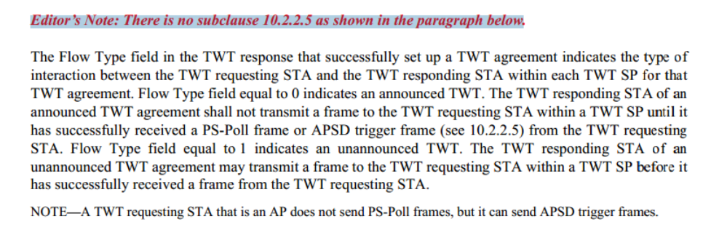

TGmd editors believe that the correct subclause should be 11.2.3.5 Power management with APSD.

Note: There is no “APSD trigger frame” though it is appeared in the draft a few times. It should be “U-APSD trigger frame”.

TGah chair suggested to change to 11.2.3.5.

Resolution: Change “10.2.2.5” to “11.2.3.5”

======
EN#7: Page 1924.14, Editor’s Note: There is no subclause 11.2.2.17 as shown in the paragraph below

Discussions:
Cited text:

TGah chair suggested to change to 11.2.3.17.

Resolution: Change 11.2.2.17 to 11.2.3.17.

======
EN#8: Page 2345.13, Editor’s Note: L is not defined in 11.6.1. The reference below for L is questionable

Discussions: This Editor’s note corresponds to CID 113 whose resolution is approved in September. The current status is subject to motion.

Resolution: Remove the Editor’s note when the motion corresponding to CID 113 is approved and the comment resolution is implemented.

======
EN#9: Page 2540.13, Editor’s Note: Figure 13-1a in IEEE 802.11ai is Figure 13-2 in D0.1

Discussions: This note is an observation.

Resolution: Remove the Editor’s note.

======
EN#10: Page 2540.62: Editor’s Note: There is no subclause 12.11.2.3.1. In an existing subclause 12.12.2.3.1, IKM is not mentioned. Should it be 12.11.1.

Discussions: TGmd editors have identified an appropriate reference and the issue is resolved.

Resolution: Remove the Editor’s note.

==
EN#11: Page 3183.55: Editor’s Note: The second sentence of item i) above is strange. What does it mean by “as described in if 1 MHz Duplicate PPDU as described in ...”?

Discussions:
Cited text:
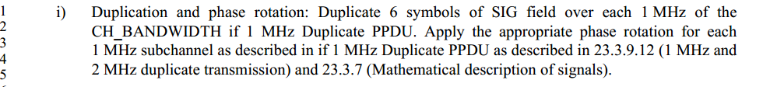

TGmd editors believe that it is an editing error and “if 1 MHz Duplicate PPDU as described in” shoud be removed.
Another suggestion is to delete “as described in”. There is no consensus. Chair suggested to leave as it is. Will submit a comment in LB.
Resolution: TBD.

======
EN#12: Page 3192.14:
Editor’s Note: Where is Note 1?

Discussions:
Cited text:

TGah chair suggested to change to “Note”.

Resolution: Change “Note 1” to “Note”.

EN#13: Page 3192.35:
Editor’s Note: Where is Note 2?

Discussions:
Cited text:

TGah chair suggested to change to “Note”.

Resolution: Change “Note 2” to “Note”.

EN#14: Page 3331.47:

Editor’s Note: There is no sub
clause 8.2.4.3
Discussions: it should be 9.2.4.3

Resolution: change “8.2.4.3” to “9.2.4.3”.

==
EN#15: Page 3331.55:

Editor’s Note: There is no sub
clause 8.2.4.3
Discussions: it should be 9.2.4.3

Resolution: change “8.2.4.3” to “9.2.4.3”.

==

EN#16: Page 3496.30: Editor’s Note: Why are there two FILS6.3?

Discussions:
Cited text:
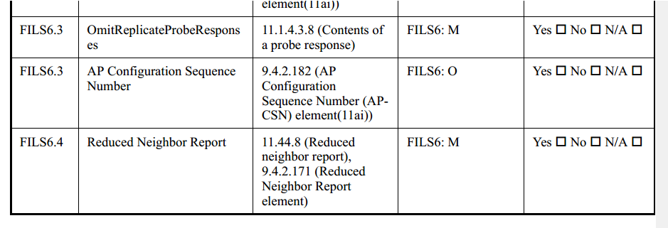

The second 6.3 should be changed to 6.4.
At 3495.17, change “FILS6.3” to “FILS6.4”. At 3495.22, change “FILS6.4” to “FILS6.5”.
The proposed resolution is same as CID 115.

Resolution: Implement the resolution in CID 115 and remove the Editor Note.

