IEEE P802.11
Wireless LANs
802.11
CC25 - Proposed Resolutions for Editorial Comments
Date: 2017-08-04
Author(s):
Name | Company | Address | Phone | email
Emily Qi | Intel Corporation |  |  | Emily.h.qi@intel.com
Abstract

This document contains proposed resolutions to CC25 editorial comments that require TG’s feedback.

R0.0: Initial proposal.
R0.1: Updated proposal based on the TGmd teleconference on August 4, 2017.

7101 | 1706.09 | 11.11.10.3 | "the reporting AP has dot11LciCivicInNeighborReport and the neighbor AP has LCI MeasurementCapability (RM Enabled Capabilities element with the LCI Measurement Capability Enabled fieldset to 1) dot11RMLCIMeasurementActivated equal to true"-- this has at least two errors "has dot11LciCivicInNeighborReport" and"Measurement Capability (...) dot11RMLCIMeasurementActivated equal to true"Note that " (RM Enabled Capabilities element with the LCI Measurement Capability Enabled field set to 1)" is also a informal way of anonymously referencing a transmission by the AP)." this can also be improved. This informality occurs in a number of places in this subclause. The proposed changes addresses two of these. | Change cited text to:"the reporting AP has dot11LciCivicInNeighborReport equal to true and the neighbor AP indicates support for LCI measurement(the neighbor AP has transmitted an RM Enabled Capabilities element with the LCI Measurement Capability Enabled field equal to true)"Make matching changes at 1706.32.

==================

249 | ???? | ???? | There are about 70 instances of "when a valid" -- what defines validity? | Delete "valid" in all instances

Discussion

All 70 instances are in clause 6.

Here is an example of cited text:

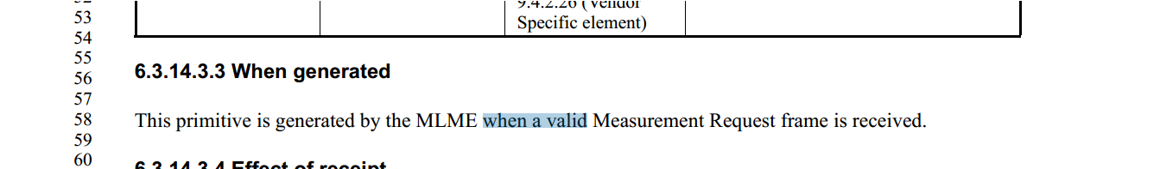

This sentence means that the primitive is generated by MLME when xxx frame is received and the xxx frame is valid. Removing “valid” will change the behaviour of MLME.

The standard doesn’t attempt to describe the behaviour. The behaviour is captured in the received.

Proposed Resolution:

Accept.

Reject.

Reject reason: This sentence means that the primitive is generated by MLME when xxx frame is received and the xxx frame is valid. Removing “valid” will change the behaviour of MLME.

123 | ???? | ???? | It is not necessary to specify the size of an integer when the size is given in the Figure descibing the field | Delete the "x-bit" or "xxx bit" before "unsigned integer"

Discussion

I searched “bit unsigned integer” through the doc, and found 33 instances.

12 instances in clause 6, for example:
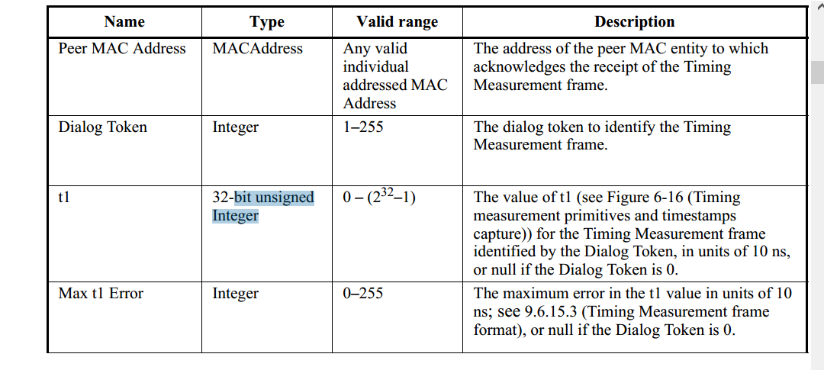
10 instances in clause 10, 12, and 14.
I think specifying the size of intergrer in the clause that is out of clause 9 or not given in the figure describing the field is neccessory. The instances in clause 6, 10, 12, 14 shouldn’t be changed.

Proposed Resolution:

Revised.

In Clause 6, delete the "x-bit unsigned" or "xxx bit unsigned " before "integer", and change "integer" to “Integer".
In Clause 9, if the size of an integer is given in the figure and the cited text is in the same subclause of the figure, delete the "x-bit" or "xxx bit" before "unsigned integer".
Otherwise, no change.

164 | ???? | ???? | It is confusing to have both a "Beamforming Report Poll frame" and "BRP frame" | Change "BRP frame" to "Beam Refinement Protocol frame" throughout the draft

Discussion

In clause 3.4 Abbreviations and acronyms, BRP is defined as “beam refinement protocol”.

It should be clear that BRP frame is for “beam refinement protocol” frame.

There is no need to rename it.

Proposed Resolution:

Reject.

Reject reason: In clause 3.4 Abbreviations and acronyms, BRP is defined as “beam refinement protocol”. It should be clear that BRP frame is for “beam refinement protocol” frame. There is no need to rename it.

169 | ???? | ???? | There is no point in the distinction between Measurement Request frames and Radio Measurement Request frames | Delete "Radio" in "Radio Measurement Request" and "Radio Measurement Report" throughout the draft

Discussion

There are differences between the Measurement Request/Report frame and Radio Measurement Request/Report frame.

The Measurement Request/Response frames are Spectrum management Action frames, see 9.6.2.
The Radio Measurement Request/Report frames are Radio Measurement action frames, see 9.6.7.

Proposed Resolution:
Rejected.

Reject reason: There are differences between the Measurement Request/Report frame and Radio Measurement Request/Report frame.

The Measurement Request/Response frames are Spectrum management Action frames, see 9.6.2.
The Radio Measurement Request/Report frames are Radio Measurement action frames, see 9.6.7.

203 | ???? | ??? | There is a definition for "DMG STA", namely "A STA whose radio transmitter is capable of transmitting  and receiving DMG physical layer (PHY) protocol data units (PPDUs)." However, there is no definition for "$PHY STA", where $PHY is "DSSS", "HR/DSSS", "OFDM", "ERP", "HT", "VHT" or "TVHT" as "A STA whose radio transmitter is capable of transmitting  and receiving DMG physical layer (PHY) protocol data units (PPDUs)." There is absolutely no reason to have the "DMG STA" definition | Delete the "DMG STA" definition
204 |  |  | There is a definition for "DMG AP", "DMG BSS". We don't do this for other PHYs. There is absolutely no reason to have these definitions | Delete the "DMG AP" and "DMG BSS" definitions

Discussion

Cited text at page 150

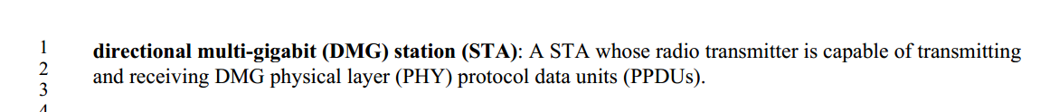

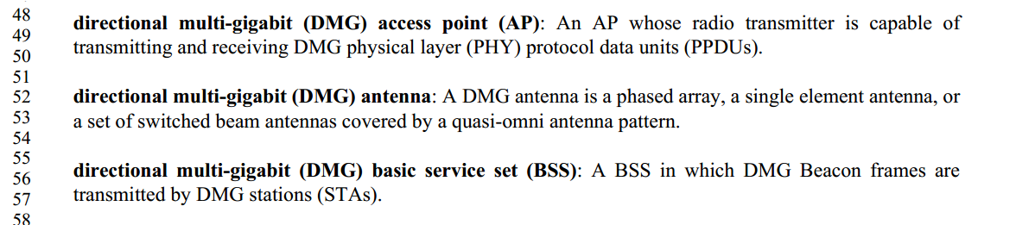

I couldn’t find definition for VHT STA, etc ....

However, I found VHT BSS definition.

very high throughput (VHT) basic service set (BSS): A BSS in which a Beacon frame transmitted by a
VHT station (STA) includes the VHT Operation element

I think there is no harm to have the definition to help clarifications.

Proposed Resolution: TBD

CID203: Accept.

CID204: Reject.
Reason: In the usage of <adjective> AP and <adjective> BSS, the situation is not always clear, without a definition. In the case of DMG BSS, confusion can also arise from whether a PBSS is a type of DMG BSS or not.
==========================================================================

208 | ???? | ??? | In two locations, "elements" is referring to a parameter, not an element | Make the changes shown in 16/0839r3 under CID 8145

Discussion:

I talked to the commenter and found the locations. Agreed to fix them.

At 348.40, 349.40

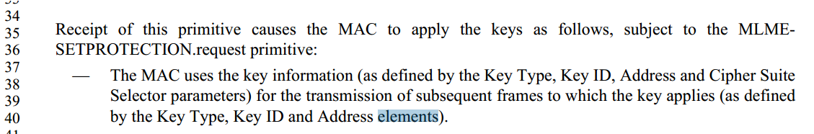

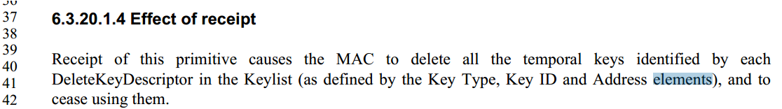

Also, the commenter identied two more locations:

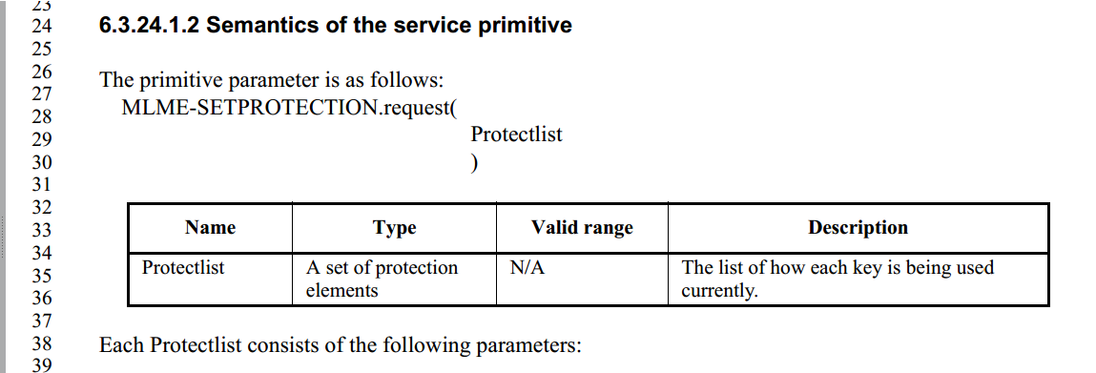

At 352.35: “protection elements” shall be “ProtectDescriptors”.
At 352.38: “Protectlist” shall be “ProtectDescriptors”.

Proposed resolution:
Revised.

At 348.40, 349.40: change “elements” to “parameters”.
At 352.35: change “protection elements” to “ProtectDescriptors”.
At 352.38: change “Protectlist” to “ProtectDescriptor”.

210 | ???? | ??? | There are 3 instances of " transmission of an A-MPDU or frame in", but though this is technically defensible when followed by "a PSDU" it is confusing (the usual layering confusion: an A-MPDU contains frames (a.k.a. MPDUs); it is not at the same level) and the middle instance is not even followed by "a PSDU" anyway | Change "QSRC[AC] shall be incremented every time transmission of an A-MPDU or frame in a PSDU of length less  than or equal to dot11RTSThreshold fails, regardless of the presence or value of the DEI field. When  dot11RobustAVStreamingImplemented is true, QSDRC[AC] shall be incremented every time transmission of  an A-MPDU or frame in which the HT variant HT Control field is present," to "QSRC[AC] shall be incremented every time transmission of a PSDU of length less  than or equal to dot11RTSThreshold fails, regardless of the presence or value of the DEI field. When  dot11RobustAVStreamingImplemented is true, QSDRC[AC] shall be incremented every time a transmission in which the HT variant HT Control field is present,"  Change "QLRC[AC] shall be incremented every time transmission of an A-MPDU or frame in a PSDU" to "QLRC[AC] shall be incremented every time transmission of a PSDU"

Discussion

3 locations:
Change
"QSRC[AC] shall be incremented every time transmission of an A-MPDU or frame in a PSDU of length less than or equal to dot11RTSThreshold fails, regardless of the presence or value of the DEI field. When dot11RobustAVStreamingImplemented is true, QSDRC[AC] shall be incremented every time transmission of an A-MPDU or frame in which the HT variant HT Control field is present,"
to
"QSRC[AC] shall be incremented every time transmission of a PSDU of length less than or equal to dot11RTSThreshold fails, regardless of the presence or value of the DEI field. When dot11RobustAVStreamingImplemented is true, QSDRC[AC] shall be incremented every time a transmission in which the HT variant HT Control field is present,"

Change
"QLRC[AC] shall be incremented every time transmission of an A-MPDU or frame in a PSDU"
to
"QLRC[AC] shall be incremented every time transmission of a PSDU"

I was inclined to accept the proposed change. Would like to get feedback from the group.

Proposed Resolution: TBD

243 | ???? | ??? | "is shown in" (Figure, Table, etc.) or similar wooly statements ("is illustrated in") should be "is defined in" (at least in Clause 9 and the cases where the figure/table is the thing that normatively defines the structure/valid values) | As it says in the comment

Discussion

679 instances of “is shown in”.
59 instances of “is illustrated in”.

Sometimes, the information is “shown” in a figure or table. It is not defined. For example,

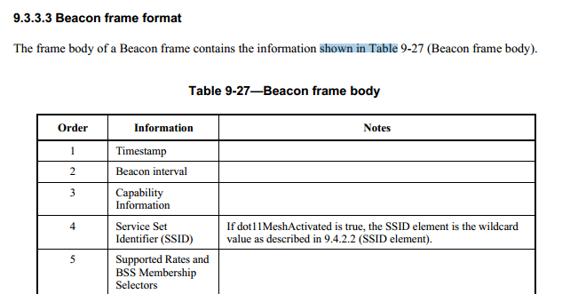

There is no definition in Table 9-27.
IMHO, there is no need to change “is shown in” to “is defined in”.

Proposed Resolution:

Reject.

The proposed resolution does not provide changes to the draft that can be immediately adapted to satisfy the comment.

248 | ???? | ??? | Should common words in field names (e.g. "of", "in", "per") be upper- or lower-case? E.g. "FTMs per Burst" v. "Format And Bandwidth" at 1076.3 (this is just an example, not a complete set) | Be consistent

Discussion:

Here is the example given by the commenter: at 1180.3

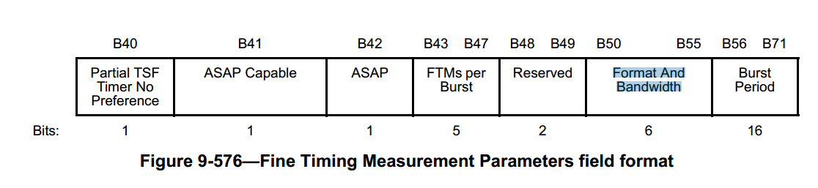

I have checked with Adrian. Here is the feedback: ☺
1. Field names are initial capitals
2. "Title case" - i.e. that used in headings does not capitalize "function" words (of, in, etc).
That said, there is no style guidance for function words (of, in etc… ) in the field name.

Proposed resolution:
Reject.
Reject Reason: There is no style guidance for function words (of, in etc… ) in the field name. The proposed resolution does not provide changes to the draft that can be immediately adapted to satisfy the comment.

254 | ???? | ??? | Is the subfield called "FMS Counters" or "FMS Counter"? I think the latter | Use "FMS Counter" and say "field". [In 802.11mc/D6.0: Delete the "s" in "FMS Counters" at 946.1 (rightmost). Add "field" after "FMS Counter" at 946.1 (rightmost) and 946.16. At 946.6, 1594.23 (2x) lowercase "Counter". At 1594.19, 1594.23, 1595.5 (2x), 1595.7, 1595.11, 1595.56, 1596.17 lowercase "Stream"]

Proposed resolution:
Revised.

At 1060.41 to 1060.56, make following changes:

The FMS Counters field contains zero or more FMS Counters fields. The format of the FMS Counter field is shown in Figure 9-409 (FMS Counter format). When one or more FMS streams are accepted at the AP, at least one
FMS counter is present in the FMS Descriptor element. A maximum of eight FMS counters are permitted.
The FMS counters are used by the non-AP STA to identify the DTIM beacon after which group addressed
BUs assigned to a particular delivery interval are transmitted. A single FMS Ccounter is shared by all FMS
streams that use the same delivery interval.
……

Figure 9-409—FMS Counter field format

Make following changes:

11.2.3.16.2 FMS general procedures
When dot11FMSActivated is true at the AP, the AP shall include the FMS Descriptor element in every
Beacon frame. The FMS Descriptor indicates the FMS group addressed buffered BUs at the AP. If there are
no buffered BUs for FMS streams accepted by the AP, the AP shall set the Length field in the FMS
Descriptor element to 1. The AP shall include the FMS Descriptor element for a nontransmitted BSSID in
the Multiple BSSID element sent in a Beacon frame.
When dot11FMSActivated is true at the AP, the AP shall support from one to eight different FMS Sstream
delivery intervals for any number of FMS streams. Corresponding to these eight delivery intervals are eight
FMS counters. More than one FMSID may have the same delivery interval and therefore will share the same
FMS Ccounter. An FMS Ccounter corresponds to each unique delivery interval of one or more FMS Sstreams.
Each FMS counter decrements once per DTIM beacon and when the FMS counter reaches 0, buffered group
addressed BUs assigned to that particular interval are scheduled for delivery immediately following the next
Beacon frame containing the DTIM transmission. After transmission of the buffered group addressed BUs,
the AP shall reset the FMS counter to the delivery interval for the FMS streams associated with that FMS
counter.
A non-AP STA that does not use FMS wakes every DTIM interval and follows group addressed BU
reception rules as defined in 11.2.3.8 (Receive operation for STAs in PS mode during the CP).
A STA that supports FMS shall be capable of supporting a delivery interval of 1 for any stream.

11.2.3.16.3 FMS Request procedures
A non-AP STA that supports FMS may request use of FMS by sending an FMS Request frame or
Reassociation Request frame that includes one or more FMS Request elements to an AP that supports FMS.
Each FMS Request element includes one or more FMS subelements. Each FMS subelement identifies an
FMS stream, the requested delivery interval and the maximum delivery interval for that stream. The FMS
delivery interval shall be an integer multiple of the DTIM period.
Upon reception of an FMS Request frame or Reassociation Request frame, the AP shall transmit a
corresponding single FMS Response frame or Reassociation Response frame that contains a corresponding FMS Response element for each FMS Request element in the same order received. Each FMS Response
element shall contain an FMS Status subelement and zero or more other subelements drawn from Table 9-
197 (Optional subelement IDs for FMS Response subelements) that corresponds to each FMS subelement in
the FMS Request element, in the same order.
For each FMS subelement, the following rules apply:
If the AP accepts the FMS subelement and the requested delivery interval, the Element Status in the
corresponding FMS Status subelement shall be set to “Accept” and the FMSID is assigned to a nonzero
value. In addition:
— If the FMS stream identified in the FMS subelement matches a delivery interval already in use at the
AP, the AP shall assign the FMS stream to use the FMS Counter ID assigned for that delivery
interval.
— When an FMS Sstream is accepted by the AP, the Current Count value for that FMS Sstream is
decremented by 1 for each DTIM Beacon frame in which the Current Count field appears.
— The AP may reschedule transmission of the FMS Sstream identified by an FMSID to align the
transmission time of the FMS stream to the transmission time of other FMS streams that the STA is
already receiving at the same delivery interval. The AP has the following two options:
— Notify the STAs using that FMS Str Sstream. The AP shall keep the nonzero Current Count value
the same across two consecutive Beacon frames in which the Current Count field appears. The
algorithm by which the AP chooses to align or offset the different FMS counters is unspecified.
— Transmit an unsolicited FMS Response frame to the group address included in the original
FMS Response frame for the stream with the updated Delivery Interval field when the Current
Count field value reaches 0. Since the AP transmits this FMS Response frame as a group
addressed frame, the frame will be scheduled for delivery at the appropriate DTIM interval
when all non-AP STAs are awake to receive the frame.
— An AP may terminate the use of FMS and resume default (non-FMS) transmission rules for any
FMS stream identified by FMSID for any reason. To terminate the FMS stream, the AP shall send
an unsolicited FMS Response frame to the group address included in the original FMS Response
frame with Delivery Interval set to 0 and the Element Status in the FMS Status subelement set to one
of “Terminate, due to AP policy change”, “Terminate, due to lack of resources of AP,” and
“Terminate, due to other FMS stream with higher priority”.
— If the FMS subelement contained a nonzero delivery interval and the non-AP STA specified a
maximum delivery interval as part of the FMS request, the AP shall not modify the delivery interval
for the stream greater than the maximum delivery interval specified by the non-AP STA.
— An AP shall transmit MSDUs belonging to the same FMSID in the same order that they were
received at the MAC Data SAP. MSDUs belonging to the different FMSIDs are transmitted by the
AP at the appropriate DTIM in the order received at the MAC data SAP based on the interval
configured for the FMS stream.
If the AP denies the FMS subelement for any reason, including requested delivery interval, maximum
delivery interval and TCLAS, the Element Status in the corresponding FMS Status subelement shall be set
to one of “Deny, due to request format error or ambiguous classifier”, “Deny, due to lack of resources on
AP”, “Deny, due to requested classifier(s) matching 2 or more existing streams on different intervals,”
“Deny, by policy, requested stream or filter is not permitted to participate in the service”, and “Deny, reason
unspecified”.
If the AP selects an alternate delivery interval or alternate maximum delivery interval from the value
specified in the FMS Request, the Element Status field in the corresponding FMS Status subelement shall be
set to one of “Alternate proposed, due to existing stream with different delivery interval”, “Alternate
proposed, due to policy limits on AP”, “Alternate proposed, because the AP changed the delivery interval”, and “Alternate proposed, because the AP changed the maximum delivery interval” and the FMS subelement
shall indicate the AP selected value(s).
To terminate the use of FMS for an FMS Sstream identified by FMSID, the non-AP STA shall transmit an
FMS Request frame with an FMS Request element and FMS subelement with the FMSID matching the
FMS stream and the delivery interval set to 0.
The AP shall respond to a malformed FMS Request frame or Reassociation Request frame with an FMS
Response frame or Reassociation Response frame that denies all FMS Request elements by including an
FMS Status code “Deny, due to request format error or ambiguous classifier” in the Element Status field in
each FMS Status subelement in the FMS Response element.
11.2.3.16.4 FMS Response procedures
Upon reception of an FMS Response element in a frame that has a value in Address 1 that matches its MAC
address or that is a group address corresponding to a group of which it is a member and that was transmitted
by the AP with which it is associated, a non-AP STA that supports FMS shall use the following procedures,
based on the value of the Element Status value in the FMS Status subelement in the received FMS Response
element.
— If the Element Status value in the FMS Status subelement is “Accept”:
— The AP has accepted the FMS subelement contained within the FMS Request element. If the
FMS Request element specified a nonzero delivery interval, the AP will deliver the requested
streams at the delivery interval as specified by the non-AP STA in the FMS Request element.
— After receiving the FMS Response element, the non-AP STA shall be awake for the next
DTIM beacon so that the non-AP STA can synchronize with the FMS Current Count for the
requested FMS Sstream. Once synchronized with the FMS Current Count, the non-AP STA
need not wake up at every DTIM interval to receive group addressed BUs.
— If the Element Status value in the FMS Status subelement is one of “Deny, due to request format
error or ambiguous classifier”, “Deny, due to lack of resources on AP”, “Deny, due to requested
classifier(s) matching 2 or more existing streams on different intervals”, “Deny, by policy, requested
stream or filter is not permitted to participate in the service”, and “Deny, reason unspecified”:
— The AP does not deliver the requested streams at the delivery interval as specified by the nonAP STA in the FMS Request element. The AP delivers the requested stream at every DTIM
interval.
— If the Element Status value in the FMS Status subelement is one of “Alternate proposed, due to
existing stream with different delivery interval”, “Alternate proposed, due to policy limits on AP”,
“Alternate proposed, because the AP changed the delivery interval”, and “Alternate proposed,
because the AP changed the maximum delivery interval”:
— The AP does not deliver the requested streams at the delivery interval and maximum delivery
interval as specified by the non-AP STA in the FMS Request element. The FMS Status
subelement specifies a delivery interval and a maximum delivery interval that the AP is willing
to accept for the specified streams if the non-AP STA sends another FMS Request with that
delivery interval and maximum delivery interval specified.
— The non-AP STA may submit a new FMS Request that includes the delivery interval value
received from the AP. If the AP accepts this new FMS Request, it shall respond as described in
11.2.3.16.2 (FMS general procedures).
— If the Element Status value in the FMS Status subelement is “Alternate proposed, because the AP is
unable to provide requested TCLAS-based classifiers”:
— The AP does not deliver the requested streams at the delivery interval as specified by the nonAP STA in the FMS Request element. The TCLAS element(s) or TCLAS Processing element
in the TCLAS Status subelement contains one or more fields or subfields whose values have been modified by the AP. The AP may include fewer TCLAS elements in the FMS Response
element than were present in the request; when the AP’s response includes a single TCLAS
element, it does not include a TCLAS Processing element. If the AP changes a TCLAS
element’s Classifier Type field in the FMS Response element but is unable to suggest a value
for the Classifier Mask field, it shall set that field to 0. If the AP changes a TCLAS element’s
Classifier Type field or Classifier Mask field in the FMS Response element but is unable to
suggest values for one or more Classifier Parameter subfields, it shall set those fields to 0.
— A non-AP STA receiving a modified TCLAS element having a Classifier Mask field equal to 0
or Classifier Parameter subfields equal to 0 shall interpret these values as meaning that no
suggested value has been provided by the AP.
— If the Element Status value in the FMS Status subelement is one of “Terminate, due to AP policy
change”, “Terminate, due to lack of resources of AP”, and “Terminate, due to other FMS stream
with higher priority”:
— The AP will terminate the use of FMS transmission rules for any FMS stream identified by
FMSID. If the AP terminates the usage of FMS for a particular stream, the stream is
transmitted at DTIM interval.
— The non-AP STA shall wake up at every DTIM interval to receive group addressed BUs after
receiving the FMS Response element.

257 | ???? | ??? | It is not necessary in Clause 9 to say things are done according to the conventions in 9.2.2. It is confusing to do so, because it implies something unusual is happening. | Delete the sentences like "The order of the  Organization Identifier field is described in 9.2.2 (Conventions)." or "All fields use the bit convention from 9.2.2 (Conventions)." or " It is encoded following the conventions in 9.2.2  (Conventions)." at [mc/D6.0 references] 685.46, 827.4, 828.41, 881.22, 881.26, 881.62, 882.43, 883.44, 999.59, 999.64, 1007.33, 1083.20, 1101.58, 1101.62, 1130.33, 1144.47. Delete the NOTE at 706.48. Change 880.20 to say "The MDID field contains an arbitrary value." At 951.39 delete ", encoded according to 9.2.2 (Conventions)". At 1085.14 delete " and is encoded following the  conventions given in 9.2.2 (Conventions)"

Discussion:
This comment was rejected in TGmc.
There is no confusing. It seems to me that it is more clear.

Proposed resolution:
Reject.

Reject Reason: There is no confusion.

260 | ???? | ??? | Like "RSNE", other abbreviations for elements should either never or always be used | Globally replace all instances of the expansion of MME, FFE, FTE, MDE, PWE, RDE and TIE with their abbreviation, except in Clause 3

Discussion:
This comment was rejected in TGmc.

I am not sure it is correct. Some of them are used in a subclause title, for example:

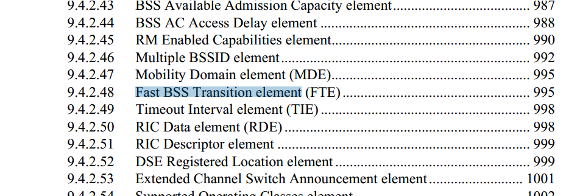

It would look odd if we change subclause title from “Fast BSS Transition element (FTE) to “FTE”.

Proposed resolution:
Reject.

Reject reason: Globally replacing is incorrect.

The proposed resolution does not provide changes to the draft that can be immediately adapted to satisfy the comment.

270 | ???? | ??? | " The Measurement Report Element field is included in the Location  Track Notification frame if the Location Parameters Element field contains a Location Indication Options subelement" -- move this condition to be in the table with all the other conditions (Table 9-318---Location Parameters Element field for  Location Track Notification frame) | As it says in the comment

Discussion:
Cited “Table 9-318” should be Table 9-328.
Table 9-328 is for allowed Location Parameters subelements for the Location Parameters Element field. The cited text is for “The Measurement Report Element field is included in the Location Track Notification frame if the Location Parameters Element field contains a Location Indication Options subelement.”

Proposed resolution:
Reject.

Reject reason: Table 9-328 is for allowed subelements for the Location Parameters Element field. The cited text is for the Measurement Report Element field, - different context.

275 | ???? | ??? | ", and delete existing TPK handshake key state for this sequence" -- the term "TPK handshake key state" is not defined | Delete the cited text

Discussion:
Cited text is at 2197.32
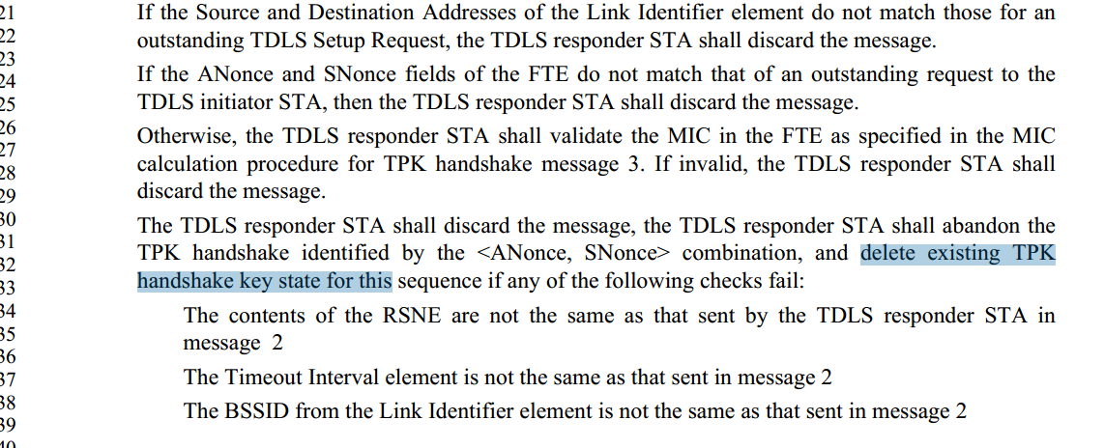

Need input.

Proposed resolution: TBD

277 | ???? | ??? | Some of the ResultCodes in the SAP have underscores (e.g. JOIN_FAILURE_TIMEOUT, NOT_SUPPORTED) some not (e.g. AUTH FAILURE TIMEOUT, ANTI-CLOGGING  TOKEN REQUIRED) | Remove the underscores from all the ResultCodes in the SAP

Discussion:
There is no rule on whether ResultCode should include underscores or not.
Some of them include underscores, indeed a lot of them includes underscores for example:
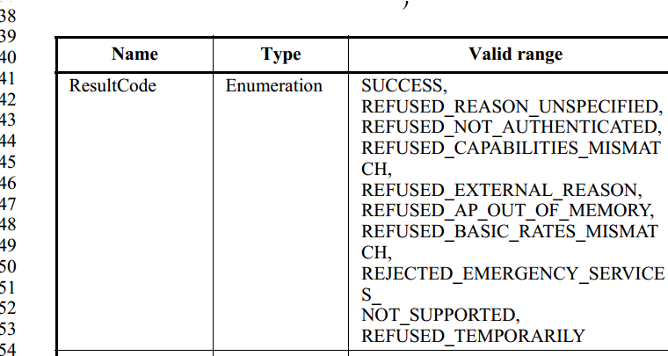

Proposed resolution:

Reject.

Reason: There is no rule on whether ResultCode should include underscores or not. Uderscores are used for ResultCode everywhere. No need to remove them.

278 | ???? | ??? | There are about 20 instances of "zero or one", but some are followed by the singular and some are followed by the plural | Either always follow with plural or always with singular

Discussion:

For example: 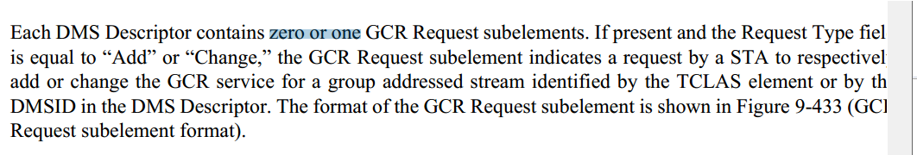

I believe “singular” should be used.

Proposed resolution:

Revised.

1078.29: change to “zero or one GCR Request subelement.”
1342.45, change “zero or one Power Constraint elements” to “zero or one Power Constraint element”.
1342.50: change “zero or one EDCA Parameter Set elements” to “zero or one EDCA Parameter Set element”.
2283.31: change “zero or one Expedited Bandwidth Request elements” to “zero or one Expedited Bandwidth Request
element”.
2283.38: change “followed by zero or one Schedule elements” to “followed by zero or one
Schedule element”.
2284.63: change “zero or one Resource Descriptors.” To “zero or one Resource Descriptor”. .
===============================================================================

301 | ???? | ??? | "FST" is an action (fast session transfer), so what's an "FST session"? It doesn't make sense to say that an FST session is the state resulting from the operation of the FST session setup protocol -- a session is clearly not a state | Change all instances of "FST session" to "FST-capable association"

Discussion:

At 240.14, it states:

An FST session is the state resulting from the operation of the FST session setup protocol.

FST session is fine as a state. No change needed.

Proposed resolution:

Reject.

326 | ???? | ??? | An RTT is the time between a signal going out and coming back. It includes any processing time at the other side. The spec uses "RTT" to mean the total time of flight, not the RTT | Delete the RTT definition from 3.4 and instead add "TOF time of flight"  At 83.58 change "round trip time (RTT)" to "distance"  At 1771.20 change "an RTT" to "a two-way TOF"  At 1772.28 change "The round trip time (RTT)" to "The two-way TOF" and change "RTT" to "TOF" in the equation  At 3598.21 change "RTT" to "two-way TOF"  (all references are to mc/D5.0)

Discussion:

This is a technical comment.
RTT is definition is clear. Do not see the reason to change.

Proposed resolution:

Reject.

327 | ???? | ??? | There seem to be at least three flavours of awake window: mesh, TDLS and DMG. The first seems to be so denoted, but the others not | Add "TDLS" or "DMG" before "awake window" where "mesh" is not present there

Discussion:

When awake windows appear in the TDLS section, they are awake window used for TDLS.
When awake windows appear in the DMG section, they are awake window used for DMS.
Please note 194 instances of awake windows. Some of them are Awake Window element.

Proposed resolution:

Reject.
Reason: Commenter doesn’t provide reasons why they need to be changed. Doesn’t identify the locations to change. Doesn’t specify what to change.

119 | ???? | ??? | "unspecified ", "not specified", "implementation dependent", "outside the scope", and "beyond the scope" - all are okay, but do we need all these different ways to say it? | Choose one (or maybe two?) and change the others to match

Discussion:

Not Specified", "implementation dependent" and "outside of the scope" are different. Using these different ways to say it is appropriate .

Proposed resolution:

Reject.
The proposed resolution does not provide changes to the draft that can be immediately adapted to satisfy the comment.

28 | 4.2.5 | 187.20 | "handle" replace with "handles" or delete the "the" in front of "IEEE Std" | Choose one (or maybe two?) and change the others to match

Discussion:

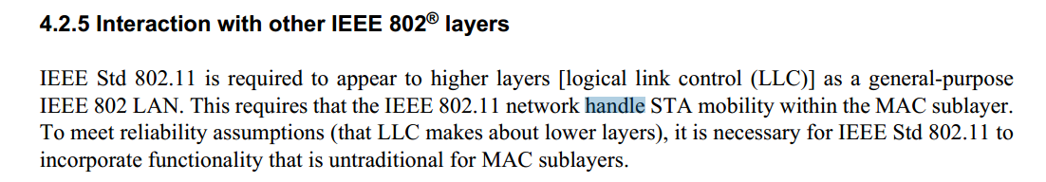

Proposed resolution:

Revised. Replace "handle" with "handles"

100 | 9.2.4.1.3 | 675.22 | Table 9-1 uses binary numbers to identify Type and Subtype values. IMHO, it would be clearer to refer to these fields as base-10 integers instead (i.e., 00 --> 0, 01 --> 1, 10 --> 2, 11 --> 3; and similarly for the 4-bit Subtype values). | Consider replacing binary values for multi-bit-integers in Table 9-1 and all similar tables throughout the draft with base-10 integers.

Discussion:

The Table 9-1 with this format has been there since IEEE 802.11-2007 (at least), these is no need to change a different format.

Proposed resolution:

Rejected. Do not see any benefit to change base-10 integers in Table 9-1. The Table 9-1 with this format has been there since IEEE 802.11-2007 (at least), these is no need to change a different format.

147 | 9.4.2.21.10 | 877.37 | There should not be two Maximum Age Subelement definitions | Define a new "Fields that are not elements" for this, and then make 877.28 and 890.26 refer back to this.

Discussion:

Subelement is “local” parameter (subelement). The subelement usage is in the scope of a particular field or element. There should be okay if two subelements that belongs to two different fields have the same format and same names.

In each of these subelements, the definitions of the Maxium Age field is different. See:

“The Maximum Age field of the Maximum Age subelement indicates the maximum elapsed time between
when FTM ranges are determined and when a Fine Timing Measurement Range request is received, within
which the FTM ranges satisfy the Fine Timing Measurement Range request. The Maximum Age field is
encoded as an unsigned integer with units of 0.1 s. The value 0 is reserved. The value 65 535 indicates that
FTM ranges determined at any time are acceptable.”

“The Maximum Age field of a Maximum Age subelement indicates the maximum elapsed time between
when an LCI is determined and when an LCI request is received, within which the LCI satisfies the LCI
request. The Maximum Age field is encoded as an unsigned integer with units of 0.1 s. The value of 0 is
reserved. The value of 65 535 indicates that any LCI age is acceptable.

Option 1: Reject.

Option 2: Revised. Change names of subelements.

In 9.4.2.21.10 (Page 877 area), change “Maximum Age Subelement” to “LCI Maximum Age Subelement”. There is no change to the field name “Maximum Age”.

In 11.11.9.6 LCI report, change “Maximum Age” to “LCI Maximum Age”, and “maximum age” to “LCI maximum age” if it is associated with subelement.

In 9.4.2.21.19 Fine Timing Measurement Range request (Page 890 area), change “Maximum Age Subelement” to change “FTM Range Maximum Age Subelement”. There is no change to the field name “Maximum Age”.

In 11.11.9.11 Fine Timing Measurement Range report, change “Maximum Age” to “FTM Range Maximum Age”, and “maximum age” to “FTM range maximum age” if it is associated with subelement.

Proposed resolution: TBD

