IEEE P802.11
Wireless LANs
802.11
Proposed comment resolution for CID 336
Date: 2017-05-10
Author(s):
Name | Company | Address | Phone | email
Adrian Stephens | Intel Corporation |  |  | Adrian.p.stephens@ieee.org
Abstract

This document contains a proposed comment resolution for 802.11REVmd pre-ballot comment CID 336.

Comment

CID | Page | Clause | Resn Status | Comment | Proposed Change | Resolution | Owning Ad-hoc
336 | 1558.00 | 10.27.8 |  | The subsection of 10.27.8 Extensible element parsing is not clear. What is the "the value indicated in Table 9-77" in line 32 and "the maximum length indicated in this table" in line 33. They can not be found in Table 9-77. And how to understand "this truncated element"? What is "A STA" in line 30, is it legacy STA or new STA. How do they parse the Extensible element, respectively？ | Provide the corresponding clarification and make the Table 9-77 complete.

Context (1558.10 & 833.26): (cited locations highlighted)
10.27.8 Extensible element parsing

Table 9-77 (Element IDs) indicates which elements are considered extensible in future revisions of the standard, by placing a Yes in the Extensible column. A STA that receives an extensible element in which the Length field plus two exceeds the value indicated in Table 9-77 (Element IDs) shall discard any part of the element beyond the maximum length indicated in this table and shall otherwise process the element as though this truncated element had been received.

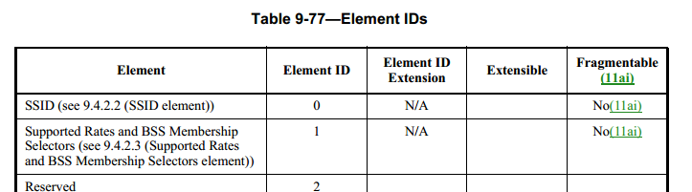

Discussion

This table originally included a “length” column. The 2016 revision removed this column because comments were received pointing out that the value in the table did not match the definition of the element.

This is a good example of the dangers of repeating normative specification. What do you do if they differ?

Clearly the change to remove the column was incomplete, because it left dangling the reference from the cited location. We have a choice of undoing the former change or fixing the dangling reference. In this author’s mind, the latter is indubitably the better response to the comment, and is what is proposed in this submission.

In regard to the second part of the comment: “What is "A STA" in line 30, is it legacy STA or new STA. How do they parse the Extensible element, respectively？” A standard doesn’t use the word “legacy” (notwithstanding that L-SIG steers perilously close to this terminological wind). The standard describes that which is current compliant behaviour for a STA implemented to that standard notwithstanding that earlier standards have existed, and subsequent revisions may bloom like fragrant flowers in the garden of our engineering ingenuity.

So the answer to the question is that A STA is a device that is compliant to the normative requirements for a STA defined in this standard.

Proposed Resolution:
Revised.

At 1558.30 replace: “A STA that receives an extensible element in which the Length field plus two exceeds the value indicated in Table 9-77 (Element IDs) shall discard any part of the element beyond the maximum length indicated in this table and shall otherwise . . . ”

with: “Each element that has a Yes in the Extensible column has an Information field with a known length that can be determined from the definition of the Information field in this Standard – i.e., the Information field has a fixed structure, or has a variable structure whose length is determined by fields within the Information field. A STA that receives an extensible element in which the Length field exceeds the known length of the Information field of that element shall discard any part of the Information field beyond the known length and shall otherwise . . .”

In reply to the commenter, Table 9-77, in a previous revision, held a column of lengths. When that column was removed, the cited text should have been updated. The change above updates the cited text to remove this dangling reference.

In reply to the commenter’s question: “What is "A STA" in line 30, is it legacy STA or new STA. How do they parse the Extensible element, respectively？”, a STA is a device that is compliant to the normative requirements for a STA defined in the standard. The standard can only make statements about devices compliant with it, however the extensibility has been designed to ensure that this and subsequent revisions can update extensible elements without “causing confusion” to STAs compliant to the any revision of the standard.

