IEEE P802.11 Wireless LANs
Proposed Resolution to CID 856-858 and 860 on TGaj D5.0 from the initial sponsor ballot
Date: 2017-06-08
Author(s):
Name | Company | Address | Phone | Email
Shiwen HE | SEU |  |  | shiwenhe@seu.edu.cn

Abstract

This document proposes resolutions CID 856-858 and 860 on TGaj D5.0 from the initial sponsor ballot.

Editorial Comments
CID | Clause | Page | Line | Type | Comment | Proposed Change | Remark
856 | 25.2.3 | 193 | 24 | E | Channel matrices should have only one type. Compression is part of the MAC packet format and of no business of the PHY | Simplify the interface to a single format of channel matrix matrix.
Proposed resolution: Revised
Remove the noncompressed channel feedback type from the draft and leave the compressed channel feedback type. In Table 25-1, remove parameter CHAN_MAT_TYPE and reduce CHAN_MAT to a single type, i.e. compressed feedback.
Change Table 25-1 as follows:
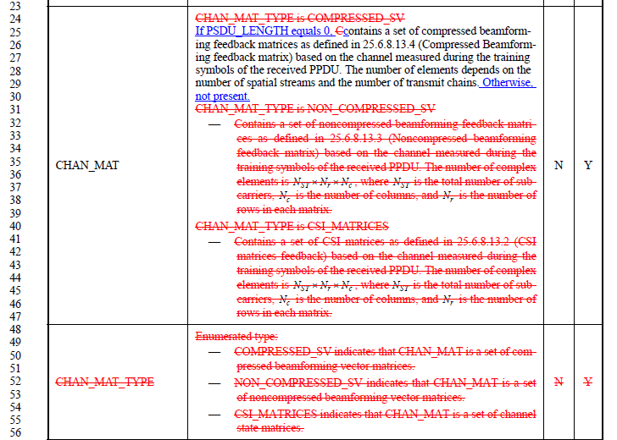
Remove noncompressed feedback type related subclauses: 9.4.1.62, 9.4.1.63, 25.6.8.13.2, 25.6.8.13.3 as follows:
9.4.1.62 CMMG CSI Report field
The CMMG CSI Report field is used by the CMMG CSI frame (see Error: Reference source not found) to carry explicit channel state information to a CMMG transmit beamformer, as described in 10.32.5 (Explicit feedback beamforming for CMMG STAs).
The CSI Matrix subfields in the CMMG CSI Report field shown in Error: Reference source not found are matrices whose elements are taken from the CHAN_MAT parameter of RXVECTOR (see Table 25-1 (TXVECTOR and RXVECTOR parameters)…………….……………………………………….
9.4.1.63 CMMG Noncompressed Beamforming Report field
The CMMG Noncompressed Beamforming Report field is used by the CMMG Noncompressed Beamforming frame (see Error: Reference source not found) to carry explicit feedback in the form of noncompressed beamforming feedback matrices V for use by a transmit CMMG beamformer to determine steering matrices Q, as described in 10.32.5 (Explicit feedback beamforming for CMMG STAs) and 25.6.8.13 (Beamforming) ……………………………………………….
25.6.8.13.2 CSI matrices feedback
In CSI matrices feedback, the beamformee shall remove the space-time stream CSD in Error: Reference source not found from the measured channel before computing a set of matrices for feedback to the beamformer. The CSI matrix, found by the beamformee for subcarrier k shall be encoded using method described in 9.4.1.62 (CMMG CSI Report field) so that applying the procedure in 19.3.12.3.3 (CSI matrices feedback decoding procedure) optimally reconstructs the matrix.
25.6.8.13.3 Noncompressed beamforming feedback matrix
In noncompressed beamforming feedback matrix, the beamformee shall remove the space-time stream CSD in Error: Reference source not found from the measured channel before computing a set of matrices for feedback to the beamformer. The beamforming feedback matrices, , found by the beamformee are sent to the beamformer in the order of real and imaginary components per tone as specified in 9.6.31.4 (CMMG Compressed Beamforming frame format). The beamformer might use these matrices to determine the steering matrices .
The beamformee shall encode the matrices using the method described in 19.3.12.3.4 (Example of CSI matrices feedback encoding) so a beamformer applying the procedure in 19.3.12.3.5 (Noncompressed beamforming feedback matrix) optimally reconstructs the matrix.
Change the second paragraph of 25.6.8.13.1 as follows:
For CMMG OFDM MIMO mode beamforming, the steering matrix Q_{k} can be determined from the effective channel H_{eff,k}, or the beamforming feedback matrix, V_{k}, that is sent back to the beamformer by the beamformee using CSI feedback matrix format as defined in Error: Reference source not found, or noncompressed beamforming feedback matrix format as defined in 25.6.8.13.3 Noncompressed beamforming feedback matrix, or the compressed beamforming feedback matrix format as defined in Error: Reference source not found. The feedback report format is described in 9.6.31.2 (CMMG CSI frame format) 9.6.31.3 (CMMG Noncompressed Beamforming frame format), and 9.6.31.4 (CMMG Compressed Beamforming frame format), respectively.

CID | Clause | Page | Line | Type | Comment | Proposed Change | Remark
857 | 25.2.2 | 193 | 2 | E | It is not clear why the expansion matrices are transmitted in 3 methods from the MAC. The expansion matrix, should be computed by the MAC and sent in a single format to the PHY | Simplify the interface to a single format of expension matrix

Proposed resolution: Revised
Remove the noncompressed channel feedback type from the draft and leave the compressed channel feedback type. In Table 25-1, reduce EXPANSION_MAT to a single type, i.e. compressed feedback.and remove parameter EXPANSION_MAT_TYPE.
Change Table 25-1 as follows:
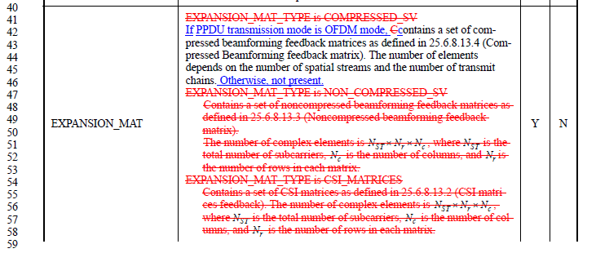
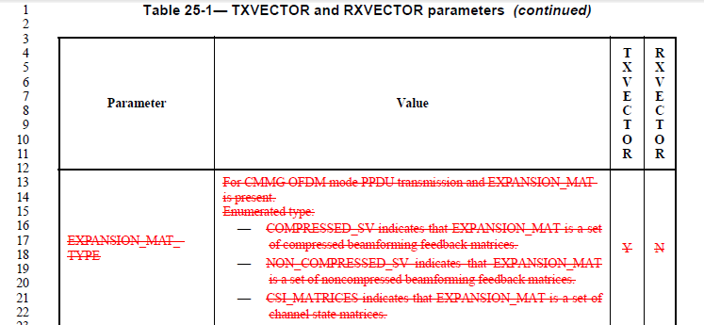
Remove noncompressed feedback type related subclauses: 9.4.1.62, 9.4.1.63, 25.6.8.13.2, 25.6.8.13.3 as follows:
9.4.1.62 CMMG CSI Report field
The CMMG CSI Report field is used by the CMMG CSI frame (see Error: Reference source not found) to carry explicit channel state information to a CMMG transmit beamformer, as described in 10.32.5 (Explicit feedback beamforming for CMMG STAs).
The CSI Matrix subfields in the CMMG CSI Report field shown in Error: Reference source not found are matrices whose elements are taken from the CHAN_MAT parameter of RXVECTOR (see Table 25-1 (TXVECTOR and RXVECTOR parameters)…………….……………………………………….
9.4.1.63 CMMG Noncompressed Beamforming Report field
The CMMG Noncompressed Beamforming Report field is used by the CMMG Noncompressed Beamforming frame (see Error: Reference source not found) to carry explicit feedback in the form of noncompressed beamforming feedback matrices V for use by a transmit CMMG beamformer to determine steering matrices Q, as described in 10.32.5 (Explicit feedback beamforming for CMMG STAs) and 25.6.8.13 (Beamforming) ……………………………………………….
25.6.8.13.2 CSI matrices feedback
In CSI matrices feedback, the beamformee shall remove the space-time stream CSD in Error: Reference source not found from the measured channel before computing a set of matrices for feedback to the beamformer. The CSI matrix, found by the beamformee for subcarrier k shall be encoded using method described in 9.4.1.62 (CMMG CSI Report field) so that applying the procedure in 19.3.12.3.3 (CSI matrices feedback decoding procedure) optimally reconstructs the matrix.
25.6.8.13.3 Noncompressed beamforming feedback matrix
In noncompressed beamforming feedback matrix, the beamformee shall remove the space-time stream CSD in Error: Reference source not found from the measured channel before computing a set of matrices for feedback to the beamformer. The beamforming feedback matrices, , found by the beamformee are sent to the beamformer in the order of real and imaginary components per tone as specified in 9.6.31.4 (CMMG Compressed Beamforming frame format). The beamformer might use these matrices to determine the steering matrices .
The beamformee shall encode the matrices using the method described in 19.3.12.3.4 (Example of CSI matrices feedback encoding) so a beamformer applying the procedure in 19.3.12.3.5 (Noncompressed beamforming feedback matrix) optimally reconstructs the matrix.
Change the second paragraph of 25.6.8.13.1 as follows:
For CMMG OFDM MIMO mode beamforming, the steering matrix can be determined from the effective channel , or the beamforming feedback matrix,, that is sent back to the beamformer by the beamformee using CSI feedback matrix format as defined in Error: Reference source not found, or noncompressed beamforming feedback matrix format as defined in 25.6.8.13.3 Noncompressed beamforming feedback matrix, or the compressed beamforming feedback matrix format as defined in Error: Reference source not found. The feedback report format is described in 9.6.31.2 (CMMG CSI frame format) 9.6.31.3 (CMMG Noncompressed Beamforming frame format), and 9.6.31.4 (CMMG Compressed Beamforming frame format), respectively.

CID | Clause | Page | Line | Type | Comment | Proposed Change | Remark
858 | 9.4.2.232.2 | 58 | 46 | E | CMMG antenna is used but not defined | Define what is a CMMG antenna (is related to an omni antenan or to an TX/RX chain)
Proposed resolution: Revised
This is a typo. There is no CMMG antenna defined in the draft. CMMG STA uses the same antenna pattern as defined for DMG antenna.
Change Figure 9-589y as follows:
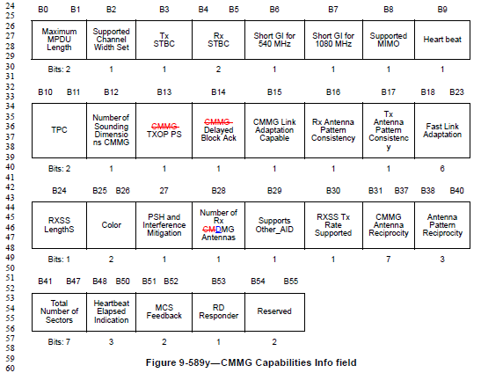
Change Table 9-262b as follows:
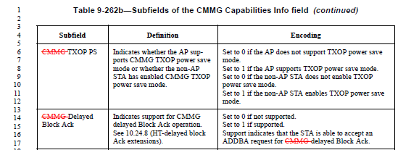
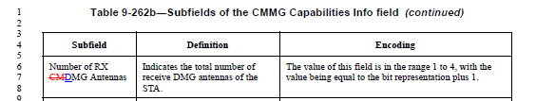

CID | Clause | Page | Line | Type | Comment | Proposed Change | Remark
860 | 9.4.1.63 | 35 | 1 | E | There are two methods for CSI feedback. This will lead to interoperabiolity nightmare as it has led in 802.11n. One method should be chosen as it has been in 802.11ac | Chose the compressed beamforming report and remove other methods.
Proposed resolution: Revised
Chose the compressed CSI feedback method and remove Noncompressed CSI feedback methods. Remove the subsection of 9.4.1.63 CMMG Noncompressed Beamforming Report field. Remove or revise some related contents listed as follows:

Change Figure 9-589ac as follows:
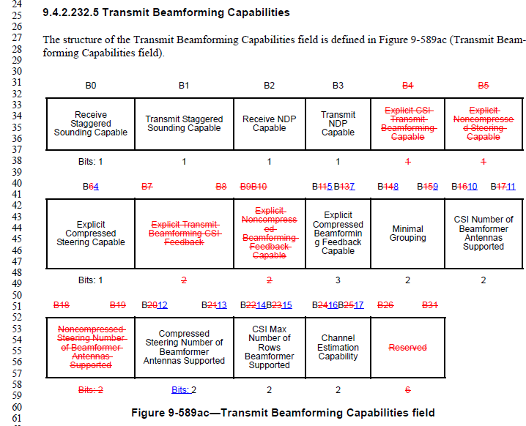

Change Table 9-262e as follows:
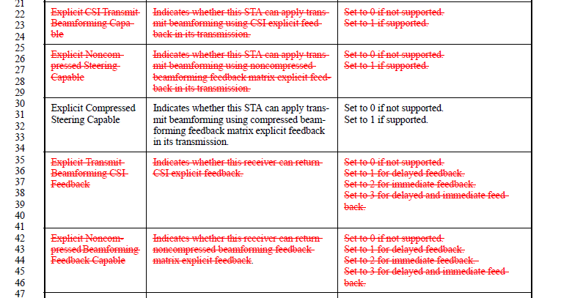
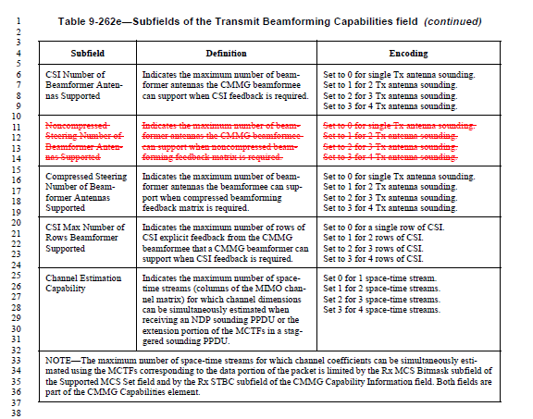

Remove 9.4.1.63, 9.6.31.2, 9.6.31.3:
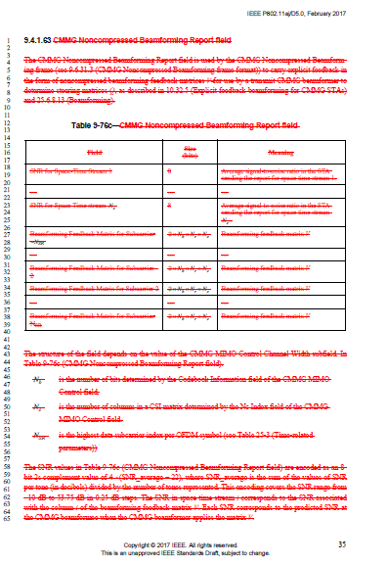
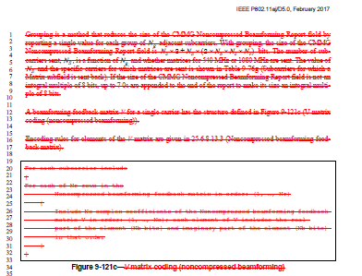
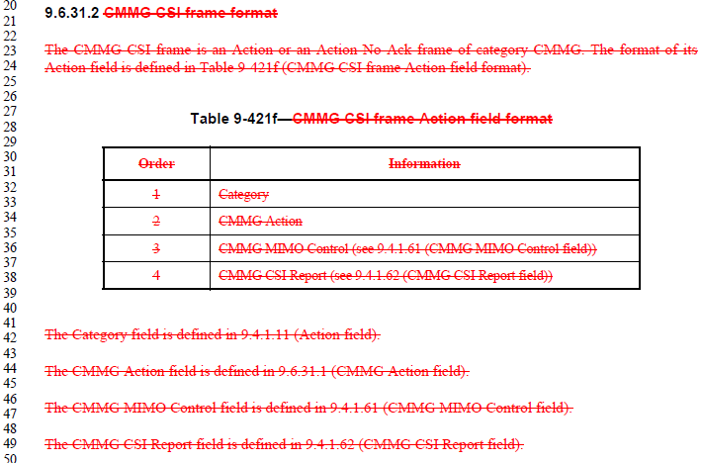
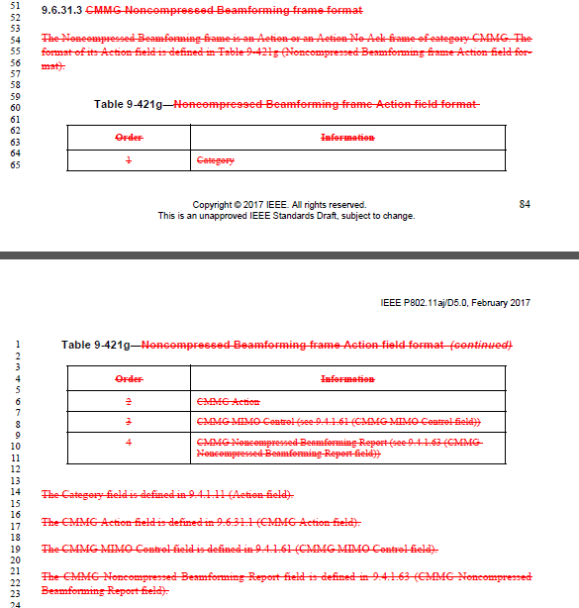
Change the following paragraphs as follows:
P.101， L48：
If the MFB is in the same PPDU as a CMMG Noncompressed Beamforming frame or a Compressed Beamforming frame, the MFB responder should estimate the recommended MFB under the assumption that the MFB requester uses the steering matrices contained therein.
P. 102, L28:
If a beamformer transmits a PPDU with the TXVECTOR EXPANSION_MAT_TYPE set to either COMPRESSED_SV or NON_COMPRESSED_SV, it should use the recommended MCS associated with those matrices reported in a Noncompressed Beamforming frame or a Compressed Beamforming frame.
P. 103, L31:
- CSI: The CMMG beamformee sends the MIMO channel coefficients to the CMMG beamformer.
- Noncompressed beamforming: The CMMG beamformee sends calculated beamforming feedback matrices to the CMMG beamformer.
P. 103, L44-50:
A CMMG beamformee’s responding capabilities shall be advertised in CMMG Capabilities elements contained in DMG Beacon, Probe Request, Probe Response, Association Request, Association Response, Action, and Action No Ack frames that are transmitted by the CMMG beamformee. Devices that are capable of acting as a CMMG beamformee shall advertise one of the following response capabilities in the Explicit Transmit Beamforming CSI Feedback subfieldExplicit Compressed Beamforming Feedback Capable of the Transmit Beamforming Capability field:
- Immediate: The CMMG beamformee is capable of sending a feedback response an SIFS after receiving a sounding PPDU and/or is capable of sending a feedback response aggregated in a PPDU that contains a MAC response within the CMMG beamformer’s TXOP.
- Delayed: The CMMG beamformee is not capable of sending the feedback response within the CMMG beamformer’s TXOP, but it is capable of sending the feedback response in a TXOP that it obtains.
- Immediate and Delayed: The CMMG beamformee is capable of sending a feedback response an SIFS after receiving a sounding PPDU, sending a feedback response aggregated in a PPDU that contains a MAC response within the CMMG beamformer’s TXOP, or sending the feedback response in a TXOP that it obtains.

P. 104, L1-19:
The sounding frame types supported by the CMMG beamformee, staggered and/or NDP, are advertised in the CMMG Capabilities element in frames that are transmitted by the CMMG beamformee.
A STA that sets any of the Explicit Transmit Beamforming CSI Feedback Capable, Explicit Noncompressed Beamforming Feedback Capable, or Explicit Compressed Beamforming Feedback Capable fields to 1 shall transmit explicit feedback based on the receipt of a +CMMGC sounding PPDU in which the CSI/Steering subfield has a nonzero value. This requirement is independent of the values of the Receive Staggered Sounding Capable and the Receive NDP Capable fields.
An CMMG beamformer shall set the SOUNDING parameter of the TXVECTOR to SOUNDING in the PHY-TXSTART.request primitive corresponding to each packet that is used for sounding.
A CMMG beamformer shall set the response type format indicated in the CSI/Steering subfield of the CMMG Control field of any sounding frame excluding the NDP and of any PPDU with the NDP Sounding Announcement field equal to 1 to one of the nonzero values (CSI, Compressed Beamforming, or Noncompressed Beamforming) that corresponds to a type that is supported by the CMMG beamformee.
P. 104, L31-65:
A CMMG beamformee that transmits a feedback frame in response to a sounding PPDU sent by a beamformer shall transmit a frame of the type (CSI, Compressed Beamforming frame, or Noncompressed Beamforming) indicated in the CSI/Steering subfield of the CMMG Control field transmitted by the beamformer.
The CMMG bBeamformee decides on any tone grouping to be used in the explicit beamforming feedback. The value selected shall be a value supported by the CMMG beamformer as indicated in the Minimal Grouping subfield of the CMMG beamformer’s CMMG Capabilities element.
An CMMG beamformee that sets the Explicit Transmit Beamforming CSI Feedback field of its CMMG Capabilities element to either 2 or 3 shall transmit explicit CSI feedback after SIFS or later in the CMMG beamformer’s TXOP as a response to a non-NDP request for feedback in a frame that is appropriate for the current frame exchange sequence following Table 10-18a (Rules for CMMG beamformee immediate feedback transmission responding to non-NDP sounding). A beamformee that sets the Explicit Noncompressed Beamforming Feedback Capable field of its CMMG Capabilities element to either 2 or 3 shall transmit explicit noncompressed beamforming feedback after SIFS or later in the CMMG beamformer’s TXOP as a response to a non-NDP request for feedback in a frame that is appropriate for the current frame exchange sequence following Error: Reference source not found.
An CMMG beamformee that sets the Explicit Transmit Beamforming CSI Feedback field of its CMMG Capabilities element to either 2 or 3 shall transmit the explicit CSI feedback after SIFS or later in the beamformer’s TXOP as a response to an NDP request for feedback in a frame that is appropriate for the current
The value of within an explicit beamforming feedback frame transmitted by a CMMG beamformee shall not exceed the value indicated in the CMMG Bbeamformee STS Capability subfield of the CMMG Capabilities element.
An CMMG beamformee that sets the Explicit Compressed Feedback Capable field of its CMMG Capabilities element to either 2 or 3 shall transmit explicit compressed beamforming feedback after SIFS or later in the CMMG beamformer’s TXOP as a response to a non-NDP request for feedback in a frame that is appropriate for the current frame exchange sequence following Error: Reference source not found.

P. 105, L27-61:
An CMMG beamformee that sets the Explicit Noncompressed Beamforming Feedback Capable field of its CMMG Capabilities element to either 2 or 3 shall transmit the explicit noncompressed beamforming feedback after SIFS or later in the beamformer’s TXOP as a response to an NDP request for feedback in a frame that is appropriate for the current frame exchange sequence following Error: Reference source not found.
Remove the Table 10-18b.
An CMMG beamformee that sets the Explicit Noncompressed Beamforming Feedback Capable field of its CMMG Capabilities element to either 2 or 3 shall transmit the explicit noncompressed beamforming feedback after SIFS or later in the beamformer’s TXOP as a response to an NDP request for feedback in a frame that is appropriate for the current frame exchange sequence following Error: Reference source not found.
An CMMG beamformee that sets the Explicit Compressed Beamforming Feedback Capable field of its CMMG Capabilities element to either 2 or 3 shall transmit the explicit compressed beamforming feedback after SIFS or later in the CMMG beamformer’s TXOP as a response to an NDP request for feedback in a frame that is appropriate for the current frame exchange sequence following Error: Reference source not found.
When the CMMG beamformee sets the Explicit Transmit Beamforming CSI Feedback field of its CMMG Capabilities element to either 2 or 3 and the CMMG beamformer has transmitted an NDP or an non-NDP explicit beamforming CSI feedback request in a frame that does not require immediate control response, the CMMG beamformer shall not transmit the next packet to the beamformee until PIFS after transmitting the sounding request.
When the CMMG beamformee sets the Explicit Noncompressed Beamforming Feedback Capable field of its CMMG Capabilities element to either 2 or 3 and the CMMG beamformer has transmitted an NDP or an non-NDP explicit noncompressed beamforming feedback request in a frame that does not require immediate control response, the CMMG beamformer shall not transmit the next packet to the beamformee until PIFS after the sounding request.

P. 106, L37:
NDP explicit compressed beamforming feedback request in a frame that does not require immediate control response, the CMMG beamformer shall not transmit the next packet to the CMMG beamformee until PIFS after transmitting the sounding request.
A CMMG beamformee shall not transmit a CSI, Compressed Beamforming, or Noncompressed Beamforming frame except in response to a request for feedback.
P. 106, L51:
If necessary, the CSI Report field, Noncompressed Beamforming Report field, or Compressed Beamforming Report field may be split into up to 8 frames. The length of each segment shall be equal number of octets for all segments except the last, which may be smaller.

