IEEE P802.11
Wireless LANs
Specification Framework for TGaz
Date: 2018-0401
Author(s):
Name | Affiliation | Address | Phone | email
Chao-Chun Wang | MediaTek Inc | 2840 Junction Ave, San Jose, CA | +1-408-526-1899 | chao-chun.wang@mediatek.com

Abstract
This document provides the framework from which sections of the draft TGaz amendment.

The document provides an outline of each the functional blocks that will be a part of the final amendment. The document is intended to reflect the working consensus of the group on the broad outline for the draft specification and is derived from the set of functional requirements. As such it is expected to begin with minimal detail reflecting agreement on specific techniques and highlighting areas on which agreement is still required (<TBD> in the document). It may also begin with an incomplete feature list with additional features added as they are justified. The document will evolve over time until it includes sufficient detail on all the functional blocks and their inter-dependencies so that work can begin on the draft amendment itself.

Revision history
Revision | Date | Changes
0 | Mar 14, 2016 | Initial Version
1 | March 13, 2017 | R1
1.1 | May 11th , 2017 | R2
1.2 | June 25th, 2017 | R5
1.3 | August 20th, 2017 | R6
1.4 | October 30th, 2017 | R8
1.4 | November 3th, 2017 | R9
1.4 | November 9th, 2017 | R10
1.5 | December 25th, 2017 | R11
1.6 | January 16th, 2018 | R12
1.7 | January 23th, 2018 | R13
1.8 | April, 2, 2018 | R14
1.9 | July 25, 2018 | R15
1.10 | September, 9, 2018 | R16

Contents
1 Definitions 5
2 Abbreviations and acronyms 6
3 Positioning Protocol for Improved Accuracy and Coverage over 2.4, and 5 GHz bands 6
3.1 General 6
3.2 Protocol Description 7
3.2.1 Protocol Negotiation 7
3.2.2 VHTz Measurement Exchange 8
HEz Measurement Exchange 9
3.2.3 9
4 Positioning Protocol while operating in the 60 GHz band 12
4.1 General 12
4.2 Direction Measurement 13
5 Scalability aspects of the Positioning Protocol 14
6 Security [May 2017] 15
7 Frame formats 20
8 References 24

Definitions

FTM Initiator – the STA initiating the FTM procedure.

FTM Responder – the STA responding to the FTM Procedure establishment request

IFTM – Initial FTM frame.

IFTMR – Initial FTM Request frame.

Type A Adversary – The attacker is assumed to have response time to standard-specified OTA events or scenario dependent fields of 1 msec or longer.

Type B Adversary - The attacker is assumed to have response time to known OTA events or known pre-defined fields of 1usec or longer (up to 1msec). [2017/0120r2]

Ranging Protocols – Time of Flight (ToF) measurement; may be extended for others (needs more discussion)
- REVmc D8.0 Fine Timing Measurement Prototocol (FTM)
- VHT NDP Sounding-based .11az protocol (VHTz)
- HE NDP Sounding-based .11az protocol (HEz)
- Ranging protocol while operating in DMG/EDMG (EDMGz)

Ranging ID - Association ID-like value assigned to an unassociated STA by an rSTA to facilitate the negotiation phase and subsequently the ranging phase [September, 1473]

iSTA – Initiating STA

rSTA – Responding STA

Abbreviations and acronyms

MU – Multi User
SU – Single User
NDP – Null Data Packet
NDPA – NDP Announcement
VHTz - VHT NDP Sounding-based .11az SU protocol
HEz - HEW NDP based sounding.11az Trigger Based protocol
TOF – Time Of Flight
BRP – Beam Refinement Protocol

Positioning Protocol for Improved Accuracy and Coverage over 2.4, and 5 GHz bands

General

- The .11az protocol shall extend the REVmc iFTMR/iFTM for .11az ToF measurement parameter negotiation

- The .11az protocol shall support VHT, DMG, EDMG, and HE mode operation, named VHTz, DMGz, EDMGz, and HEz mode respectively.

- The .11az protocol shall define the following phases

- a capability discovery
- a Time of Flight (ToF) measurement parameter negotiation)
- A set of ToF measurement exchanges [11-16-1494]

- For HEz ranging the following rules shall be followed,
• Polling:
• There is a single polling phase prior to the measurement phase.
• iSTA to rSTA LMR feedback:
• iSTA to rSTA LMR feedback is supported and is negotiated at service establishment.
• ACK-ing of LMR feedback:
• rSTA to iSTA or iSTA to rSTA LMR feedback is neither acknowledged nor retransmitted
- For Ranging rSTA to iSTA LMR feedback consists of TOA and TOD reporting only
- For Ranging iSTA to rSTA LMR feedback consists of TOA and TOD reporting only [November 2017 - 11-17/1754r0]

• Ranging Sequence:
• [TF Poll -> Poll Rsp. -> (TF Sound -> UL NDP) x N -> DL NDPA -> DL NDP -> rSTA to ISTA LMRs] x M
• Where:
• The arrow ‘->’ denotes a SIFS interval
• The rSTA to ISTA LMRs are unicast report frames
• Supported PHY frame formats are TBD
• M is the number of HEz ranging groups and is constrained by the availability window size.
• N is the number of iSTA groupings, separated in time for UL sounding.
• Sequence with for iSTA to rSTA LMR feedback:
• [TF Poll -> Poll Rsp. -> (TF Sound -> UL NDP) x N -> DL NDPA -> DL NDP -> rSTA to iSTA LMRs -> TF LMR -> iSTA to rSTA LMRs] x M
• Note: rSTA to iSTA LMR feedbacks are carried in an HE MU PPDU [November 2017 - 11-17/1741r2]

- For HEz Ranging for Passive Location, the 11az protocol shall have the following properties: [March 2018 – 276r5]
  - The Polling part is the same as the HEz Ranging polling part.
  - The measurement part shall be based on the HEz Ranging measurement part with the following attributes:
    - Each TF Sounding solicits a single user ASTA NDP (a subset behavior of the Ranging HEz).
    - The measurements frames are full BW.
    - The ASTA measures the TOA of the NDP transmitted by RSTA and optionally by other ASTAs of the same sequence only.
    - The listening client measures the differential time of flight of pairs of RSTA and/or ASTAs.
    - The measurement sequence (UL and DL) completes in a single TxOP.
  - The indication of ‘passive location HEz Ranging type’ for the TFs in the sequence is TBD.
- The HEz Ranging for Passive Location protocol shall define: [March 2018 – 276r5]
  - Reporting of all TOA measurements by ASTA of the same ranging opportunity (delayed or immediate).
  - Method of conveying LMR to passively locating STA.
  - Negotiation for Passive Location session establishment between RSTA and an ASTA.
  - Schedule advertisement of HEz Ranging for Passive Location support.
  - LCI announcement.”

Protocol Description

Protocol Negotiation
- In the HEz mode, Negotiation phase shall support an enhancement to FTM Request frame in both SU and MU modes for both associated and unassociated STAs

- In the HEz mode, the SU – SU negotiation procedure in the 11az shall have the following properties:
  - Frame exchange sequence is the same as REVmc:
    - FTM Request and Response frame formats needs to be updated, for example the response frame for unassociated STAs carry an ID (Ranging, Pre) and the NGP IE.

- A new field in the NGP Parameters IE included in the IFTM and IFTMR frames shall indicate the request and consent to use ISTA2RSTA LMR feedback. [March 2018 – 1701r2]
  - In the IFTMR frame, the ISTA uses this field to indicate whether it’s willing to report its LMR information to RSTA.
  - In the IFTM frame, this field is used by RSTA to notify ISTA whether the RSTA will request the ISTA’s LMR report
Note: The proposed formate is shown in caluse 7.

- In the IFTMR, The ISTA shall request an RSTA for an availability window schedule by specifying a subset of preferred Availability windows from the RSTA’s advertised Availability windows set. An ISTA may also indicate ‘Any Window Assignment Is Acceptable’ [May 2018: 18-855r1]

- The 802.11az protocol shall define an LMR feedback type (immediate or delayed) parameter field in NGP Parameters subelement of IFTMR frame for VHTz and HEz ranging sequences: [March 2018 – 1701r2]
  - This parameter field is used by ISTA to indicate the ISTA2RSTA LMR feedback type during FTM negotiation.
    - Immediate feedback type ‒ ISTA2RSTA LMR delivers measurement performed at the same TxOP or availability window.
    - Delayed feedback type ‒ ISTA2RSTA LMR delivers measurement performed at the previous TxOP or availability window.”

- Once consent is set and ISTA2RSTA LMR reporting was agreed on, during the HEz sequence the ISTA shall only respond to a poll once the delayed ISTA2RSTA LMR results are available at ISTA [March 2018 – 1701r2]

- The LMR feedback frame shall include a reference to the associated NDP exchange [March 2018 -553r1]

- In the HEz mode, the 11az protocol shall support multiple iSTAs sending FTM Request in SU mode (SU PPDU) and the rSTA sends FTM Response in a SU PPDU to address multiple STAs [July 2017]

- In the HEz mode, The resource allocation for initial FTM request in MU negotiation for unassociated iSTAs to be based on OFDMA random access [May 2017]

VHTz Measurement Exchange
- The measurement phase for the ranging protocol for VHTz shall be based on IEEE 802.11 VHT sounding protocol and have the following frame exchange sequence

Note: the contents of NDP Announce (.11az), NDP (.11az) and Measurement Feedback; and the spacing between the NDP (.11az) and Measurement Feedback are TBD.

- For VHTz operation, the following behavior bounds the protocol development:
  - Only LMR feedback calculation (TOA) and then delivery may require a scheduling mechanism.
  - The VHTz case does not require a re-occurring availability window mechanism
  - [September, 2017 11-17-1305r2]

- The VHTz ranging protocol will support both immediate and delayed reporting.
  - Note: The report formats (e.g. TOA, CSI) to be defined separately
  - [September, 2017 11-17-1305r2]

- The VHTz measurement and measurement report sequence shall be:
NDPA (UL) <-SIFS-> NDP (UL) <-SIFS-> NDP (DL) <-SIFS-> LMR (DL)
Where for immediate feedback the LMR is of this round and for delayed the LMR is the feedback from previous round.”
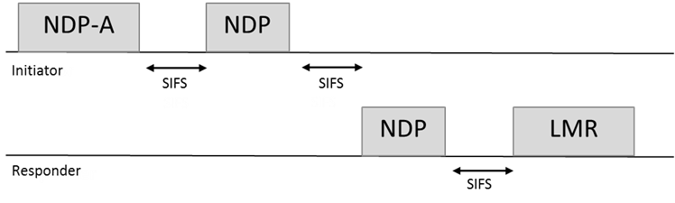

- In VHTz operation, when both RSTA2ISTA and ISTA2RSTA LMR feedback were previously negotiated the following sequence shall be used [March 2018 - 11-17-1701r2]
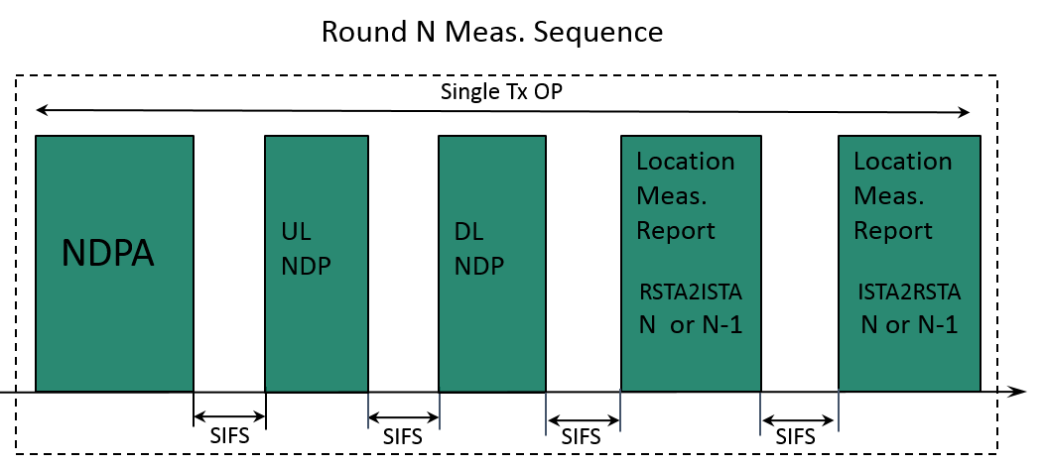

Note: the LMR could be either immediate (for round N) or delayed (for round N-1) and the error recovery rule is TBD.

- The VHTz NDP Bandwidth Selection in Range Measurement [March 2018 – 457 r0]
  - The bandwidth of the transmitted NDPA shall be no larger than the negotiated bandwidth.
  - The bandwidth of the transmitted NDPA sets the bandwidth of the UL and DL sounding NDP frames.
  - This bandwidth also corresponds to the bandwidth set by the bandwidth signalling TA field within the NDPA frame.

- In VHTz mode the iSTA shall not initiate another measurement sequence earlier than MinToaReady. If the iSTA initiates a following measurement sequence later than MaxToaAvailable, then the results may not be available (flushed)” [Septenmber, 2017 11-17-1305r2]
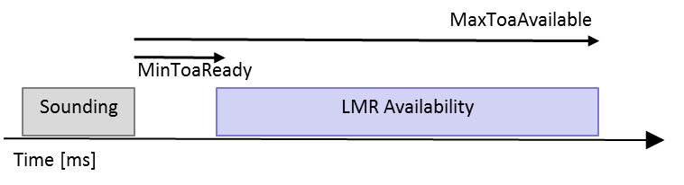

- The MinToaReady and MaxToaAvailable are measured starting from t4/t3 in the preceding sounding sequence to t1/t2 when receiving the new sounding sequence [March 2018- 11-18/0461r0]

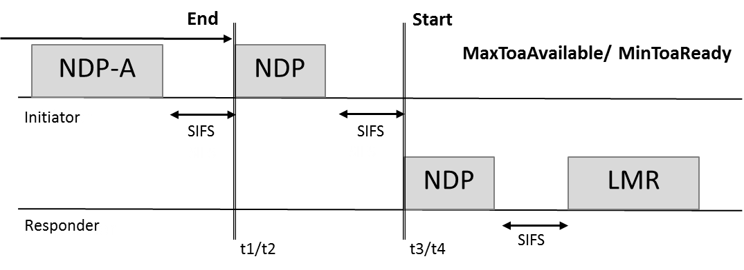

- rSTA to iSTA LMR feedback: Support of TOA and TOD is mandatory and CSI report is optional for both iSTA and rSTA and is agreed upon during negotiation [November 2017 - 11-17/1754r0]

- The bandwidth and the MCS/rate of the ranging report are defined by:
  - The data rate/MCS of ranging report is solely decided by the rSTA.
  - The bandwidth of ranging report is not wider than the bandwidth of the soliciting NDPA.” [November 2017 - 11-17/1754r0]

- iSTA to rSTA LMR feedback is supported and is negotiated at service establishment. [November 2017 - 11-17/1742r1]

- rSTA to iSTA or iSTA to rSTA LMR feedback is neither acknowledged nor retransmitted. [November 2017 - 11-17/1742r1]

HEz Measurement Exchange

- In the HEz mode, the protocol shall define a polling phase for ranging request feedback prior to NDP sounding-based measurement. [May 2017]

- OFDMA is the mandatory mode for conveying HEz polling responses

Note: Support for UL MU MIMO and/or mixed mode (UL MU MIMO and OFDMA concurrently) capabilities is exchanged during the 11az negotiation; and modes beyond ODFMA can only be supported if both ends are capable

- In the HEz mode, the Measurement phase for the ranging protocol for Multiple STAs shall be only based on NDP sounding and have the following frame exchange sequence:

Note : the detailed design of DL Trigger, DL NDPA, UL NDP, DL NDP are TBD.

- The HEz NDP Bandwidth Selection in Range Measurement [March 2018 – 457 r0]
  - The bandwidth of the transmitted TF of type Location and subtype Sounding shall be no larger than the negotiated bandwidth.
  - The TF of type Location and subtype Sounding is used for bandwidth selection and channel reservation of the UL and DL sounding.
  - The BW of the TF Location Sounding is the same bandwidth of the solicited UL and DL sounding NDP frames and the NDPA of the same measurement sequence.
  - This bandwidth is also indicated by BW field in the TF Common Info field of the TF frame.

- In the HEz mode, within the MU measurement phase the UL sounding shall use one or more of the following multiplexing techniques:
  - Spatial Multiplexing using P-Matrix encoding,
  - OFDMA multiplexing
  - TDMA multiplexing (various methods, TBD) [May 2017]

- In the HEz mode, the measurement phase ranging protocol shall consists of one or more rounds of uplink sounding followed by one round of downlink sounding, where each round of uplink sounding includes one trigger frame soliciting one, or more NDP sounding frame(s) from iSTA(s) and the downlink sounding consists of one NDPA frame and one NDP sounding frame.

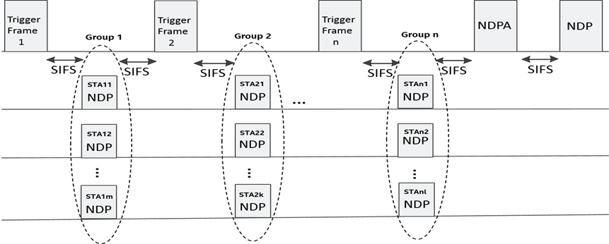

- Details of the NDP sounding structure are TBD. [May 2017]
  - In the HEz mode, availability windows where the rSTA and iSTA shall perform measurements are defined as follows:
  - These availability windows are scheduled
  - Within an availability window, rSTAs shall perform ranging activities related to polling, measurement, and measurement results and group related scheduling
  - Each availability window consists by default of a single TXOP and can be extended to multiple TxOPs by announcement if single TxOP is insufficient to accommodate all iSTAs responding to the polling phase
  - Availability windows are negotiated/signaled between rSTA and a iSTA such that the iSTA knows when those availability windows occur.
  - An iSTA is not expected and does not perform MU ranging measurement and measurement results activities outside these windows. [September, 1455r1]
  - In each availability window, there is nominally a single poll, each poll is to all iSTAs assigned to the availability window.
  - If the available BW does not allow for the polling of all iSTAs within the group there is an indication within the TF Poll that an additional TF Poll is expected within the availability window.
  - Within the availability window there is a single measurement for those iSTAs responding to the poll (and correctly received) with the relevant LMRs feedbacks.” [November 2017 - 11-17/1739r0]

- In HEz mode signaling behavior on LMR feedback scheduling is as follows
  - Measurements and/or measurement results are provided for in the same availability window
  - Measurement results may be from this window’s measurement or the results of a measurement performed in a prior window
  - Protocol will support signaling for measurement results availability for current or next availability window within the measurement phase
  - The Trigger control frame or the NDPA control frame carries a dynamic signaling of measurement results availability in this or next availability window
  - In HEz and VHTz measurement exchange sequences, the ISTA2RSTA LMR shall include a CFO feedback.

  - The Fine Timing Measurement Report field of the VHTz and HEz LMR (RSTA to ISTA) shall include an optional Angle of Arrival (AoA) feedback field

  - The Poll Response frame for HEz ranging shall be a CTS-to-self frame carried in an HE TB PPDU

- For HEz operation in the unassociated mode the following mechanisms are reused and active:
  - –UL Power control.
  - –Timing and frequency synchronization for UL transmission.
  - –Supported trigger subtypes for 11az trigger type:
  - TF Location -> Poll
  - TF Location -> Uplink Sounding
  - TF Location -> LMR
  - TF Location -> (Loc. negotiation using RA) and behavior to follow RA access. Details TBD.”
  - The Location Trigger frame subtype HEz Poll shall have no Trigger Dependent User Info field

  - Note: this list may be extended in the future to accommodate OBSS operation. [Nov. 2017 11-17/1700r0]

- Ranging ID assignment and handling:
  - Ranging IDs are of the same size and range as AIDs and following same rules and limitations.
  - Ranging IDs and AIDs are from same space and non-conflicting.
  - The assignment of Ranging IDs by a rSTA to unassociated iSTA resulting in the execution MU HEz Ranging protocol with the rSTA:
    - The assigned Ranging ID is included in the HEz Specific sub element contained in iFTM.
    - The rSTA may advertise a Ranging ID lifetime which defines the duration for which the Ranging ID remains valid
    - the mechanism to advertise Ranging ID lifetime is TBD
    - The best choice for Ranging ID lifetime value is implementation dependent
  - The Ranging ID is retired at both iSTA and rSTA when the corresponding Ranging ID Lifetime expires which also terminates the FTM session.
  - Ranging ID lifetime may be equal to MAX BSS IDLE PERIOD.
  - When an FTM session terminates or aborts the Ranging ID expires.
  - Termination may be explicit (i.e. using FTM or FTM Req) or implicit due to Ranging ID Lifetime expiration.
  - Support of the Ranging ID Lifetime is optional. [November 2017, 11-17/1733r1]
  - When an HEz FTM session is terminated, the Ranging-ID assigned for a MU ranging operation of an unassociated STA is released. [November 2017 - 11-17/1725r0.]

- An RSTA shall advertise Availability Window schedule in advertisement Management frames. The advertisement includes an indication of whether the RSTA can accept proposals for an Availability Window schedule from the ISTA that is different from the advertised ones [May 2018: 18-855r1]

- Associated and unassociated STAs shall only use BSS Color announced by AP for HEz measurement exchange [May 2018, 18-893r1]

Positioning Protocol while operating in the 60 GHz band

General

- The 11az protocol shall define at least one mode in which LOS/NLOS estimation (an estimation likelihood that the measurement is performed on a LOS path) is provided as part of the measurement.”

- The 11az protocol shall define at least one mode in which BRP training may operate on the LOS path (rather than on the strongest path).”

- The trigger field in the FTM frame shall be set to 2 to indicate that the burst triggered by this frame shall be transmitted and received using the antenna setting of the First Path. When the trigger field is set to 1, the antenna setting of the best quality path shall be used throughout the burst. The trigger field may be set to 2 only if both the initiator and the responder have indicated support for First Path BF training in their capabilities fields.

- The return to best quality antenna setting, when the trigger field was set to 2, shall occur at the end of the burst, when the number of FTM exchanges is reached or when the Burst Duration is reached. [Jan, 2018 11-17/1884r1]

Direction Measurement

- The 11az protocol shall enable 60GHz AOA and AOD measurement which has three phases
  - Capability exchange
  - Parameters exchange
  - Feedback

- Capability exchange shall include the following information
  - AOA measurement – as transmitter and receiver
  - AOD measurement – as transmitter and receiver
  - AOD feedback capabilities
    - Best TRN subfield
    - Channel measurement feedback

- Parameters exchange shall include the following information
  - Initiator Request may include
    - AOA on FTM
    - AOD on FTM
    - AOA on ACK
    - AOD on ACK
  - Parameters shall include
    - Number of TRN subfields
    - AOA measurement density

- Feedback- AOA results element
  - AOA (in earth coordinates), Degrees
    - Includes azimuth and elevation
    - Other formats possible
  - AOA accuracy (estimate)
  - AOD response (no elements defined)
    - Best sector
    - Channel measurement feedback [11-18/140r0]

- In the DMGz/EDMGz direction measurement protocol, to enable Initiator to Responder AOD measurement feedback, a Best AWV ID field (11bit) shall be added to the Direction Measurement result element. The Best AWV ID shall be included in the first FTM frame within a burst from the responder to the initiator after the transmission of the AOD TRN field [May 2018, 552r1]
- In the DMGz/EDMGz direction measurement protocol, to enable a Responder to Initiator AOD feedback, Two new elements are added as in figure above. The exchange of these elements, as part of FTM frames shall occur after the end of the FTM burst. [May 2018, 552r1]
  - The multiple Best AWV ID element shall be sent by the initiator to the responder. The responder shall then send the multiple AOD feedback element to the initiator

Scalability aspects of the Positioning Protocol

This section describes the protocol features that enable operation in a dense environment.

- The sub-type for the UL sounding TF in the Passive HEz sequence shall be ‘HEz uplink Sounding for Passive Location’ Trigger Frame SubType [May 2018: 11-18-928r0]

Trigger SubType Field Value | Description
0 | HEz Poll
1 | HEz Uplink Sounding
2 | HEz LMR
3 | Location negotiation
4 | HEz Uplink Sounding for Passive Location
5-15 | Reserved

- The UL NDP in HEz ranging for support of passive location to be of type HE NDP PPDU. [May 2018: 11-18-928r0]

- The Passive Location HEz sequence shall have two broadcast frames as depicted in the figure below for broadcasting of information such as LCI, MAC address tables and measurement results of the current round (N) or the last round (N-1):

  - The first frame to contain information known early by the Responder, e.g. LCI info, MAC address tables and DL measurement results.
  - The second frame to contain information available late in the opportunity, e.g. the UL measurement results” [May 2018: 11-18-928r0]

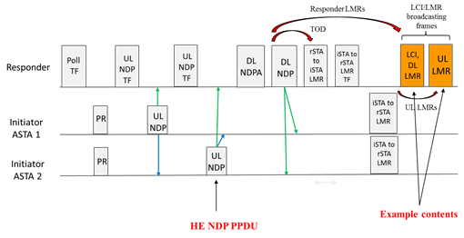

- Add a bit to HEz ranging negotiation parameters in the IFTM and IFTMR, to indicate request/grant to participate in an HEz ranging opportunity for passive location: [May 2018, 18-882r3]
  - The bit shall be present in the request from an ASTA, taking on the role of ISTA, as well as in the RSTA response.
  - A request for HEz Ranging session for passive location can be made by the ASTA or ISTA if the RSTA has indicated capability of supporting HEz Ranging for passive Location.
  - The capability shall be indicated in the Extended Capabilities element of the RSTA.

- The UL NDP in HEz ranging for support of passive location to be of type HE NDP PPDU

Security [May 2017]

- The security setup to be negotiated in a separate optional step prior to the 802.11az protocol parameter negotiation
  - Note that in lieu of security negotiation, keys derived using an out-of-band mechanism may be used to secure the exchange between the initiator and the responder [May 2017]

- The REVmc, HEz, and VHTz FTM modes, the fields over which range measurements are performed shall be protected against a VHT/HE Type B adversary attack [May 2017]

- The DMGz and EDMGz FTM modes, the fields over which range measurements are performed shall be protected against a DMG/EDMG Type B adversary attack (TGaz R37)

- In the PHY Security mode (VHTz, HEz, DMGz, EDMGz), the field used for channel/ToA measurement shall not include any form of repetition in time domain or structure that is predictable [September 2017, 1373r1]

- In the PHY Security mode (VHTz, HEz, DMGz, EDMGz), the training waveform shall be transmitted with zero power (no signal) guard intervals preceding and following the field(s) used for channel/ToAmeasurement. (Note that zero power guard interval shall be inserted following the last sounding symbol if the last sounding symbol is followed by non-zero power signal)
- In the PHY Security mode (VHTz, HEz, DMGz, EDMGz), the field used for channel/ToA measurement shall be derived from (a) random sequence(s) known by the authorized I-STA and R-STA only. [November - 2017 11-17/1767r0]

- For operation in the sub 7GHz and 60GHz bands, multiple zero padded waveforms in a single packet shall be transmitted for channel estimation in a single Tx antenna case [Jan. 2018. 11-18/0222r0]

- For operation in the sub 7GHz band, multiple P-matrix encoded and zero padded training symbol sets in a single packet shall be transmitted to enable multiple channel estimates in a multiple Tx antenna case. [Jan. 2018. 11-18/0222r0]

- For VHTz and HEz, the secured PHY LTF shall have a Null GI on the Tx side only, and have an implementation specific Rx FFT size (i.e. not specified by the standard). [Jan 2018 11-18/0223r0]

- For DMGz and EDMGz, the secured PHY TRN field shall have a Null GI on the Tx side only, and the receive processing shall remain unchanged (e.g., Rx FFT size). For example: GI is 72ns, core symbol is 218ns.
  - For DMGz, L_{zero pad}=128, L_{core}=384, and N_{FFT,rx}=512;
  - For EDMGz with channel bonding: L_{zero pad}=128*N_{CB}, L_{core}=384*N_{CB}, and N_{FFT,rx}=512*N_{CB}. [Jan 2018 11-18/0223r0]

- For secure ranging over the 60GHz band, a SC-PHY mode with zero padded waveforms included in the TRN field shall be used as shown below

  - DMGz:
    - STA defers based on the length field in L-Header.
  - EDMGz:
    - STA defers based on the length field in EDMG-Header-A.
    - Simpler than stitching channel estimates from multiple bands [Jan 2018 11-18/0223r0]

DMGz secure ranging

EDMGz secure ranging:

- Security keys for 11az Management Frame Protection and range measurement field protection are derived based on security negotiation and never shared OTA (associated mode or pre-association security negotiation).

  - Range measurement field sequence is generated from some shared information and derived from the range measurement field protection key(s).
  - Keys used for data exchange and 11az management protection may be different from keys used for range measurement field protection.
  - PMF framework is used for FTM Req, FTM and LMR management frames; the key may either be derived from associated or pre-associated security negotiation.” [November 2017 - 11-17/1776r0]
  - Note: For HEz and VHTz PPDUs the measurement field refers to HE LTF and VHT LTF respectively [November 2017 - 11-17/1776r0 in 1776r1]

- The Pre-association Security Negotiation (PASN) authentication shall allow authentication, encryption, and message integrity to be provided for selected 802.11 frames that require such protection.
  - Whether such protection is required for a frame is determined by the security parameters negotiated for the exchange (e.g. 11az Protocol Negotiation) to which the frame belongs.
    - An AP indicates PASN support by advertising a [TBD] PASN AKM in RSNIE that is included in Beacons and Probe Responses, and also in neighbor reports and reduced neighbor reports where supported.
    - A non-AP STA selects use of PASN authentication based on the security requirements of features that need pre-association security. 11az protocol security for an un-associated STA requires PASN.
  - A non-AP STA and an AP use 802.11 authentication frames with the Authentication algorithm number set to [TBD] (PASN Authentication) for the protocol exchange.
    - A non-AP STA optionally, via PASN protocol, proposes to an AP a base AKM and PMKID(s) used to identify the PMK used for derivation of PTK for key confirmation and frame protection.
    - An AP optionally, via PASN protocol, indicates to the non-AP STA, a base AKM and PMKID corresponding to the PMK used for derivation of PTK for key confirmation and frame protection.
  - PASN protocol allows a FILS base AKM using shared key (See 12.12.2.3 of [1])
    - PASN protocol allows any base protocol with a PMK – e.g. FT base AKM using PMKr1
    - A non-AP STA and AP exchange ephemeral public keys to derive protection keys via PASN.
  - The PTK for the exchange is derived from PMK, if any, and the shared secret from the ephemeral key exchange.
  - If 11az measurement security for type A or type B attackers is required, the IEEE 802.11az negotiation protocol and measurement reports shall be integrity protected and encrypted for privacy.
  - If 11az measurement security for type B attacker is required, the fields over which measurements are performed shall be protected (e.g. LTF sequence derived using the keys from PASN protocol). [January, 2018 11-17/1879r1]

- For normal operation of secure VHTz ranging:
  - The keys or cipher sequence (if needed) for LTF sequence generation are the result of the FTM negotiation
  - Sequence generation information for the first measurement instance is part of the IFTM, the measurement phase only commences once the negotiation is successful
  - The frame used to deliver subsequent LTF sequence generation information is the protected LMR frame
  - The specifics of LTF sequence generation information is TBD, this information is associated with a Sequence Authentication Code (SAC).
  - The NDPA carries the SAC indication; a specific reserved value indicates “New LTF generation information is needed”. The SAC is also included in the IFTM for the first measurement instance and in the LMR for subsequent measurement instances [Jan 2018, 11-18/0229r1]

- For secure VHTz ranging measurement (SAC operation):
  - The size of the SAC should be sufficiently long to prevent simple guessing
  - An adversary doesn’t know the SAC and is unable to predict it and thus can’t trigger the measurement instance (DOS). In addition the SAC and its associated measurement results are carried in the LMR.
  - If an incorrect SAC is received by the RSTA, the RSTA discards the NDPA (no DL NDP) and keep the current SAC and associated LTF sequence generation information [Jan 2018, 11-18/0229r1]

- For secure VHTz ranging measurement (LMR error recovery operation):
  - The LMR is an Action No ACK frame
  - If the LMR was not correctly received:
    - The iSTA comes back to the channel and transmit an NDPA indicating “New LTF generation information is needed”. The previous LTF generation information is invalidated.
    - For UL NDP the iSTA uses a known UL NDP LTF sequence (not suitable for measurement).
    - For DL NDP the rSTA may use the secured DL NDP LTF sequence (not suitable for measurement).
    - The rSTA sends a new PMF protected LMR frame with a new SAC and new sequence generation information (measurements results included in the LMR are invalid only for the immediate VHTz case).
    - The iSTA may come back to the channel and initiate a new sounding sequence minToaReady time after. [Jan 2018, 11-18/0229r1]

- For secure HEz ranging measurement (general operation):
  - Secure HEz ranging measurement procedure is limited to a single ISTA (extension to multiple ISTAs is TBD):
  - The delayed sequence generation where sequence generation information is carried in the previous sounding sequence instance.
  - The keys or cipher sequence (if needed) for LTF sequence generation are the result of the FTM negotiation.
  - LTF sequence generation information for the first measurement instance is a part of an IFTM, the measurement phase only commences once the negotiation is successful.
  - The frame used to deliver subsequent LTF sequence generation information is the protected LMR frame [Jan 2018, 11-18/0229r1]

- For secure HEz ranging measurement (normal operation):
  - The specifics of LTF sequence generation information are TBD, but this information is associated with a Sequence Authentication Code (SAC).
  - The Trigger Frame (TF) -> Location Uplink Sounding indicates the SAC for the following NDP frame corresponding to the LTF generation information.
  - The SAC is also included in the IFTM for the first measurement instance and in the LMR for subsequent measurement instances.
  - An adversary doesn’t know the SAC and is unable to predict it.
  - In addition, the SAC and its associated measurement results are carried in the LMR.
  - If an incorrect SAC is received by the ISTA, the ISTA may respond with a known LTF sequence or with any other LTF sequence and discards the current SAC and associated LTF sequence generation information.
  - The size of the SAC should be sufficiently long to prevent simple guessing [Jan 2018, 11-18/0229r1]

- For secure HEz ranging measurement (LMR error recovery operation):
  - The LMR is an Action No ACK frame
  - If the LMR was not correctly received:
    - For UL NDP, the ISTA uses a known UL NDP LTF sequence (not suitable for measurement).
    - For DL NDP, the RSTA may use the secured DL NDP LTF sequence (not suitable for measurement).
    - If two sided LMR is used, the ISTA indicates measurements are invalidated.
    - The RSTA sends a new PMF protected LMR frame with a new SAC and new sequence generation information (measurements results included in the LMR are invalid only for the immediate HEz case).
    - The ISTA may come back to the channel and participate in a new sounding sequence at the next availability interval by responding to a future TF Location -> Poll. [Jan 2018, 11-18/0229r1]

- The LMR frame shall include an indication of invalid measurement. [March 2018 - 11-18/539r0]

Frame formats

- The Initial FTM Request shall include
  - at least one of
-FTM Parameters element
-NGP Parameters element (optional subelements for ranging protocol- specific parameters)
  - optionally LCI and/or Location Civic Measurement Request element
-Trigger Field
-Trigger field set to 1 (for 802.11-2016 FTM backward compatibility)

- “A new field in the NGP Parameters IE included in the IFTM and IFTMR frames shall indicate the request and consent to use ISTA2RSTA LMR feedback. [March 2018 – 1701r2]
  - In the IFTMR frame, the ISTA uses this field to indicate whether it’s willing to report its LMR information to RSTA.
  - In the IFTM frame, this field is used by RSTA to notify ISTA whether the RSTA will request the ISTA’s LMR report” clause 3.2.1

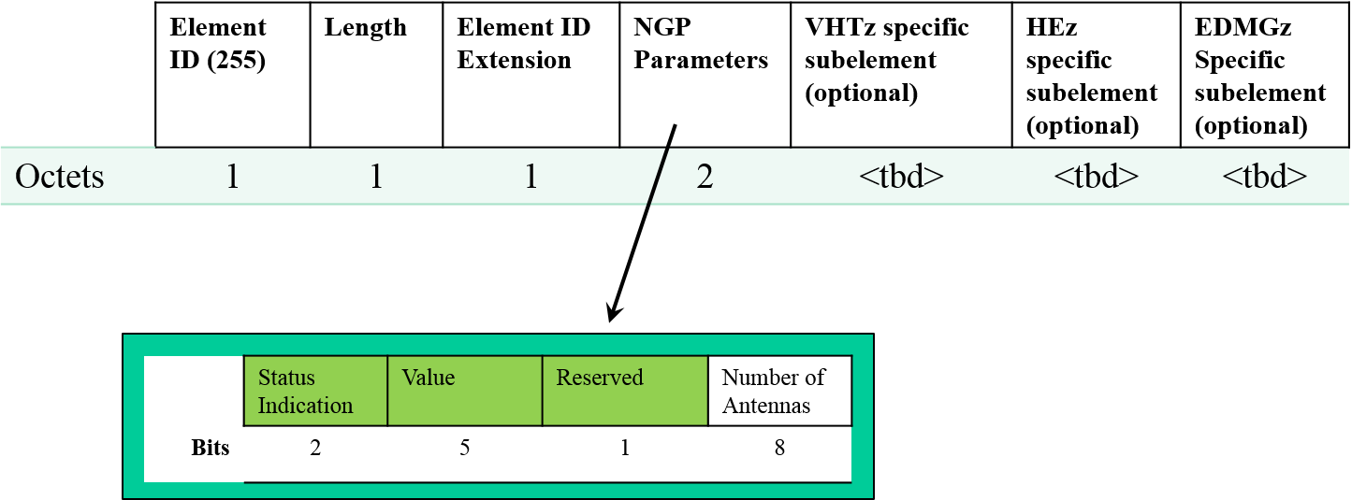

- In HEz NDP ranging measurement phase, the NDPA has the following properties

B0 B1 bits value of the Sounding Dialog Token field shall be set to 0b10 to indicate 11az sequence

AID field will be used to indicate the receiver participating in the sounding exchange

Feedback Type field will be in 4-byte per STA info field (refer to the figure below)

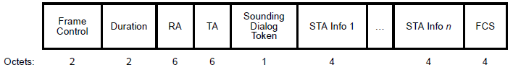
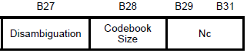
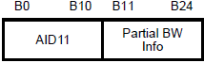
Reserved
Reserved
Feedback
Type
B26

- The ID for ranging operation for an unassociated STA used for measurement phase will be in the FTM Rsp frame

- The protocol shall define a single Trigger Type field value for the 11az amendment and a Trigger Sub-type subfield in Trigger Dependent Common Info field [May 2017]

- The NGP Parameters element includes:At least one of VHTz-specific Subelement, HEz-specific subelement or EDMGz-specific subelement
Note: if the rSTA has not advertised support for the corresponding protocol it will ignore it if at least one supported protocol specific subelement is specified; otherwise the iFTM will have a status Field in the FTM or NGP Parameters element is not SUCCESSFUL
- The NGP Parameters element with the status Field in the FTM or NGP Parameters element is set to SUCCESSFUL, includes one of VHTz-specific Subelement, HEz-specific subelement or EDMGz-specific subelement

- The Status and Value fields in the iFTM shall be set as defined in IEEE802.11-2016
[September 2017, 1473]
- The VHTz-Specific subelement when included in the iFTMR shall include
<nothing defined yet>
[September 2017, 1473]
- The VHTz-specific subelement when included in the iFTM with the status Field in the FTM or NGP Parameters element is set to SUCCESSFUL shall include
  - Response: Immediate or Delayed
  - if Response == Delayed
    - MinToaReady and MaxToaAvailable
    - the results (ToA/ToD) are delivered within the successive sounding sequence
[September 2017, 1473]
- The HEz-Specific subelement when included in the iFTMR shall include
- Periodic Availability Window schedule
[September 2017, 1473]
- The HEz-specific subelement when included in the iFTM with the Status Field in the FTM or NGP Parameters element is set to SUCCESSFUL shall include:
- Response: Immediate or Delayed
- If Response == Immediate
    - results are provided in the same or next Availability Window based on a dynamic indication during the measurement phase
- If Response == Delayed
    - results are of the measurements performed in the previous Availability Window
- Included only when Status Field in the FTM or NGP Parameters element is set to SUCCESSFUL
    - Ranging ID assigned to the initiator

Note: The highlighted protion describe the normative behavior and shall go to clause 10 not clause 9.

[September 2017, 1473]

- Elements for 60GHz Direction Measurement

  - Capabilities Element (EDMG extended capabilities elements)

    - AOA TX capability indicates support for AOA TX – ability to add RX TRN field
    - AOA RX capability indicates support for AOA RX – ability to measure RX TRN field and estimate AOA
    - AOD TX capability indicates support for AOA TX – ability to transmit TX TRN field for AOA estimation
    - AOD RX capability indicates support for AOA RX – ability to measure TX TRN field for AOD estimation
    - AOD Channel Measurement Feedback – ability to measure and send channel feedback information as in DMG channel measurement feedback element

  - Parameters Element (To be added to iFTM request and iFTM measurement frames)

    - UL AOA request, DL AOA request, UL AOD request, DL AOD request: request for Angel of Arrival, Angle of Departure in uplink (ACK) and downlink (FTM).
    - L-RX, TRN-M, TRN-P are the number of TRN-Units (DMG) and TRN-Units construction (EDMG). Note: These parameters are requests from the other device for AOA training.
    - The AOA Density
      - Only first exchange in burst
      - Every 1, 2, 4, 8 measurement in burst.
      - Note: This parameter in the responder (AP) overrides the same parameter in initiator. This parameter is needed because of the additional length needed for angle measurement. Under default parameter, every 6 AWVmeasurements require 3.5usec, while transferring 100bytes require 4usec.

  - AOA results element

    - The AOA results are in deg/4 accuracy (0-360°)
    - Accuracy results are in deg/4 accuracy

References

Missing references to submissions the SFD description comes from.

[] https://mentor.ieee.org/802.11/dcn/17/11-17-1373-01-00az-phy-security-frd-and-srd-text.pptx

[]https://mentor.ieee.org/802.11/dcn/17/11-17-1455-01-00az-mu-measurement-and-feedback-scheduling.pptx

[] https://mentor.ieee.org/802.11/dcn/17/11-17-1473-02-00az-11az-negotiation-protocol-update.pptx
[] https://mentor.ieee.org/802.11/dcn/17/11-17-1700-01-00az-power-control-for-multiuser-ranging.pptx

[]https://mentor.ieee.org/802.11/dcn/17/11-17-1733-01-00az-ranging-id-and-its-lifetime-management.pptx

[] https://mentor.ieee.org/802.11/dcn/17/11-17-1767-01-00az-phy-security-srd-text-update.pptx

[] https://mentor.ieee.org/802.11/dcn/17/11-17-1739-00-00az-power-save-operation-for-ranging-measurements.pptx

[] https://mentor.ieee.org/802.11/dcn/17/11-17-1741-02-00az-mu-ranging-sequence.pptx

[] https://mentor.ieee.org/802.11/dcn/17/11-17-1742-01-00az-su-ranging-feedback.pptx

[] https://mentor.ieee.org/802.11/dcn/17/11-17-1725-00-00az-ranging-id-management.pptx

[] https://mentor.ieee.org/802.11/dcn/17/11-17-1754-00-00az-frame-responding-rules-for-ndp-ranging.pptx

[] https://mentor.ieee.org/802.11/dcn/17/11-17-1776-01-00az-frame-protection-for-11az.pptx
[] https://mentor.ieee.org/802.11/dcn/18/11-18-0140-00-00az-60ghz-direction-measurement-sfd-text.pptx

[] https://mentor.ieee.org/802.11/dcn/18/11-18-0222-01-00az-consistency-check-across-multiple-channel-estimates.ppt

[] https://mentor.ieee.org/802.11/dcn/17/11-17-1879-01-00az-pre-association-security-negotiation-for-11az-sfd.pptx
[] https://mentor.ieee.org/802.11/dcn/17/11-17-1884-01-00az-first-path-ftm-sfd-text.pptx

[] https://mentor.ieee.org/802.11/dcn/18/11-18-0223-00-00az-performance-evaluation-on-zero-padded-waveform.ppt

[]https://mentor.ieee.org/802.11/dcn/18/11-18-0229-01-00az-sequence-authentication-code-sac-signaling-in-su-and-mu-ranging.pptx

[] https://mentor.ieee.org/802.11/dcn/18/11-18-0276-06-00az-tgaz-march-agenda.pptx

[] https://mentor.ieee.org/802.11/dcn/17/11-17-1701-02-00az-two-sided-lmr-feedback-between-ap-and-sta.pptx

[] https://mentor.ieee.org/802.11/dcn/18/11-18-0553-01-00az-ndp-ranging-error-recovery.pptx

[] https://mentor.ieee.org/802.11/dcn/18/11-18-0457-00-00az-ndp-bandwidth-selection-in-range-measurement.pptx

[] https://mentor.ieee.org/802.11/dcn/18/11-18-0461-00-00az-vhtz-sounding-mintoaready.pptx

[] https://mentor.ieee.org/802.11/dcn/18/11-18-0539-00-00az-existence-indication-of-attacker-or-jammer-in-lmr.pptx

[] https://mentor.ieee.org/802.11/dcn/18/11-18-0928-00-00az-hez-ranging-sequence-for-passive-location-support

[] https://mentor.ieee.org/802.11/dcn/18/11-18-0855-01-00az-hez-ranging-sequence-for-passive-location-support

[] https://mentor.ieee.org/802.11/dcn/18/11-18-0893-01-00az-bss-color-in-ndp-ranging

[] https://mentor.ieee.org/802.11/dcn/18/11-18-0882-03-00az-negotiation-for-hez-ranging-for-passive-location-support

[] https://mentor.ieee.org/802.11/dcn/18/11-18-0552-01-00az-60ghz-aod-messagingt

2.

