IEEE P802.11
Wireless LANs
Specification Framework for TGaz
Date: 2017-12-25
Author(s):
Name | Affiliation | Address | Phone | email
Chao-Chun Wang | MediaTek Inc | 2840 Junction Ave, San Jose, CA | +1-408-526-1899 | chao-chun.wang@mediatek.com

Abstract
This document provides the framework from which sections of the draft TGaz amendment.

The document provides an outline of each the functional blocks that will be a part of the final amendment. The document is intended to reflect the working consensus of the group on the broad outline for the draft specification and is derived from the set of functional requirements. As such it is expected to begin with minimal detail reflecting agreement on specific techniques and highlighting areas on which agreement is still required (<TBD> in the document). It may also begin with an incomplete feature list with additional features added as they are justified. The document will evolve over time until it includes sufficient detail on all the functional blocks and their inter-dependencies so that work can begin on the draft amendment itself.

Revision history
Revision | Date | Changes
0 | Mar 14, 2016 | Initial Version
1 | March 13, 2017 | R1
1.1 | May 11th , 2017 | R2
1.2 | June 25th, 2017 | R5
1.3 | August 20th, 2017 | R6
1.4 | October 30th, 2017 | R8
1.4 | November 3th, 2017 | R9
1.4 | November 9th, 2017 | R10
1.5 | December 25th, 2017 | R11

Contents
1 Definitions 5
2 Abbreviations and acronyms 6
3 Positioning Protocol for Improved Accuracy and Coverage over 2.4, and 5 GHz bands 6
3.1 General 6
3.2 Protocol Description 7
3.2.1 Protocol Negotiation 7
3.2.2 VHTz Measurement Exchange 8
3.2.3 HEz Measurement Exchange 9
4 Positioning Protocol while operating in the 60 GHz band 12
4.1 General 12
5 Scalability aspects of the Positioning Protocol 13
6 Security [May 2017] 14
7 Using Angle of Departure and Angle of Arrival to estimate position 15
8 Frame formats 16
9 References 18
Contents

Definitions

FTM Initiator – the STA initiating the FTM procedure.

FTM Responder – the STA responding to the FTM Procedure establishment request

IFTM – Initial FTM frame.

IFTMR – Initial FTM Request frame.

Type A Adversary – The attacker is assumed to have response time to standard-specified OTA events or scenario dependent fields of 1 msec or longer.

Type B Adversary - The attacker is assumed to have response time to known OTA events or known pre-defined fields of 1usec or longer (up to 1msec). [2017/0120r2]

Ranging Protocols – Time of Flight (ToF) measurement; may be extended for others (needs more discussion)
- REVmc D8.0 Fine Timing Measurement Prototocol (FTM)
- VHT NDP Sounding-based .11az protocol (VHTz)
- HE NDP Sounding-based .11az protocol (HEz)
- Ranging protocol while operating in DMG/EDMG (EDMGz)

Ranging ID - Association ID-like value assigned to an unassociated STA by an rSTA to facilitate the negotiation phase and subsequently the ranging phase [September, 1473]

HEz mode

rSTA -

Abbreviations and acronyms

MU – Multi User
SU – Single User
NDP – Null Data Packet
NDPA – NDP Announcement
VHTz - VHT NDP Sounding-based .11az SU protocol
HEz - HEW NDP based sounding.11az Trigger Based protocol
TOF – Time Of Flight
BRP – Beam Refinement Protocol

Positioning Protocol for Improved Accuracy and Coverage over 2.4, and 5 GHz bands

General

- The .11az protocol shall extend the REVmc iFTMR/iFTM for .11az ToF measurement parameter negotiation

- The .11az protocol shall support VHT, DMG, EDMG, and HE mode operation, named VHTz, DMGz, EDMGz, and HEz mode respectively.

- The .11az protocol shall define the following phases

- a capability discovery
- a Time of Flight (ToF) measurement parameter negotiation)
- A set of ToF measurement exchanges [11-16-1494]

- For HEz ranging the following rules shall be followed,
• Polling:
• There is a single polling phase prior to the measurement phase.
• iSTA to rSTA LMR feedback:
• iSTA to rSTA LMR feedback is supported and is negotiated at service establishment.
• ACK-ing of LMR feedback:
• rSTA to iSTA or iSTA to rSTA LMR feedback is neither acknowledged or retransmitted
- For Ranging rSTA to iSTA LMR feedback consists of TOA and TOD reporting only
- For Ranging iSTAto rSTA LMR feedback consists of TOA and TOD reporting only [November 2017 - 11-17/1754r0]

• Ranging Sequence:
• [TF Poll -> Poll Rsp. -> (TF Sound -> UL NDP) x N -> DL NDPA -> DL NDP -> rSTA to ISTA LMRs] x M
• Where:
• The arrow ‘->’ denotes a SIFS interval
• The rSTA to ISTA LMRs are unicast report frames
• Supported PHY frame formats are TBD
• M is the number of HEz ranging groups and is constrained by the availability window size.
• N is the number of iSTA groupings, separated in time for UL sounding.
• Sequence with for iSTA to rSTA LMR feedback:
• [TF Poll -> Poll Rsp. -> (TF Sound -> UL NDP) x N -> DL NDPA -> DL NDP -> rSTA to iSTA LMRs -> TF LMR -> iSTA to rSTA LMRs] x M
• Note: rSTA to iSTA LMR feedbacks are carried in an HE MU PPDU [November 2017 - 11-17/1741r2]

Protocol Description

Protocol Negotiation
- In the HEz mode, Negotiation phase shall support an enhancement to FTM Request frame in both SU and MU modes for both associated and unassociated STAs

- In the HEz mode, the SU – SU negotiation procedure in the 11az shall have the following properties:
  - Frame exchange sequence is the same as REVmc:
    - FTM Request and Response frame formats needs to be updated, for example the response frame for unassociated STAs carry an ID (Ranging, Pre) and the NGP IE.

- In the HEz mode, the 11az protocol shall support multiple iSTAs sending FTM Request in SU mode (SU PPDU) and the rSTA sends FTM Response in a SU PPDU to address multiple STAs [July 2017]

- In the HEz mode, The resource allocation for initial FTM request in MU negotiation for unassociated iSTAs to be based on OFDMA random access [May 2017]

VHTz Measurement Exchange
- The measurement phase for the ranging protocol for VHTz shall be based on IEEE 802.11 VHT sounding protocol and have the following frame exchange sequence

Note: the contents of NDP Announce (.11az), NDP (.11az) and Measurement Feedback; and the spacing between the NDP (.11az) and Measurement Feedback are TBD.

- For VHTz operation, the following behavior bounds the protocol development:
  - Only LMR feedback calculation (TOA) and then delivery may require a scheduling mechanism.
  - The VHTz case does not require a re-occurring availability window mechanism
  - [September, 2017 11-17-1305r2]

- The VHTz ranging protocol will support both immediate and delayed reporting.
  - Note: The report formats (e.g. TOA, CSI) to be defined separately
  - [September, 2017 11-17-1305r2]

- The VHTz measurement and measurement report sequence shall be:
NDPA (UL) <-SIFS-> NDP (UL) <-SIFS-> NDP (DL) <-SIFS-> LMR (DL)
Where for immediate feedback the LMR is of this round and for delayed the LMR is the feedback from previous round.”
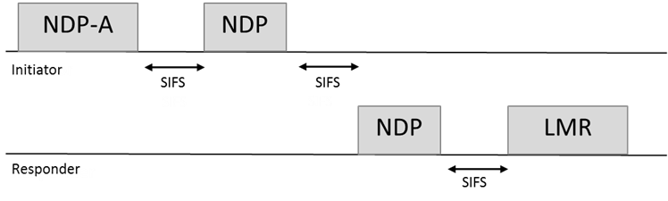

- In VHTz mode the iSTA shall not initiate another measurement sequence earlier than MinToaReady. If the iSTA initiates a following measurement sequence later than MaxToaAvailable, then the results may not be available (flushed)” [Septenmber, 2017 11-17-1305r2]
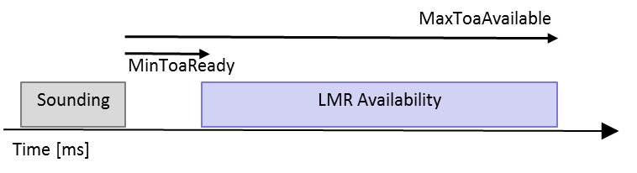

- rSTA to iSTA LMR feedback: Support of TOA and TOD is mandatory and CSI report is optional for both iSTA and rSTA and is agreed upon during negotiation [November 2017 - 11-17/1754r0]
- The bandwidth and the MCS/rate of the ranging report are defined by:
  - The data rate/MCS of ranging report is solely decided by the rSTA.
  - The bandwidth of ranging report is not wider than the bandwidth of the soliciting NDPA.” [November 2017 - 11-17/1754r0]
- iSTA to rSTA LMR feedback is supported and is negotiated at service establishment. [November 2017 - 11-17/1742r1]
- rSTA to iSTA or iSTA to rSTA LMR feedback is neither acknowledged or retransmitted. [November 2017 - 11-17/1742r1]

HEz Measurement Exchange

- In the HEz mode, the protocol shall define a polling phase for ranging request feedback prior to NDP sounding-based measurement. [May 2017]

- In the HEz mode, the Measurement phase for the ranging protocol for Multiple STAs shall be only based on NDP sounding and have the following frame exchange sequence:

- Note : the detailed design of DL Trigger, DL NDPA, UL NDP, DL NDP are TBD.

- In the HEz mode, within the MU measurement phase the UL sounding shall use one or more of the following multiplexing techniques:
  - Spatial Multiplexing using P-Matrix encoding,
  - OFDMA multiplexing
  - TDMA multiplexing (various methods, TBD) [May 2017]

- In the HEz mode, the measurement phase ranging protocol shall consists of one or more rounds of uplink sounding followed by one round of downlink sounding, where each round of uplink sounding includes one trigger frame soliciting one, or more NDP sounding frame(s) from iSTA(s) and the downlink sounding consists of one NDPA frame and one NDP sounding frame.

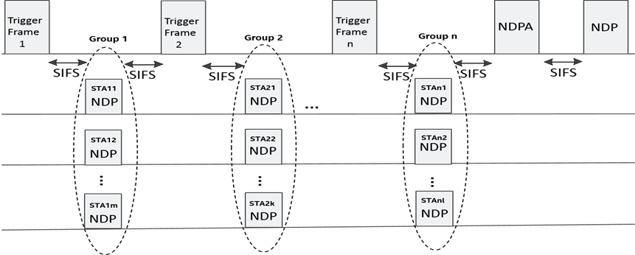

Details of the NDP sounding structure are TBD. [May 2017]

  - In the HEz mode, availability windows where the rSTA and iSTA shall perform measurements are defined as follows:
  - These availability windows are scheduled
  - Within an availability window, rSTAs shall perform ranging activities related to polling, measurement, and measurement results and group related scheduling
  - Each availability window consists by default of a single TXOP and can be extended to multiple TxOPs by announcement if single TxOP is insufficient to accommodate all iSTAs responding to the polling phase
  - Availability windows are negotiated/signaled between rSTA and a iSTA such that the iSTA knows when those availability windows occur.
  - An iSTA is not expected and does not perform MU ranging measurement and measurement results activities outside these windows. [September, 1455r1]

  - In each availability window, there is nominally a single poll, each poll is to all iSTAs assigned to the availability window.
  - If the available BW does not allow for the polling of all iSTAs within the group there is an indication within the TF Poll that an additional TF Poll is expected within the availability window.
  - Within the availability window there is a single measurement for those iSTAs responding to the poll (and correctly received) with the relevant LMRs feedbacks.” [November 2017 - 11-17/1739r0]

- In HEz mode signaling behavior on LMR feedback scheduling is as follows
  - Measurements and/or measurement results are provided for in the same availability window
  - Measurement results may be from this window’s measurement or the results of a measurement performed in a prior window
  - Protocol will support signaling for measurement results availability for current or next availability window within the measurement phase
  - The Trigger control frame or the NDPA control frame carries a dynamic signaling of measurement results availability in this or next availability window

- For HEz operation in the unassociated mode the following mechanisms are reused and active:
–UL Power control.
–Timing and frequency synchronization for UL transmission.
–Supported trigger subtypes for 11az trigger type:
- TF Location -> Poll
- TF Location -> Uplink Sounding
- TF Location -> LMR
- TF Location -> (Loc. negotiation using RA) and behavior to follow RA access. Details TBD.”

Note: this list may be extended in the future to accommodate OBSS operation. [Nov. 2017 11-17/1700r0]

- Ranging ID assignment and handling:
  - Ranging IDs are of the same size and range as AIDs and following same rules and limitations.
  - Ranging IDs and AIDs are from same space and non-conflicting.
  - The assignment of Ranging IDs by a rSTA to unassociated iSTA resulting in the execution MU HEz Ranging protocol with the rSTA:
    - The assigned Ranging ID is included in the HEz Specific subelement contained in iFTM.
    - The rSTA may advertise a Ranging ID lifetime which defines the duration for which the Ranging ID remains valid
    - the mechanism to advertise Ranging ID lifetime is TBD
    - The best choice for Ranging ID lifetime value is implementation dependent
  - The Ranging ID is retired at both IiSTA and rSTA when the corresponding Ranging ID Lifetime expires which also terminates the FTM session.
  - Ranging ID lifetime may be equal to MAX BSS IDLE PERIOD.
  - When an FTM session terminates or aborts the Ranging ID expires.
  - Termination may be explicit (i.e. using FTM or FTM Req) or implicit due to Ranging ID Lifetime expiration.
  - Support of the Ranging ID Lifetime is optional. [November 2017, 11-17/1733r1]
  - When an HEz FTM session is terminated, the Ranging-ID assigned for a MU ranging operation of an unassociated STA is released. [November 2017 - 11-17/1725r0.]

Positioning Protocol while operating in the 60 GHz band

General

- The 11az protocol shall define at least one mode in which LOS/NLOS estimation (an estimation likelihood that the measurement is performed on a LOS path) is provided as part of the measurement.”

- The 11az protocol shall define at least one mode in which BRP training may operate on the LOS path (rather than on the strongest path).”

Scalability aspects of the Positioning Protocol

This section describes the protocol features that enable operation in a dense environment.

Security [May 2017]

- The security setup to be negotiated in a separate optional step prior to the 802.11az protocol parameter negotiation
  - Note that in lieu of security negotiation, keys derived using an out-of-band mechanism may be used to secure the exchange between the initiator and the responder [May 2017]

- The REVmc, HEz, and VHTz FTM modes, the fields over which range measurements are performed shall be protected against a VHT/HE Type B adversary attack [May 2017]

- The DMGz and EDMGz FTM modes, the fields over which range measurements are performed shall be protected against a DMG/EDMG Type B adversary attack (TGaz R37)

- In the PHY Security mode (VHTz, HEz, DMGz, EDMGz), the field used for channel/ToA measurement shall not include any form of repetition in time domain or structure that is predictable [September 2017, 1373r1]

- In the PHY Security mode (VHTz, HEz, DMGz, EDMGz), the training waveform shall be transmitted with zero power (no signal) guard intervals preceding and following the field(s) used for channel/ToAmeasurement. (Note that zero power guard interval shall be inserted following the last sounding symbol if the last sounding symbol is followed by non-zero power signal)
- In the PHY Security mode (VHTz, HEz, DMGz, EDMGz), the field used for channel/ToA measurement shall be derived from (a) random sequence(s) known by the authorized I-STA and R-STA only. [November - 2017 11-17/1767r0]

- Security keys for 11az Management Frame Protection and range measurement field protection are derived based on security negotiation and never shared OTA (associated mode or pre-association security negotiation).

  - Range measurement field sequence is generated from some shared information and derived from the range measurement field protection key(s).
  - Keys used for data exchange and 11az management protection may be different from keys used for range measurement field protection.
  - PMF framework is used for FTM Req, FTM and LMR management frames; the key may either be derived from associated or pre-associated security negotiation.” [November 2017 - 11-17/1776r0]

Note: For HEz and VHTz PPDUs the measurement field refers to HE LTF and VHT LTF respectively [November 2017 - 11-17/1776r0 in 1776r1]

Using Angle of Departure and Angle of Arrival to estimate position

Frame formats

- The Initial FTM Request shall include
  - at least one of
-FTM Parameters element
-NGP Parameters element (optional subelements for ranging protocol- specific parameters)
  - optionally LCI and/or Location Civic Measurement Request element
-Trigger Field
-Trigger field set to 1 (for 802.11-2016 FTM backward compatibility)

- In HEz NDP ranging measurement phase, the NDPA has the following properties

B0 B1 bits value of the Sounding Dialog Token field shall be set to 0b10 to indicate 11az sequence

AID field will be used to indicate the receiver participating in the sounding exchange

Feedback Type field will be in 4-byte per STA info field (refer to the figure below)

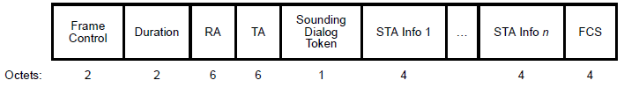
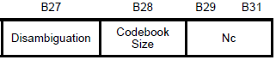
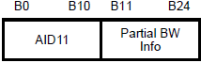
Reserved
Reserved
Feedback
Type
B26

- The ID for ranging operation for an unassociated STA used for measurement phase will be in the FTM Rsp frame

- The protocol shall define a single Trigger Type field value for the 11az amendment and a Trigger Sub-type subfield in Trigger Dependent Common Info field [May 2017]

- The NGP Parameters element includes:At least one of VHTz-specific Subelement, HEz-specific subelement or EDMGz-specific subelement
Note: if the rSTA has not advertised support for the corresponding protocol it will ignore it if at least one supported protocol specific subelement is specified; otherwise the iFTM will have a status Field in the FTM or NGP Parameters element is not SUCCESSFUL
- The NGP Parameters element with the status Field in the FTM or NGP Parameters element is set to SUCCESSFUL, includes one of VHTz-specific Subelement, HEz-specific subelement or EDMGz-specific subelement

- The Status and Value fields in the iFTM shall be set as defined in IEEE802.11-2016
[September 2017, 1473]
- The VHTz-Specific subelement when included in the iFTMR shall include
<nothing defined yet>
[September 2017, 1473]
- The VHTz-specific subelement when included in the iFTM with the status Field in the FTM or NGP Parameters element is set to SUCCESSFUL shall include
  - Response: Immediate or Delayed
  - if Response == Delayed
    - MinToaReady and MaxToaAvailable
    - the results (ToA/ToD) are delivered within the successive sounding sequence
[September 2017, 1473]
- The HEz-Specific subelement when included in the iFTMR shall include
  - Periodic Availability Window schedule
[September 2017, 1473]
- The HEz-specific subelement when included in the iFTM with the Status Field in the FTM or NGP Parameters element is set to SUCCESSFUL shall include:
  - Response: Immediate or Delayed
  - If Response == Immediate
    - results are provided in the same or next Availability Window based on a dynamic indication during the measurement phase
  - If Response == Delayed
    - results are of the measurements performed in the previous Availability Window
  - Included only when Status Field in the FTM or NGP Parameters element is set to SUCCESSFUL
    - Ranging ID assigned to the initiator

Note: The highlighted protion describe the normative behavior and shall go to clause 10 not clause 9.

[September 2017, 1473]

References

Missing refrences to submissions the SFD description comes from.

[] https://mentor.ieee.org/802.11/dcn/17/11-17-1373-01-00az-phy-security-frd-and-srd-text.pptx

[]https://mentor.ieee.org/802.11/dcn/17/11-17-1455-01-00az-mu-measurement-and-feedback-scheduling.pptx

[] https://mentor.ieee.org/802.11/dcn/17/11-17-1473-02-00az-11az-negotiation-protocol-update.pptx
[] https://mentor.ieee.org/802.11/dcn/17/11-17-1700-01-00az-power-control-for-multiuser-ranging.pptx

[]https://mentor.ieee.org/802.11/dcn/17/11-17-1733-01-00az-ranging-id-and-its-lifetime-management.pptx

[] https://mentor.ieee.org/802.11/dcn/17/11-17-1767-01-00az-phy-security-srd-text-update.pptx

[] https://mentor.ieee.org/802.11/dcn/17/11-17-1739-00-00az-power-save-operation-for-ranging-measurements.pptx

[] https://mentor.ieee.org/802.11/dcn/17/11-17-1741-02-00az-mu-ranging-sequence.pptx

[] https://mentor.ieee.org/802.11/dcn/17/11-17-1742-01-00az-su-ranging-feedback.pptx

[] https://mentor.ieee.org/802.11/dcn/17/11-17-1725-00-00az-ranging-id-management.pptx

[] https://mentor.ieee.org/802.11/dcn/17/11-17-1754-00-00az-frame-responding-rules-for-ndp-ranging.pptx

[] https://mentor.ieee.org/802.11/dcn/17/11-17-1776-01-00az-frame-protection-for-11az.pptx

