IEEE P802.11
Wireless LANs
Annex W update
Date: 2017-01-10
Author(s):
Name | Company | Address | Phone | email
Stephen McCann | BlackBerry Ltd | The Pearce Building, West Street, Maidenhead, Berkshire, SL6 1RL, UK | +44 1753 667099 | smccann@blackberry.com
Abstract
This document proposes text changes to update the P802.11aq D7.0 for the following SBO CIDs:

Annex W

(informative)

W.1.1 Background Search

Applications that run in the background (e.g., automatically receiving sales coupons within messages transmitted from a BSS, that a user has previously signed up for) might not require immediate discovery results to be presented to the user. It may be appropriate to prevent non-AP and non-PCP STAs, running such background applications, from performing a solicited PAD search. Furthermore, a solicited PAD search in a dense WLAN environment can cause network congestion. In that case, it is more effective to perform an unsolicited PAD search, in which an AP or PCP advertises multiple services known to the SIR, while non-AP and non-PCP STAs need respond only if there is a matched service.

The SIR can elect to advertise several services through the AP or PCP, using the Service Hash element, and advertise remaining services using the Service Hint element, in the Beacon or DMG Beacon. Alternatively, the SIR can elect to advertise all of the services through the AP or PCP, using either the Service Hash or Service Hint element in the Beacon or DMG Beacon. Upon receiving a Beacon or DMG Beacon, a non-AP and non-PCP STA processes the Service Hash and Service Hint elements to verify if there are any potential matching services. Figure W-1 (Example of a frame exchange for background search with high probability of false positive) and Figure W-2 (Example of a frame exchange for background search with low probability of false positive) show two cases where there is a matching Service Hint.

If the probability of false positives as indicated in the False Positive Probability Range field of the Service Hint element is considered relatively high by the non-AP and non-PCP STA (see Figure W-1 (Example of a frame exchange for background search with high probability of false positive)), the non-AP and non-PCP STA can send a Service Hash Request ANQP-element to confirm if the service is reachable through the AP or PCP. The SIR then responds through the AP or PCP, with a Service Hash Response ANQP-element with Service Information Response Tuple subfields that contain the corresponding Service Name and Instance Name fields.

The non-AP and non-PCP STA can then send a Service Information Request ANQP-element containing the Service Name, Instance Name and specific Service Information Query to the AP or PCP to obtain more information about the service from the SIR. The SIR responds to the ANQP request through the AP or PCP , with the ANQP response with Service Information Response ANQP-element containing the Service Name, Instance Name and specific Service Informatio

n Query Response fields. Following these service message exchanges the non-AP and non-AP STA can make an informed decision about choosing to associate to the AP or PCP.

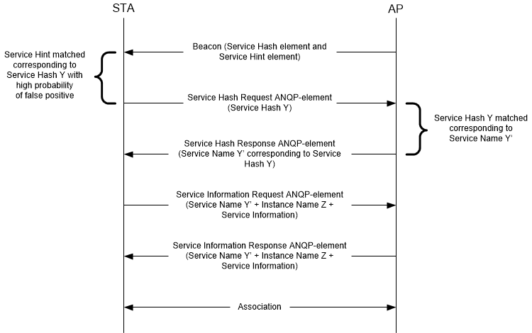

Figure W-1—Example of a frame exchange for background search with high probability of false positive

If the probability of false positive as indicated in False Positive Probability Range field of the Service Hint element is considered relatively low by the non-AP and non-PCP STA (see Figure W-2 (Example of a frame exchange for background search with low probability of false positive)), the non-AP and non-PCP STA can send a Service Information Query Request ANQP-element containing a Service Name and a Specific Service Information Query Request field to obtain more information about the service from the SIR.

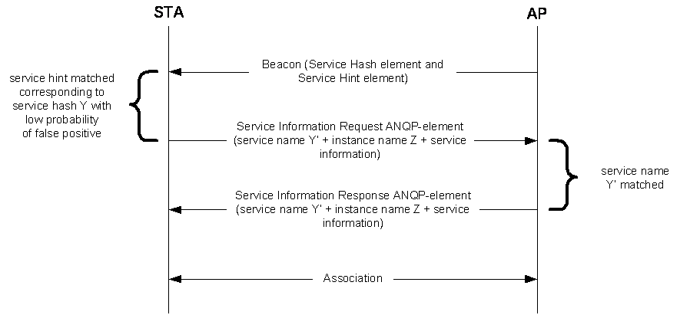

Figure W-2—Example of a frame exchange for background search with low probability of false positive

The SIR responds to the ANQP request through the AP or PCP, with a Service Information Response ANQP-element containing the service name and instance name. Following these service message exchanges the non-AP and non-AP STA can make an informed decision about choosing to associate to the AP or PCP
.

In a scenario where there is a matching service hash, the non-AP and non-PCP STA can directly send a Service Information Request ANQP-element to the AP or PCP, containing the service name and a specific Service Information Query Request to obtain more information about the service from the SIR as shown in Figure W-3 (Example of frame exchange for background search with matching Service Hash element).

The SIR responds through the AP or PCP, to the ANQP request with a Service Information Response ANQP-element containing the service name, instance name and specific Service Information Query Response. Following these service message exchanges the non-AP and non-AP STA can make an informed decision about choosing to associate to the AP or PCP.

Alternatively, the non-AP and non-PCP STA might choose to associate based on the matching Service Hash element.

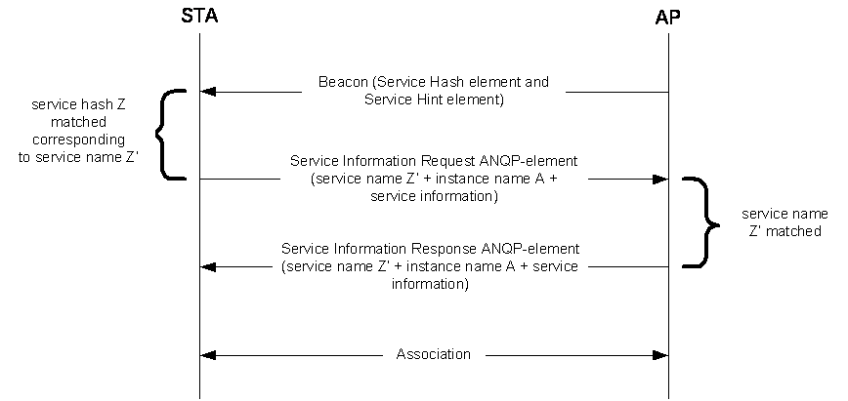

Figure W-3— Example of frame exchange for background search with matching Service Hash element

W.1.2 Immediate Search

Applications that are initiated by users (e.g., a user is looking for a fast movie download service provided by a BSS) require immediate discovery results to be presented to the STA or a user, so that network selection can be either performed by a STA or the user to obtain the desired sevice.
Figure W-4 (Example of frame exchange for immediate search)). shows a non-AP and non-PCP STA perform a solicited PAD procedure, whereby the non-AP and non-PCP STA sends a Service Hash Request ANQP-element to query specific services immediately after user initiation of the service/application. The SIR responds through the AP or PCP, with a Service Hash Response ANQP-element accordingly if there is a matched service.

When the Service Hash Request ANQP-element contains a service hash of the requested service, the SIR responds, through the AP or PCP, with a Service Hash Response ANQP-element with a Service Information Response Tuple subfield containing the corresponding service name and instance name.

The non-AP and non-PCP STA can then send a Service Information Request ANQP-element containing the Service Name, Instance Name and specific Service Information Query to the AP or PCP to obtain more information about the service from the SIR. The SIR responds to the ANQP request through the AP or PCP , with the ANQP response with Service Information Response ANQP-element containing the Service Name, Instance Name and specific Service Information Query Response fields. Following these service message exchanges the non-AP and non-AP STA can make an informed decision about choosing to associate to the AP or PCP

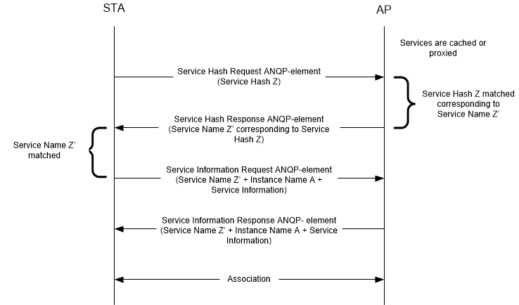

Figure W-4—Example of frame exchange for immediate search

