IEEE P802.11
Wireless LANs
802.11
Entity submissions related to TGax special measures
Date: 2016-12-15
Author(s):
Name | Company | Address | Phone | email
Adrian Stephens | Intel Corporation |  |  | Adrian.p.stephens@ieee.org

Abstract

This document is a place to publish submission to the WG chair from entities whose affiliates are subject to 802.11 TGax special measures.

R0: 2016-12-01: MediaTek
R1: 2016-12-06: + Cisco, Huawei, LGE, Qualcomm, Calypso Ventures Inc. & Toshiba
R2: 2016-12-07: + ZTE, NTT, NTT DoCoMo, Apple, Broadcom, Newracom
R3: 2016-12-09: + Sony
R4: 2016-12-12: + Samsung
R5: 2016-12-14: + Orange
R6: 2016-12-15: + Quantenna

Background

An allegation of dominance in 802.11 TGax was made https://mentor.ieee.org/802.11/dcn/16/11-16-0784-00-0000-dominance-allegation-in-tgax.doc.

The allegation was investigated and a report issued https://mentor.ieee.org/802.11/dcn/16/11-16-1519-00-0000-report-from-11ax-dominance-investigation.docx

The IEEE 802 EC approved remedies related to this report https://mentor.ieee.org/802-ec/dcn/16/ec-16-0186-03-00EC-recommendations-for-tgax-dominance-complaint.docx.
The EC instructed the 802.11 WG chair to implement the specified remedies.

The WG chair published a document describing how the remedies would be implemented here: https://mentor.ieee.org/802.11/dcn/16/11-16-1568-01-0000-interpretation-of-special-measures.doc.

The remedies allow for an entity to indicate is it not a member of DensiFi, and thereby its affiliates will no longer be subject to special measures described above.

This document is to capture those indications and place them in the public domain.

Mediatek (Received 2016-11-30)
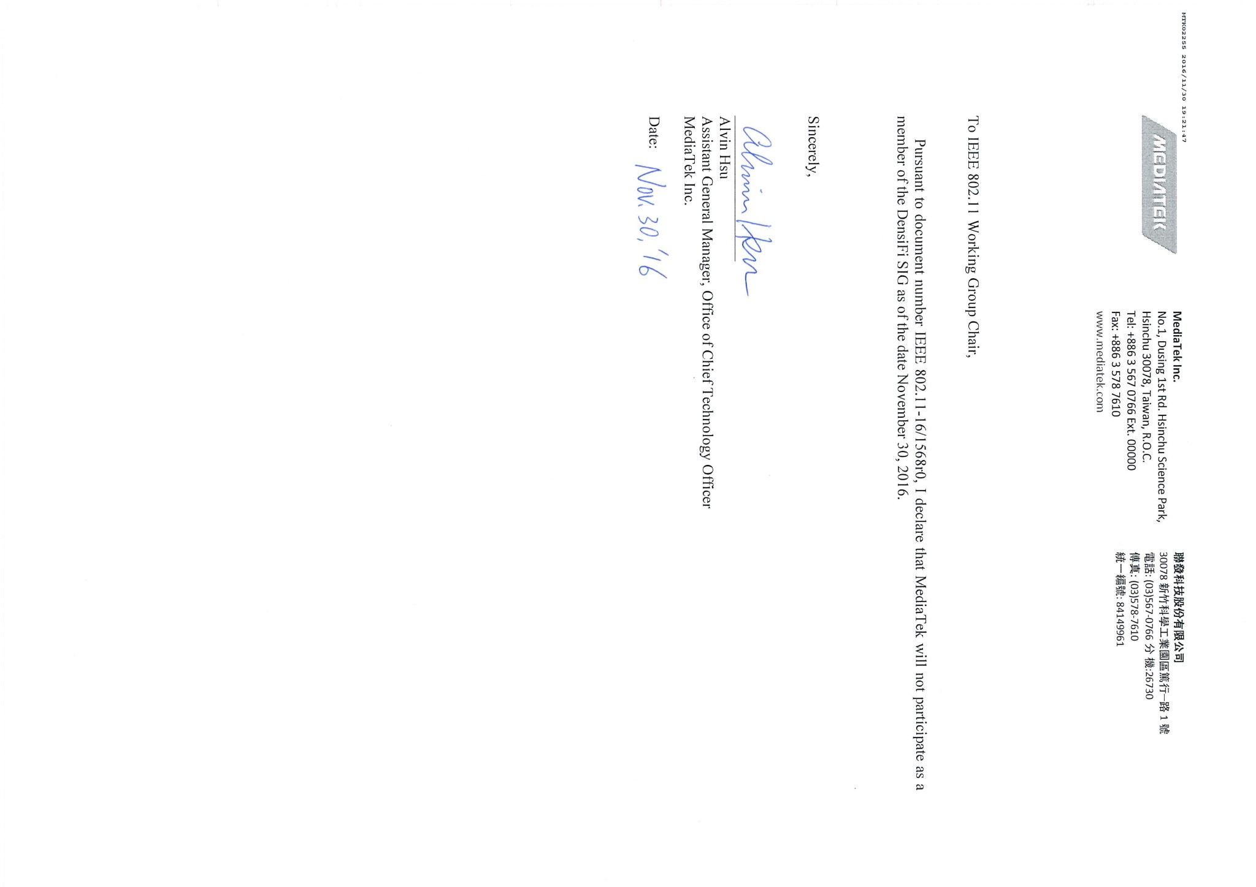

Toshiba (Received 2016-12-02)
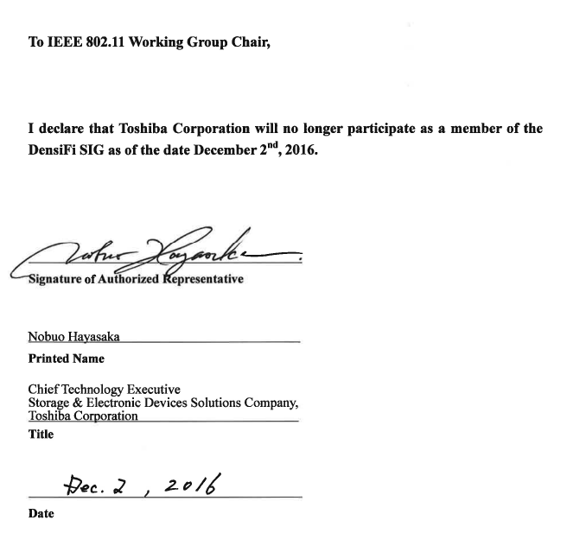

LGE (Received 2016-12-04)
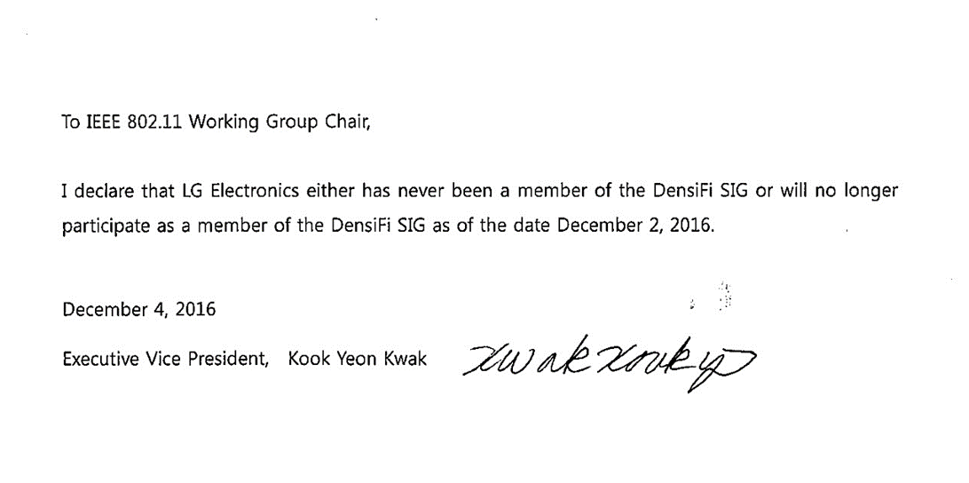

Huawei (Received 2016-12-04)

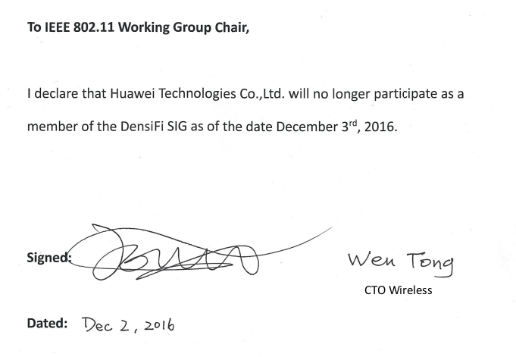

Cisco Systems (Received 2016-12-05)

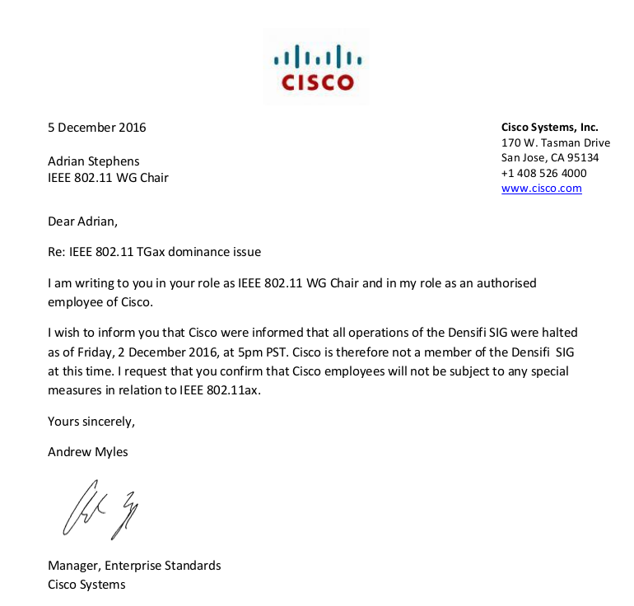

Calypso Ventures Inc. (Received 2016-12-01)
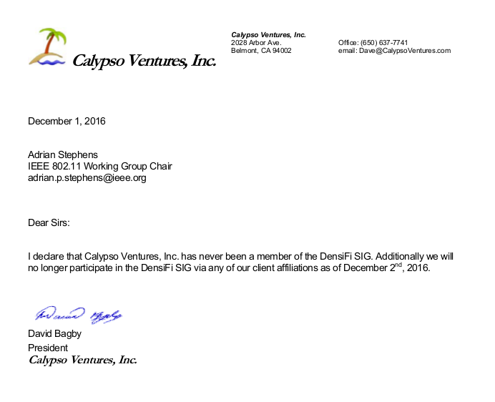

Qualcomm (Received 2016-12-06)
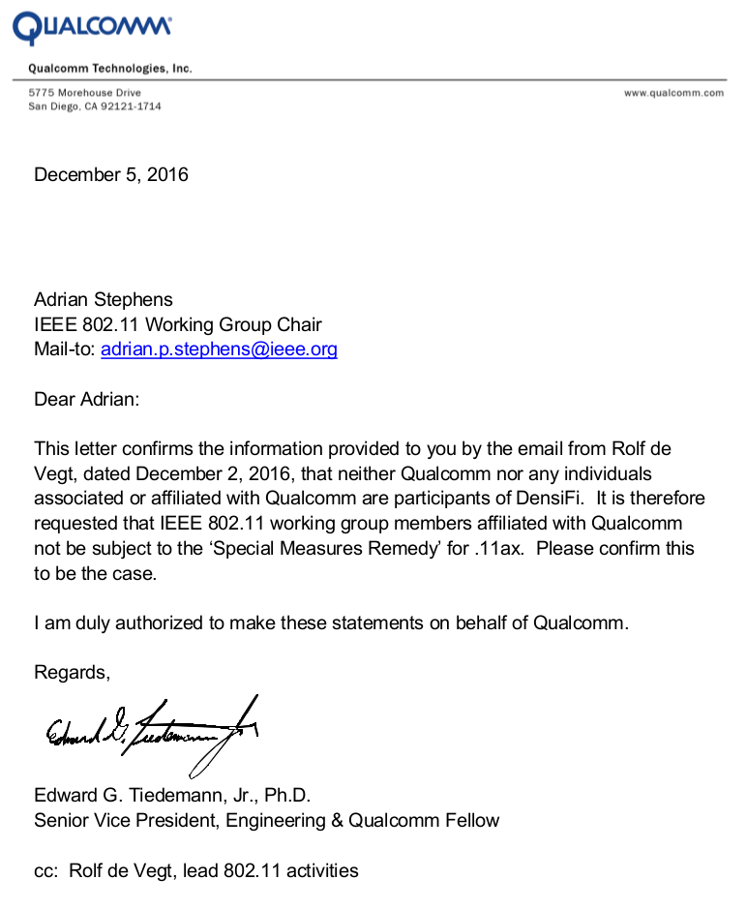

ZTE (Received 2016-12-07)
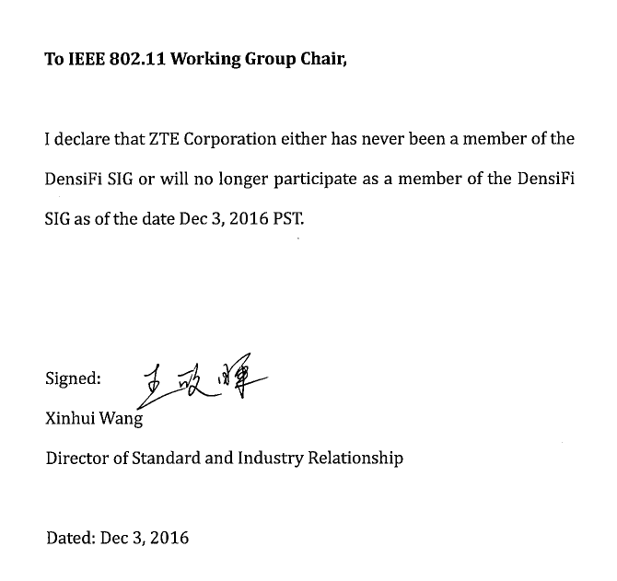

NTT & NTT DoCoMo (Received 2016-12-07)
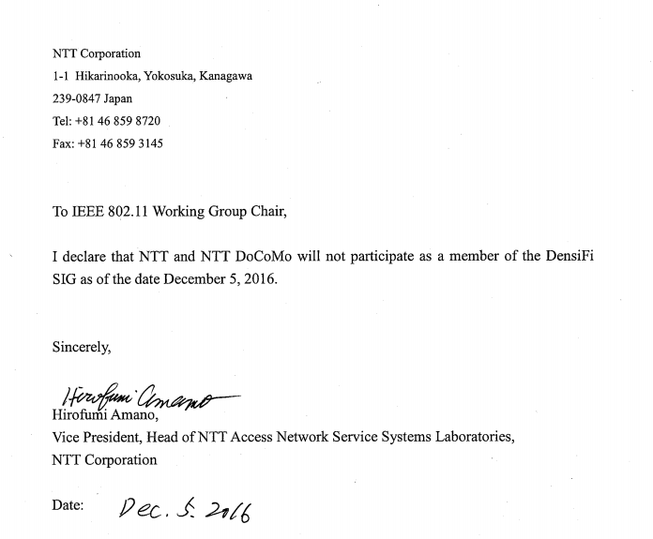

Apple (Received 2016-12-07)
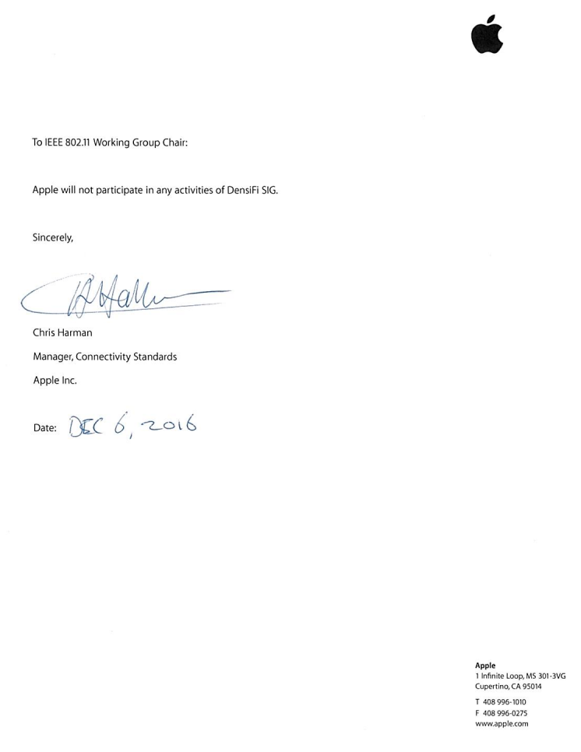

Broadcom (Received 2016-12-07)
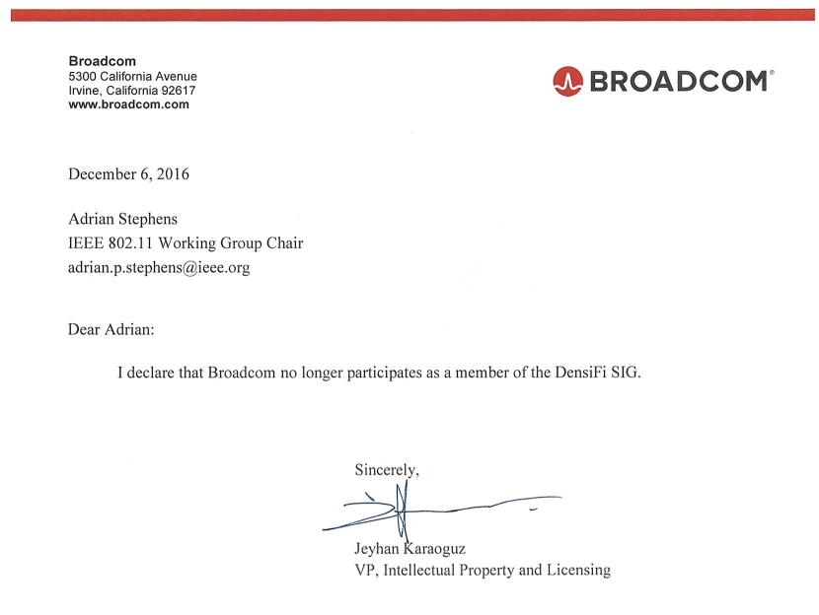

Newracom (Received 2016-12-07)
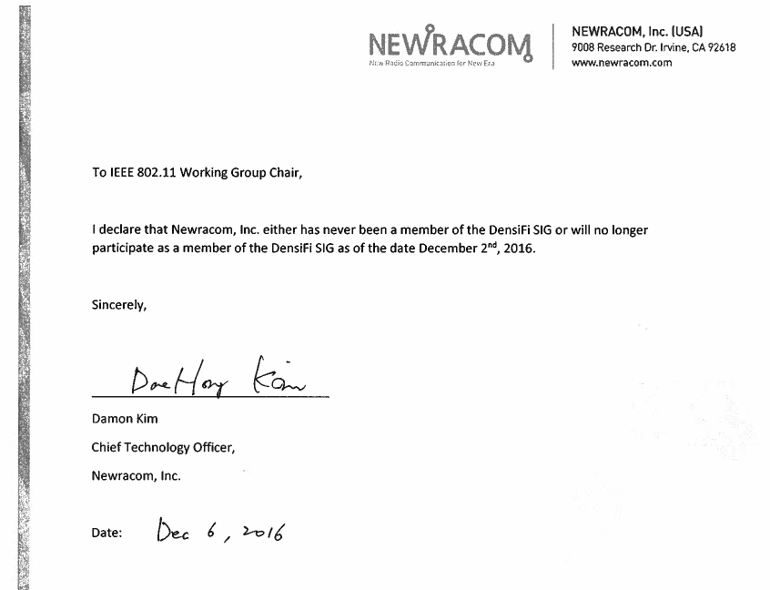

Sony (Received 2016-12-07)
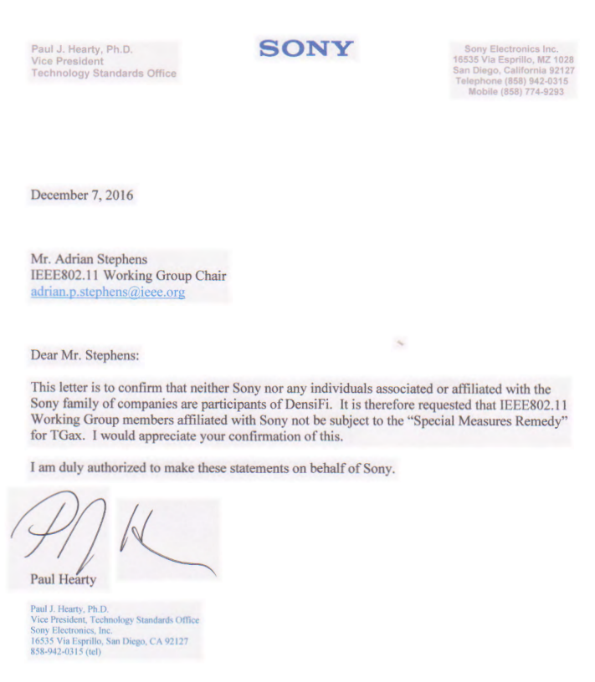

Samsung (Received 2012-12-10)
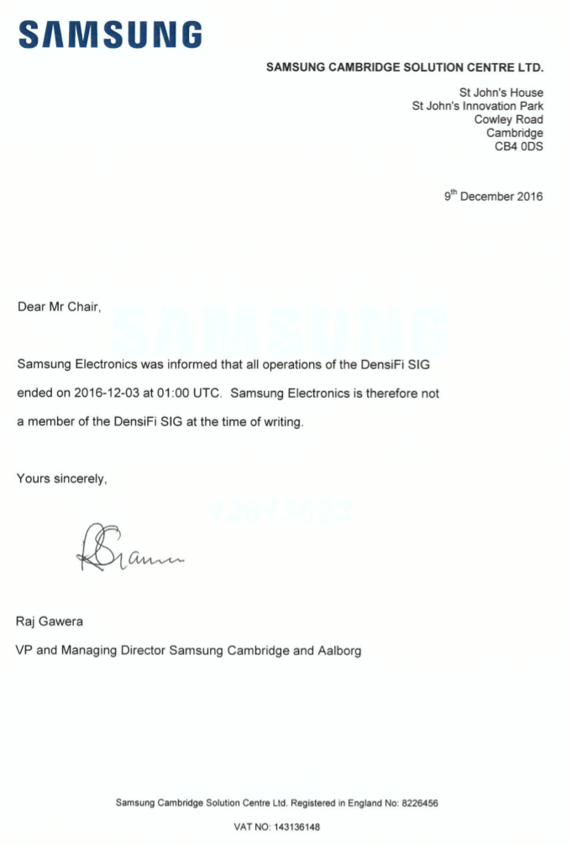

Orange (Received 2016-12-14)

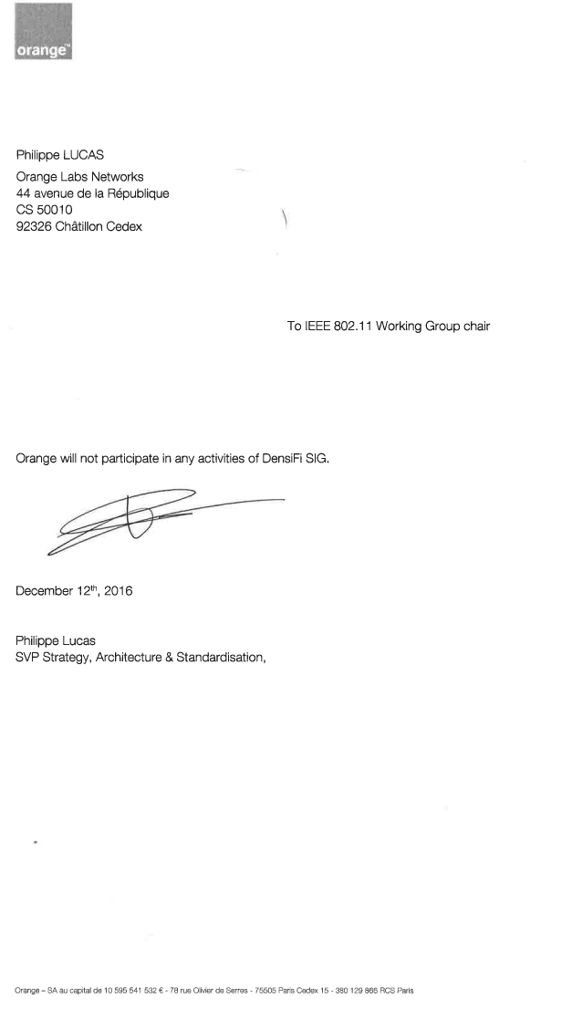

Quantenna (received 2016-12-15)
