IEEE P802.11
Wireless LANs
Service Hash Response ANQP-element
Date: 2016-11-15
Author(s):
Name | Company | Address | Phone | email
Stephen McCann | BlackBerry Ltd | 200 Bath Road, Slough, Berkshire, SL1 3XE, UK | +44 1753 667099 | smccann@blackberry.com
Abstract
This document proposes text changes to update the P802.11aq D7.0 for the following SBO CIDs:

6059

9.4.5 Access Network Query Protocol (ANQP) elements

9.4.5.1 General

Insert new rows as follows to the end of the table, with corresponding adjustment to “Reserved” value:

Table 9-271—ANQP-element definitions

ANQP-element name | Info ID | ANQP-element (subclause)
Service Hash Request | 288 | 9.4.5.27 (Service Hash Request ANQP-element)
Service Information Request | 289 | 9.4.5.28 (Service Infor- mation Request ANQP- element)
Service Information Response | 290 | 9.4.5.29 (Service Infor- mation Response ANQP- element)
Service Hash Response | 291 | 9.4.5.30 (Service Hash Response ANQP-element)

Insert the new subclause as follows:

9.4.5.29 Service Information Response ANQP-element

The Service Information Response ANQP-element contains the detailed service information in response to a Service Hash Request or a Service Information Request ANQP-element.

The format of the Service Information Response ANQP-element is shown in Figure 9-625j (Service Infor- mation Response ANQP-element format).

Info ID | Length | Service Information Response Tuples
Octets: 2 2 variable

Figure 9-625j—Service Information Response ANQP-element format

The Info ID and Length fields are defined in 9.4.5.1 (General).

The Service Information Response Tuples field contains one or more Service Information Response Tuple subfields.

The format of the Service Information Response Tuple subfield is shown in Figure 9-625k (Service Informa- tion Response Tuple subfield format).

Service Name Length | Service Name | Instance Name Length | Instance Name | Service Infor- mation Query Response Length | Service Informa- tion Query Response
Octets: 1 variable 1 variable 2 variable

Figure 9-625k— Service Information Response Tuple subfield format

The Service Name Length subfield and the Service Name subfield are defined in 9.4.5.28 (Service Information Request ANQP-element).

The Instance Name Length subfield and the Instance Name subfield are defined in 9.4.5.28 (Service Information Request ANQP-element). The Instance Name Length subfield contains a nonzero value.

The Service Information Query Response Length subfield is the length of the Service Information Query Response subfield. If the Service Information Query Response Length subfield is equal to 0, the Service Information Query Response subfield is not included. When this subfield is included in the Service Hash Response ANQP-element it is set to 0 (also in the behaviour section below)

The Service Information Query Response subfield is a variable length field. The content of the Service Information Query Response subfield is service-specific based on the requested service information and is specified in 11.25a.3 (Solicited PAD procedure).

Insert new subclause as follows:

9.4.5.30 Service Hash Response ANQP-element

The Service Hash Response ANQP-element contains the detailed service information in response to a Service Hash Request ANQP-element.

The format of the Service Hash Response ANQP-element is shown in Figure 9-625xx (Service Hash Response ANQP-element format).

Info ID | Length | Service Information Response Tuples
Octets: 2 2 variable

Figure 9-625xx—Service Hash Response ANQP-element format

The Info ID and Length fields are defined in 9.4.5.1 (General).

The Service Information Response Tuples field is defined in 9.4.5.29 (Service Information Response ANQP-element)

11. MLME

11.25 WLAN interworking with external networks procedures

11.25.3 Interworking procedures: generic advertisement service (GAS)

11.25.3.2 ANQP procedures 11.25.3.2.1 General
Insert new rows to table as follows:

Table 11-15—ANQP usage

 |  |  | BSS |  | IBSS
ANQP-element name | ANQP-element (subclause) | ANQP-  element type | AP | Non-AP STA | STA
Service Hash Request | 9.4.5.27  (Service Hash Request ANQP- element) | Q | R | T | —
Service Information Request | 9.4.5.28  (Service Information Request ANQP- element) | Q | R | T | —
Service Information Response | 9.4.5.29  (Service Information Response ANQP-element) | S | T | R | —
Service Hash Response | 9.4.5.30  (Service Hash Request ANQP- element) | S | T | R | —

11.25a.3 Solicited PAD procedure

When dot11SolicitedPADActivated is true, a non-AP and non-PCP STA may transmit to an AP or PCP a Service Hash Request ANQP-element. This element includes one or more service hashes generated from the service name(s) of the service(s) that the non-AP and non-PCP STA is searching, as well as valid combina- tions of services of interest. An AP or PCP might advertise support for the Solicited PAD procedure by set- ting the Solicited PAD field of the Extended Capabilities element to 1 in its Beacon and Probe Response frames.

When dot11SolicitedPADActivated is true, an AP or PCP shall use the information from the Service Hash Request ANQP-element (that it receives from a non-AP and non-PCP STA) to determine if it can provide the requested service(s) or combination of services. Determination is based on the service hash values in the Service Hashes field of the received Service Hash Request ANQP-element, and valid service combinations specified through the Flags and Service Combination fields of the Service Hash Request ANQP-element. If the AP or PCP determines that it can provide the requested service(s) or combination of services, it shall respond by transmitting a Service Hash Response ANQP-element that contains a Service Information Response Tuple subfield for each service that satisfies the request.

NOTE—For example, an AP or PCP that receives a Service Hash Request ANQP-element frame that includes hash val- ues for 4 services S1, S2, S3 and S4 (in that order) and a value of 0xFEEE in its Service Combination field, responds to the request if and only if it can provide service S1 or service S2 or both services S3 and S4. The Service Hash Response ANQP-element can contain Service Information Response Tuple subfields for any set of available services that satisfy the ANQP request, e.g., S1, S3 and S4.

The requesting non-AP STA shall process the Service Hash Response ANQP-element in the received ANQP response to select a service combination that satisfies the non-AP and non-PCP STA request.

If there is a matching service name, the non-AP and non-PCP STA might decide to proceed with the service information procedure (see 11.25.3.2.16 (Service information procedure) or authentication and association procedure (see 11.3 (STA authentication and association)) depending on the nature of the service (see exam- ples illustrated in W.1 (Pre-association discovery usage scenarios)).

B.4.30 Pre-association discovery extensions

Item | Protocol Capability | References | Status | Support
PAD1 | Service Hint element | 9.4.2.217 (Service Hint element) | CF33:M | Yes □ No □ N/A □
PAD2 | Service Hash element | 9.4.2.218 (Service Hash element) | CF33:M | Yes □ No □ N/A □
PAD3 | Service Hash Request ANQP- element | 9.4.5.27 (Service Hash Request ANQP- element) | (IW2.2.2 AND CF33):M | Yes □ No □ N/A □
PAD4 | Service Information Request ANQP-element | 9.4.5.28 (Service Information Request ANQP-element) | (IW2.2.2 AND CF33):M | Yes □ No □ N/A □
PAD5 | Service Information Response ANQP-element | 9.4.5.29 (Service Information Response ANQP-element) | (IW2.2.2 AND CF33):M | Yes □ No □ N/A □
PAD4 | Service Hash Response ANQP- element | 9.4.5.30 (Service Hash Response ANQP- element) | (IW2.2.2 AND CF33):M | Yes □ No □ N/A □
PAD7 | Unsolicited PAD procedure | 11.25a.2 (Unsolicited PAD procedure) | CF33:M | Yes □ No □ N/A □
PAD8 | Solicited PAD procedure | 11.25a.3 (Solicited PAD procedure) | (IW2.2.2 AND CF33):M | Yes □ No □ N/A □

Annex W

(informative)

Background Search

Applications that run in the background (e.g., automatically receiving sales coupons that a user has previ- ously signed up for) might not require immediate discovery results to be presented to the user. It may be appropriate to prevent non-AP STAs, running such background applications, from performing a solicited PAD search. Furthermore, a solicited PAD search in a dense WLAN environment can cause network con- gestion. In that case, it is more effective to perform an unsolicited PAD search, in which an AP or PCP advertises multiple services known to the SIR, while non-AP STAs need respond only if there is a matched service.

The AP or PCP can elect to advertise several services using the Service Hash element, and advertise remain- ing services using the Service Hint element, in the Beacon or DMG Beacon. Alternatively, the AP or PCP can elect to advertise all of the services using either the Service Hash or Service Hint element in the Beacon or DMG Beacon. Upon receiving a Beacon or DMG Beacon, a non-AP STA processes the Service Hash and Service Hint elements to verify if there are any potential matching services. Figure W-1 (Example of a frame exchange for background search with high probability of false positive) and Figure W-2 (Example of a frame exchange for background search with low probability of false positive) show two cases where there is a matching Service Hint.

If the probability of false positives as indicated in the False Positive Probability Range field of the Service Hint element is considered relatively high by the non-AP STA (see Figure W-1 (Example of a frame exchange for background search with high probability of false positive)), the non-AP STA can send a Ser- vice Hash Request ANQP-element to confirm if the service is reachable through the AP or PCP. The AP or PCP then responds with a Service Hash Response ANQP-element with Service Information Response Tuple subfields that contain the corresponding Service Name and Instance Name fields.

The non-AP STA can then send a Service Information Request ANQP-element containing the Service Name, Instance Name and specific Service Information Query to obtain more information about the service from the AP or PCP. The AP or PCP responds to the ANQP request with the ANQP response with Service Information Response ANQP-element containing the Service Name, Instance Name and specific Service

Information Query Response fields. After the ANQP request and ANQP response exchange, the non-AP STA can obtain more information on available services after it associates to the AP or PCP.

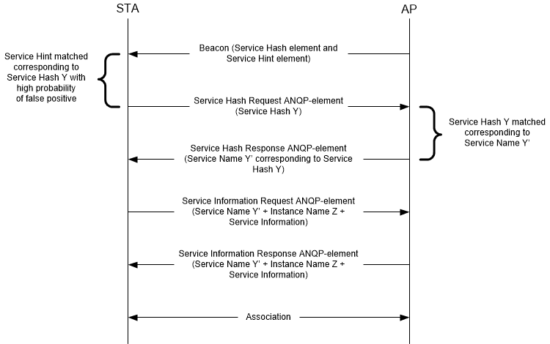

Figure W-1—Example of a frame exchange for background search with high probability of false positive

If the probability of false positive as indicated in False Positive Probability Range field of the Service Hint element is considered relatively low by the non-AP STA (see Figure W-2 (Example of a frame exchange for background search with low probability of false positive)), the non-AP STA can directly send a Service Information Query Request ANQP-element containing a Service Name and a Specific Service Information Query Request field to obtain more information about the service from the AP or PCP.

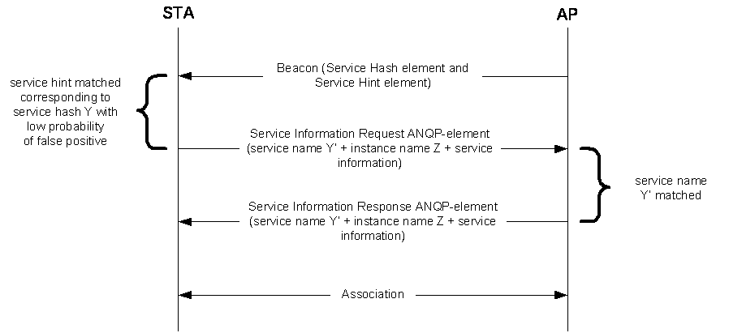

Figure W-2—Example of a frame exchange for background search with low probability of false positive

The AP or PCP responds to the ANQP request with a Service Information Response ANQP-element con- taining the service name and instance name. After the ANQP request and ANQP response exchange, the non-AP STA can obtain information on available services after associating to the AP or PCP.

In a scenario where there is a matching service hash, the non-AP STA can directly send a Service Informa- tion Request ANQP-element containing the service name and a specific Service Information Query Request to obtain more information about the service from the AP or PCP as shown in Figure W-3 (Example of frame exchange for background search with matching Service Hash element).

The AP or PCP responds to the ANQP request with a Service Information Response ANQP-element con- taining the service name, instance name and specific Service Information Query Response. After the ANQP request and ANQP response exchange, the non-AP STA can make an informed decision about choosing to associate to the AP or PCP.

Alternatively, the non-AP STA might choose to associate based on the matching Service Hash element.

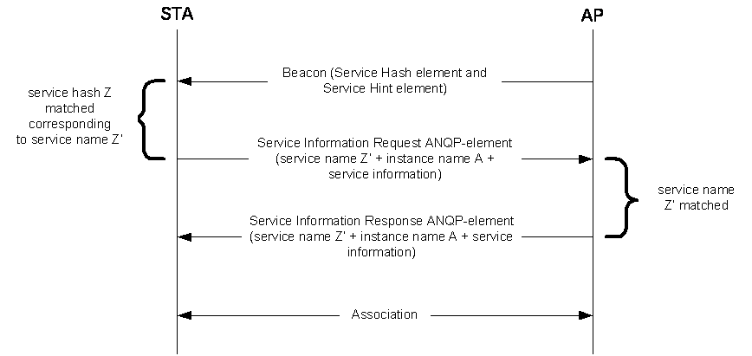

Figure W-3— Example of frame exchange for background search with matching Service Hash element

    - Immediate Search

Applications that are initiated by users (e.g., a user is looking for a fast movie download service) require immediate discovery results to be presented to the user. In this scenario, a non-AP STA performs a solicited PAD procedure, whereby the non-AP STA sends a Service Hash Request ANQP-element to query specific services immediately after user initiation of the service/application. The AP or PCP responds with a Service Information Response ANQP-element accordingly if there is a matched service (see Figure W-4 (Example of frame exchange for immediate search)). The Service Hash Request ANQP-element contains a service hash of the requested service. The AP or PCP responds with a Service Hash Response ANQP-element with a Service Information Response Tuple subfield containing the corresponding service name and instance name. The non-AP STA then might perform a service information ANQP request and ANQP response exchange with the AP or PCP, as shown in Figure W-4 (Example of frame exchange for immediate

search), to obtain more information about the service. After the ANQP request and ANQP response exchange, the non-AP STA can make an informed decision about choosing to associate to the AP or PCP.

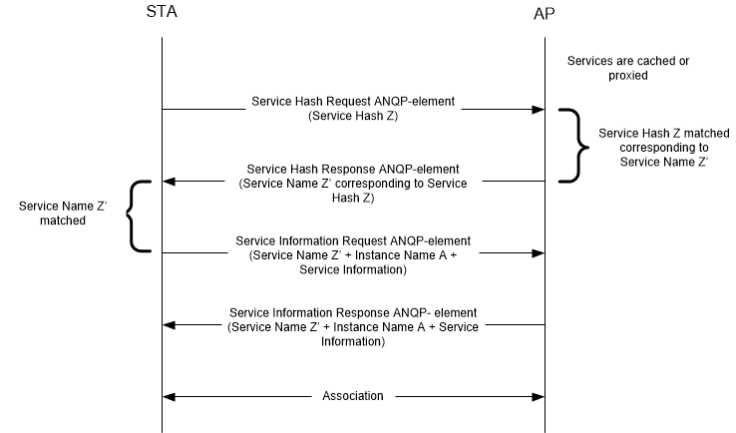

Figure W-4—Example of frame exchange for immediate search

