IEEE P802.11
Wireless LANs
Service Hash Response ANQP-element
Date: 2016-11-08
Author(s):
Name | Company | Address | Phone | email
Stephen McCann | BlackBerry Ltd | 200 Bath Road, Slough, Berkshire, SL1 3XE, UK | +44 1753 667099 | smccann@blackberry.com
Abstract
This document proposes text changes to update the P802.11aq D7.0 for the following SBO CIDs:

xxx

9.4.5 Access Network Query Protocol (ANQP) elements

9.4.5.1 General

Insert new rows as follows to the end of the table, with corresponding adjustment to “Reserved” value:

Table 9-271—ANQP-element definitions

ANQP-element name | Info ID | ANQP-element (subclause)
Service Hash Request | 288 | 9.4.5.27 (Service Hash Request ANQP-element)
Service Hash Response | 289 | 9.4.5.28 (Service Hash Response ANQP-element)
Service Information Request | 290 | 9.4.5.29 (Service Infor- mation Request ANQP- element)
Service Information Response | 291 | 9.4.5.30 (Service Infor- mation Response ANQP- element)

Insert new subclause as follows:

Service Hash Response ANQP-element

The Service Hash Response ANQP-element contains the detailed service information in response to a Service Hash Request ANQP-element.

The format of the Service Hash Response ANQP-element is shown in Figure 9-625xx (Service Hash Response ANQP-element format).

Info ID | Length | Service Hash Response Tuples
Octets: 2 2 variable

Figure 9-625xx—Service Hash Response ANQP-element format

The Info ID and Length fields are defined in 9.4.5.1 (General).

The Service Hash Response Tuples field contains one or more Service Hash Response Tuple subfields.

The format of the Service Hash Response Tuple subfield is shown in Figure 9-625xx (Service Hash Response Tuple subfield format).

Service Name Length | Service Name | Instance Name Length | Instance Name
Octets: 1 variable 1 variable

Figure 9-625xx — Service Hash Response Tuple subfield format

The Service Name Length subfield is set to either zero or the length of the Service Name subfield, in octets. If the Service Name Length is not equal to 0, the Service Name subfield contains a UTF-8 encoded string as defined in IETF RFC 6335. For example, service name for print service is "_ipp._tcp". If the Service Name Length subfield is equal to 0, the Service Name subfield contains a 6-octet service hash value (see 11.25a.4 (Service hash procedures)).

The Instance Name Length subfield contains the length of the Instance Name subfield, in octets. The Instance Name is an instance of service associated with the service name. The Instance Name subfield con- tains a UTF-8 encoded string with a maximum length of 63 octets as defined in IETF RFC 6763. An exampl ple of an instance name is "John Home Printer". If the Instance Name Length subfield is equal to 0, the Instance Name subfield is not included in the Service Information Request Tuple subfield.
Insert new subclause as follows:

      - Service Information Request ANQP-element

The Service Information Request ANQP-element contains the request for service information associated with a given service name or an instance name associated with a service name. Additional information can also be provided to refine the request.

The format of the Service Information Request ANQP-element is shown in Figure 9-625h (Service Informa- tion Request ANQP-element format).

Info ID | Length | Service Infor- mation Request Tuples
Octets: 2 2 variable

Figure 9-625h—Service Information Request ANQP-element format

The Info ID and Length fields are defined in 9.4.5.1 (General).

The Service Information Request Tuples field contains one or more Service Information Request Tuple sub- fields. The format of the Service Information Request Tuple subfield is shown in Figure 9-625i (Service Information Request Tuple subfield format).

Service Name Length | Ser- vice Name | Instance Name Length | Instance Name | Service Informa- tion Query Request Length | Service Informa- tion Query Request

Octets
:
1 variable 1 variable 1 variable

Figure 9-625i— Service Information Request Tuple subfield format

The Service Name Length subfield and the Service Name subfield are defined in 9.4.5.28 (Service Hash Response ANQP-element).

The Instance Name Length subfield and the Instance Name subfield are defined in 9.4.5.28 (Service Hash Response ANQP-element). The Instance Name Length subfield contains a nonzero value.

The Service Information Query Request Length subfield is the length of the Service Information Query Request subfield. If the Service Information Query Request Length subfield is equal to 0, the Service Infor- mation Query Request subfield is not included.

The Service Information Query Request subfield contains service-specific query. The value of this subfield is out of scope of this standard.

Insert the new subclause as follows:

Service Information Response ANQP-element

The Service Information Response ANQP-element contains the detailed service information in response to a Service Hash Request or a Service Information Request ANQP-element.

The format of the Service Information Response ANQP-element is shown in Figure 9-625j (Service Infor- mation Response ANQP-element format).

Info ID | Length | Service Information Response Tuples
Octets: 2 2 variable

Figure 9-625j—Service Information Response ANQP-element format

The Info ID and Length fields are defined in 9.4.5.1 (General).

The Service Information Response Tuples field contains one or more Service Information Response Tuple subfields.

The format of the Service Information Response Tuple subfield is shown in Figure 9-625k (Service Informa- tion Response Tuple subfield format).

Service Name Length | Service Name | Instance Name Length | Instance Name | Service Infor- mation Query Response Length | Service Informa- tion Query Response
Octets: 1 variable 1 variable 2 variable

Figure 9-625k— Service Information Response Tuple subfield format

The Service Name Length subfield and the Service Name subfield are defined in 9.4.5.28 (Service Hash Response ANQP-element).

The Instance Name Length subfield and the Instance Name subfield are defined in 9.4.5.28 (Service Hash Response ANQP-element). The Instance Name Length subfield contains a nonzero value.

The Service Information Query Response Length subfield is the length of the Service Information Query Response subfield. If the Service Information Query Response Length subfield is equal to 0, the Service Information Query Response subfield is not included.

The Service Information Query Response subfield is a variable length field. The content of the Service Information Query Response subfield is service-specific based on the requested service information and is specified in 11.25a.3 (Solicited PAD procedure).

11. MLME

11.25 WLAN interworking with external networks procedures

11.25.3 Interworking procedures: generic advertisement service (GAS)

11.25.3.2 ANQP procedures 11.25.3.2.1 General
Insert new rows to table as follows:

Table 11-15—ANQP usage

 |  |  | BSS |  | IBSS
ANQP-element name | ANQP-element (subclause) | ANQP-  element type | AP | Non-AP STA | STA
Service Hash Request | 9.4.5.27  (Service Hash Request ANQP- element) | Q | R | T | —
Service Hash Response | 9.4.5.28  (Service Hash Request ANQP- element) | S | T | R | —
Service Information Request | 9.4.5.29  (Service Information Request ANQP- element) | Q | R | T | —
Service Information Response | 9.4.5.30  (Service Information Response ANQP-element) | S | T | R | —

Insert new subclause as follows:

11.25.3.2.16 Service information procedure

An AP or PCP may support the service information procedure. An AP or PCP that supports the service information procedure shall set the Service Information field in the Extended Capabilities element to 1.

The Service Information Request ANQP-element is used by a non-AP STA to request information about ser- vices reachable through the BSS to associated STAs. A service name or a service hash generated from the service name is placed within the ANQP request that is used to identify a service, as described in W.1 (Pre- association discovery usage scenarios).

The Service Information Response ANQP-element contains detailed information about the services con- tained within the SIR.

When dot11UnsolicitedPADActivated or dot11SolicitedPADActivated is true, a non-AP STA may send an ANQP request with a Service Information Request ANQP-element (see 9.4.5.28 (Service Information Request ANQP-element)) to obtain information about a matching service from the SIR. The Service Infor- mation Request ANQP-element may include one or more Service Information Request Tuple subfields. Each Service Information Tuple subfield shall include a Service Name subfield, and if applicable an Instance Name subfield, and may include a Service Information Query Request subfield that is service-spe- cific.

When dot11UnsolicitedPADActivated or dot11SolicitedPADActivated is true, an AP or PCP receiving a Service Information Request ANQP-element shall respond with a Service Information Response ANQP-ele- ment (see 9.4.5.29 (Service Information Response ANQP-element)) populated with information from the SIR. The Service Information Response ANQP-element shall include a Service Information Response Tuple subfield for each service matching the request.

Based on the content of the Service Information Response ANQP-element, the non-AP STA might decide to proceed with the authentication and association procedure (see 11.3 (STA authentication and association)) (see examples illustrated in W.1 (Pre-association discovery usage scenarios)). The details of this decision are outside the scope of this standard.

Insert new subclauses as follows:

11.25a Pre-association discovery (PAD) procedures

11.25a.1 General

There are two types of PAD procedures: unsolicited and solicited. The unsolicited PAD procedure is described in 11.25a.2 (Unsolicited PAD procedure) and the solicited PAD procedure is described in 11.25a.3 (Solicited PAD procedure). Both unsolicited PAD and solicited PAD procedures may be followed by the service information procedure described in 11.25.3.2.16 (Service information procedure).

When dot11UnsolicitedPADActivated or dot11SolicitedPADActivated is true, a non-AP STA may use PAD procedures to discover the availability of services that the same non-AP STA may access when associated. While the specification of service specific information is outside the scope of this standard, the service spe- cific information in the BSS is proxied by a SIR (see 4.5.9.1.3 (Service information registry)), which might be collocated with the AP or PCP

11.25a.2 Unsolicited PAD procedure

When dot11UnsolicitedPADActivated is true, an AP shall advertise services using a Service Hint element or Service Hash element or both in Beacon or Probe Response frames. Each service shall be advertised using either Service Hint element or Service Hash element or both in Beacon or Probe Response frames. When dot11UnsolicitedPADActivated is true, a PCP shall advertise services using a Service Hint element or Ser- vice Hash element or both in DMG Beacon or Announce frames. A Service Hint element is used to advertise the presence of one or more services with a probability of matching a wrong service as indicated in False

Positive Probability Range field of the Service Hint element. A Service Hash element is used to advertise the presence of one or more services with a negligible probability of matching a wrong service. The selection of a Service Hash or Service Hint element to advertise a particular service is beyond the scope of this standard.

When dot11UnsolicitedPADActivated is true, a non-AP STA searching for a service or services shall per- form the following steps:

    - Determine if a Service Hash, Service Hint element or both are included in received Beacon or Probe Response frames.
    - Construct a service hash value for each searched service or determine the bit positions in the Bloom Filter Array field that will be set to 1 for the searched services.
    - For each searched service, determine if there is a matched service based on either of the follow- ing:
      - The service hash value in the Service Hashes field of the Service Hash element matches to the corresponding service hash value constructed in step 2.
      - The values of the bit positions of the Bloom Filter Bit Array field of the Service Hint ele- ment, as determined in step 2, are all equal to 1.

The non-AP STA may use the information on available services to determine how to proceed. The non-AP STA might proceed with solicited PAD procedure (see 11.25a.3 (Solicited PAD procedure)), service infor- mation procedure (11.25.3.2.16 (Service information procedure), or authentication and association proce- dure (see 11.3 (STA authentication and association)) based on the perceived false positive probability and the nature of the service (see the examples in W.1 (Pre-association discovery usage scenarios)).

11.25a.3 Solicited PAD procedure

When dot11SolicitedPADActivated is true, a non-AP and non-PCP STA may transmit to an AP or PCP a Service Hash Request ANQP-element. This element includes one or more service hashes generated from the service name(s) of the service(s) that the non-AP and non-PCP STA is searching, as well as valid combina- tions of services of interest. An AP or PCP might advertise support for the Solicited PAD procedure by set- ting the Solicited PAD field of the Extended Capabilities element to 1 in its Beacon and Probe Response frames.

When dot11SolicitedPADActivated is true, an AP or PCP shall use the information from the Service Hash Request ANQP-element (that it receives from a non-AP and non-PCP STA) to determine if it can provide the requested service(s) or combination of services. Determination is based on the service hash values in the Service Hashes field of the received Service Hash Request ANQP-element, and valid service combinations specified through the Flags and Service Combination fields of the Service Hash Request ANQP-element. If the AP or PCP determines that it can provide the requested service(s) or combination of services, it shall respond by transmitting a Service Hash Response ANQP-element that contains a Service HashResponse Tuple subfield for each service that satisfies the request.

NOTE—For example, an AP or PCP that receives a Service Hash Request ANQP-element frame that includes hash val- ues for 4 services S1, S2, S3 and S4 (in that order) and a value of 0xFEEE in its Service Combination field, responds to the request if and only if it can provide service S1 or service S2 or both services S3 and S4. The Service Hash Response ANQP-element can contain Service Hash Response Tuple subfields for any set of available services that satisfy the ANQP request, e.g., S1, S3 and S4.

The requesting non-AP STA shall process the Service Hash Response ANQP-element in the received ANQP response to select a service combination that satisfies the non-AP and non-PCP STA request.

If there is a matching service name, the non-AP and non-PCP STA might decide to proceed with the service information procedure (see 11.25.3.2.16 (Service information procedure) or authentication and association procedure (see 11.3 (STA authentication and association)) depending on the nature of the service (see exam- ples illustrated in W.1 (Pre-association discovery usage scenarios)).

11.25a.4 Service hash procedures

A service hash is generated from a service name after all single octet uppercase alphabetic characters (A-Z) in the service name are converted into corresponding lowercase characters (a-z).

A service hash contained in the Service Hash subfield of the Service Hash element, Service Hash Request ANQP-element or Service Hash Response ANQP-element or used to map into the Bloom Filter Bit Array field is generated as follows:

service hash = L(SHA-256(service name), 0, 48).

A service hash contained in a Service Name subfield of the Service Information Request ANQP-element is generated as follows:

service hash = L(SHA-256(service name), 48, 48).

A service hash contained in a Service Name subfield of the Service Information Response ANQP-element is generated as follows:

service hash = L(SHA-256(service name), 96, 48).

For example, for the service name of "_ipp._tcp":

    - the service hash contained in the Service Hash subfield of the Service Hash element, the Service Hash Request ANQP-element or the Service Hash Response ANQP-element is "bfd39037d25c", and the service hash used to map into the Bloom Filter Bit Array field is "0xbfd39037d25c";
    - the service hash contained in a Service Name subfield of the Service Information Request ANQP- element is "b99322def844"; and
    - the service hash contained in a Service Name subfield of the Service Information Response ANQP- element is "48964b3a97f9".

B.4.30 Pre-association discovery extensions

Item | Protocol Capability | References | Status | Support
PAD1 | Service Hint element | 9.4.2.217 (Service Hint element) | CF33:M | Yes □ No □ N/A □
PAD2 | Service Hash element | 9.4.2.218 (Service Hash element) | CF33:M | Yes □ No □ N/A □
PAD3 | Service Hash Request ANQP- element | 9.4.5.27 (Service Hash Request ANQP- element) | (IW2.2.2 AND CF33):M | Yes □ No □ N/A □
PAD4 | Service Hash Response ANQP- element | 9.4.5.28 (Service Hash Response ANQP- element) | (IW2.2.2 AND CF33):M | Yes □ No □ N/A □
PAD5 | Service Information Request ANQP-element | 9.4.5.29 (Service Information Request ANQP-element) | (IW2.2.2 AND CF33):M | Yes □ No □ N/A □
PAD6 | Service Information Response ANQP-element | 9.4.5.30 (Service Information Response ANQP-element) | (IW2.2.2 AND CF33):M | Yes □ No □ N/A □
PAD7 | Unsolicited PAD procedure | 11.25a.2 (Unsolicited PAD procedure) | CF33:M | Yes □ No □ N/A □
PAD8 | Solicited PAD procedure | 11.25a.3 (Solicited PAD procedure) | (IW2.2.2 AND CF33):M | Yes □ No □ N/A □

Annex W

(informative)

  - Pre-association discovery usage scenarios

The Pre-association discovery (PAD) and Service information procedures (see 11.25a (Pre-association dis- covery (PAD) procedures) and 11.25.3.2.16 (Service information procedure)) support several ways of obtaining service information. The following subclauses describe two methods: background search and immediate search.

Background Search

Applications that run in the background (e.g., automatically receiving sales coupons that a user has previ- ously signed up for) might not require immediate discovery results to be presented to the user. It may be appropriate to prevent non-AP STAs, running such background applications, from performing a solicited PAD search. Furthermore, a solicited PAD search in a dense WLAN environment can cause network con- gestion. In that case, it is more effective to perform an unsolicited PAD search, in which an AP or PCP advertises multiple services known to the SIR, while non-AP STAs need respond only if there is a matched service.

The AP or PCP can elect to advertise several services using the Service Hash element, and advertise remain- ing services using the Service Hint element, in the Beacon or DMG Beacon. Alternatively, the AP or PCP can elect to advertise all of the services using either the Service Hash or Service Hint element in the Beacon or DMG Beacon. Upon receiving a Beacon or DMG Beacon, a non-AP STA processes the Service Hash and Service Hint elements to verify if there are any potential matching services. Figure W-1 (Example of a frame exchange for background search with high probability of false positive) and Figure W-2 (Example of a frame exchange for background search with low probability of false positive) show two cases where there is a matching Service Hint.

If the probability of false positives as indicated in the False Positive Probability Range field of the Service Hint element is considered relatively high by the non-AP STA (see Figure W-1 (Example of a frame exchange for background search with high probability of false positive)), the non-AP STA can send a Ser- vice Hash Request ANQP-element to confirm if the service is reachable through the AP or PCP. The AP or PCP then responds with a Service Hash Response ANQP-element with Service Hash Response Tuple subfields that contain the corresponding Service Name and Instance Name fields.

The non-AP STA can then send a Service Information Request ANQP-element containing the Service Name, Instance Name and specific Service Information Query to obtain more information about the service from the AP or PCP. The AP or PCP responds to the ANQP request with the ANQP response with Service Information Response ANQP-element containing the Service Name, Instance Name and specific Service

Information Query Response fields. After the ANQP request and ANQP response exchange, the non-AP STA can obtain more information on available services after it associates to the AP or PCP.

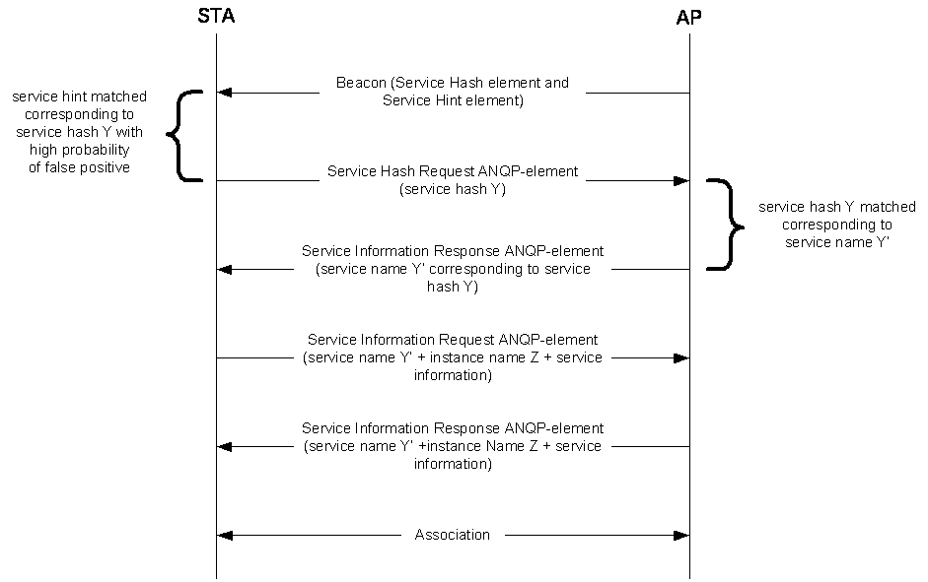

Figure W-1—Example of a frame exchange for background search with high probability of false positive (needs updating)

If the probability of false positive as indicated in False Positive Probability Range field of the Service Hint element is considered relatively low by the non-AP STA (see Figure W-2 (Example of a frame exchange for background search with low probability of false positive)), the non-AP STA can directly send a Service Information Query Request ANQP-element containing a Service Name and a Specific Service Information Query Request field to obtain more information about the service from the AP or PCP.

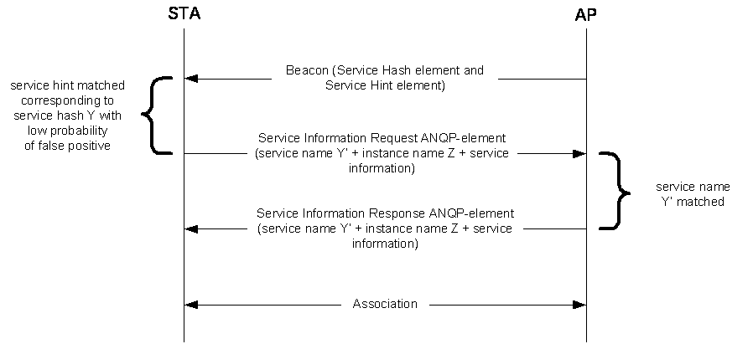

Figure W-2—Example of a frame exchange for background search with low probability of false positive

The AP or PCP responds to the ANQP request with a Service Information Response ANQP-element con- taining the service name and instance name. After the ANQP request and ANQP response exchange, the non-AP STA can obtain information on available services after associating to the AP or PCP.

In a scenario where there is a matching service hash, the non-AP STA can directly send a Service Informa- tion Request ANQP-element containing the service name and a specific Service Information Query Request to obtain more information about the service from the AP or PCP as shown in Figure W-3 (Example of frame exchange for background search with matching Service Hash element).

The AP or PCP responds to the ANQP request with a Service Information Response ANQP-element con- taining the service name, instance name and specific Service Information Query Response. After the ANQP request and ANQP response exchange, the non-AP STA can make an informed decision about choosing to associate to the AP or PCP.

Alternatively, the non-AP STA might choose to associate based on the matching Service Hash element.

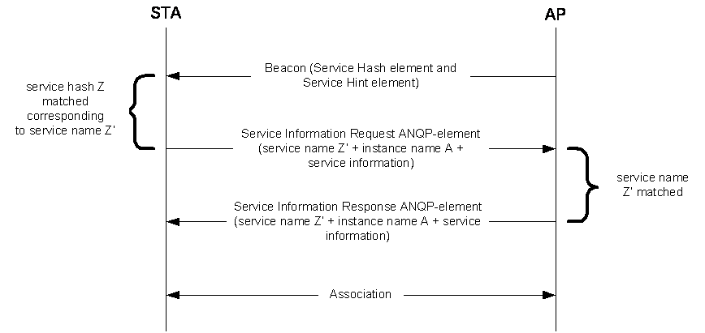

Figure W-3— Example of frame exchange for background search with matching Service Hash element

    - Immediate Search

Applications that are initiated by users (e.g., a user is looking for a fast movie download service) require immediate discovery results to be presented to the user. In this scenario, a non-AP STA performs a solicited PAD procedure, whereby the non-AP STA sends a Service Hash Request ANQP-element to query specific services immediately after user initiation of the service/application. The AP or PCP responds with a Service Information Response ANQP-element accordingly if there is a matched service (see Figure W-4 (Example of frame exchange for immediate search)). The Service Hash Request ANQP-element contains a service hash of the requested service. The AP or PCP responds with a Service Hash Response ANQP-ele- ment with a Service Hash Response Tuple subfield containing the corresponding service name and instance name. The non-AP STA then might perform a service information ANQP request and ANQP response exchange with the AP or PCP, as shown in Figure W-4 (Example of frame exchange for immediate

search), to obtain more information about the service. After the ANQP request and ANQP response exchange, the non-AP STA can make an informed decision about choosing to associate to the AP or PCP.

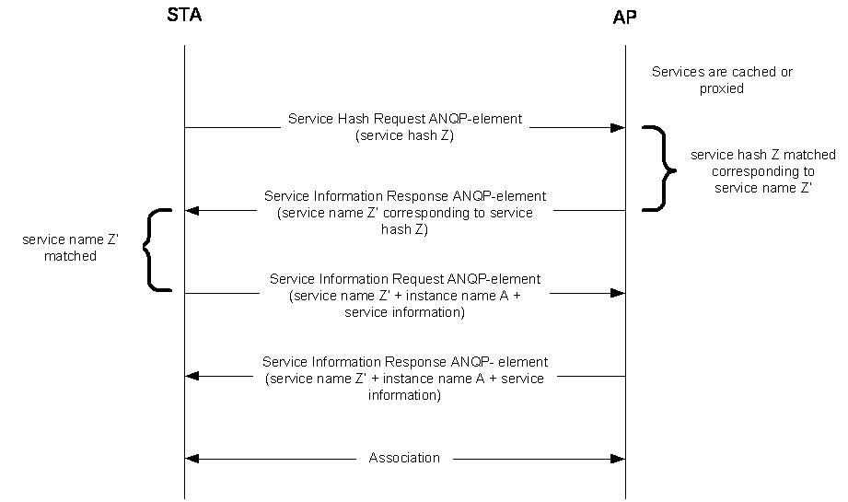

Figure W-4—Example of frame exchange for immediate search (needs updating)

