IEEE P802.11
Wireless LANs
Implementation of Channel Models for IEEE 802.11ay
Date: 11-04-2016
Author(s):
Name | Affiliation | Address | Phone | email
Yaroslav Gagiev | Intel | Turgeneva str., 30, Nizhny Novgorod, 603024, Russia | +78312969444 | yaroslav.p.gagiev@intel.com
Artyom Lomayev | Intel | Turgeneva str., 30, Nizhny Novgorod, 603024, Russia |  | artyom.lomayev@  intel.com
Alexander Maltsev | Intel | Turgeneva str., 30, Nizhny Novgorod, 603024, Russia |  | alexander.maltsev@intel.com
Felix Fellhauer | University of Stuttgart | Pfaffenwaldring 47, Stuttgart, 70569, Germany | +4971168569210 | fellhauer@inue.uni-stuttgart.de
Sven Seiler | University of Stuttgart | Pfaffenwaldring 47, Stuttgart, 70569, Germany |  | seilersv@inue.uni-stuttgart.de
Nabil Loghin | Sony ltd. Europe | Hedelfinger Str. 61, Stuttgart, 70327, Germany |  | nabil.loghin@sony.com
Abstract
Description of the source code implementing Conference Room Channel Model for IEEE 802.11ay proposed in [1].

Revision History

- November 2016 – Initial version with implementation of the conference room environment.

Source Code

The source code for Conference Room is attached below in a zip-archive.

Table of Contents

1 Channel Model Code Description 3
1.1 General Code Structure 3
1.2 Description of Data Structures Used in Channel Model 3
1.3 Directory Tree for Channel Model Source Code 10
1.4 Channel Model Test Script 12

Channel Model Code Description
This document describes a structure of the Matlab source code developed for channel model of the conference room environment and supporting all SU-MIMO configurations defined in [2].

General Code Structure
This section provides description of internal organization and partitioning on functional blocks of the conference room source code.
The functional block diagram showing general code structure and relations between different high-level functions is shown in Figure 1 below.
Figure 1. General code structure implementing Conference Room channel model
As it can be seen from the figure above, the top function cr_ch_model.m calls subsequently a function for input parameters initialization cr_ch_cfg.m, a channel impulse response generation function gen_cr_ch.m, a function implementing beamforming algorithm beamforming.m, a function digitize.m implementing analog to discrete time conversion of channel impulse response with the target sample rate, and a subroutine normalize.m implementing normalization of channel impulse response in accordance with [2].
The first function in the pipeline is the configuration function where all input channel model parameters set by user are copied into a data structure cfg. It includes the following substructures: cfg.cr contains parameters of conference room environment, cfg.bf contains beamforming settings and parameters defined in [1], and cfg.paa contains phased antenna array parameters described in [1]. Whole cfg structure is fed to the gen_cr_ch.m implementing generation of space-temporal channel impulse response realization for the conference room environment including angular, temporal, amplitude and phase characteristics. Generation of inter-cluster parameters is performed using embedded ray tracer, also it allows easily taking into account space correlation for SU-MIMO configurations. After channel impulse response generation, beamforming.m is executed implementing analog beamforming algorithm with max power ray criteria. The output of this function is a channel impulse response between the transmitter and receiver with optimally steered antenna patterns. Then channel impulse response is supplied to the digitize.m, normalize.m functions for discrete time conversion and normalization.

Description of Data Structures Used in Channel Model
This section provides a description of the configuration structure cfg, channel impulse response structure ch and the output imp_res structure used in the developed channel model.
Table 1 shows all fields of cfg structure and provides short description for every field including default values of the fields.
Table 1. Description of cfg structure fields
# | Structure Field | Field Description | Default Value
1 | cfg.Pnorm | Normalization parameter: 0 - w/o normalization, 1 - apply normalization for output channel impulse response. | 1
2 | cfg.sample_rate | Sample rate in [GHz] applied for continuous time to discrete time channel impulse response conversion. | 2.64
3 | cfg.cr | Substructure contains settings for the Conference Room channel model. | n/a
4 | cfg.bf | Substructure contains beamforming algorithm settings. | n/a

Table 2 shows all fields of cfg.cr substructure and provides short description for every field and gives default values of the fields.
Table 2. Description of cfg.cr substructure fields
# | Structure Field | Field Description | Default Value
1 | cfg.cr.ap_sp | Parameter selects subscenario, permitted values: 0 – STA-STA subscenario, 1 - STA-AP subscenario. | 0
2 | cfg.cr.D | Distance in meters between transmitter and receiver sides. Note that for the STA-AP subscenario D is set in projection to horizontal plane. | 2
3 | cfg.cr.Plos | LOS (Line-of-Sight) parameter, permitted values: 0 – corresponds to NLOS scenario, 1 – corresponds to LOS scenario. | 0
4 | cfg.cr.Psta_1st_c | Probability that the cluster is present (i.e. not blocked) for the 1st order reflections from ceiling for STA-STA subscenario. | 1
5 | cfg.cr.Psta_1st_w | Probability that the cluster is present (i.e. not blocked) for the 1st order reflections from walls for STA-STA subscenario. | 0.76
6 | cfg.cr.Psta_2nd_wc | Probability that the cluster is present (i.e. not blocked) for the 2nd order wall-ceiling (ceiling-wall) reflections for STA-STA subscenario. | 0.963
7 | cfg.cr.Psta_2nd_w | Probability that the cluster is present (i.e. not blocked) for the 2nd order reflections from walls for STA-STA subscenario. | 0.825
8 | cfg.cr.Pap_1st | Probability that the cluster is present (i.e. not blocked) for the 1st order reflections from walls for the STA-AP subscenario. | 0.874
9 | cfg.cr.Pap_2nd | Probability that the cluster is present (i.e. not blocked) for the 2nd order reflections from walls for the STA-AP subscenario. | 0.93

Table 3 shows all fields of cfg.bf substructure, provides short description for every field and gives default values of the fields.
Table 3. Description of cfg.bf substructure fields
# | Structure Field | Field Description | Default Value
1 | cfg.bf.ant_type | Antenna type, permitted values: 1 – phased antenna array with single polarization, 2 – phased antenna array with dual polarization, 3 - double phased antenna array with two streams, 4 – double phased antenna array with four streams; 5 – phased antenna array with single polarization on transmitter and dual-polarization on receiver; | 2
2 | cfg.bf.ps | Polarization support parameter: 0 – transmitter/receiver polarization vectors are not applied, 1 - polarization is applied [ used only for cfg.bf.ant_type = 1 ] | 1
3 | cfg.bf.pol | Antenna polarization type vector: 0 - linear in θ direction, 1 - linear in φ direction. First dimension corresponds to antenna polarization on transmitter side; second dimension corresponds to antenna polarization type on receiver side. | [1,0]
4 | cfg.bf.tx_pol | Antenna polarization on transmitter side: 0 - linear in θ direction, 1 - linear in φ direction. First dimension corresponds to first antenna polarization on transmitter side; second dimension corresponds to second antenna polarization type on transmitter side; [ only for cfg.bf.ant_type = 3 ] | [1,0]
5 | cfg.bf.dist_tx | Distance in meters between antennas on transmitter side; [ only for cfg.bf.ant_type = 3, 4 ] | 0.3
6 | cfg.bf.rx_pol | Antenna polarization on transmitter side: 0 - linear in θ direction, 1 - linear in φ direction. First dimension corresponds to first antenna polarization on transmitter side; second dimension corresponds to second antenna polarization type on transmitter side; [ only for cfg.bf.ant_type = 3 ] | [1,0]
7 | cfg.bf.dist_rx | Distance in meters between antennas on receiver side; [ only for cfg.bf.ant_type = 3, 4 ] | 0.3
8 | cfg.bf.paa | Substructure contains parameters for phased antenna array | n/a

Table 4 shows all fields of cfg.bf.paa substructure, provides short description for every field and gives default values of the fields.
Table 4. Description of cfg.bf.paa substructure fields
# | Structure Field | Field Description | Default Value
1 | cfg.bf.paa.Nx | Number of phased antenna array elements through X-axis | 2
2 | cfg.bf.paa.Nx | Number of phased antenna array elements through Y-axis | 8
3 | cfg.bf.paa.lyam | Wavelength | 5e-3
4 | cfg.bf.paa.dx | Distance between phased antenna array elements on X-axis | cfg.bf.paa.lyam / 2
5 | cfg.bf.paa.dy | Distance between phased antenna array elements on Y-axis | cfg.bf.paa.lyam / 2
6 | cfg.bf.paa.phi_tx | Angle of transmitter rotation in azimuth plane along LOS direction | Random from [0, 2π]
7 | cfg.bf.paa.phi_rx | Angle of receiver rotation in azimuth plane along LOS direction | Random from [0, 2π]

Tables below show all fields of ch structure and provide a short description for every field.
Table 5. Description of ch structure fields for cfg.bf.ant_type=1
# | Structure Field | Field Description
1 | ch.am | Complex amplitudes corresponding to LOS/NLOS rays existing between transmitter and receiver parts.
1 | ch.toa | Times of arrival (in [ns]) of rays calculated relatively to time of arrival of LOS component.
1 | ch.tx_az,  ch.tx_el | Transmit azimuth/elevation angles for different rays.
1 | ch.rx_az,  ch.rx_el | Receive azimuth/elevation angles for different rays.
Table 6. Description of ch structure fields for cfg.bf.ant_type=2
# | Structure Field | Field Description
1 | ch.am_11,  ch.am_12,  ch.am_21,  ch.am_22 | Complex amplitudes corresponding to LOS/NLOS rays existing between transmitter and receiver parts, where am_11, am_22 – direct links, am_21, am_22 – cross links.
1 | ch.toa | Times of arrival (in [ns]) of rays calculated relatively to time of arrival of LOS component.
1 | ch.tx_az,  ch.tx_el | Transmit azimuth/elevation angles for different rays.
1 | ch.rx_az,  ch.rx_el | Receive azimuth/elevation angles for different rays.
Table 7. Description of ch structure fields for cfg.bf.ant_type=3
# | Structure Field | Field Description
1 | ch.am_11 | Complex amplitudes corresponding to LOS/NLOS rays existing between first transmit and first receive antennas.
1 | ch.toa_11 | Times of arrival (in [ns]) of rays calculated relatively to time of arrival of LOS component between first transmit and first receive antennas.
1 | ch.tx_az_11,  ch.tx_el_11 | Transmit azimuth/elevation angles for different rays between first transmit and first receive antennas.
1 | ch.rx_az_11, ch.rx_el_11 | Receive azimuth/elevation angles for different rays between first transmit and first receive antennas.
2 | ch.am_12 | Complex amplitudes corresponding to LOS/NLOS rays existing between transmitter and receiver parts between first transmit and second receive antennas.
2 | ch.toa_12 | Times of arrival (in [ns]) of rays calculated relatively to time of arrival of LOS component between first transmit and second receive antennas.
2 | ch.tx_az_12, ch.tx_el_12 | Transmit azimuth/elevation angles for different rays between first transmit and second receive antennas.
2 | ch.rx_az_12,  ch.rx_el_12 | Receive azimuth/elevation angles for different rays between first transmit and second receive antennas.
3 | ch.am_21 | Complex amplitudes corresponding to LOS/NLOS rays existing between second transmit and first receive antennas.
3 | ch.toa_21 | Times of arrival (in [ns]) of rays calculated relatively to time of arrival of LOS component between second transmit and first receive antennas.
3 | ch.tx_az_21,  ch.tx_el_21 | Transmit azimuth angles for different rays between second transmit and first receive antennas.
3 | ch.rx_az_21,  ch.rx_el_21 | Receive azimuth/elevation angles for different rays between second transmit and first receive antennas.
4 | ch.am_22 | Complex amplitudes corresponding to LOS/NLOS rays existing between second transmit and second receive antennas.
4 | ch.toa_22 | Times of arrival (in [ns]) of rays calculated relatively to time of arrival of LOS component between second transmit and second receive antennas.
4 | ch.tx_az_22,  ch.tx_el_22 | Transmit azimuth/elevation angles for different rays between second transmit and second receive antennas.
4 | ch.rx_az_22,  ch.rx_el_22 | Receive azimuth/elevation angles for different rays between second transmit and second receive antennas.
Table 8. Description of ch structure fields for cfg.bf.ant_type=4
# | Structure Field | Field Description
1 | ch.am_11vv,  ch.am_11vh,  ch.am_11hv,  ch.am_11hh | Complex amplitudes corresponding to LOS/NLOS rays existing between first transmit and first receive antennas for different polarizations.
1 | ch.toa_11 | Times of arrival (in [ns]) of rays calculated relatively to time of arrival of LOS component between first transmit and first receive antennas.
1 | ch.tx_az_11,  ch.tx_el_11 | Transmit azimuth/elevation angles for different rays between first transmit and first receive antennas.
1 | ch.rx_az_11,  ch.rx_el_11 | Receive azimuth/elevation angles for different rays between first transmit and first receive antennas.
2 | ch.am_12vv,  ch.am_12vh,  ch.am_12hv,  ch.am_12hh | Complex amplitudes corresponding to LOS/NLOS rays existing between first transmit and second receive antennas for different polarizations.
2 | ch.toa_12 | Times of arrival (in [ns]) of rays calculated relatively to time of arrival of LOS component between first transmit and second receive antennas.
2 | ch.tx_az_12,  ch.tx_el_12 | Transmit azimuth/elevation angles for different rays.
2 | ch.rx_az_12,  ch.rx_el_12 | Receive azimuth/elevation angles for different rays.
3 | ch.am_21vv,  ch.am_21vh,  ch.am_21hv,  ch.am_21hh | Complex amplitudes corresponding to LOS/NLOS rays existing between second transmit and first receive antennas for different polarizations.
3 | ch.toa_21 | Times of arrival (in [ns]) of rays calculated relatively to time of arrival of LOS component between second transmit and first receive antennas.
3 | ch.tx_az_21,  ch.tx_el_21 | Transmit azimuth/elevation angles for different rays between second transmit and first receive antennas.
3 | ch.rx_az_21,  ch.rx_el_21 | Receive azimuth/elevation angles for different rays between second transmit and first receive antennas.
4 | ch.am_22vv,  ch.am_22vh,  ch.am_22hv,  ch.am_22hh | Complex amplitudes corresponding to LOS/NLOS rays existing between second transmit and second receive antennas for different polarizations.
4 | ch.toa_22 | Times of arrival (in [ns]) of rays calculated relatively to time of arrival of LOS component between second transmit and second receive antennas.
4 | ch.tx_az_22,  ch.tx_el_22 | Transmit azimuth/elevation angles for different rays between second transmit and second receive antennas.
4 | ch.rx_az_22,  ch.rx_el_22 | Receive azimuth/elevation angles for different rays between second transmit and second receive antennas.
Table 9. Description of ch structure fields for cfg.bf.ant_type=5
# | Structure Field | Field Description
1 | ch.am_11,  ch.am_12, | Complex amplitudes corresponding to LOS/NLOS rays existing between transmitter and receiver parts.
1 | ch.toa | Times of arrival (in [ns]) of rays calculated relatively to time of arrival of LOS component.
1 | ch.tx_az,  ch.tx_el | Transmit azimuth/elevation angles for different rays.
1 | ch.rx_az,  ch.rx_el | Receive azimuth/elevation angles for different rays.

Tables show all fields of imp_res structure and provide a short description for every field.
Table 10. Description of imp_res structure fields for cfg.bf.ant_type=1, 2
# | Structure Field | Field Description
1 | imp_res.h11, imp_res.h12,  imp_res.h21,  imp_res.h22 | Complex amplitudes corresponding to LOS/NLOS rays existing between transmitter and receiver parts with dual-polarization.
1 | imp_res.toa_11 | Times of arrival (in [ns]) of rays calculated relatively to time of arrival of LOS component.
Table 11. Description of imp_res structure fields for cfg.bf.ant_type=3
# | Structure Field | Field Description
1 | imp_res.h11 | Complex amplitudes corresponding to LOS/NLOS rays existing between first transmit and first receive antennas.
1 | imp_res.toa_11 | Times of arrival (in [ns]) of rays calculated relatively to time of arrival of LOS component.
2 | imp_res.h12 | Complex amplitudes corresponding to LOS/NLOS rays existing between first transmit and second receive antennas.
2 | imp_res.toa_12 | Times of arrival (in [ns]) of rays calculated relatively to time of arrival of LOS component.
3 | imp_res.h21 | Complex amplitudes corresponding to LOS/NLOS rays existing between second transmit and first receive antennas.
3 | imp_res.toa_21 | Times of arrival (in [ns]) of rays calculated relatively to time of arrival of LOS component.
4 | imp_res.h22 | Complex amplitudes corresponding to LOS/NLOS rays existing between second transmit and second receive antennas.
4 | imp_res.toa_22 | Times of arrival (in [ns]) of rays calculated relatively to time of arrival of LOS component.
Table 12. Description of imp_res structure fields for cfg.bf.ant_type=4
# | Structure Field | Field Description
1 | imp_res.h11, imp_res.h12,  imp_res.h21,  imp_res.h22 | Complex amplitudes of direct links corresponding to LOS/NLOS rays existing between first transmit and first receive antennas.
1 | imp_res.toa_11 | Times of arrival (in [ns]) of rays calculated relatively to time of arrival of LOS component.
2 | imp_res.h13, imp_res.h14,  imp_res.h23,  imp_res.h24 | Complex amplitudes of cross links corresponding to LOS/NLOS rays existing between first transmit and second receive antennas.
2 | imp_res.toa_12 | Times of arrival (in [ns]) of rays calculated relatively to time of arrival of LOS component.
3 | imp_res.h31, imp_res.h32,  imp_res.h41,  imp_res.h42 | Complex amplitudes of cross links corresponding to LOS/NLOS rays existing between second transmit and first receive antennas.
3 | imp_res.toa_21 | Times of arrival (in [ns]) of rays calculated relatively to time of arrival of LOS component.
4 | imp_res.h33, imp_res.h34,  imp_res.h43,  imp_res.h44 | Complex amplitudes of direct links corresponding to LOS/NLOS rays existing between second transmit and second receive antennas
4 | imp_res.toa_22 | Times of arrival (in [ns]) of rays calculated relatively to time of arrival of LOS component.
Table 13. Description of imp_res structure fields for cfg.bf.ant_type=5
# | Structure Field | Field Description
1 | imp_res.h11, imp_res.h12 | Complex amplitudes corresponding to LOS/NLOS rays existing between transmitter and receiver parts for two polarizations.
1 | imp_res.toa_11 | Times of arrival (in [ns]) of rays calculated relatively to time of arrival of LOS component.

Directory Tree for Channel Model Source Code
The directory tree and all files for the channel model source code are shown in Figure 2.
Figure 2. Directory tree for the channel model source code
To start up channel simulations it is necessary to run startup.m script. This script adds the specified in Figure 2 directories to the top of the current Matlab search path and changes current directory to /work folder. After that the cr_ch_model.m function may be used to generate channel impulse response realizations.

Channel Model Test Script
The /work folder contains also cr_test.m file developed for a simple check that the channel model functions works correctly. Figure 3 shows example of the figures obtained by running cr_test.m, script with default settings of the configuration files for initial seed = 1 in randn/rand generators (Matlab 8.4.0 R2014b).

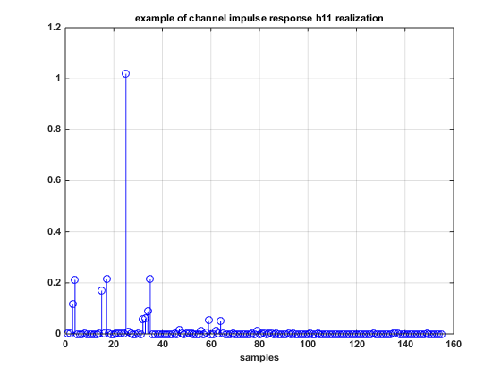 (a) H₁₁ | 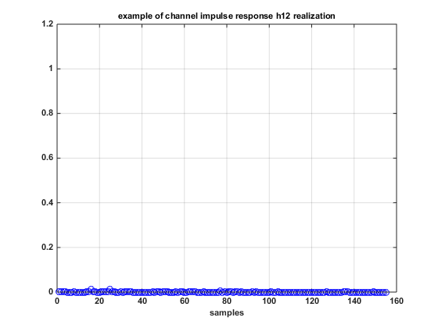 (b) H₁₂
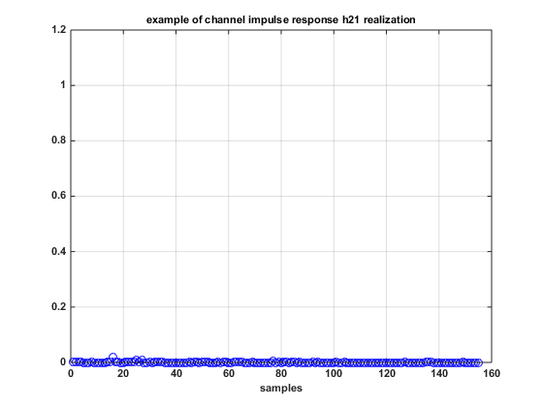 (c) H₂₁ | 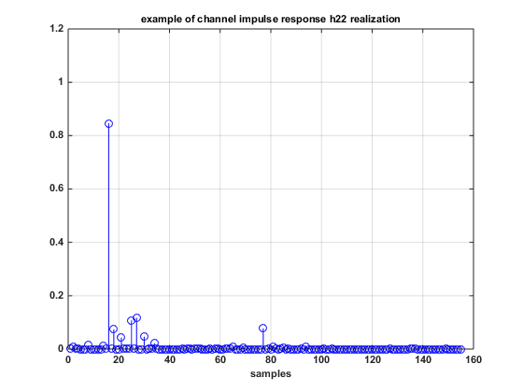 (d) H₂₂
Figure 3. Example of the figure obtained by running cr_test.m script with cfg.bf.ant_type=2

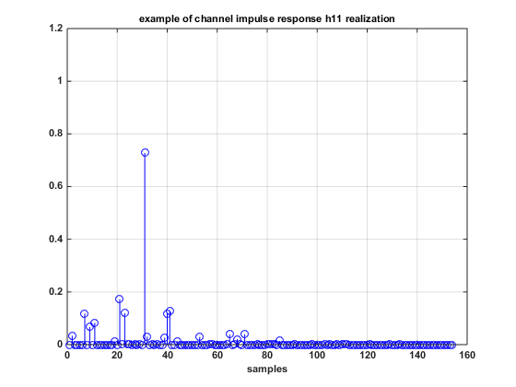 (a) H₁₁ | 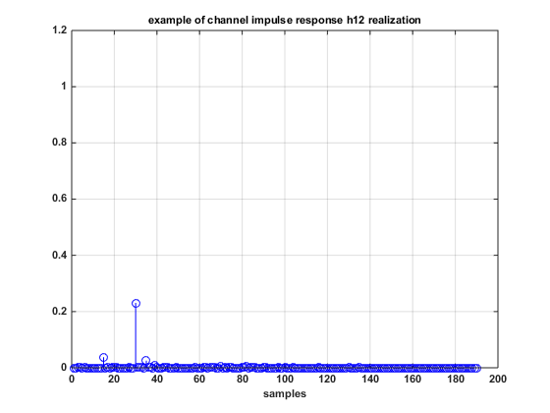 (b) H₁₂
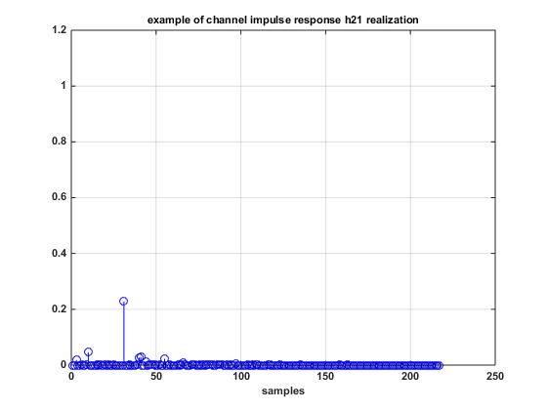 (c) H₂₁ | 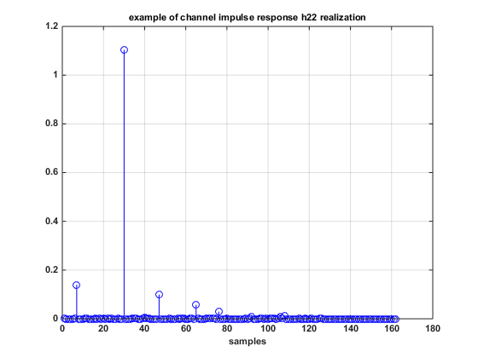 (d) H₂₂
Figure 4. Example of the figure obtained by running cr_test.m script with cfg.bf.ant_type=3

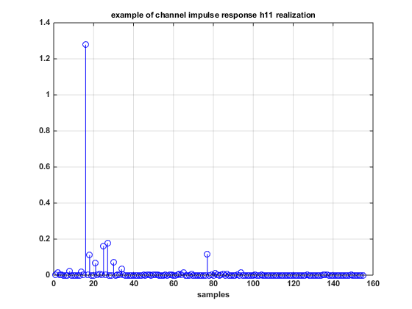 (a) H₁₁ | 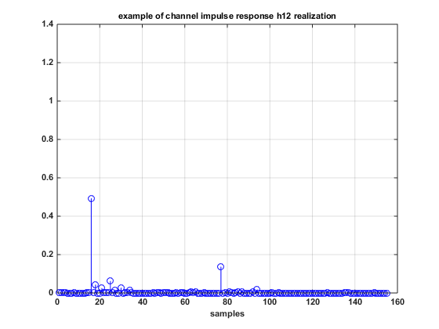 (b) H₁₂
Figure 5. Example of the figure obtained by running cr_test.m script with cfg.bf.ant_type=5
References
- A. Maltsev et al. “Channel Models for IEEE 802.11ay,” IEEE doc. 802.11-15/1150r6, Sept., 2015.
- L. Cariou, “11ay Evaluation Methodology,” IEEE doc. 802.11-15/866r4, July, 2015.

