IEEE P802.11
Wireless LANs
Proposed resolutions to comments on clause 26.3.10.15
Date: 2016-09-12
Author(s):
Name | Company | Address | Phone | email
Meilu Lin | Huawei Technologies | F1-17-A011S, Huawei Base, Bantian, Longgang, Shenzhen, Guangdong, China, 518129 | +86  18118760148 | linmeilu@huawei.com
Richard Yun Liu | Huawei Technologies | F1-17-A011S, Huawei Base, Bantian, Longgang, Shenzhen, Guangdong, China, 518129 | +86 13581632082 | liuyun5@huawei.com
Ross Jian Yu | Huawei Technologies |  |  | ross.yujian@huawei.com
Yan Zhang | Marvel
Abstract
This submission contains proposed comment resolutions to comments on D0.1.

The comments assigned to the Richard and Meilu Lin in Clause 26.3.10.15 are:
336, 1459, 2100, 2101, 2102, 2104, 2105, 2135, 2568, 2569, 2570, 2571, 2573, 1414, 1626.

The resolutions proposed in this document are marked with green.

The changes marked in this document are based on TGax Draft 0.1, the corresponding page and line is also given in D0.4.

Revision Notes

R0 | Initial revision

Comments for Clause 26.3.10.15

CID 1626

CID | Page.  Line | Clause Number | Comment | Proposed Change | Comment Group
1626 |  |  | a-factor is sometimes italicised and sometimes quoted | Italicise everywhere, never quote | Accepted

Note to the editor that the changes need to go across the whole spec

CID 2100 & 2101
CID | Page.  Line | Clause Number | Comment | Proposed Change | Comment Group
2100 | 151.60 | 26.3.10.15 | Average power of Packet extension | "same average power as the Data field". Is this just supposed to be transmit power, or should beamforming properties (if any) also be similar to the Data field? | REVISED.  Reason: The beamforming vector can be the same but doesn’t need to be the same. Can just leave it as implementation specific.  Instruction to Editor:  Please make the following changes in TGax D0.1 P151 L57(D0.4 P220, L6) under subclause 26.3.10.15according to the changes in doc 16-1150r3
2101 | 151.60 | 26.3.10.15 | Frequency content of Packet extension | "content is arbitary". The Data Field will only have power in "active" RUs. Shouldn't the same be true for the packet extension? | REVISED.  Reason: PE is supposed to be discarded by Rx anyway. Doesn’t have to be within that RU. Furthermore, since the spec already specifies the content is arbitrary, hence the TBD is deleted.  Instruction to Editor:  Refer to the resolution of CID 2100 in doc 16-1150r3

Instruction to Editor:
Please make the following changes in TGax D0.1 P151 L57 under subclause 26.3.10.15
A HE PPDU may have a Packet Extension (PE) field appended at the end of the PPDU, with possible durations being 0µs, 4µs, 8µs, 12µs, or 16µs. The PE field, when present, shall betransmitted with the same average power as the Datafield, and its content is arbitrary (PE content TBD).

CID 1459 & 2569 & 1414

CID | Page.  Line | Clause Number | Comment | Proposed Change | Comment Group
1459 | 152.01 | 26.3.10.15 | Text says 'Maximum PE capabilities' (2x) but there is no such field in 9.4.2.213. Additionally, p. 32 uses the term 'minimum duration' for PE. | Modify text to say just 'PE capabilities' | REVISED.  Agree on the need to change, use PPE thresholds for consistency  Instruction to Editor:  Please make the following changes in TGax D0.1 P151 L62(D0.4 P220 L8) under subclause 26.3.10.15 according to the changes in doc 16-1150r3
2569 | 152.01 | 26.3.10.15 | Correct name is "PPE Thresholds". | Change "Maximum PE capabilities" to "PPE Thresholds" on P152L1, P152L4 (and probably more places). Also update the Figure labels for Figures 26-34 and 26-35. | REVISED.  Instruction to Editor:  Refer to the resolution of CID 1459 in doc 16-1150r3
1414 | 152.04 |  | "as defined by the Maximum PE capabilities" -- there is no such subfield | Refer to a subfield that exists | REVISED.  Instruction to Editor:  Refer to the resolution of CID 1459 in doc 16-1150r3

Instruction to Editor:
Please make the following changes in TGax D0.1 P151 L62 under subclause 26.3.10.15
The PE field is applied for the recipient of the PPDU to obtain longer processing time at the end of a HE PPDU, and its duration is determined by both the a-factor value in the last OFDM symbol(s) of the Data field, and the maximum PE duration requested by the recipient for the signal bandwidth (or RU size), the number of spatial streams, and the constellation size of the current PPDU, which is based on the Maximum PE capabilities PPE thresholds as defined in HE capabilities field (9.4.2.213 (HE Capabilities Element)).

For a HE PPDU, the maximum PE durations as defined by the Maximum PE capabilities by PPE Thresholds in HE capabilities (9.4.2.213 (HE Capabilities Element)) are 0 µs, 8 µs and 16 µs.

CID 2102

CID | Page.  Line | Clause Number | Comment | Proposed Change | Comment Group
2102 | 152.05 | 26.3.10.15 | The requirements on packet Extension should be spelled out in text. | A mandatory requirement should not be contained only in a Figure. The requirement needs to be written out explicitly. | REJECTED.  Reason: The requirements on packet extension are clearly spelled in Page 152~153 and Eqn. (26-112) of D0.1.

CID 2568 & 2570 & 2573 & 2751
CID | Page.  Line | Clause Number | Comment | Proposed Change | Comment Group
2568 | 151.64 | 26.3.10.15 | What the recipient requests is the 'minimum' PE druation, not the 'maximum'. | Change "maximum PE duration" to "minimum PE duration" on P151L64, P152L4, P152L7, ... (too many places...) | REJECTED  Reason: It should be the maximum PE. The maximum PE duration will decide the meaning of a_factor. 8 μs maximum PE duration means that a PE field of 0 μs, 0 μs, 4 μs, and 8 μs are appended at the end of the PPDU, corresponding to a-factor being 1, 2, 3 and 4, respectively.A 16 μs maximum PE duration means that a PE field of 4 μs, 8 μs, 12 μs, and 16 μs are appended at the end of the PPDU, corresponding to a-factor being 1, 2, 3 and 4, respectively.
2570 | 152.07 | 26.3.10.15 | The PPE Threshold indicates the 'minimum' Post-FEC padding + PE the receiver needs. See 25.12 (P66L27) "... the transmitting STA shall include a packet extension that yields a total post-FEC padding plus packet extension that corresponds to AT LEAST the value indicated in the HE Capabilities element received from the receiving STA." | Change "A 0 ╬╝s maximum PE duration means no PE is present" to "A 0 usec PPE Threshold means the receiver does not require PE". Change "A 8 ╬╝s maximum PE duration means that a PE field of 0 ╬╝s, 0 ╬╝s, 4 ╬╝s, and 8 ╬╝s are appended at the end of the PPDU, corresponding to a-factor being 1, 2, 3 and 4, respectively." to " A 8 usec PPE Threshold means that the receiver requires PE duration of at least 0 usec, 0 usec, 4 usec and 8 usec for a-factors of 1, 2, 3 and 4, respectively" Change "A 16 ╬╝s maximum PE duration means that a PE field of 4 ╬╝s, 8 ╬╝s, 12 ╬╝s, and 16 ╬╝s are appended at the end of the PPDU, corresponding to a-factor being 1, 2, 3 and 4, respectively" to "A 16 usec PPE Threshold means that the receiver requires PE duration of at least 4 usec, 8 usec, 12 usec and 16 usec for a-factors of 1, 2, 3 and 4, respectively" | REJECTED  Reason: The concept of the maximum PE duration is different from that of PPE threshold. The PPE threshold is the minimum maximum total duration of the post-FEC padding and packet extension requirement for an HE PPDU transmitted to this STA using the constellation index = x, NSS = n and RU = m.
2573 | 152.07 | 26.3.10.15 | The PPE Threshold indicates the 'minimum' Post-FEC padding + PE the receiver needs. See 25.12 (P66L27) "... the transmitting STA shall include a packet extension that yields a total post-FEC padding plus packet extension that corresponds to AT LEAST the value indicated in the HE Capabilities element received from the receiving STA." | Change "A 0 ╬╝s maximum PE duration means no PE is present" to "A 0 usec PPE Threshold means the receiver does not require PE". Change "A 8 ╬╝s maximum PE duration means that a PE field of 0 ╬╝s, 0 ╬╝s, 4 ╬╝s, and 8 ╬╝s are appended at the end of the PPDU, corresponding to a-factor being 1, 2, 3 and 4, respectively." to " A 8 usec PPE Threshold means that the receiver requires PE duration of at least 0 usec, 0 usec, 4 usec and 8 usec for a-factors of 1, 2, 3 and 4, respectively" Change "A 16 ╬╝s maximum PE duration means that a PE field of 4 ╬╝s, 8 ╬╝s, 12 ╬╝s, and 16 ╬╝s are appended at the end of the PPDU, corresponding to a-factor being 1, 2, 3 and 4, respectively" to "A 16 usec PPE Threshold means that the receiver requires PE duration of at least 4 usec, 8 usec, 12 usec and 16 usec for a-factors of 1, 2, 3 and 4, respectively" | REJECTED  Reason: The concept of the maximum PE duration is different from that of PPE threshold. The PPE threshold is the maximum total duration of the post-FEC padding and packet extension requirement for an HE PPDU transmitted to this STA using the constellation index = x, NSS = n and RU = m.
2571 | 153.04 | 26.3.10.15 | Change "AP shall choose the largest PE duration among all users" to "AP shall choose a PE duration which is at least as long as the longest PE duration required among all users". | Change "AP shall choose the largest PE duration among all users" to "AP shall choose a PE duration which is at least as long as the longest PE duration required among all users". Also, update Equation (26-112) to "TPE >= max_u (TPE,u)" | REJECTED  Reason: From the efficiency perspective, there is no need to choose PE duration larger than the largest PE duration among all users. Since with the largest PE duration, all users will have sufficient processing time at the end of a HE PPDU.

CID 2135 & 2104
CID | Page.  Line | Clause Number | Comment | Proposed Change | Comment Group
2135 | 153.17 | 26.3.10.15 | Method of communicating packet extension not fully consistent with 9.3.1.23 or other frame types. 9.3.1.23 states LSIG length is sent, which doesn't require communicating T_PE, but disambiguation bit instead. Would also be consistent with non-triggered frame types. | Change T_PE to disambiguation bit. | REVISED  Modified with more details  Instruction to Editor:  Please make the following changes in TGax D0.1 P153 L15 D0.4 (P221 L40) under subclause 26.3.10.15according to the changes in doc 16-1150r3
2104 | 153.18 | 26.3.10.15 | TBD | Define | REVISED  Further add notes for explanation  Instruction to Editor:  Refer to the resolution of CID 2135 in doc 16-1150r3

Instruction to Editor:
Please make the following changes in TGax D0.1 P153 L15 under subclause 26.3.10.15
For an HE trigger-based PPDU, the AP indicates the common PE duration, TPE, for all the users in the Trigger frame. The value of TPE is TBD. the AP provides the packet extension duration information by the Packet Extension subfield, for all the users in the Trigger frame. The first two bits in the Packet Extension subfield indicate the “a-factor” and the third bit indicates the PE-Disambiguity. Each user, when responding the Trigger frame with an HE trigger-based PPDU, shall append PE field at the end of the current HE trigger-based PPDU, with a duration T_{PE}. The value of TPE is TBD. The value of T_{PE} can be calculated using the “Length” and the “Packet Extension” subfields of the Common Info field in trigger frame.
Where
LENGTH is the value indicated by “Length” subfield
is the third bit in the “Packet Extension” subfield of the Common Info field in trigger frame.
are defind in Table 26-3.

CID 2105 & 336
CID | Page.  Line | Clause Number | Comment | Proposed Change | Comment Group
2105 | 153.61 | 26.3.10.15 | "-20" is not needed in (26-113) | 20 is divisible by 4, so will always disappear in the subtraction. Formula can be simplified to T_PE + 4*ceil(TXTIME/4)-TXTIME >= T_SYM | REVISED.  Modified with details  Instruction to Editor:  Please make the following changes in TGax D0.4 P222 L24 under subclause 26.3.12 Packet extension, D0.4 P240 L55 under subclause 26.3.19 HE receive procedure according to the changes in doc 16-1150r3
336 | 154.06 | 26.3.10.15 | Equations on how to compute Nsym and Tpe at the recipient side are not provided. This could lead to ambiguity on how the Nsym and Tpe values are computed | Provide equatons for computing Nsym and Tpe at the receiver whtn the PE disambiguity bit is set or not. It is important to clarify how the disambiguity bit resolves the values. | REVISED.  Further add notes for explanation  Instruction to Editor:  Refer to the resolution of CID 2105 in doc 16-1150r3

Instruction to Editor:
Please make the following changes in TGax D0.4 P222 L24 under subclause 26.3.12 Packet extension
The PE Disabmbituity subfield of the Packet Extension field shall be set to 1 if the condition in Equation (26-113) is met, otherwise it shall be set to 0.

Where
is the PE field duration
is the symbol duration of the Data field as defined in 26.3.6 (Timing-related parameters)
TXTIME (in µs) is defined in 26.4.3 (TXTIME and PSDU_LENGTH calculation).

Based on PE disambiguity field and a-factor field, the recipient shall compute N_{SYM} and T_{PE} listed in 26.3.15 using Equation (26-120) for an HE SU PPDU and HE trigger-based PPDU, Equation (26-121) for an HE MU PPDU and Equation (26-122) for an HE extended range SU PPDU.

(26-120)

(26-121)

(26-122)

Where
are defind in Table 26-3.
are defined in Table 26-6.
is the PE disambiguity bit mentioned in Table 26-36.

Please make the following changes in TGax D0.4 P240 L55 under subclause 26.3.19 HE receive procedure

Except in an HE NDP PPDU, a Data field follows the HE-STF and HE-LTF fields. Based on PE disambiguity field and a-factor field, the recipient shall compute N_{SYM} and T_{PE} listed in 26.3.15 using Equation (26-120) for an HE SU PPDU and HE trigger-based PPDU, Equation (26-121) for an HE MU PPDU and Equation (26-122) for an HE extended range SU PPDU (See subclause 26.3.12 Packet extension).

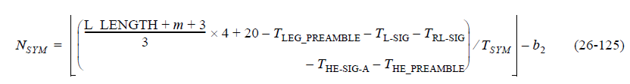
The number of symbols in Data field is determined by Equation (26-126) for HE extended range SU PPDU.
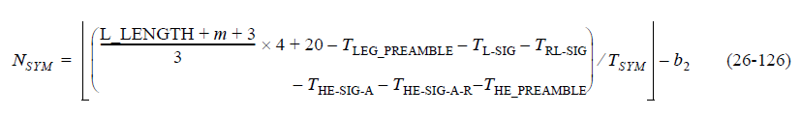
The number of symbols in Data field is determined by Equation (26-127) for HE MU PPDU.
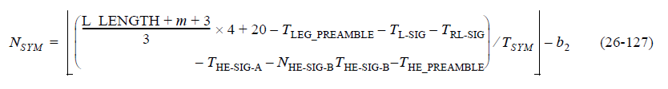
The PE field duration for an HE SU PPDU and HE trigger-based PPDU is determined by Equation (26-128).
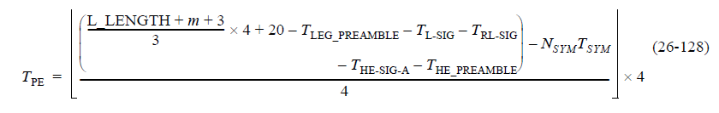
The PE field duration for an HE extended range SU PPDU is determined by Equation (26-129).
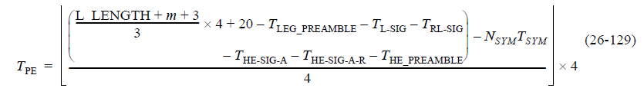
The PE field duration for an HE MU PPDU is determined by Equation (26-130).
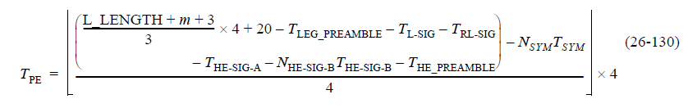

where L_LENGTH is the LENGTH field in L-SIG; b2 indicates PE disambiguity in packet extension field in HE-SIG-A.

