IEEE P802.11
Wireless LANs
Annex W Resolution
Date: 2016-07-26
Author(s):
Name | Company | Address | Phone | email
Stephen McCann | BlackBerry Ltd | 200 Bath Road, Slough, Berkshire, SL1 3XE, UK | +44 1753 667099 | smccann@blackberry.com
Abstract
This document proposes text changes to update the P802.11aq draft Annex W for the following LB 221 CIDs:

4015

Annex W

(informative)

W.1 Pre-association discovery usage scenarios

The Pre-association discovery (PAD) and Service information procedures (see 11.25a (Pre-association discovery (PAD) procedures) and 11.25.3.2.16 (Service information procedure)) support several ways of obtaining service information. The following subclauses describe two methods: background search and immediate search.

W.1.1 Background Search

Applications that run in the background (e.g., automatically receiving sales coupons that a user has previ- ously signed up for) might not require immediate discovery results to be presented to the user. It may be appropriate to prevent non-AP STAs, running such background applications, from performing a solicited PAD search. Furthermore, a solicited PAD search in a dense WLAN environment can cause network con- gestion. In that case, it is more effective to perform an unsolicited PAD search, in which an AP or PCP advertises multiple services known to the SIR, while non-AP STAs need respond only if there is a matched service.

The AP or PCP can elect to advertise several services using the Service Hash element, and advertise remaining services using the Service Hint element, in the Beacon or DMG Beacon. Alternatively, the AP or PCP can elect to advertise all of the services using either the Service Hash or Service Hint element in the Beacon or DMG Beacon. Upon receiving a Beacon or DMG Beacon, a non-AP STA processes the Service Hash and Service Hint elements to verify if there are any potential matching services. Figure W-1 (Example of a frame exchange for background search with high probability of false positive) and Figure W-2 (Example of a frame exchange for background search with low probability of false positive) show two cases where there is a matching Service Hint.

If the probability of false positives as indicated in the False Positive Probability Range field of the Service Hint element is considered relatively high by the non-AP STA (see Figure W-1 (Example of a frame exchange for background search with high probability of false positive)), the non-AP STA can send a Ser- vice Hash Request ANQP-element to confirm if the service is reachable through the AP or PCP. The AP or PCP then responds with a Service Information Response ANQP-element that contains the corresponding Service Name and Instance Name fields.

The non-AP STA can then send a Service Information Request ANQP-element containing the Service Name, Instance Name and specific Service Information Query to obtain more information about the service from the AP or PCP. The AP or PCP responds to the ANQP request with the ANQP response with Service Information Response ANQP-element containing the Service Name, Instance Name and specific Service Information Query Response fields. After the ANQP request and ANQP response exchange, the non-AP STA may obtain more information on available services after it associates to the AP or PCP.

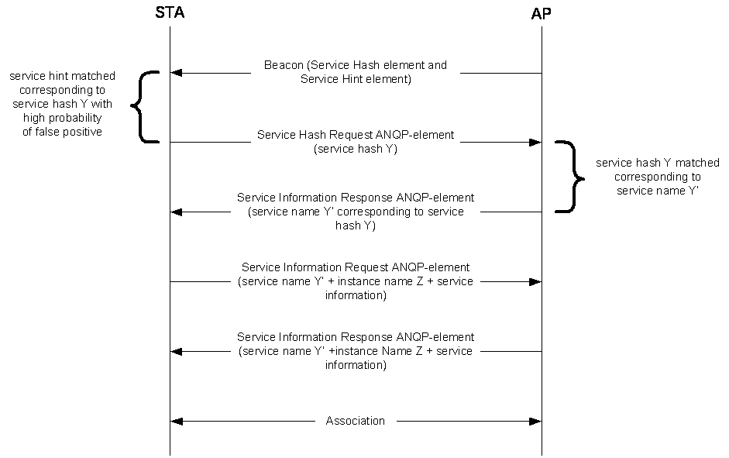

Figure W-1—Example of a frame exchange for background search with high probability of false positive

If the probability of false positive as indicated in False Positive Probability Range field of the Service Hint element is considered relatively low by the non-AP STA (see Figure W-2 (Example of a frame exchange for background search with low probability of false positive)), the non-AP STA can directly send a Service Information Query Request ANQP-element containing a Service Name and a Specific Service Information Query Request field to obtain more information about the service from the AP or PCP.

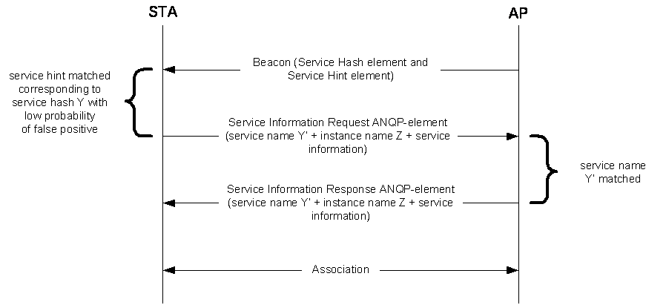

Figure W-2—Example of a frame exchange for background search with low probability of false positive

The AP or PCP responds to the ANQP request with a Service Information Response ANQP-element containing the service name and instance name. After the ANQP request and ANQP response exchange, the non-AP STA can obtain information on available services after associating to the AP or PCP.

In a scenario where there is a matching service hash, the non-AP STA can directly send a Service Information Request ANQP-element containing the service name and a specific Service Information Query Request to obtain more information about the service from the AP or PCP as shown in Figure W-3 (Example of frame exchange for background search with matching Service Hash element).

The AP or PCP responds to the ANQP request with a Service Information Response ANQP-element containing the service name, instance name and specific Service Information Query Response. After the ANQP request and ANQP response exchange, the non-AP STA can make an informed decision about choosing to associate to the AP or PCP.

Alternatively, the non-AP STA might choose to associate based on the matching Service Hash element.

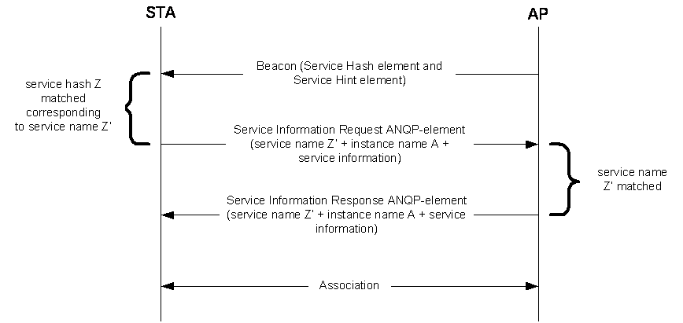

Figure W-3— Example of frame exchange for background search with matching Service Hash element

W.1.2 Immediate Search

Applications that are initiated by users (e.g., a user is looking for a fast movie download service) require immediate discovery results to be presented to the user. In this scenario, a non-AP STA performs a solicited PAD procedure, whereby the non-AP STA sends a Service Hash Request ANQP-element to query specific services immediately after user initiation of the service/application. The AP or PCP responds with a Service Information Response ANQP-element accordingly if there is a matched service (see Figure W-4 (Example of frame exchange for immediate search)). The Service Hash Request ANQP-element contains a service hash of the requested service. The AP or PCP responds with a Service Information Response ANQP-element with a Service Information Response Tuple subfield containing the corresponding service name and instance name. The non-AP STA then might perform a service information ANQP request and ANQP response exchange with the AP or PCP, as shown in Figure W-4 (Example of frame exchange for immediate search), to obtain more information about the service. After the ANQP request and ANQP response exchange, the non-AP STA can make an informed decision about choosing to associate to the AP or PCP.

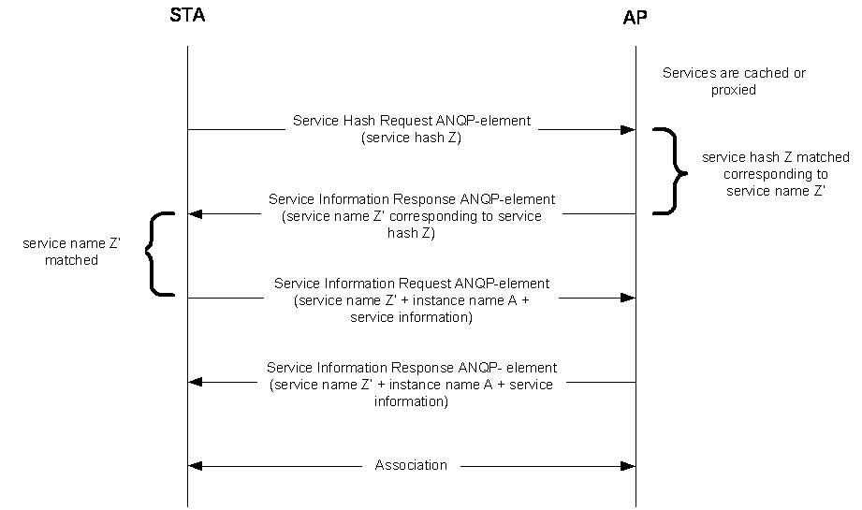

Figure W-4—Example of frame exchange for immediate search

