IEEE P802.11  
Wireless LANs

|  |  |  |  |  |
| --- | --- | --- | --- | --- |
| CID 8020, 8025, 8026 resolution text 64-QAM non-uniform constellation for SC DMG | | | | |
| Date: 2016-07-15 | | | | |
| Author(s): | | | | |
| Name | Affiliation | Address | Phone | Email |
| Thomas Handte | Sony Europe Ltd. | Hedelfinger Str. 61, 70327 Stuttgart, Germany | +49-711-5858-236 | thomas.handte@eu.sony.com |
|  |  |  |  |  |

Abstract

This contribution is provided as possible resolution of CID 8020, 8025, 8026.

This submission proposes to modify the 64-QAM constellation. A *single* non-uniform constellation is proposed which can achieve significant gains for all code rates.

The changes are relative to Draft P802.11REVmc_D6.0 [1].

## Comments

|  |  |  |  |  |  |
| --- | --- | --- | --- | --- | --- |
| 8020 | 3163.50 |  | (Submitted for Thomas Handte)  Receive sensitivity requirements of all 64-QAM MCS exceed the maximum of OFDM. Coverage of 64-QAM is too low. Those MCSs will likely be never selected. | Consider non-uniform constellation for 64-QAM. Detailed comment resolution will be provided. | GEN |
| 8025 | 2475.01 |  | (Submitted for Thomas Handte) 64-QAM can not meet FER requirements with phase noise model of TGad and TGay | Consider non-uniform constellation for 64-QAM. Detailed comment resolution will be provided. | GEN |
| 8026 | 2477.15 |  | (Submitted for Thomas Handte)  Tx EVM requirements of all 64-QAM MCS exceed the maximum EVM requirement of OFDM. Implementation burden of 64-QAM is too high. | Consider non-uniform constellation for 64-QAM. Detailed comment resolution will be provided. | GEN |

## Discussion

The current text in draft 6.0 of REVmc defines in subclause 20.6.3.2.4.5 entitled “π/2-64QAM modulation” a rectangular uniform constellation for 64-QAM.

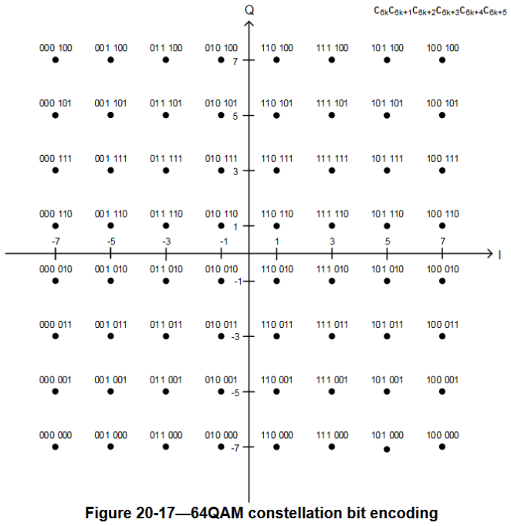

The FER performance of the uniform constellation (UC) is limited. In particular, it requires a significantly high SNR in presence of strong phase noise as it has been defined in the 11ad/11ay evaluation methodology. Thus, receiver architectures are required to implement advanced phase noise mitigation algorithms in order to achieve reasonable FER for low SNR.

For this reason, we provide a *single* non-uniform constellation (NUC) which can provide both a shaping gain and a peak-to-average power gain. Both can reduce requirements on transmitter and receiver side and simplify RF frontend implementation.

**Performance summary (detailed analysis see below)**

The proposed non-uniform constellation provides:

* Single constellation for all code rates
* SNR gain between 0.1 and 0.3dB in AWGN channel and up to 3dB in presence of phase noise.
* Progressive SNR gain, i.e. the stronger the impairment, the greater the SNR gain. This means that the NUC is more robust as the UC.
* Peak power gain of 0.6dB.
* A moderate but manageable increase in demapper complexity.

## Proposed changes:

*All changes are in reference to D6.0 [1]*

**20.6.3.2.4.5 π/2-64QAM modulation**

In π/2-64QAM modulation, the input bit stream is grouped in sets of 6 bits and mapped according to the following table:

|  |  |
| --- | --- |
| (c6k+2, c6k+3, c6k+4, c6k+5) |  |
| (0, 0, 0, 0) | (1-2c6k)1.0997 +j(2c6k+1-1)0.5419 |
| (0, 0, 0, 1) | (1-2c6k)0.1440 +j(2c6k+1-1)0.4167 |
| (0, 0, 1, 0) | (1-2c6k)0.7484 +j(2c6k+1-1)0.4663 |
| (0, 0, 1, 1) | (1-2c6k)0.4369 +j(2c6k+1-1)0.4317 |
| (0, 1, 0, 0) | (1-2c6k)1.0414 +j(2c6k+1-1)0.1712 |
| (0, 1, 0, 1) | (1-2c6k)0.1414 +j(2c6k+1-1)0.1379 |
| (0, 1, 1, 0) | (1-2c6k)0.7230 +j(2c6k+1-1)0.1517 |
| (0, 1, 1, 1) | (1-2c6k)0.4272 +j(2c6k+1-1)0.1421 |
| (1, 0, 0, 0) | (1-2c6k)1.0691 +j(2c6k+1-1)0.9443 |
| (1, 0, 0, 1) | (1-2c6k)0.1426 +j(2c6k+1-1)0.7102 |
| (1, 0, 1, 0) | (1-2c6k)0.7360 +j(2c6k+1-1)0.8042 |
| (1, 0, 1, 1) | (1-2c6k)0.4351 +j(2c6k+1-1)0.7394 |
| (1, 1, 0, 0) | (1-2c6k)1.4058 +j(2c6k+1-1)0.2115 |
| (1, 1, 0, 1) | (1-2c6k)0.1695 +j(2c6k+1-1)1.0298 |
| (1, 1, 1, 0) | (1-2c6k)0.5981 +j(2c6k+1-1)1.1597 |
| (1, 1, 1, 1) | (1-2c6k)0.2236 +j(2c6k+1-1)1.3784 |

where k is the output symbol index, k=0,1, …. Each output symbol is then rotated according to the following equation . The constellation bit encoding is depicted in Figure 20-17 (64QAM constellation bit encoding).

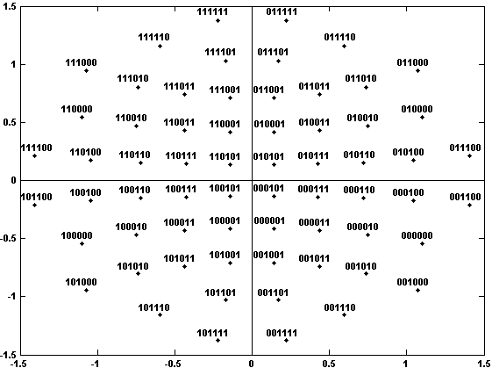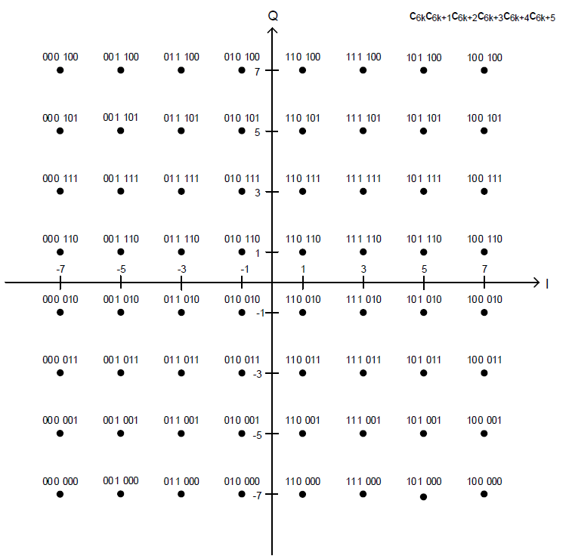

**Figure 20-17—64QAM constellation bit encoding**

## Performance of the proposed constellation

The proposed non-uniform constellation (NUC) has major advantages compared to the uniform constellation (UC) as will be outlined in the following.

The NUC features a shaping gain which results in an SNR gain in the FER characteristic. Figure 1 shows the FER of UC and the proposed NUC as a function of SNR in AWGN channel for all 11ad code rates. For any code rate and target FER, NUC requires a lower SNR.

Figure 2 depicts the shaping gain at an FER of ${10}^{-2}$ in AWGN channel (like in Figure 1) and in AWGN channel with phase noise at transmitter and receiver. The phase noise is modelled according to the 11ad/ay evaluation methodology. It can be seen that the shaping gain is a function of the actual code rate and is between 0.1 and 0.3dB in AWGN channel. When phase noise is additionally added, the shaping gain enhances significantly for high code rates. Including phase noise the shaping gain is between 0 and 3.1dB.

|  |  |
| --- | --- |
| Figure 1: FER as a function of SNR | Figure 2: Shaping gain as a function of code rate |

Furthermore, the proposed NUC features a reduced peak-to-average power ratio $p$ compared to UC. The NUC has $p_{NUC}=3.09\text{dB}$, whereas the UC has $p_{UC}=3.68\text{dB}$. Thus, NUC features a PAPR gain of roughly 0.6dB. Exploitation of this gain is implementation dependend.

Furthermore, the NUC performance in presence of quantization and 11ad channel models has been investigated in [11-15/1290r0](https://mentor.ieee.org/802.11/dcn/15/11-15-1290-00-00ay-effect-of-impairments-on-the-performance-of-non-uniform-constellations.pptx). Throughout all scenarios, it has been shown that the shaping gain of NUC is at least maintained or even further increased. This motivated a theoretical analysis of the shaping gain for arbitrary impairment.

The analysis bases on a capacity formula which gives the achievable capacity as a function of the SNR. The formula was extended to include interference noise given by SIR $γ_{i}$ which is the measured SNR at the receiver given that no noise from the channel is present.

Figure 3 shows the analytical capacity analysis for UC and NUC as a function of the SNR for various $γ_{i}$. The figure further holds the capacity threshold which is required to achieve an FER of ${10}^{-2}$ for code rate 13/16. Two major aspects can be observed:

* The required SNR increases the stronger the impairments are, i.e. lower $γ_{i}$.
* The NUC shaping gain increases the stronger the impairments are. This means that the shaping gain in progressive, i.e. NUC gain increases with stronger impairments.

The analytical results haven been successfully verified by simulations.

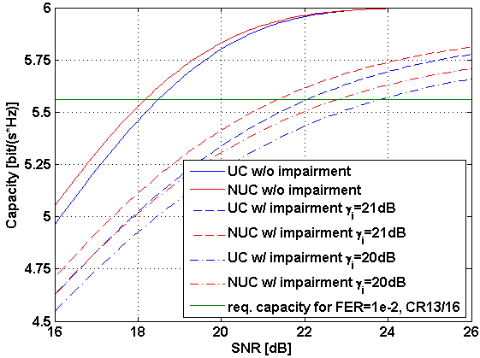

**0.3dB**

**0.7dB**

**1.0dB**

Figure 3: Analytical capacity analysis of UC and NUC

NUC requires a modification of the demapper which results in a more complex hardware design compared to a UC demapper. However, complexity increase is limited and in comparison to the achieved gain justified. Realization of the same gain with an LDPC code would require a much longer codeword length as we have in 11ad which would be associated with a very strong increase in LDPC decoder compexlity.

Different demapper implementations for NUC exist. They typically employ LUTs with precomputed LLRs. Furthermore, low-complexity demapper implementations are well known, e.g. [2], which apply methods to reduce the signal point search space.

The simulation parameters of the entire analysis are given in Table 1.

Table 1: Simulation parameters

|  |
| --- |
| Single carrier modulation |
| 11ad LDPC with code rates: 1/2, 3/4, 5/6, 13/16, 7/8 |
| Message length: 1000Bytes |
| AWGN channel |
| Phase noise mask according to 11ad/ay evaluation methodology |
| MMSE frequency-domain equalizer |
| Phase noise compensation based on unique words |

### Summary

The proposed non-uniform constellation provides:

* Single constellation for all code rates
* SNR gain up to 0.3dB in AWGN channel and up to 3dB in presence of phase noise.
* Progressive SNR gain, i.e. the stronger the impairment, the greater the SNR gain. This means that the NUC is more robust as the UC.
* Peak power gain of 0.6dB.
* A moderate but manageable increase in demapper complexity.



**References:**

[1] Draft P802.11REVmc_D6.0

[2] M. Fuentes, D. Vargas, and D. Gómez-Barquero “Low-Complexity Demapping Algorithm for Two-Dimensional Non-Uniform Constellations”, IEEE Trans. on Broadcasting, Nov. 2015