IEEE P802.11
Wireless LANs
Proposed Resolution to CID 3,5,15,17,20,21, and 38 on TGaj D2.0 in LB220
Date: 2016-07-24
Author(s):
Name | Company | Address | Phone | Email
Shiwen HE | SEU |  |  | shiwenhe@seu.edu.cn

Abstract

This document proposes resolutions CID 3,5,15,17,20,21, and 38 on TGaj D2.0 in LB220.

Editorial Comments
CID | Clause | Page | Line | Type | Comment | Proposed Change | Remark
3 | 26.10 | 253 |  | T | Channel number is not unique between bandwidths, i.e. Channel 2 can be either 2.16, 1.08, or 0.54 GHz bandwidth channel with different center frequencies. This may lead to confusion. | Clarify that channel numbering is not unique and is required to be considered in context with channel bandwidth.
Proposed resolution: Reject
45MG STAs are newly defined in 11aj in parallel with HT/VHT/DMG STAs although a number of mechanisms defined for DMG STAs are adopted by 45QMG STAs. Different kinds of STAs may reuse channel numbers, such as DMG STAs and HT STAs both use channel number {1,2,3… }. In 26.10, the channel numbers are only used for the 45MG STAs that only support the channel bandwidth of 1.08 or 0.54 GHz. The channel bandwidth of 2.16 GHz is for CDMG STA that operates on 60GHz only. So 45MG STAs may reuse some of the channel numbers that are also used by CDMG STAs.

CID | Clause | Page | Line | Type | Comment | Proposed Change | Remark
5 | 10.22.2 | 95 | 25 | T | In the resolution of CID 21 submitted on LB217  "Proposed resolution: Revised  We have added the corresponding description of 45MG MAC STA architecture. A CDMG STA is a DMG STA. So it follows the same rule as DMG STAs."  If you follows the same rule as DMG STAs, remove all changes shown on the 10.22.2 (EDCA). | remove all changes shown on the 10.22.2 (EDCA).
Proposed resolution: Reject
45MG STAs are newly defined in 11aj in parallel with HT/VHT/DMG/CDMG STAs although they also adopt a number of mechanisms currently defined for DMG STAs. We have added the corresponding description of 45MG MAC STA architecture, since 45MG STA may support omnidirectional transmission and dynamic bandwidth operation based on EDCA. Therefore, we have added some specific description in 10.22.2 for 45MG STA. In other words, the changes in 10.22.2 (EDCA) in IEEE802.11aj 2.0 are applicable for 45MG STAs only.
In 45MG and CDMG STAs are two different kinds STAs that operate on different frequency band following with different PHY and MAC mechanisms. However, as defined in 11aj, CMDG STAs follow the same rule as DMG STAs but there is no change for CDMG STAs here. Therefore, the changes here could not be removed.
9.2 MAC architecture
9.2.1 General
Change the first paragraph as follows:
The MAC architecture is shown in Figure 9-1 (Non-DMG STA MAC architecture), Figure 9-2 (DMG STA MAC architecture) and Error: Reference source not found.
Insert the following Figure 9-2a (45MG STA MAC architecture) and the corresponding description after the third paragraph.
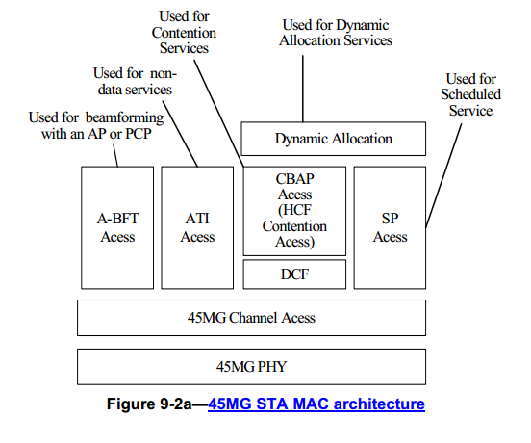
In a 45MG STA:
- The MAC provides services using the 45MG channel access mechanisms.
- Specific rules apply for access during scheduled periods, which include the association beamforming training (A-BFT) period, announcement transmission interval (ATI), contention based access period (CBAP), and service period (SP).
- The DCF is used during contention based access periods.
- Dynamic allocation (Error: Reference source not found) is built on service period and contention based access period.

CID | Clause | Page | Line | Type | Comment | Proposed Change | Remark
15 | 2 |  |  | T | Consider a name for 45MG made of alphabet letters only | Consider a name such as QDMG
Proposed resolution: Reject.
In IEEE802.11aj, we have defined two transmission models for 45MG STAs, namely, 45MG STAs may support directional transmission or omnidirectional transmission. In addition, CID83 (LB217) is that “I don't think Q band is a widely used name for the band. Can you provide a reference for this definition, or just use the frequency band, or provide more context or a reference to Q-band.”. The proposed change is to use 45MG. Therefore, we decide to use “45MG” instead of “QMG”. Anyway we open on this and if it does not meet requirement of the 802.11 style or there is a better suggested one.

CID | Clause | Page | Line | Type | Comment | Proposed Change | Remark
17 | 9.3.4.2 | 30 | 9 | T | "The 45MG Capabilities element is optionally present; otherwise not present." Lack of the condition when the 45MG Capabilities element is present. Same problem exists in P30L11. | Per comment.
Proposed resolution: Revised
Refer to Draft P802.11REVmc_D6.0, the corresponding description are revised.
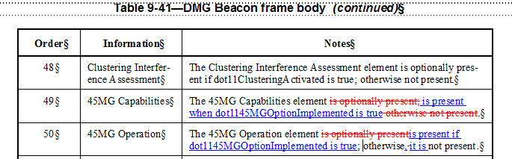

CID | Clause | Page | Line | Type | Comment | Proposed Change | Remark
20 | 9.6.25.2 | 83 | 23 | T | "The CSI frame is an ....." the frame name here should be "45MG CSI frame". Ditto at the title of Table 9-421. | Change "CSI frame" to "45MG CSI frame" where applicable.
21 | 9.6.25.3 | 83 | 46 |  | "In a CSI frame, the subfields of the 45MG MIMO Control field ...." The 45 MIMO Control field is not a subfields. No need to say "In a CSI frame" here. | Change to "The 45MG MIMO Control field..." Fix the similar problems throughout the draft.
Proposed resolution: Revised
9.6.25.2 45MG CSI frame forma
The 45MG CSI frame is an Action or an Action No Ack frame of category 45MG.
In a CSI frame, the subfields of tThe 45MG MIMO Control field (see is defined in Error: Reference source not found) are used as described in Error: Reference source not found.
9.6.25.2 45MG Noncompressed Beamforming frame format
In a Noncompressed Beamforming frame, the subfields of tThe 45MG MIMO Control field (seeis defined in Error: Reference source not found) are used as described in Error: Reference source not found.

CID | Clause | Page | Line | Type | Comment | Proposed Change | Remark
38 |  | 184 | 12 | T | Grammatical fix and is there a shall statement somewhere for this? | Change from "The RSN operations in 45MG BSS is the same with" to "The RSN operations in a 45MG BSS are the same as". Add a shall for this.
Proposed resolution: Revised
Insert the following note at the end of subclause 112.1.2:
Note: The RSN operations in a 45MG BSS is shall be the same with the RSN operations in a DMG BSS.

