IEEE P802.11
Wireless LANs
Solicited PAD Comment Resolutions
Date: 2016-05-14
Author(s):
Name | Company | Address | Phone | email
Michael Montemurro | BlackBerry Ltd | 4701 Tahoe Blvd  Mississauga, ON, CANADA L4W 0B4 | +1-289-261-4183 | mmontemurro@blackberry.com
Stephen McCann | BlackBerry Ltd | 200 Bath Road, Slough, Berkshire, SL1 3XE, UK | +44 1753 667099 | smccann@blackberry.com

Abstract
This document proposes text changes to update the P802.11aq draft to update procedures for Solicited PAD.

IEEE Draft Standard P802.11aqTM/D4.0

IEEE Standard for Information technology—
Telecommunications and information exchange between systems Local and metropolitan area networks—
Specific requirements

Part 11: Wireless LAN Medium Access Control (MAC) and Physical Layer (PHY) Specifications

Amendment 3: Pre-Association Discovery

This amendment is based on IEEE 802.11mc/D5.0, amended by IEEE P802.11ai D6.0 and IEEE P802.11ah D5.0

IMPORTANT NOTICE: This standard is not intended to ensure safety, security, health, or environmen- tal protection in all circumstances. Implementers of the standard are responsible for determining appro- priate safety, security, environmental, and health practices or regulatory requirements.

This IEEE document is made available for use subject to important notices and legal disclaimers. These notices and disclaimers appear in all publications containing this document and may be found under the heading “Important Notice” or “Important Notices and Disclaimers Concerning IEEE Documents.” They can also be obtained on request from IEEE or viewed at http://standards.ieee.org/IPR/disclaimer.

NOTE — The editing instructions contained in this amendment define how to merge the material contained therein into the existing base standard and its amendments to form the comprehensive standard.

The editing instructions are shown in bold italic. For editing instructions are used: change, delete, insert, and replace. Change is used to make corrections in existing text or tables. The editing instructions specifies the location of the change and describes what is being changed by using strike through (to remove old mate- rial) and underscore (to add new material). Delete removes existing material. Insert adds new material with- out disturbing the existing material. Insertions may require renumbering. If so, renumbering instructions are given in the editing instruction. Replace is used to make changes in figures or equations by removing the

existing figure or equation and replacing it with a new one. Editorial notes will not be carried over into future editions because the changes will be incorporated into the base standard.

- Overview

1.3 Supplementary information on purpose

Normative references

Definitions, acronyms, and abbreviations

3.1 Definitions

3.4 Abbreviations and acronyms

General description

Overview of the services

Interworking with external networks

Insert the following new clauses:

      - Pre-association Discovery (PAD)

Architecture

Service Information Entities

Service Information Registry

Service Information Client

6. Layer Management

MLME SAP interface

Scan

      - MLME-SCAN.request

        - Semantics of the service primitive Change the primitive parameter list as follows: The primitive parameters are as follows:

MLME-SCAN.request(

BSSType, BSSID, SSID,
ScanType, ProbeDelay, ChannelList, MinChannelTime, MaxChannelTime, RequestInformation, SSID List, ChannelUsage, AccessNetworkType, HESSID,
MeshID, DiscoveryMode, FILSRequestParameters ReportingOption,
APConfigurationSequenceNumber, ServiceHash,
VendorSpecificInfo
)

When Generated

Insert row (ignoring the header row) in the table as follows:

Name | Type | Valid range | Description
ServiceHash | As defined in  9.4.2.218 (Service Hash element) | As defined in  9.4.2.218 (Service Hash element) | Specifies services. The element is optionally present if either dot11UnsolicitedPADActivated or dot11SolicitedPADActivated is true, and absent otherwise.

      - MLME-SCAN.confirm

        - Semantics of the service primitive

Insert the following new rows to the end of the BSSDescription parameter table (ignoring the header row)
:

Name | Type | Valid range | Description
ServiceHint | As defined in  9.4.2.216 (Service Hint element) | As defined in  9.4.2.216 (Service Hint element) | Provides an indication of the services advertised in Beacon frames and Probe Response frames. The element is present if such an element was present in the Beacon or Probe Response frame.
ServiceHash | As defined in  9.4.2.218 (Service Hash element) | As defined in  9.4.2.218 (Service Hash element) | Specifies services advertised in Beacon and Probe Response frames. The element is present if such an element was present in the Probe Response or Beacon frame.

6.3.11 Start

6.3.11.2 MLME-START.request

6.3.11.2.2 Semantics of the service primitive

Change the primitive parameter list as follows:

MLME-START.request(

SSID,
BSSType, BeaconPeriod, DTIMPeriod,
CF parameter set, PHY parameter set, IBSS parameter set,
NAVSyncDelay,
CapabilityInformation,
BSSBasicRateSet,
OperationalRateSet,
Country,
IBSS DFS Recovery Interval,
EDCAParameterSet,

DSERegisteredLocation,
HT Capabilities, HT Operation,
BSSMembershipSelectorSet, Extended Capabilities,
20/40 BSS Coexistence, Overlapping BSS Scan Parameters, MultipleBSSID,
InterworkingInfo, AdvertisementProtocolInfo, RoamingConsortiumInfo, Mesh ID,
Mesh Configuration, QMFPolicy,
DMG Capabilities, Multi-band,
MMS,
DMG Operation, Clustering Control, CBAP Only,
PCP Association Ready, VHT Capabilities,
VHT Operation, ServiceHint,
ServiceHash, VendorSpecificInfo
)

Insert the following new rows before VendorSpecificInfo in the parameter table:

Name | Type | Valid range | Description
ServiceHint | As defined in  9.4.2.216 (Service Hint element) | As defined in  9.4.2.216 (Service Hint element) | Provides an indication of the services advertised in Beacon and Probe Response frames. The element is optionally present if dot11UnsolicitedPADActivated is true, and absent otherwise.
ServiceHash | As defined in  9.4.2.218 (Service Hash element) | As defined in  9.4.2.218 (Service Hash element) | Specifies services advertised in Beacon and Probe Response frames. The element is optionally present if either dot11UnsolicitedPADActivated or dot11SolicitedPAD- Activated is true, and absent otherwise.

9. Frame formats

9.3 Format of individual frame types

9.3.3 Management frames

9.3.3.3 Beacon frame format

Insert the following rows (ignoring the header row) in the table:

Table 9-27—Beacon frame body

Order | Information | Notes
70 | Service Hash | The Service Hash element is optionally present if dot11UnsolicitedPADActivated is true.
71 | Service Hint | The Service Hint element is optionally present if dot11UnsolicitedPADActivated is true.

      - Probe Response frame format

Insert new rows to the table as follows:

Table 9-34—Probe Response frame body

Order | Information | Notes
85 | Service Hash | The Service Hash element is optionally present if dot11UnsolicitedPADActivated is true.
86 | Service Hint | The Service Hint element is optionally present if dot11UnsolicitedPADActivated is true.

9.4 Management and Extension frame body components

9.4.2 Elements

9.4.2.1 General

Insert new rows to the table as follows

Table 9-76— Element IDs

Element | Element ID | Element ID Extension | Extensible | Fragmentable
Service Hint (see  9.4.2.216 (Service Hint element)) | <ANA> | <ANA> | No
Service Hash (see  9.4.2.218 (Service Hash element)) | <ANA> | <ANA> | No

9.4.2.27 Extended Capabilities element

      - Service Hint element

      - Service Hash element

9.4.5 Access Network Query Protocol (ANQP) elements

9.4.5.1 General

Inserting new rows as follows to the end of the table, with corresponding adjustment to “Reserved” value:

Table 9-266—ANQP-element definitions

ANQP-element name | Info ID | ANQP-element (subclause)
Service Information Request | <ANA> | 9.4.5.27 (Service Information Request ANQP- element)
Service Information Response | <ANA> | 9.4.5.28 (Service Information Response ANQP- element)
Solicited PAD Request | <ANA> | 9.4.5.29 (Solicited PAD Request ANQP- element)
Solicited PAD Response | <ANA> | 9.4.5.30 (Solicited PAD Response ANQP- element)

Insert new subclause as follows:

      - Service Information Request ANQP-element

Service Information Response ANQP-element

      - Solicited PAD Request ANQP-element

The Solicited PAD Request ANQP-element contains the request for Solicited PAD associated with a given service name or an instance name associated with a service name.

The format of the Solicited PAD Request ANQP-element is shown in Figure 9-622f (Solicited PAD Request ANQP-element format).

Info ID | Length | Service Hashes
Octets: 2 2 variable

Figure 9-622f—Solicited PAD Request ANQP-element format

The Info ID and Length fields are defined in 9.4.2.1 (General).

The Service Hashes field contains one or more 6-octet service hash values. See 11.25a.6 (Service hash procedures) for procedures for generating a service hash used in the Solicited PAD Request ANQP-element.

Solicited PAD Response ANQP-element

The Solicited PAD Response ANQP-element contains the detailed Solicited PAD information, in response to a Solicited PAD Request ANQP-element.

The format of the Solicited PAD Response ANQP-element is shown in Figure 9-622h (Solicited PAD Response ANQP-element format)

Info ID | Length | Basic Service Information Descriptors
Octets: 2 2 variable

Figure 9-622h—Solicited PAD Response ANQP-element format

The Info ID and Length fields are defined in 9.4.2.1 (General).

The Basic Service Information Descriptors field contains one or more Basic Service Information Descriptor subfields. The format of the Basic Service Information Descriptor subfield is shown in Figure 9-586cn (Basic Service Information Descriptor subfield format).

Service Name Length | Service Name | Instance Name Length | Instance Name
Octets: 1 variable 1 variable

Figure 9-586cn—Basic Service Information Descriptor subfield format

The Service Name Length subfield contains the length of the Service Name subfield. The Service Name Length field is set to a non-zero value.

The Service Name subfield contains a UTF-8 encoded string as defined in IETF RFC 6335. For example, of service name for print service is "_ipp._tcp".

The Instance Name Length subfield contains the length of the Instance Name subfield, in octets.

The Instance Name is an instance of service associated with the service name. The Instance Name subfield contains a UTF-8 encoded string with a maximum length of 63 octets as defined in IETF RFC 6763. An example of an instance name is "John Home Printer". The Instance Name Length is set to a non-zero value.

11. MLME

11.25 WLAN interworking with external networks procedures

11.25.3 Interworking procedures: generic advertisement service (GAS)

11.25.3.2 ANQP procedures 11.25.3.2.1 General
Insert new rows to table as follows:

Table 11-15—ANQP usage

 |  |  | BSS |  | IBSS
ANQP-element name | ANQP-element (subclause) | ANQP-  element type | AP | Non-AP STA | STA
Service Information Request | 9.4.5.27  (Service Information Request ANQP- element) | Q | R | T | —
Service Information Response | 9.4.5.28  (Service Information Response ANQP-element) | S | T | R | —
Solicited PAD request | 9.4.5.29  (Solicited PAD Request ANQP-element) | Q | R | T | —
Solicited PAD response | 9.4.5.30  (Solicited PAD Response ANQP-element) | S | T | R | —
Symbols
Q element is an ANQP query
- element is an ANQP response
- ANQP-element may be transmitted by MAC entity R ANQP-element may be received by MAC entity
— ANQP-element is neither transmitted nor received by MAC entity

Insert new subclause as follows:

11.25.3.2.16 ANQP service information procedures

The Service Information Request ANQP-element is used to request information about services available after association. A service name may be placed within the request. The service name is used after association to the BSS to assist with discovering services, as described in Annex W ().

The Service Information Response ANQP-element is returned in response to a Service Information Request ANQP-element.

Insert new subclauses as follows (note that 11aq has identified this as a level 2 clause, which would make the number be 11.25a as shown however the numbering spreadsheet indicates that it wold be level 4 numbered 11.25.3.4):

11.25a Pre-association discovery (PAD) procedures

11.25a.1 General

a.2 Unsolicited PAD procedure

11.25a.3 Solicited PAD procedure

When dot11SolicitedPADActivated is true, a non-AP STA may transmit to an AP or PCP a Solicited PAD Request ANQP-element with a Service Hashes field. This element includes one or more service hashes generated from the service name(s) of the service(s) that the non-AP STA is searching. An AP or PCP might advertise support for the Solicited PAD procedure by setting the Solicited PAD field of the Extended Capabilities element to 1 in its Beacon and Probe Response frames.

When dot11SolicitedPADActivated is true, an AP or PCP shall use the information from the Solicited PAD Request ANQP-element (that it receives from a non-AP STA) to verify whether there are any matching services. The service matching process is based on the service hash value in the Service Hashes field of the received Solicited PAD Request ANQP element being the same as the corresponding service hash value of the service that the AP or PCP is offering. The AP or PCP compares each service hash value in the Service Hash field of the Solicited PAD Request ANQP element to the service hash values of the services which the AP or PCP is offering. If the AP or PCP determines that one or more matching services are available, it shall respond by transmitting a Solicited PAD Response ANQP-element whose Service Advertisement element contains a Basic Service Information Descriptor field for each matching service.

The requesting non-AP STA shall process the Service Advertisement element in the received Solicited PAD Response ANQP-element to determine whether any received service name matches with a service name that the non-AP STA is requesting.

If there is a matching service name, the non-AP STA might decide to proceed with the PAD ANQP procedure (11.25a.4 (PAD ANQP procedure) or authentication and association procedure (11.3 (STA authentication and association)) depending on the nature of the service (see examples illustrated in Annex W.1 (Pre- association discovery usage scenarios)), the details of which are out of the scope of this standard.

11.25a.4 Service Information procedure

11.25a.5 Bloom filter hash function operation

a.6 Service hash procedures

Annex A

(informative)

Bibliography

Annex B

(normative)

Protocol Implementation Conformance Statement (PICS) proforma

B.1 Introduction

B.1.2 Protocol Implementation Conformance Statement (PICS) proforma

Editor’s Note: Any occurrences of <year> throughout this clause will be replaced by the year of publica- tion by the IEEE-SA publication editor.

B.2.2 General abbreviations for Item and Support columns

B.4 PICS proforma—IEEE Std 802.11-<year>1

B.4.3 IUT configuration

B.4.30 Pre-association Discovery Extensions
Annex C

(normative)
ASN.1 encoding of the MAC and PHY MIB

C.3 MIB Detail

Annex W

(informative)

  - Pre-association discovery usage scenarios

Background Search

Applications that run in the background (e.g., automatically receiving sales coupons that a user has previously signed up for) might not require immediate discovery results to be presented to the user. It may be appropriate to prevent non-AP STAs, running such background applications, from performing a solicited PAD search. Furthermore, solicited PAD search in a dense WLAN environment can cause network congestion. In that case, it is more effective to perform unsolicited PAD search, inwhich an AP advertises multiple services it proxied, while non-AP STAs need respond only if there is a matched service.

The AP can elect to advertise several typical services using the Service Hash element, and advertise the remaining services using the Service Hint element, in the Beacon frames. Alternatively, the AP can elect to advertise all of the services using either the Service Hash or Service Hint element in the Beacon frames. Upon receiving the Beacon frame, a non-AP STA processes the Service Hash and Service Hint elements to verify if there are any potential matching services. Figure W-1 (Example of a frame exchange for back- ground search with high probability of false positive) and Figure W-2 (Example of a frame exchange for background search with low probability of false positive) show two cases where there is a matching Service Hint.

Based on the probability of false positives as indicated in the False Positive Probability Range field of the Service Hint element is considered relatively high by the non-AP STA (see Figure W-1 (Example of a frame exchange for background search with high probability of false positive)), the non-AP STA can send a Solicited PAD Request ANQP-element with the Service Hashes field to confirm the service is indeed offered through the AP or PCP. The AP then responds with a Solicited PAD Response ANQP-element with a Service Advertisement element that contains the corresponding Service Name and Instance Name.

The non-AP STA can then send an ANQP request with a Service Information Request ANQP-element containing the Service Name, Instance Name and specific Service Information Query to obtain more information about the service from the AP or PCP. The AP responds to the ANQP request with the ANQP response with Service Information ANQP-element containing the Service Name, Instance Name and specific Service Information Query. After the ANQP request and ANQP response exchange, the non-AP STA may have received more information on available services after it associates to the AP or PCP.

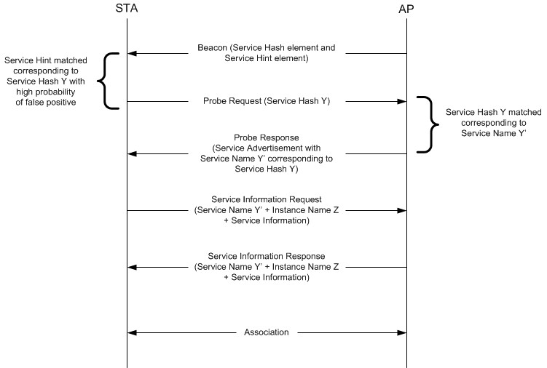

Figure W-1—Example of a frame exchange for background search with high probability of false positive

Based on the probability of false positive as indicated in False Positive Probability Range field of the Service Hint element is considered relatively low by the non-AP STA (see Figure W-2 (Example of a frame exchange for background search with low probability of false positive)), the non-AP STA can directly send an ANQP request with Service Information ANQP-element containing the Service Name and specific Service Information ANQP element to obtain more information about the service from the AP or PCP.

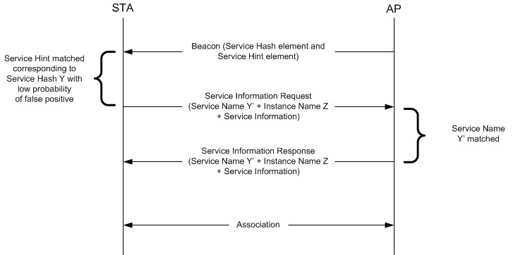

Figure W-2—Example of a frame exchange for background search with low probability of false positive

The AP or PCP responds to the ANQP request with the ANQP response with Service Information ANQP-element containing the Service Name, Instance Name. After the ANQP request and ANQP response exchange, the non-AP STA can obtain information on available services after associating to the AP or PCP.

In a scenario where there is a matching Service Hashes field, the non-AP STA can directly send an ANQP request with Service Information ANQP-element containing the Service Name and specific Service Information Query Request to obtain more information about the service from the AP or PCP as shown in Figure W-3 (Example of frame exchange for background search with matching Hash element).

The AP or PCP responds to the ANQP request with the ANQP response with Service Information \ANQP-element containing the Service Name, Instance Name and specific Service Information Query Response. After the ANQP request and ANQP response exchange, the non-AP STA can make an informed decision about choosing to associate to the AP or PCP.

Alternatively, the non-AP STA might choose to associate based on the matching Service Hash element.

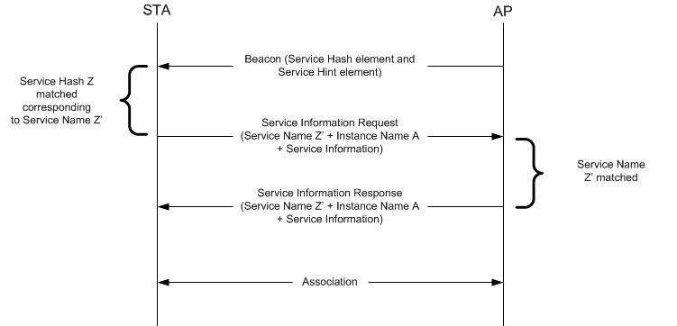

Figure W-3— Example of frame exchange for background search with matching Hash ele- ment

    - Immediate Search

Applications that are initiated by users (e.g., a user is looking for a fast movie download service) require immediate discovery results to be presented to the user. In this scenario, a non-AP STA performs a Solicited PAD procedure, whereby the non-AP STA sends Solicited PAD Request ANQP-element frames to query specific services immediately after user initiation of the service/application and the AP or PCP responds with a Solicited PAD Response ANQP-element frame accordingly if there is a matched service (Figure W-4 (Example of frame exchange for immediate search)). The Solicited PAD Request ANQP-element frame contains the Service Hashes field of the search service. The AP or PCP responds with a Solicited PAD Response ANQP-element frame with a Service Advertisement element containing the corresponding Service Name and Instance Name. The non-AP STA then might perform an ANQP request and ANQP response exchange with the AP or PCP, as shown in Figure W-4 (Example of frame exchange for immediate search), to obtain more information about the service. After the ANQP request and ANQP response exchange, the non-AP STA can make an informed decision about choosing to associate to the AP or PCP.

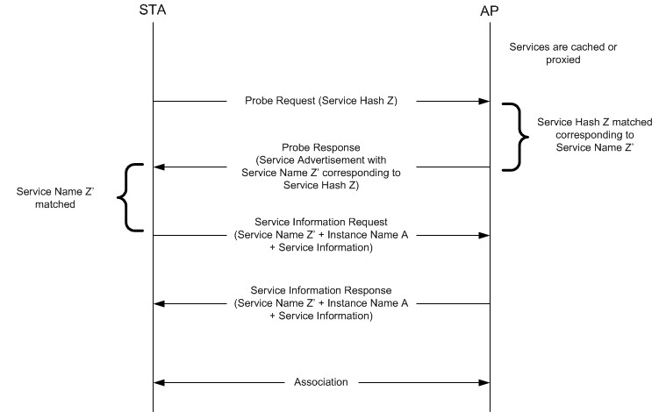

Figure W-4—Example of frame exchange for immediate search

