IEEE P802.11
Wireless LANs
Solicited PAD Comment Resolutions
Date: 2016-05-14
Author(s):
Name | Company | Address | Phone | email
Michael Montemurro | BlackBerry Ltd | 4701 Tahoe Blvd  Mississauga, ON, CANADA L4W 0B4 | +1-289-261-4183 | mmontemurro@blackberry.com
Stephen McCann | BlackBerry Ltd | 200 Bath Road, Slough, Berkshire, SL1 3XE, UK | +44 1753 667099 | smccann@blackberry.com

Abstract
This document proposes text changes to update the P802.11aq draft to update procedures for Solicited PAD.

IEEE Draft Standard P802.11aqTM/D4.0

IEEE Standard for Information technology—
Telecommunications and information exchange between systems Local and metropolitan area networks—
Specific requirements

Part 11: Wireless LAN Medium Access Control (MAC) and Physical Layer (PHY) Specifications

Amendment 3: Pre-Association Discovery

This amendment is based on IEEE 802.11mc/D5.0, amended by IEEE P802.11ai D6.0 and IEEE P802.11ah D5.0

IMPORTANT NOTICE: This standard is not intended to ensure safety, security, health, or environmen- tal protection in all circumstances. Implementers of the standard are responsible for determining appro- priate safety, security, environmental, and health practices or regulatory requirements.

This IEEE document is made available for use subject to important notices and legal disclaimers. These notices and disclaimers appear in all publications containing this document and may be found under the heading “Important Notice” or “Important Notices and Disclaimers Concerning IEEE Documents.” They can also be obtained on request from IEEE or viewed at http://standards.ieee.org/IPR/disclaimer.

NOTE — The editing instructions contained in this amendment define how to merge the material contained therein into the existing base standard and its amendments to form the comprehensive standard.

The editing instructions are shown in bold italic. For editing instructions are used: change, delete, insert, and replace. Change is used to make corrections in existing text or tables. The editing instructions specifies the location of the change and describes what is being changed by using strike through (to remove old mate- rial) and underscore (to add new material). Delete removes existing material. Insert adds new material with- out disturbing the existing material. Insertions may require renumbering. If so, renumbering instructions are given in the editing instruction. Replace is used to make changes in figures or equations by removing the

existing figure or equation and replacing it with a new one. Editorial notes will not be carried over into future editions because the changes will be incorporated into the base standard.

- Overview

1.3 Supplementary information on purpose

Insert the following dash list item at the end of the list of items in 1.3:

- Define mechanisms to enable delivery of pre-association service discovery information to IEEE 802.11 stations (STAs).

Normative references

Insert the following reference:

IETF RFC 6335, Service Name and Port Number Procedures, August 2011

Definitions, acronyms, and abbreviations

3.1 Definitions

Insert the following new definition:

universally unique service identifier (UUSID): An identifier that universally and uniquely identifies a ser- vice.

3.4 Abbreviations and acronyms

Insert the following new abbreviations/acronym definitions:

PAD pre-association discovery

General description

Overview of the services

Interworking with external networks

Change as follows:

An overview of the interworking functions addressed in this standard is provided below:

      - Network discovery and selection
        - Discovery and selection of a suitable IEEE Std 802.11 infrastructure using advertisement protocols (e.g. access network query protocol (ANQP) in a PBSS, the BSS or an external network
        - Selection of an SSPN or external network with its corresponding IEEE Std 802.11 Infrastructure
      - Pre-association discovery (PAD)
        - Discovery of services offered by a PBSS, BSS, or an external network
      - Emergency services
        - Emergency Call and Network Alert support at the link level
      - QoS mapping distribution
      - SSPN interface service between the AP or PCP and the SSPN

Insert the following new clauses:

      - Pre-association Discovery (PAD)

PAD is a service provided by a PBSS or BSS to allow non-AP STAs, in a pre-association state, to discover information concerning services that are available to STAs that are already associated with the PBSS or BSS. This information may allow a (non-AP??) STA to choose during network selection, which PBSS or BSS (i.e. a network) to associate with to obtain services.

Architecture

Figure 4-11a (Pre-association Discovery Architecture) shows the functional flow of MAC messaging and service information between a Service Information Client (SIC)and a Service Information Registry (SIR). These entities are described below,

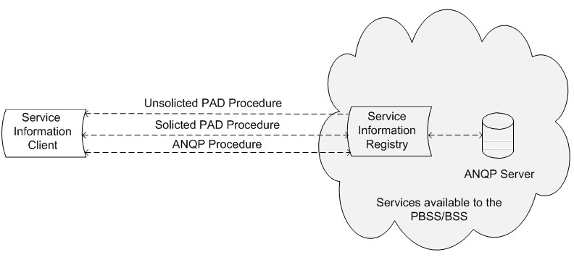

Figure 4-11a — Pre-association Discovery Architecture
NOTE- A proxy server can be co-located with the AP or outside the AP.

Service Information Entities

Service Information Entities (e.g. the client and registry) are used to exchange information between higher layer resources above both the non-AP STA and the AP or PCP. The PAD and ANQP service discovery procedures operate between these entities.

Entities are used to encapsulate service relevant information (e.g. a service name), and then exchange that information between the SIC and SIR. As shown in Figure 4-11a (Pre-association Discovery Architecture), PAD signaling is opaque to the service relevant information because it is handled by these entities in the STA and AP or PCP.

Service Information Registry

The Service Information Registry (SIR) is a logical entity that contains caches of information about services that may be available via the PBSS or BSS, for the STA to connect to after it associates with the AP or PCP. How the service information registry obtains the information about services is outside the scope of this standard.

There is typically one SIR assigned to each ESS and it is a distributed logical entity. It can be reached by each AP and each service within that ESS. It includes supporting service discovery requests and responses from the PBSS or BSS.

The SIR communicates with the ANQP Server that is also available via the PBSS or BSS.

Service Information Client

The Service Information Client (SIC), also shown in Figure 4-11a (Pre-association Discovery Architecture), is a logical entity that initiates STA service discovery.

Within a STA this exchange includes supporting service discovery requests and responses to and from applications. The SME determines whether to use unsolicited PAD, solicited PAD or ANQP. The SME also creates the contents of the probe requests and ANQP requests.

6. Layer Management

MLME SAP interface

Scan

      - MLME-SCAN.request

        - Semantics of the service primitive Change the primitive parameter list as follows: The primitive parameters are as follows:

MLME-SCAN.request(

BSSType, BSSID, SSID,
ScanType, ProbeDelay, ChannelList, MinChannelTime, MaxChannelTime, RequestInformation, SSID List, ChannelUsage, AccessNetworkType, HESSID,
MeshID, DiscoveryMode, FILSRequestParameters ReportingOption,
APConfigurationSequenceNumber, ServiceHash,
VendorSpecificInfo
)

When Generated

Insert row (ignoring the header row) in the table as follows:

Name | Type | Valid range | Description
ServiceHash | As defined in  9.4.2.218 (Service Hash element) | As defined in  9.4.2.218 (Service Hash element) | Specifies services. The element is optionally present if either dot11UnsolicitedPADActivated or dot11SolicitedPADActivated is true, and absent otherwise.

      - MLME-SCAN.confirm

        - Semantics of the service primitive

Insert the following new rows to the end of the BSSDescription parameter table (ignoring the header row)
:

Name | Type | Valid range | Description
ServiceHint | As defined in  9.4.2.216 (Service Hint element) | As defined in  9.4.2.216 (Service Hint element) | Provides an indication of the services advertised in Beacon frames and Probe Response frames. The element is present if such an element was present in the Beacon or Probe Response frame.
ServiceHash | As defined in  9.4.2.218 (Service Hash element) | As defined in  9.4.2.218 (Service Hash element) | Specifies services advertised in Beacon and Probe Response frames. The element is present if such an element was present in the Probe Response or Beacon frame.

6.3.11 Start

6.3.11.2 MLME-START.request

6.3.11.2.2 Semantics of the service primitive

Change the primitive parameter list as follows:

MLME-START.request(

SSID,
BSSType, BeaconPeriod, DTIMPeriod,
CF parameter set, PHY parameter set, IBSS parameter set,
NAVSyncDelay,
CapabilityInformation,
BSSBasicRateSet,
OperationalRateSet,
Country,
IBSS DFS Recovery Interval,
EDCAParameterSet,

DSERegisteredLocation,
HT Capabilities, HT Operation,
BSSMembershipSelectorSet, Extended Capabilities,
20/40 BSS Coexistence, Overlapping BSS Scan Parameters, MultipleBSSID,
InterworkingInfo, AdvertisementProtocolInfo, RoamingConsortiumInfo, Mesh ID,
Mesh Configuration, QMFPolicy,
DMG Capabilities, Multi-band,
MMS,
DMG Operation, Clustering Control, CBAP Only,
PCP Association Ready, VHT Capabilities,
VHT Operation, ServiceHint,
ServiceHash, VendorSpecificInfo
)

Insert the following new rows before VendorSpecificInfo in the parameter table:

Name | Type | Valid range | Description
ServiceHint | As defined in  9.4.2.216 (Service Hint element) | As defined in  9.4.2.216 (Service Hint element) | Provides an indication of the services advertised in Beacon and Probe Response frames. The element is optionally present if dot11UnsolicitedPADActivated is true, and absent otherwise.
ServiceHash | As defined in  9.4.2.218 (Service Hash element) | As defined in  9.4.2.218 (Service Hash element) | Specifies services advertised in Beacon and Probe Response frames. The element is optionally present if either dot11UnsolicitedPADActivated or dot11SolicitedPAD- Activated is true, and absent otherwise.

9. Frame formats

9.3 Format of individual frame types

9.3.3 Management frames

9.3.3.3 Beacon frame format

Insert the following rows (ignoring the header row) in the table:

Table 9-27—Beacon frame body

Order | Information | Notes
70 | Service Hash | The Service Hash element is optionally present if dot11UnsolicitedPADActivated is true.
71 | Service Hint | The Service Hint element is optionally present if dot11UnsolicitedPADActivated is true.

      - Probe Response frame format

Insert new rows to the table as follows:

Table 9-34—Probe Response frame body

Order | Information | Notes
86 | Service Hint | The Service Hint element is optionally present if dot11SolicitedPADActivated is true or the AP has a matching service for a Service Hash included in the Probe Request frame to which this Probe Response frame is a response.

9.4 Management and Extension frame body components

9.4.2 Elements

9.4.2.1 General

Insert new rows to the table as follows

Table 9-76— Element IDs

Element | Element ID | Element ID Extension | Extensible | Fragmentable
Service Hint (see  9.4.2.216 (Service Hint element)) | <ANA> | <ANA> | No
Service Hash (see  9.4.2.218 (Service Hash element)) | <ANA> | <ANA> | No

9.4.2.27 Extended Capabilities element

Insert a new row at the end of the table as follows:

Table 9-134—Capabilities field

Bit | Information | Notes
<ANA> | Solicited PAD | Indicates support for Solicited PAD procedure (10.26.3).
<ANA> | PAD ANQP | Indicates support for Solicited PAD procedure (10.26.4).

I

Insert new subclauses as follows:

      - Service Hint element

The Service Hint element contains information about a Bloom filter that provides a probabilistic representation of a set of services. The Service Hint element is included in Beacon and Probe Response frames.

Element ID | Length | Bloom Filter Information | Bloom Filter Bit Array
Octets: 1 1 1 variable

Figure 9-586ck—Service Hint element format

The Element ID and Length fields are defined in 9.4.2.1 (General).

The Bloom Filter Information field is a 1-octet field, representing the settings of the Bloom filter. The format of the Bloom Filter Information field is shown in Figure 9-586cl (Bloom Filter Information field format).

B0 B3 B4 B7

False Positive Probability Range
Number of Hash Functions
Bits: 4 4

Figure 9-586cl—Bloom Filter Information field format

The False Positive Probability Range field represents the false positive probability range of the Bloom filter. The False Positive Probability Range field is shown in Table 9-248aa (False Positive Probability Range field values).

Table 9-248aa—False Positive Probability Range field values

False Positive Probability Range | False positive probability range, p
0 | p > 25%
1 | 20% < p≤ 25%
2 | 15% < p≤ 20%
3 | 10% < p≤ 15%
4 | 5% < p≤ 10%
5 | 1% < p≤ 5%
6 | 0.5% < p≤ 1%
7 | 0.1% < p≤ 0.5%
8 | 0.05% < p≤ 0.1%
9 | 0.01% < p≤ 0.1%
10 | p≤ 0.01%
11:15 | Reserved

The Number of Hash Functions field is set to a value equal to k-1, where k is the number of hash functions used by the Bloom filter as described in 11.25a.5 (Bloom filter hash function operation).

The Bloom Filter Bit Array field is a variable-length field that provides an indication of the services offered by or through the AP or PCP with a target probability of false positive p. The maximum length of the Bloom Filter Bit Array field is 128 octets. Each service hash X is mapped to k bit positions that are calculated using the function H(j,X,m) where j = 0,…,k-1 as given in 11.25a.5 (Bloom filter hash function operation).

      - Service Hash element

The Service Hash element contains information in the form of a Bloom Filter that provides the probabilistic representation of an available set of services in the BSS or in an external network reachable via the BSS. The format of the Service Hash element is shown in Figure 9-586co (Service Hash element format).

Element ID | Length | Service Hashes
Octets: 1 1 variable

Figure 9-586co—Service Hash element format

The Element ID and Length fields are defined in 9.4.2.1 (General).

The Service Hashes field contains one or more 6-octet service hash values. See 11.25a.6 (Service hash procedures) for procedures for generating a service hash used in the Service Hash element.

9.4.5 Access Network Query Protocol (ANQP) elements

9.4.5.1 General

Inserting new rows as follows to the end of the table, with corresponding adjustment to “Reserved” value:

Table 9-266—ANQP-element definitions

ANQP-element name | Info ID | ANQP-element (subclause)
Service Information Request | <ANA> | 9.4.5.27 (Service Information Request ANQP- element)
Service Information Response | <ANA> | 9.4.5.28 (Service Information Response ANQP- element)
Solicited PAD Request | <ANA> | 9.4.5.29 (Solicited PAD Request ANQP- element)
Solicited PAD Response | <ANA> | 9.4.5.30 (Solicited PAD Response ANQP- element)

Insert new subclause as follows:

      - Service Information Request ANQP-element

The Service Information Request ANQP-element contains the request for service information associated with a given service name or an instance name associated with a service name. Additional information can also be provided to refine the request.

The format of the Service Information Request ANQP-element is shown in Figure 9-622f (Service Information Request ANQP-element format).

Info ID | Length | Service Information Request Tuples
Octets: 2 2 variable

Figure 9-622f—Service Information Request ANQP-element format

The Info ID and Length fields are defined in 9.4.2.1 (General).

The Service Information Request Tuples field contains one or more Service Information Request Tuple sub- fields. The format of the Service Information Request Tuple subfield is shown in Figure 9-622g (Service Information Request Tuple subfield format). .

Service Name Length | Service Name | Instance Name Length | Instance Name | Service Information Query Request Length | Service Information Query Request
Octets: 1 variable 1 variable 1 variable

Figure 9-622g—Service Information Request Tuple subfield format

If the Service Name Length is not equal to 0, the format is defined in 9.4.2.217 (Service Advertisement element) together with the format of the Service Name subfield. If the Service Name Length subfield is equal to 0, the Service Name subfield contains a 6-octet service hash value (see 11.25a.6 (Service hash procedures)).

The Instance Name Length subfield and the Instance Name subfield are defined in 9.4.2.217 (Service Advertisement element). If the Instance Name Length subfield is equal to 0, the Instance Name subfield is not included in the Service Information Request Tuple subfield.

The Service Information Query Request Length subfield is the length of the Service Information Query Request subfield. If the Service Information Query Request Length subfield is equal to 0, the Service Information Query Request subfield is not included.

The Service Information Query Request subfield contains service-specific query. The value of this subfield is out of scope of this standard.

Insert the new subclause as follows:

Service Information Response ANQP-element

The Service Information Response ANQP-element contains the detailed service information in response to a Service Information Request ANQP-element.

The format of the Service Information Response ANQP-element is shown in Figure 9-622h (Service Infor- mation Response ANQP-element format).

Info ID | Length | Service Information Response Tuples
Octets: 2 2 variable

Figure 9-622h—Service Information Response ANQP-element format

The Info ID and Length fields are defined in 9.4.2.1 (General).

The Service Information Response Tuples field contains one or more Service Information Response Tuple subfields.

The format of the Service Information Response Tuple subfield is shown in Figure 9-622i (Service Information Response Tuple subfield format).

Service Name Length | Service Name | Instance Name Length | Instance Name | Service Information Query Response Length | Service Information Query Response
Octets: 1 variable 1 variable 2 variable

Figure 9-622i— Service Information Response Tuple subfield format

If the Service Name Length is not equal to 0, the format is defined in 9.4.2.217 (Service Advertisement element) together with the format of the Service Name subfield. If the Service Name Length subfield is equal to 0, the Service Name subfield contains a 6-octet service hash value (see 11.25a.6 (Service hash procedures)).

The Instance Name Length subfield and the Instance Name subfield are defined in 9.4.2.217 (Service Advertisement element). The Instance Name Length subfield contains a nonzero value.

The Service Information Query Response Length subfield is the length of the Service Information Query Response subfield.If the Service Information Query Request Length subfield is equal to 0, the Service Information Query Request subfield is not included.

The Service Information Query Response subfield is a variable length field. The content of the Service Information Query Response subfield is service-specific based on the requested service information and is not specified in this standard.

      - Solicited PAD Request ANQP-element

The Solicited PAD Request ANQP-element contains the request for Solicited PAD associated with a given service name or an instance name associated with a service name. Additional information can also be provided to refine the request.

The format of the Solicited PAD Request ANQP-element is shown in Figure 9-622f (Solicited PAD Request ANQP-element format).

Info ID | Length | Service Hashes
Octets: 2 2 variable

Figure 9-622f—Solicited PAD Request ANQP-element format

The Info ID and Length fields are defined in 9.4.2.1 (General).

The Service Hashes field contains one or more 6-octet service hash values. See 11.25a.6 (Service hash procedures) for procedures for generating a service hash used in the Service Hash element.

Solicited PAD Response ANQP-element

The Solicited PAD Response ANQP-element contains the detailed Solicited PAD information, in response to a Solicited PAD Request ANQP-element.

The format of the Solicited PAD Response ANQP-element is shown in Figure 9-622h (Solicited PAD Response ANQP-element format)

Info ID | Length | Basic Service Information Descriptors
Octets: 2 2 variable

Figure 9-622h—Solicited PAD Response ANQP-element format

The Info ID and Length fields are defined in 9.4.2.1 (General).

The Basic Service Information Descriptors field contains one or more Basic Service Information Descriptor subfields. The format of the Basic Service Information Descriptor subfield is shown in Figure 9-586cn (Basic Service Information Descriptor subfield format).

Service Name Length | Service Name | Instance Name Length | Instance Name
Octets: 1 variable 1 variable

Figure 9-586cn—Basic Service Information Descriptor subfield format

The Service Name Length subfield contains the length of the Service Name subfield. The Service Name Length field is set to a non-zero value.

The Service Name subfield contains a UTF-8 encoded string as defined in IETF RFC 6335. For example, of service name for print service is "_ipp._tcp".

The Instance Name Length subfield contains the length of the Instance Name subfield, in octets.

The Instance Name is an instance of service associated with the service name. The Instance Name subfield contains a UTF-8 encoded string with a maximum length of 63 octets as defined in IETF RFC 6763. An example of an instance name is "John Home Printer". The Instance Name Length is set to a non-zero value.

11. MLME

11.25 WLAN interworking with external networks procedures

11.25.3 Interworking procedures: generic advertisement service (GAS)

11.25.3.2 ANQP procedures 11.25.3.2.1 General
Insert new rows to table as follows:

Table 11-15—ANQP usage

 |  |  | BSS |  | IBSS
ANQP-element name | ANQP-element (subclause) | ANQP-  element type | AP | Non-AP STA | STA
Service Information Request | 9.4.5.27  (Service Information Request ANQP- element) | Q | R | T | —
Service Information Response | 9.4.5.28  (Service Information Response ANQP-element) | S | T | R | —
Solicited PAD request | 9.4.5.29  (Solicited PAD Request ANQP-element) | Q | R | T | —
Solicited PAD response | 9.4.5.30  (Solicited PAD Response ANQP-element) | S | T | R | —
Symbols
Q element is an ANQP query
- element is an ANQP response
- ANQP-element may be transmitted by MAC entity R ANQP-element may be received by MAC entity
— ANQP-element is neither transmitted nor received by MAC entity

Insert new subclause as follows:

11.25.3.2.16 ANQP service information procedures

The Service Information Request ANQP-element is used to request information about services available after association. A service name may be placed within the request. The service name is used after association to the BSS to assist with discovering services, as described in Annex W ().

The Service Information Response ANQP-element is returned in response to a Service Information Request ANQP-element.

Insert new subclauses as follows (note that 11aq has identified this as a level 2 clause, which would make the number be 11.25a as shown however the numbering spreadsheet indicates that it wold be level 4 numbered 11.25.3.4):

11.25a Pre-association discovery (PAD) procedures

11.25a.1 General

There are two types of PAD procedures: unsolicited and solicited. The unsolicited PAD procedure is described in 11.25a.2 (Unsolicited PAD procedure) and the solicited PAD procedure is described in 11.25a.3 (Solicited PAD procedure). Both unsolicited PAD and solicited PAD procedures may be followed by ANQP-SD procedures. The ANQP-SD procedures are described in 11.25a.4 (PAD ANQP procedure).

When dot11UnsolicitedPADActivated or dot11SolicitedPADActivated is true, a non-AP STA may use PAD procedures to discover the availability of services that the same non-AP STA may access when associated. While the specification of service-specific information is outside the scope of this standard, the service-specific information in the BSS are proxied to the AP or PCP through a logical proxy, which may be collocated with the AP or PCP.

a.2 Unsolicited PAD procedure

When dot11UnsolicitedPADActivated is true, an AP or PCP shall advertise services using a Service Hint element or Service Hash element or both in Beacon or Probe Response frames. Each service shall be advertised using either Service Hash element or Service Hint element, but not both, in the same Beacon or Probe Response frame. A Service Hint element is used to advertise the presence of one or more services with a probability of matching a wrong service as indicated in False Positive Probability Range field of the Service Hint element. A Service Hash element is used to advertise the presence of one or more services with a negligible probability of matching a wrong service. The selection of Service Hash or Service Hint element to advertise a particular service is beyond the scope of this standard.

When dot11UnsolicitedPADActivated is true, a non-AP STA searching for a service or services shall follow the following steps:

    - Determine if a Service Hash or Service Hint or both elements are included in received Beacon or Probe Response frames.
    - Construct the service hash value of each service for which the non-AP STA is searching, or determine the bit positions of the Bloom Filter Bit Array field which will be set to 1 for the service for which the non-AP STA is searching.
    - For each searched service, determine if there is a matched service based on either of the following:
      - The service hash value in the Service Hash field of the Service Hash element matches to the corresponding service hash value constructed in step 2.
      - The values of the bit positions of the Bloom Filter Bit Array field of the Service Hint element, as determined in step 1, are all equal to 1.

If the non-AP STA may use the information on available services to determine how to proceed. The non-AP STA might proceed with solicited PAD procedure (11.25a.3 (Solicited PAD procedure)), ANQP-SD procedure (11.25a.4 (PAD ANQP procedure), or authentication and association procedure (11.3 (STA authentication and association)) based on the perceived false positive probability and the nature of the service (see the examples in W.1 (Pre-association discovery usage scenarios)), the details of which are outside the scope of this standard.

11.25a.3 Solicited PAD procedure

When dot11SolicitedPADActivated is true, a non-AP STA may transmit to an AP or PCP a Solicited PAD Request ANQP-element with a Service Hash element. This element includes one or more service hashes generated from the service name(s) of the service(s) that the non-AP STA is searching. An AP or PCP might advertise support for the Solicited PAD procedure by setting the Solicited PAD field of the Extended Capabilities element to 1 in its Beacon and Probe Response frames.

When dot11SolicitedPADActivated is true, an AP or PCP shall use the information from the Solicited PAD Request ANQP-element (that it receives from a non-AP STA) to verify whether there are any matching services. The service matching process is based on the service hash value in the Service Hash field of the received Service Hash element being the same as the corresponding service hash value of the service that the AP or PCP is offering. The AP or PCP compares each service hash value in the Service Hash field of the Service Hash element to the service hash values of the services which the AP or PCP is offering. If the AP or PCP determines that one or more matching services are available, it shall respond by transmitting a Solicited PAD Response ANQP-element whose Service Advertisement element contains a Basic Service Information Descriptor field for each matching ser- vice.

The requesting non-AP STA shall process the Service Advertisement element in the received Solicited PAD Response ANQP-element to determine whether any received service name matches with a service name that the non- AP STA is requesting.

If there is a matching service name, the non-AP STA might decide to proceed with the PAD ANQP procedure (11.25a.4 (PAD ANQP procedure) or authentication and association procedure (11.3 (STA authentication and association)) depending on the nature of the service (see examples illustrated in Annex W.1 (Pre- association discovery usage scenarios)), the details of which are out of the scope of this standard.

11.25a.4 PAD ANQP procedure

An AP or PCP may advertise support for the PAD ANQP procedure by setting the PAD ANQP field of Extended Capabilities element to 1 in its Beacon and Probe Response frames.

When dot11UnsolicitedPADActivated or dot11SolicitedPADActivated is true, a non-AP STA may send an ANQP request with a Service Information Request ANQP-element (see 9.4.5.27 (Service Information Request ANQP-element)) to obtain more information about a matching service from the AP or PCP. The Service Information Request ANQP-element shall include one or more Service Information Request Tuple subfields. Each Service Information Request Tuple subfield shall include the Service Name subfield, and if applicable the Instance Name subfield, and may include a Service Information Query Request subfield that is service-specific.

When dot11UnsolicitedPADActivated or dot11SolicitedPADActivated is true, an AP or PCP receiving a Service Information Request ANQP-element shall respond with a Service Information Response ANQP-element (see 9.4.5.28 (Service Information Response ANQP-element)). The Service Information Response ANQP-element shall include Service Information Response Tuple subfield for each service matching the request.

Based on the Service Information Response ANQP-element in the received ANQP response, the non-AP STA might decide to proceed with the authentication and association procedure (11.3 (STA authentication and association)) (see examples illustrated in Annex W.1 (Pre-association discovery usage scenarios)). The details of this decision are outside the scope of this standard.

11.25a.5 Bloom filter hash function operation

The Bloom filter for a set of service hashes is created as described below.

Let m denote the number of bits in the Bloom filter and let k-1 be the setting of the Number of Hash Functions field in the Bloom filter information field (see 9.4.2.216 (Service Hint element)), i.e., k is the number of Bloom filter hash functions (out of a maximum of 16) used by the Bloom filter. For example, when the Number of Hash Functions field is equal to “0001”, the first 2 hash functions are used (j =0x00,0x01).

To create the Bloom filter:

start with setting all bits in the Bloom filter to zero.
for each service hash in the set of service hashes: compute the k bit positions by setting j = 0,….k-1, in the function H(j,X,m) shown below. Set the bits at the k computed bit positions to 1. Note that in some cases, different values of j may return the same bit position.

Let H(j,X,m) denote the Bloom filter hash function, where
j is the Bloom filter hash function pre-pend parameter used in the computation
j is a single octet and ranges from 0x00 to 0x0F, in hexadecimal notation,
X is the service hash that is mapped into the Bloom filter Bit Array field (see 11.25a.6 (Service hash procedures) for procedures for generating a service hash used to map into the Bloom Filter Bit Array field), and
m is the size, in number of bits, of the Bloom filter.

The H(j,X,m) is computed as follows:

Step 1: Compute A(j,X) = [j || X], where || denotes an append operation
Step 2: Compute B(j,X) = CRC32(A(j,X)) & 0x0000FFFF. i.e., obtain the last 2 bytes of the 32 bit CRC of A(j,X), where CRC32() is the same 32-bit CRC as defined in 8.2.4.8 (FCS field), and
Step 3: H(j,X,m) = B(j,X) mod m

a.6 Service hash procedures

A service hash is generated from a service name after all single-octet upper-case alphabetic characters (A-Z) in the service name are converted into corresponding low-case ones (a-z).

A service hash contained in the Service Hash field of the Service Hash element or used to map into the Bloom Filter Bit Array field is generated as follows:

service hash = L(SHA-256(service name), 0, 48).

A service hash contained in a Service Name subfield of the Service Information Request ANQP-element is generated as follows:

service hash = L(SHA-256(service name), 48, 48).

A service hash contained in a Service Name subfield of the Service Information Response ANQP-element is generated as follows:

service hash = L(SHA-256(service name), 96, 48).

For example, for the service name of "_ipp._tcp":

    - the service hash contained in the Service Hash field of the Service Hash element or used to map into the Bloom Filter Bit Array field is "bfd39037d25c" in hexadecimal;
    - the service hash contained in a Service Name subfield of the Service Information Request ANQP- element is "b99322def844" in hexadecimal; and
    - the service hash contained in a Service Name subfield of the Service Information Response ANQP- element is "48964b3a97f9" in hexadecimal.

Annex A

(informative)

Bibliography

Insert the following:

[B56] S. Tarkoma, C. E. Rothenberg, and E. Lagerspetz, "Theory and Practice of Bloom Filters for Distrib- uted Systems," IEEE Communications Surveys and Tutorials, vol. 14, no. 1, pp. 131-155, Feb 2011.

Annex B

(normative)

Protocol Implementation Conformance Statement (PICS) proforma

B.1 Introduction

B.1.2 Protocol Implementation Conformance Statement (PICS) proforma

Editor’s Note: Any occurrences of <year> throughout this clause will be replaced by the year of publica- tion by the IEEE-SA publication editor.

B.2.2 General abbreviations for Item and Support columns

Insert the following entry in the appropriate place in B.2.2:

PAD pre-association discovery

B.4 PICS proforma—IEEE Std 802.11-<year>1

B.4.3 IUT configuration

1Copyright release for PICS proforma: Users of this standard may freely reproduce the PICS proforma in this annex so that it can be used for its intended purpose and may further publish the completed PICS.

Insert the following new row at the end of the table:

Item | IUT configuration | References | Status | Support
* CF33 | Pre-association discovery procedure | 11.25a  (Pre- association discovery (PAD)  procedures) | O | Yes □ No □N/A □

Insert new subclause as follows:

B.4.30 Pre-association Discovery Extensions

Item | Protocol Capability | References | Status | Support
PAD1 | Service Hint element | 9.4.2.216 (Service Hint element) | CF33:M | Yes □ No □ N/A □
PAD3 | Service Hash element | 9.4.2.218 (Service Hash element) | CF33:M | Yes □ No □ N/A □
PAD4 | Service Information request ANQP-element | 9.4.5.27 (Service Information Request ANQP-element) | (IW2.2.2 AND CF33):M | Yes □ No □ N/A
PAD5 | Service Information response ANQP-element | 9.4.5.28 (Service Information Response ANQP-element) | (IW2.2.2 AND CF33):M | Yes □ No □ N/A
PAD6 | Unsolicited PAD procedure | 11.25a.2 (Unsolicited PAD procedure) | CF33:M | Yes □ No □ N/A □
PAD7 | Solicited PAD procedure | 11.25a.3 (Solicited PAD procedure) | CF33:M | Yes □ No □ N/A □

Annex C

(normative)
ASN.1 encoding of the MAC and PHY MIB

C.3 MIB Detail

Editor note: Insert the following entries at the end of the “Dot11StatonConfigEntry” of the “dot11Sta- tionConfig TABLE” :

dot11SolicitedPADActivated, TruthValue, dot11UnsolicitedPADActivated, TruthValue
}

-- Editor Note: Insert new MIB values as follows

dot11SolicitedPADActivated OBJECT-TYPE SYNTAX TruthValue
MAX-ACCESS read-write STATUS current DESCRIPTION
"This is a control variable.
It is written by an external management entity or the SME. Changes take effect as soon as practical in the implementation.
This attribute when true, indicates that the capability of the STA to operate Solicited PAD with external networks is enabled. The capability is dis- abled otherwise."
DEFVAL {false}
::= { dot11StationConfigEntry <ANA> }

dot11UnsolicitedPADActivated OBJECT-TYPE SYNTAX TruthValue
MAX-ACCESS read-write STATUS current DESCRIPTION
"This is a control variable.
It is written by an external management entity or the SME. Changes take effect as soon as practical in the implementation.
This attribute when true, indicates that the capability of the STA to operate Unsolicited PAD with external networks is enabled. The capability is dis- abled otherwise."
DEFVAL {false}
::= { dot11StationConfigEntry <ANA> }

-- Editor Note: Insert the following compliance statement after the "Compliance Statements - S1G" sec- tion:

-- ********************************************************************

-- * Compliance Statements - PAD
-- ********************************************************************

dot11PADComplianceGroup OBJECT-GROUP OBJECTS {
dot11SolicitedPADActivated, dot11UnsolicitedPADActivated }
STATUS current DESCRIPTION
"This object group provides the objects from the IEEE 802.11 MIB required to manage pre-association discovery functionality."
::= { dot11Groups <ANA> } dot11PADCompliance MODULE-COMPLIANCE STATUS current
DESCRIPTION
"This object class provides the objects from the IEEE 802.11 MIB required to manage Pre-association discovery functionality." MODULE -- this module
MANDATORY-GROUPS {
dot11PADComplianceGroup }
::= { dot11Compliances 6 }

Annex W

(informative)

  - Pre-association discovery usage scenarios

The Pre-association discovery (PAD) procedures (see 11.25a (Pre-association discovery (PAD) procedures)) support several ways of obtaining service information. The following subclauses describe two methods: background search and immediate search.

Background Search

Applications that run in the background (e.g., automatically receiving sales coupons that a user has previously signed up for) might not require immediate discovery results to be presented to the user. It may be appropriate to prevent non-AP STAs, running such background applications, from performing a solicited PAD search. Furthermore, solicited PAD search in a dense WLAN environment can cause network congestion. In that case, it is more effective to perform unsolicited PAD search, inwhich an AP or PCP advertises multiple services it proxied, while non-AP STAs need respond only if there is a matched service.

The AP or PCP can elect to advertise several typical services using the Service Hash element, and advertise the remaining services using the Service Hint element, in the Beacon frames. Alternatively, the AP can elect to advertise all of the services using either the Service Hash or Service Hint element in the Beacon frames. Upon receiving the Beacon frame, a non-AP STA processes the Service Hash and Service Hint elements to verify if there are any potential matching services. Figure W-1 (Example of a frame exchange for back- ground search with high probability of false positive) and Figure W-2 (Example of a frame exchange for background search with low probability of false positive) show two cases where there is a matching Service Hint.

Based on the probability of false positives as indicated in the False Positive Probability Range field of the Service Hint element is considered relatively high by the non-AP STA (see Figure W-1 (Example of a frame exchange for background search with high probability of false positive)), the non-AP STA can send a Probe Request with the Service Hash element to confirm the service is indeed offered through the AP or PCP. The AP or PCP then responds with a Probe Response with a Service Advertisement element that contains the corresponding Service Name and Instance Name.

The non-AP STA can then send an ANQP request with a Service Information Request ANQP-element containing the Service Name, Instance Name and specific Service Information Query Request to obtain more information about the service from the AP or PCP. The AP or PCP responds to the ANQP request with the ANQP response with Service Information Response ANQP-element containing the Service Name, Instance Name and specific Service Information Query Response. After the ANQP request and ANQP response exchange, the non-AP STA may have received more information for a decision about choosing to associate to the AP or PCP.

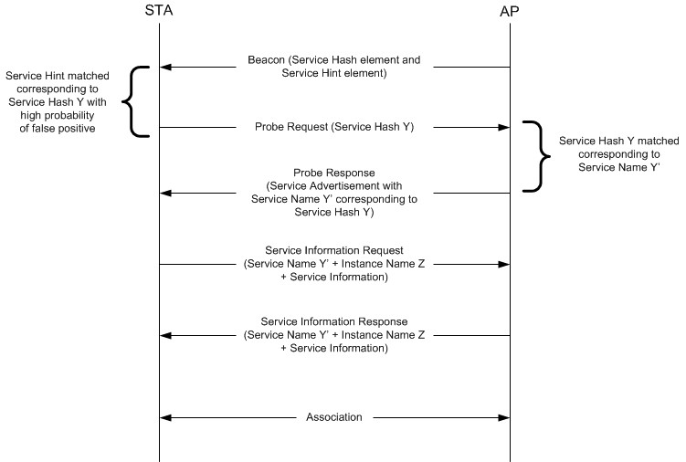

Figure W-1—Example of a frame exchange for background search with high probability of false positive

Based on the probability of false positive as indicated in False Positive Probability Range field of the Service Hint element is considered relatively low by the non-AP STA (see Figure W-2 (Example of a frame exchange for background search with low probability of false positive)), the non-AP STA can directly send an ANQP request with Service Information Request ANQP-element containing the Service Name and specific Service Information Query Request to obtain more information about the service from the AP or PCP.

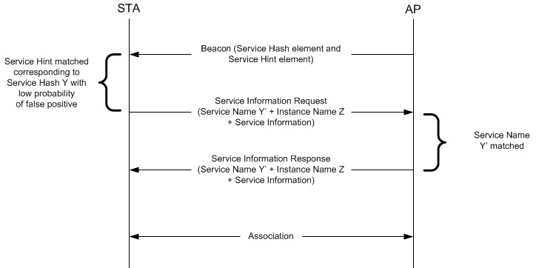

Figure W-2—Example of a frame exchange for background search with low probability of false positive

The AP or PCP responds to the ANQP request with the ANQP response with Service Information Response ANQP-element containing the Service Name, Instance Name and specific Service Information Query Response. After the ANQP request and ANQP response exchange, the non-AP STA can make an informed decision about associating with the AP or PCP.

In a scenario where there is a matching Service Hash element, the non-AP STA can directly send an ANQP request with Service Information Request ANQP-element containing the Service Name and specific Service Information Query Request to obtain more information about the service from the AP or PCP as shown in Figure W-3 (Example of frame exchange for background search with matching Hash element).

The AP or PCP responds to the ANQP request with the ANQP response with Service Information Response ANQP-element containing the Service Name, Instance Name and specific Service Information Query Response. After the ANQP request and ANQP response exchange, the non-AP STA can make an informed decision about choosing to associate to the AP or PCP.

Alternatively, the non-AP STA might choose to associate based on the matching Service Hash element.

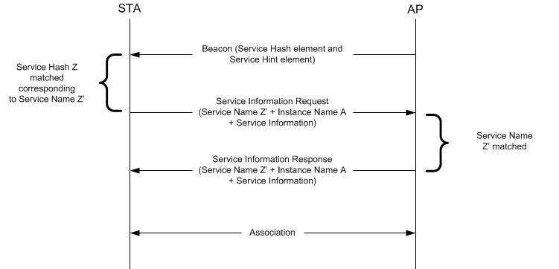

Figure W-3— Example of frame exchange for background search with matching Hash ele- ment

    - Immediate Search

Applications that are initiated by users (e.g., a user is looking for a fast movie download service) require immediate discovery results to be presented to the user. In this scenario, a non-AP STA performs a Solicited PAD procedure, whereby the non-AP STA sends Probe Request frames to query specific services immediately after user initiation of the service/application and the AP or PCP responds with a Probe Response frame accordingly if there is a matched service (Figure W-4 (Example of frame exchange for immediate search)). The Probe Request frame contains the Service Hash element of the search service. The AP or PCP responds with a Probe Response frame with a Service Advertisement element containing the corresponding Service Name and Instance Name. The non-AP STA then might perform an ANQP request and ANQP response exchange with the AP or PCP, as shown in Figure W-4 (Example of frame exchange for immediate search), to obtain more information about the service. After the ANQP request and ANQP response exchange, the non-AP STA can make an informed decision about choosing to associate to the AP or PCP.

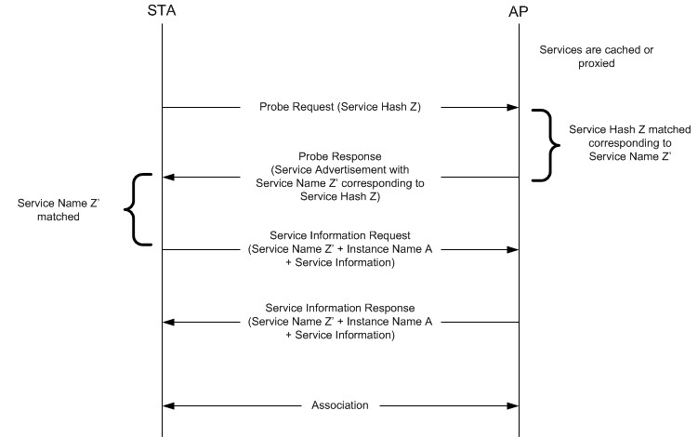

Figure W-4—Example of frame exchange for immediate search

