IEEE P802.11
Wireless LANs
802.11
SB1 - Proposed resolutions for some MAC comments
Date: 2016-03-13
Author(s):
Name | Company | Address | Phone | email
Emily Qi | Intel Corporation |  |  | Emily.h.qi@intel.com
Abstract

This document contains proposed resolutions to SB1 comments: #7316; #7590; #7101
#7267; #7310; and #7501

R0: Initial draft
R1: updated with feedback from Tuesday (3/14) meeting
R2: updated on #7310 and #7501, provided resolution for #7121.
R3: removed resolutions for #7121.

7101 | 1706.09 | 11.11.10.3 | "the reporting AP has dot11LciCivicInNeighborReport and the neighbor AP has LCI MeasurementCapability (RM Enabled Capabilities element with the LCI Measurement Capability Enabled fieldset to 1) dot11RMLCIMeasurementActivated equal to true"-- this has at least two errors "has dot11LciCivicInNeighborReport" and"Measurement Capability (...) dot11RMLCIMeasurementActivated equal to true"Note that " (RM Enabled Capabilities element with the LCI Measurement Capability Enabled field set to 1)" is also a informal way of anonymously referencing a transmission by the AP)." this can also be improved. This informality occurs in a number of places in this subclause. The proposed changes addresses two of these. | Change cited text to:"the reporting AP has dot11LciCivicInNeighborReport equal to true and the neighbor AP indicates support for LCI measurement(the neighbor AP has transmitted an RM Enabled Capabilities element with the LCI Measurement Capability Enabled field equal to true)"Make matching changes at 1706.32.

7101 | 1706.09 | 11.11.10.3 | "the reporting AP has dot11LciCivicInNeighborReport and the neighbor AP has LCI MeasurementCapability (RM Enabled Capabilities element with the LCI Measurement Capability Enabled fieldset to 1) dot11RMLCIMeasurementActivated equal to true"-- this has at least two errors "has dot11LciCivicInNeighborReport" and"Measurement Capability (...) dot11RMLCIMeasurementActivated equal to true"Note that " (RM Enabled Capabilities element with the LCI Measurement Capability Enabled field set to 1)" is also a informal way of anonymously referencing a transmission by the AP)." this can also be improved. This informality occurs in a number of places in this subclause. The proposed changes addresses two of these. | Change cited text to:"the reporting AP has dot11LciCivicInNeighborReport equal to true and the neighbor AP indicates support for LCI measurement(the neighbor AP has transmitted an RM Enabled Capabilities element with the LCI Measurement Capability Enabled field equal to true)"Make matching changes at 1706.32.

Discussion:

Cited text at 1706.09:

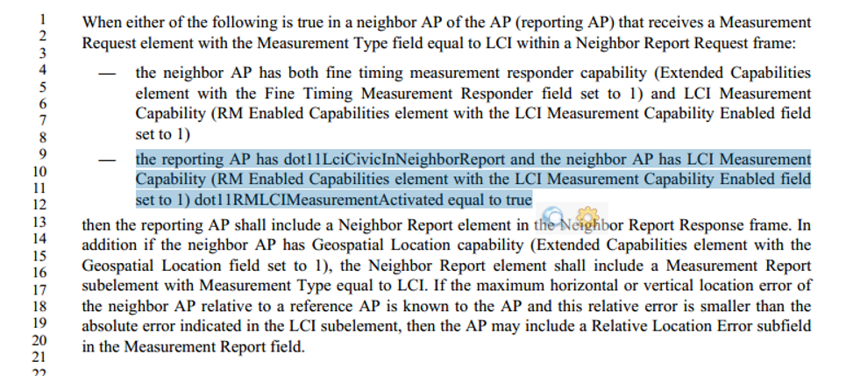

Agreed with the commenter, but would prefer to the wording is consistant with the first bullet.
Also, “dot11RMLCIMeasurementActivated equal to true” seems redundent.

Proposed Resolution:
Revised.

At 1706.09, make following changes:
When either of the following is true in a neighbor AP of the AP (reporting AP) that receives a Measurement
Request element with the Measurement Type field equal to LCI within a Neighbor Report Request frame:
— the neighbor AP has both fine timing measurement responder capability (Extended Capabilities
element with the Fine Timing Measurement Responder field set to 1) and LCI measurement
capability (RM Enabled Capabilities element with the LCI Measurement Capability Enabled field
set to 1)
— the reporting AP has dot11LciCivicInNeighborReport equal to true and the neighbor AP has LCI measurement capability (RM Enabled Capabilities element with the LCI Measurement Capability Enabled field set to 1).

At 1706.32, make following changes:
When either of the following is true in a neighbor AP of the AP (reporting AP) that receives a Measurement Request element with the Measurement Type equal to Location Civic within a Neighbor Report Request frame:
— the neighbor AP has both fine timing measurement responder capability (Extended Capabilities element with the Fine Timing Measurement Responder field set to 1) and civic location measurement capability (RM Enabled Capabilities element with Civic Location Measurement Capability Enabled set to 1)
— the reporting AP has dot11LciCivicInNeighborReport equal to true and the neighbor AP has civic location measurement capability (RM Enabled Capabilities element with Civic Location Measurement
Capability Enabled set to 1)

7104 | 1897.37 | 11.46 | "the STA may assume any value for the average MSDU size" - No normative effect can be attributed to "may assume"? | Reword in terms of observable behaviour.

Discussion:

There are two locations of “ the STA may assume …” in the same page:

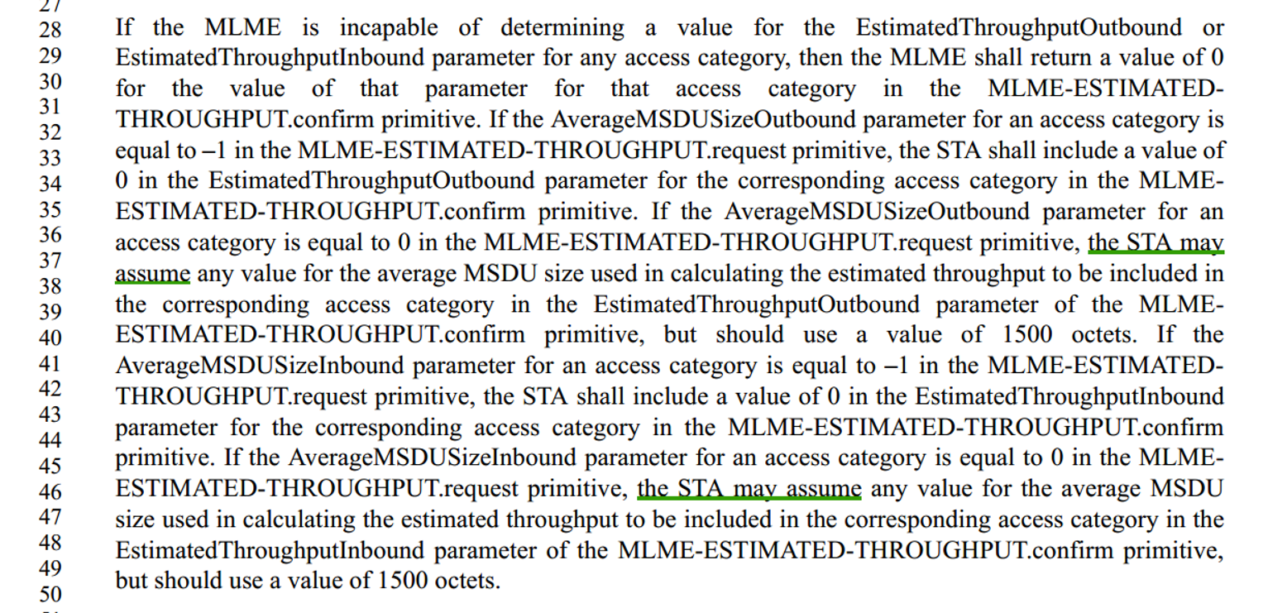

Proposed Resolution:
Revised.

At 1897.37, make following changes:
If the MLME is incapable of determining a value for the EstimatedThroughputOutbound or EstimatedThroughputInbound parameter for any access category, then the MLME shall return a value of 0 for the value of that parameter for that access category in the MLME-ESTIMATED-THROUGHPUT.confirm primitive. If the AverageMSDUSizeOutbound parameter for an access category is equal to –1 in the MLME-ESTIMATED-THROUGHPUT.request primitive, the STA shall include a value of 0 in the EstimatedThroughputOutbound parameter for the corresponding access category in the MLME-ESTIMATED-THROUGHPUT.confirm primitive. If the AverageMSDUSizeOutbound parameter for an access category is equal to 0 in the MLME-ESTIMATED-THROUGHPUT.request primitive, the STA may use any value for the average MSDU size used in calculating the estimated throughput to be included in the corresponding access category in the EstimatedThroughputOutbound parameter of the MLME-ESTIMATED-THROUGHPUT.confirm primitive, but should use a value of 1500 octets. If the AverageMSDUSizeInbound parameter for an access category is equal to –1 in the MLME-ESTIMATED-THROUGHPUT.request primitive, the STA shall include a value of 0 in the EstimatedThroughputInbound parameter for the corresponding access category in the MLME-ESTIMATED-THROUGHPUT.confirm primitive. If the AverageMSDUSizeInbound parameter for an access category is equal to 0 in the MLME-ESTIMATED-THROUGHPUT.request primitive, the STA may use any value for the average MSDU size used in calculating the estimated throughput to be included in the corresponding access category in the EstimatedThroughputInbound parameter of the MLME-ESTIMATED-THROUGHPUT.confirm primitive, but should use a value of 1500 octets.

7267 | 1272.58 | 10.3.2.3.5 | ""A correctly received frame is one where the PHY-RXEND.indication primitive does not indicate an error and the FCS indicates the frame is error free." is the very definition of frame reception | Delete the cited sentence

Discussion:

Agreed with the commenter.

Proposed Resolution:
Revised.

Moved cited sentence to 1269.40.

7310 | 1346.56 | 10.21.4 | "When dot11OperatingClassesImplemented is true, the following statements apply:" -- the first statement is already made in the previous subclause | Delete the first bullet | MAC |  | EDITOR: 2016-02-02 12:17:12Z - I agree this is aparent duplication. However that is not an editorial function. Transferring to MAC/Operation.  EDITOR_Q: 2016-02-01 23:47:06Z- Personally, I think the first bullet is needed. A group discussion is needed. | Assigned

Discussion:

Cited text at 1346.56:
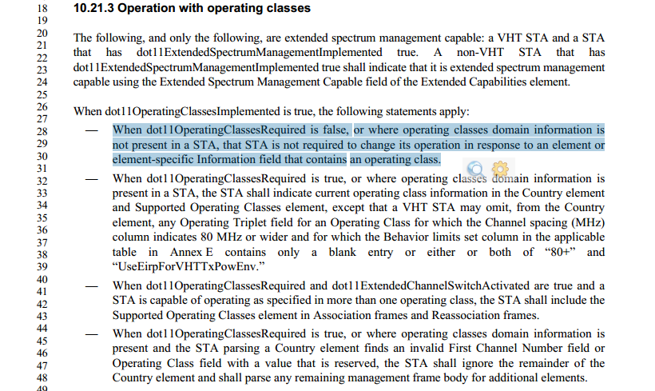

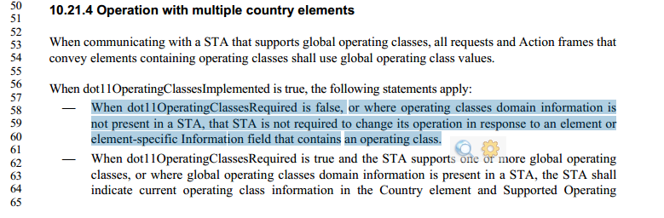

They are repeated texts, but serve the different purpose.

The cited text is needed to cover all cases. If the cited text is removed, a comment may be raised: what happen if “When dot11OperatingClassesRequired is false” ?

I talked to Peter, here are responses:
- 10.21.3 could be one or more regulatory domains, including local domain only.
- 10.21.4 cannot be local only regulatory domain, only more than one regulatory domain, which implies global is one of them.
- Please reject the comment for the reason that the statement in 10.21.4 is unique to itself, not already being stated in 10.21.3.

Proposed Resolution:
Rejected.

Rationales:
- The statement in 10.21.4 is unique to itself, not already being stated in 10.21.3.
- 10.21.3 could for one or more regulatory domains, including local domain only.
- 10.21.4 cannot for local only regulatory domain, only more than one regulatory domain, which implies global is one of them.

7316 | 873.41 | 9.4.2.40 | "When included in a Beacon, Probe Response, or Location Track Notification frame, the Antenna ID identifies the antenna(s) used to transmit the Beacon, Probe Response, or Location Track Notification frame. When included in a measurement report, or Location Track Notification frame, the Antenna ID identifies the antenna(s) used for the reported measurement or transmission of the Location Track Notification frame. The valid range for the Antenna ID is 1 to 254. The value 0 indicates that the antenna identifier is unknown. The value 255 indicates that this measurement was made with multiple antennas, i.e., antennas were switched during the measurement duration. In a Beacon Report or Frame Report, the Antenna ID always identifies the antenna used to receive the reported beacon or frame." but it's not clear to me that the antenna element can be included in anything except a beacon or probe response (from grepping for "Antenna element") | Change to "The Antenna ID identifies the antenna(s) used to transmit the frame the Antenna element is contained in. The valid range for the Antenna ID is 1 to 254. The value 0 indicates that the antenna identifier is unknown. The value 255 indicates that this transmission was made with multiple antennas, i.e., antennas were switched during the transmission."

Discussion:

Agreed with the commenter.

Note that the commenter missed the second “ " ” in the quoted text.
Therefore, the cited text is recited in the proposed resolution.

Proposed Resolution:
Revised.

Change “When included in a Beacon, Probe Response, or Location Track Notification frame, the Antenna ID identifies the antenna(s) used to transmit the Beacon, Probe Response, or Location Track Notification frame. When included in a measurement report, or Location Track Notification frame, the Antenna ID identifies the antenna(s) used for the reported measurement or transmission of the Location Track Notification frame. The valid range for the Antenna ID is 1 to 254. The value 0 indicates that the antenna identifier is unknown. The value 255 indicates that this measurement was made with multiple antennas, i.e., antennas were switched during the measurement duration.”

To “The Antenna ID identifies the antenna(s) used to transmit the frame the Antenna element is contained in. The valid range for the Antenna ID is 1 to 254. The value 0 indicates that the antenna identifier is unknown. The value 255 indicates that this transmission was made with multiple antennas, i.e., antennas were switched during the transmission.”

7501 | 1361.04 | 10.22.2.10.1 | "All retransmission attempts by a non-DMG STA for an MPDU that is not sent under a block ack agreement and that has failed the acknowledgment procedure one or more times shall be made with the Retry subfield set to 1 in the Data or Management frame. " -- what is the purpose of the words from "in the" onwards? Maybe better to move the "Data or Management" to the "MPDU" and delete from "in the" onwards. Ditto next sentence. Ditto in the DCF: "All retransmission attempts for an MPDU the Type subfield equal to Data or Management that has failed the Ack procedure one or more times shall be made with the Retry field set to 1 in the Data or Management frame." - delete from "in the onwards"). | As it says in the comment

Discussion:

Agreed with the commenter.

Proposed Resolution:
Revised.

At 1361.05, make following changes:
All retransmission attempts by a non-DMG STA for an MPDU with the Type subfield equal to Data or Management that is not sent under a block ack agreement and that has failed the acknowledgmentprocedure one or more times shall be made with the Retry subfield set to 1. All retransmission attempts by a DMG STA for an MPDU with the Type subfield equal to Data or Management that has failed the acknowledgment procedure one or more times shall be made with the Retry subfield set to 1.

At 1293.48 make following changes:
After transmitting a frame that requires acknowledgment, the STA shall perform the Ack procedure, as defined in 10.3.2.9 (Ack procedure). The SRC for an MPDU with the Type subfield equal to Data or Management and of length less than or equal to dot11RTSThreshold and the SSRC shall be incremented every time transmission of that MPDU fails. This SRC and the SSRC shall be reset when transmission of that MPDU succeeds. The LRC for an MPDU with the Type subfield equal to Data or Management and of length greater than dot11RTSThreshold and the SLRC shall be incremented every timetransmission of that MPDU fails. This LRC and the SLRC shall be reset when transmission of that MPDU succeeds. All retransmission attempts for an MPDU with the Type subfield equal to Data or Management that has failed the Ack procedure one or more times shall be made with the Retry subfield set to 1.

7590 | 1063.21 | 9.4.2.167 | Status Indication and Value need to be specified as being reserved for the initiating STA | As it says in the comment

Discussion:

“Status Indication” field need to be specified as being reserved for the initiating STA.

I don’t think “Value” filed need to. It is already specified at 1064.29: “When the Status Indication field equals 3, the Value field contains a duration in units of seconds; otherwise the Value field is reserved.”

Proposed Resolution:
Revised.

At 1064.4, make following changes:
The Status Indication field and Value field are reserved in the initial Fine Timing Measurement Request frame. When the Status Indication field is set to 3 by the responding STA, the Value field contains a duration in units of seconds; otherwise the Value field is reserved.

